**Propositional Logic**

Last Updated : 27 Jan, 2025

Logic is the basis of all mathematical reasoning and all automated reasoning. The rules of logic specify the meaning of mathematical statements. These rules help us understand and reason with statements such as –

*∃ x such that x ≠ a2 + b2, where x, a, b∈ Z∃ x such that x = a2 + b2, where x, a, b∈ Z  
Which in Simple English means “****There exists an integer that is not the sum of two squares****“.*

**Importance of Mathematical Logic**

The rules of logic give precise meaning to mathematical statements. These rules are used to distinguish between valid and invalid mathematical arguments. Apart from its importance in understanding mathematical reasoning, logic has numerous applications in Computer Science, varying from the design of digital circuits to the construction of computer programs and verification of the correctness of programs.

**Table of Content**

* [Types of Propositions](https://www.geeksforgeeks.org/proposition-logic/#types-of-propositions)
* [Propositional Logic](https://www.geeksforgeeks.org/proposition-logic/#propositional-logic)
* [Truth Table of Propositional Logic](https://www.geeksforgeeks.org/proposition-logic/#truth-table)
* [Propositional Logic Examples](https://www.geeksforgeeks.org/proposition-logic/#propositional-logic-examples)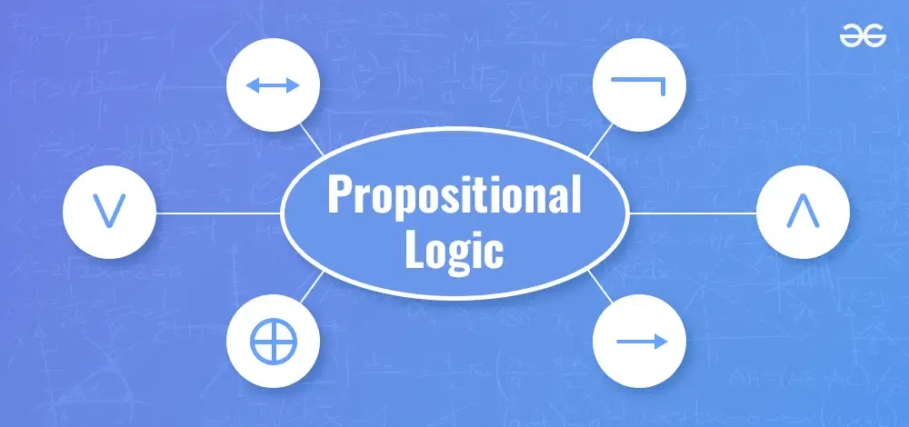

**Types of Propositions**

In propositional logic, propositions are statements that can be evaluated as true or false. They are the building blocks of more complex logical statements. Here’s a breakdown of the two main types of propositions:

* Atomic Propositions
* Compound Propositions

**Propositional Logic**

Propositional logic is a branch of mathematics that studies the logical relationships between propositions (or statements, sentences, assertions) taken as a whole, and connected via logical connectives.

***For Example,***

1. *The sun rises in the East and sets in the West.*
2. *1 + 1 = 2*
3. *‘b’ is a vowel.*

*Above 3 sentences are propositions, where the first two are Valid(True) and the third one is Invalid(False).*

All of the above sentences are propositions, where the first two are Valid(True) and the third one is Invalid(False). Some sentences that do not have a truth value or may have more than one truth value are not propositions. For Example,

1. What time is it?
2. Go out and Play
3. x + 1 = 2

The above sentences are not propositions as the first two do not have a truth value, and the third one may be true or false. To represent propositions, **propositional variables** are used. By Convention, these variables are represented by small alphabets such as p,q,r,s   *p*,*q*,*r*,*s* . The area of logic which deals with propositions is called **propositional calculus** or **propositional logic**. It also includes producing new propositions using existing ones. Propositions constructed using one or more propositions are called **compound propositions**. The propositions are combined together using **Logical Connectives** or **Logical Operators**.

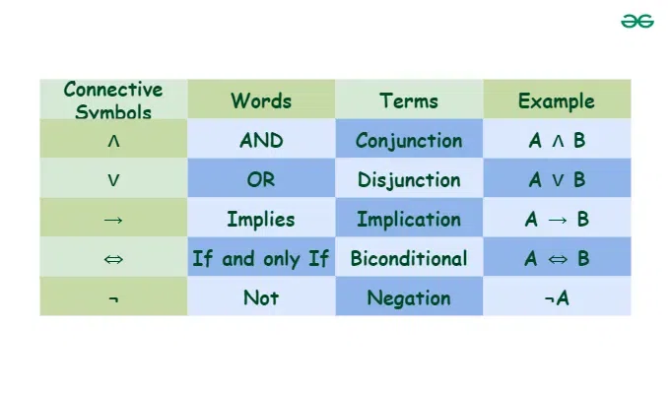

*Propositional Logic*

**Truth Table of Propositional Logic**

Since we need to know the truth value of a proposition in all possible scenarios, we consider all the possible combinations of the propositions which are joined together by Logical Connectives to form the given compound proposition. This compilation of all possible scenarios in a tabular format is called a **truth table**. Most Common Logical Connectives-

**1. Negation**

If p   *p* is a proposition, then the negation of p   *p* is denoted by ¬p   ¬*p* , which when translated to simple English means- “It is not the case that **p**” or simply “not **p**“. The truth value of **-p** is the opposite of the truth value of **p**. The truth table of **-p** is:

| **p** | **¬p** |
| --- | --- |
| T | F |
| F | T |

**Example,**Negation of “It is raining today”, is “It is not the case that is raining today” or simply “It is not raining today”.

**2. Conjunction**

For any two propositions p   *p* and q   *q* , their conjunction is denoted by p∧q   *p*∧*q* , which means “p   *p* and q   *q* “. The conjunction p∧q   *p*∧*q* is True when both p   *p* and q   *q* are True, otherwise False. The truth table of p∧q   *p*∧*q* is:

| **p** | **q** | **p ∧ q** |
| --- | --- | --- |
| T | T | T |
| T | F | F |
| F | T | F |
| F | F | F |

**Example,** Conjunction of the propositions p   *p* – “Today is Friday” and q   *q* – “It is raining today”, p∧q   *p*∧*q* is “Today is Friday and it is raining today”. This proposition is true only on rainy Fridays and is false on any other rainy day or on Fridays when it does not rain.

**3. Disjunction**

For any two propositions p   *p* and q   *q* , their disjunction is denoted by p∨q   *p*∨*q* , which means “p   *p* or q   *q* “. The disjunction p∨q   *p*∨*q* is True when either p   *p* or q   *q* is True, otherwise False. The truth table of p∨q   *p*∨*q* is:

| **p** | **q** | **p ∨ q** |
| --- | --- | --- |
| T | T | T |
| T | F | T |
| F | T | T |
| F | F | F |

**Example,**Disjunction of the propositions p   *p* – “Today is Friday” and q   *q* – “It is raining today”, p∨q   *p*∨*q* is “Today is Friday or it is raining today”. This proposition is true on any day that is a Friday or a rainy day(including rainy Fridays) and is false on any day other than Friday when it also does not rain.

**4. Exclusive Or**

For any two propositions p   *p* and q   *q* , their exclusive or is denoted by p⊕q   *p*⊕*q* , which means “either p   *p* or q   *q* but not both”. The exclusive or p⊕q   *p*⊕*q* is True when either p   *p* or q   *q* is True, and False when both are true or both are false. The truth table of p⊕q   *p*⊕*q* is:

| **p** | **q** | **p ⊕ q** |
| --- | --- | --- |
| T | T | F |
| T | F | T |
| F | T | T |
| F | F | F |

**Example,**Exclusive or of the propositions p   *p* – “Today is Friday” and q   *q* – “It is raining today”, p⊕q   *p*⊕*q* is “Either today is Friday or it is raining today, but not both”. This proposition is true on any day that is a Friday or a rainy day(not including rainy Fridays) and is false on any day other than Friday when it does not rain or rainy Fridays.

**5. Implication**

For any two propositions p   *p* and q   *q* , the statement “if p   *p* then q   *q* ” is called an implication and it is denoted by p→q   *p*→*q* . In the implication p→q   *p*→*q* , p   *p* is called the **hypothesis** or **antecedent** or **premise** and q   *q* is called the **conclusion** or **consequence**. The implication is p→q   *p*→*q* is also called a **conditional statement**. The implication is false when p   *p* is true and q   *q* is false otherwise it is true. The truth table of p→q   *p*→*q* is:

| **p** | **q** | **p → q** |
| --- | --- | --- |
| T | T | T |
| T | F | F |
| F | T | T |
| F | F | T |

One might wonder that why is p→q   *p*→*q* true when p   *p* is false. This is because the implication guarantees that when p   *p* and q   *q* are true then the implication is true. But the implication does not guarantee anything when the premise p   *p* is false. There is no way of knowing whether or not the implication is false since p   *p* did not happen. This situation is similar to the “Innocent until proven Guilty” stance, which means that the implication p→q   *p*→*q* is considered true until proven false. Since we cannot call the implication p→q   *p*→*q* false when p   *p* is false, our only alternative is to call it true.

This follows from the **Explosion Principle** which says: “A False statement implies anything” Conditional statements play a very important role in mathematical reasoning, thus a variety of terminology is used to express p→q   *p*→*q* , some of which are listed below.

*“If p, then “q”p is sufficient for q””q when p””a necessary condition for p is q””p only if q””q unless ≠p””q follows from p”*

**Example,**“If it is Friday then it is raining today” is a proposition which is of the form p→q   *p*→*q* . The above proposition is true if it is not Friday(premise is false) or if it is Friday and it is raining, and it is false when it is Friday but it is not raining.

**6. Biconditional or Double Implication**

For any two propositions p   *p* and q   *q* , the statement “p   *p* if and only if(iff) q   *q* ” is called a biconditional and it is denoted by p↔q   *p*↔*q* . The statement p↔q   *p*↔*q* is also called a **bi-implication**. p↔q   *p*↔*q* has the same truth value as (p→q)∧(q→p)   (*p*→*q*)∧(*q*→*p*) The implication is true when p   *p* and q   *q* have same truth values, and is false otherwise. The truth table of p↔q   *p*↔*q* is:

| **p** | **q** | **p ↔ q** |
| --- | --- | --- |
| T | T | T |
| T | F | F |
| F | T | F |
| F | F | T |

Some other common ways of expressing p↔q   *p*↔*q* are:

“p is necessary and sufficient for q””if p then q, and conversely””p if q”

Example, “It is raining today if and only if it is Friday today.” is a proposition which is of the form p↔q   *p*↔*q* . The above proposition is true if it is not Friday and it is not raining or if it is Friday and it is raining, and it is false when it is not Friday or it is not raining.

**Propositional Logic Examples**

**1) Consider the following statements:**

* P: Good mobile phones are not cheap.
* Q: Cheap mobile phones are not good.
* L: P implies Q
* M: Q implies P
* N: P is equivalent to Q

**Which one of the following about L, M, and N is CORRECT?**

**(A)** Only L is TRUE.

**(B)** Only M is TRUE.

**(C)** Only N is TRUE.

**(D)** L, M and N are TRUE.

**Solution:**

*Let a and b be two proposition  
a: Good Mobile phones.  
b: Cheap Mobile Phones.  
  
P and Q can be written in logic as  
P: a–>~b  
Q: b–>~a.  
  
Truth Table  
a b ~a ~b P Q  
T T F F F F  
T F F T T T  
F T T F T T  
F F T T T T  
  
it clearly shows P and Q are equivalent.  
so option D is Correct*

**2)** **Which one of the following is not equivalent to p <-> q**

(A)(¬p∨q)∧(p∨¬q)(B)(¬p∨q)∧(q→p)(C)(¬p∧q)∨(p∧¬q)(D)(¬p∧¬q)∨(p∧q)  (*A*)(¬*p*∨*q*)∧(*p*∨¬*q*)(*B*)(¬*p*∨*q*)∧(*q*→*p*)(*C*)(¬*p*∧*q*)∨(*p*∧¬*q*)(*D*)(¬*p*∧¬*q*)∨(*p*∧*q*)

**Conjunction** of p and q, denoted by p∧q, is the proposition ‘p and q’. The conjunction p ∧ q is True, when both p and q is True. **Disjunction** of p and q, denoted by p∨q, is the proposition ‘p or q’. The disjunction p∨q is False when both p and q is False.

**Logical Implication –** It is a type of relationship between two statements or sentence. Denoted by ‘p → q’. The conditional statement p → q is false when p is true and q is false, and true otherwise. i.e. p → q = ¬p ∨ q

B**i-Condition** A bi-conditional statement is a compound statement formed by combining two conditionals under “and.” Bi-conditionals are true when both statements have the exact same truth value.

**Solution:**

*p↔q means both p→q and q→p p→q is equivalent to ⌉p ∨ q and q is equivalent to ⌉q ∨ p So A and B are fine. D is a different way of writing A p ↔ q = (p→ q) ∧ (q→p) = (⌉p ∨ q) ∧ (q → p) [ Since p→ q = ⌉p ∨ q ] = (⌉p ∨ q) ∧ (⌉q ∨ p) = (¬p ∧ p )∨ (¬p ∧¬q )∨ (q ∧p ) ∨(q ∧¬q ) (Distributive law) [As ((¬p∧ p )=0,(q ∧¬q )=0) (Complementation) ] (⌉p ∧ ⌉q) ∨ (p ∧ q) which is Option (D) Only option which is not equivalent to p↔q is option (C). So, option (C) is correct.*

**Conclusion**

Propositional logic is a fundamental branch of mathematical logic that deals with propositions (statements that are either true or false) and their relationships. It uses logical connectives such as AND (∧), OR (∨), NOT (¬), IMPLIES (→), and IF AND ONLY IF (↔) to form compound propositions. The truth or falsity of these compound propositions can be determined using truth tables. Propositional logic provides a foundation for more complex logical systems and is essential in various fields, including computer science, mathematics, and philosophy.

**Propositions Laws and Algebra**

Last Updated : 27 Jan, 2025

Propositional logic is the foundation of logical reasoning, playing a vital role in understanding mathematical proofs and algorithms. It is especially important for college students preparing for competitive exams like GATE.

This article explores:

* Fundamental laws and concepts in the algebra of propositions like Idempotent, Associative, Distributive, and Commutative Laws.
* Special conditional statements essential for understanding logical reasoning.

Prerequisites: [*Propositional Logic – Definitions & Truth Table*](https://www.geeksforgeeks.org/proposition-logic/)

**Laws of Algebra of Propositions**

Below mentioned are the laws of Algebra of Propositions

**Idempotent Law**

* p ∨ p ≅ p
* p ∧ p ≅ p

The truth table of [conjunction](https://www.geeksforgeeks.org/proposition-logic/) and disjunction of a proposition with itself will equal the proposition.

**Associative Law**

* (p ∨ q) ∨ r ≅ p ∨ (q ∨ r)
* (p ∧ q) ∧ r ≅ p ∧ (q ∧ r)

Associative Law states that propositions also follow associativity and can be written as mentioned above.

**Distributive Law**

* p ∨ (q ∧  r) ≅ (p ∨ q) ∧ (p ∨ r)
* p ∧ (q ∨  r) ≅ (p ∧ q) ∨ (p ∧ r)

Distributive Law states that propositions also follow the distribution and can be written as mentioned above.

**Commutative Law**

* p ∨ q ≅ q ∨ p
* p ∧ q ≅ q ∧ p

It states that propositions follow commutative property i.e if a=b then b=a

**Identity Law**

* p ∨ T ≅ T
* p ∨ F ≅ p
* p ∧ T ≅ p
* p ∧ F ≅ F

where T is a Tautology, F is a Contradiction and p is a proposition.

**De Morgan’s Law**

In [propositional logic](https://www.geeksforgeeks.org/proposition-logic/) and boolean algebra, De Morgan’s laws are a pair of transformation rules that are both valid [**rules of inference**](https://www.geeksforgeeks.org/mathematical-logic-rules-inference/). They are named after Augustus De Morgan, a 19th-century British mathematician. The rules allow the expression of conjunctions and disjunctions purely in terms of each other via negation. In formal language, the rules are written as –

* ¬(p∧q)≡¬p∨¬q¬(*p*∧*q*)≡¬*p*∨¬*q*
* ¬(p∨q)≡¬p∧¬q¬(*p*∨*q*)≡¬*p*∧¬*q*

**Involution Law**

* ~~p ≅ p

**Complement Law**

* p ∨ ~p ≅ T
* p ∧ ~p ≅ F
* ~T ≅ F
* ~F ≅ T

where T is a Tautology, F is a Contradiction and p is a proposition.

**Special Conditional Statements**

As we know that we can form new propositions using existing propositions and logical connectives. New conditional statements can be formed starting with a conditional statement p→q    *p*→*q* . In particular, there are three related conditional statements that occur so often that they have special names.

* **Implication :** p→q*p*→*q*
* **Converse :** The converse of the proposition p→q    *p*→*q* is q→p*q*→*p*
* **Contrapositive :** The contrapositive of the proposition p→q    *p*→*q* is ¬q→¬p¬*q*→¬*p*
* **Inverse :** The inverse of the proposition p→q    *p*→*q* is ¬p→¬q¬*p*→¬*q*

**Note :**It is interesting to note that the truth value of the conditional statement p→q    *p*→*q* is the same as it’s contrapositive, and the truth value of the Converse of p→q    *p*→*q* is the same as the truth value of its Inverse. When two compound propositions always have the same truth value, they are said to be equivalent. Therefore,

* p→q≡¬q→¬p*p*→*q*≡¬*q*→¬*p*
* q→p≡¬p→¬q*q*→*p*≡¬*p*→¬*q*

**Example :**

**Implication :** If today is Friday, then it is raining. The given proposition is of the form p→q    *p*→*q* , where p    *p* is “Today is Friday” and q    *q* is “It is raining today”. Contrapositive, Converse, and Inverse of the given proposition respectively are-

* ***Converse:*** *If it is raining, then today is Friday****or*** *if q -> p is converse of p-> q*
* ***Contrapositive:*** *If it is not raining, then today is not Friday* ***or*** *if ~q -> ~p is contrapositive of p-> q*
* ***Inverse:*** *If today is not Friday, then it is not raining  
                                                    or  
  if ~p -> ~q is inverse of p-> q*

**Implicit Use of Biconditionals**

The last article, part one of this topic, ended with a discussion of bi-conditionals, what it is, and their truth table. In Natural Language bi-conditionals are not always explicit. In particular, the if construction (if and only if) is rarely used in the common language. Instead, bi-conditionals are often expressed using “if, then” or an “only if” construction. The other part of the “if and only if” is implicit, i.e. the converse is implied but not stated. For example consider the following statement, “If you complete your homework, then you can go out and play”. What is really meant is “You can go out and play if and only if you complete your homework”. This statement is logically equivalent to two statements, “If you complete your homework, then you can go out and play” and “You can go out and play only if you complete your homework”. Because of this imprecision in Natural Language, an assumption needs to be made whether a conditional statement in natural language includes its converse or not.

**Precedence Order of Logical Connectives**

Logical connectives are used to construct compound propositions by joining existing propositions. Although parenthesis can be used to specify the order in which the logical operators in the compound proposition need to be applied, there exists a precedence order in Logical Operators. The precedence Order is-

*OperatorPrecedence¬1∧2∨3→4↔5Operator¬∧∨→↔​Precedence12345​​*

Here, higher the number lower the precedence.

**Translating English Sentences**

As mentioned above in this article, Natural Languages such as English are ambiguous i.e. a statement may have multiple interpretations. Therefore it is important to convert these sentences into mathematical expressions involving propositional variables and logical connectives. The above process of conversion may take certain reasonable assumptions about the intended meaning of the sentence. Once the sentences are translated into logical expressions they can be analyzed further to determine their truth values. [Rules of Inference](https://www.geeksforgeeks.org/mathematical-logic-rules-inference/) can then further be used to reason about the expressions.

**Example :** “You can access the Internet from campus only if you are a computer science major or you are not a freshman.” The above statement could be considered as a single proposition but it would be more useful to break it down into simpler propositions. That would make it easier to analyze its meaning and to reason with it. The above sentence could be broken down into three propositions,

*p – “You can access the Internet from campus.”  
q – “You are a computer science major.”  
r – “You are a freshman.”*

Using logical connectives we can join the above-mentioned propositions to get a logical expression of the given statement. “only if” is one way to express a conditional statement, (as discussed in Part 1 of this topic in the previous Article), Therefore the logical expression would be –

*p→(q∨¬r)p→(q∨¬r)*

**Examples**

**1. Implication**

If today is Friday, then it is raining.

* **Converse:** If it is raining, then today is Friday.
* **Contrapositive:** If it is not raining, then today is not Friday.
* **Inverse:** If today is not Friday, then it is not raining.

**2. Translate English Sentence**

“**You can access the Internet from campus only if you are a computer science major or you are not a freshman**.”

* Logical Expression: 𝑝 – > (𝑞 ∨ ¬ 𝑟 )
* Where:
  + **p** = “You can access the Internet from campus.”
  + **q** = “You are a computer science major.”
  + **r** = “You are a freshman.”

**Unsolved Problems**

1. **Simplify ¬(p ∨ ¬q).**
2. **Prove p ∧ (p ∨ q) ≅ p.**
3. **What is the inverse of p → q?**
4. **Simplify ¬p ∨ (p ∧ q).**
5. **Prove (p ∧ T) ≅ p.**
6. **Determine the contrapositive of p → q.**
7. **Simplify ¬(p ∧ ¬q).**
8. **Prove (p ∨ F) ≅ p.**
9. **What is the converse of p → ¬q?**
10. **Simplify ¬(p ∨ q).**

**GATE CS Corner Questions**

Practicing the following questions will help you test your knowledge. All questions have been asked in GATE in previous years or in GATE Mock Tests. It is highly recommended that you practice them.

* [GATE CS 2009, Question 24](https://www.geeksforgeeks.org/gate-gate-cs-2009-question-24/)
* [GATE CS 2014 Set-1, Question 63](https://www.geeksforgeeks.org/gate-gate-cs-2014-set-1-question-63/)
* [GATE CS 2006, Question 28](https://www.geeksforgeeks.org/gate-gate-cs-2006-question-28/)
* [GATE CS 2002, Question 8](https://www.geeksforgeeks.org/gate-gate-cs-2002-question-8/)
* [GATE CS 2000, Question 30](https://www.geeksforgeeks.org/gate-gate-cs-2000-question-30/)
* [GATE CS 2015 Set-1, Question 24](https://www.geeksforgeeks.org/gate-gate-cs-2015-set-1-question-24/)

**Propositional Logic – FAQs**

**What is the significance of De Morgan’s Law?**

*De Morgan’s Law helps in transforming conjunctions into disjunctions and vice versa using negation, which is useful in simplifying logical expressions.*

**What are special conditional statements?**

*Special conditional statements include the converse, contrapositive, and inverse of a given implication.*

**Why is it important to translate English sentences into logical expressions?**

*Translating sentences into logical expressions removes ambiguity and allows for precise analysis of the truth values.*

**Propositional Equivalences**

Last Updated : 28 Dec, 2024

**Propositional equivalences** are fundamental concepts in logic that allow us to simplify and manipulate logical statements. Understanding these equivalences is crucial in computer science, engineering, and mathematics, as they are used to design circuits, optimize algorithms, and prove theorems. This article explores the main propositional equivalences, their applications, and examples.

**What are Propositional Equivalences?**

Propositional equivalences are logical statements that are true for the same set of truth values. Two propositions P and Q are said to be logically equivalent if they have the same truth table. This is denoted as P≡Q.

**Types of Propositions**

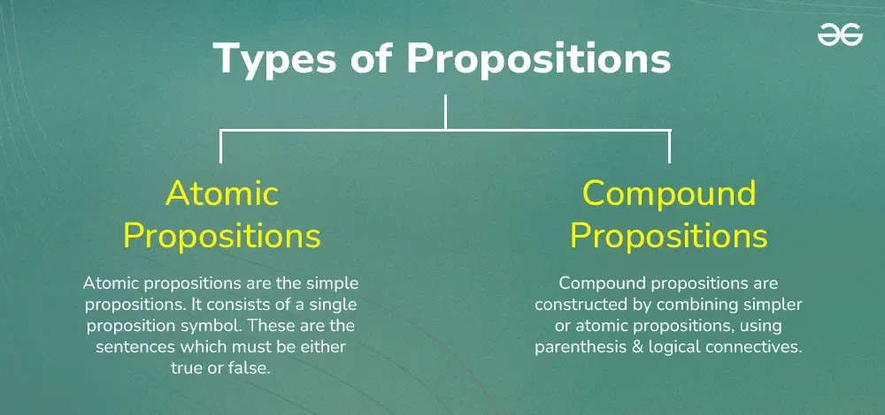

Propositional logic helps in simplifying and solving logical expressions.

**1. Atomic Propositions**

* They are also called primitive propositions or basic statements.
* They are the simplest form of propositions and cannot be further divided into smaller meaningful statements.
* They represent a single fact or idea.
* Examples:
  + “The sun is shining.” (True)
  + “It is raining today.” (False)
  + “2 + 2 = 4” (True)

**2. Compound Propositions**

* Created by combining atomic propositions using logical connectives.
* Logical connectives are symbols like “and”, “or”, “not”, “implies”, etc., that define the relationship between the atomic propositions.
* Examples:
  + “The sun is shining and it is raining today.” (Compound proposition using “and”)
  + “It is raining today or the sun is shining.” (Compound proposition using “or”)
  + “It is not raining today.” (Compound proposition using “not”)

**Key Propositional Equivalences**

**1. Identity Laws**

P∧true≡P

P∨false≡P

**2. Domination Laws**

P∨true≡true

P∧false≡false

**3. Idempotent Laws**

P∨P≡P

P∧P≡P

**4. Double Negation Law**

¬(¬P)≡P

**5. Commutative Laws**

P∨Q≡Q∨P

P∧Q≡Q∧P

**6. Associative Laws**

(P∨Q)∨R≡P∨(Q∨R)

(P∧Q)∧R≡P∧(Q∧R)

**7. Distributive Laws**

P∨(Q∧R)≡(P∨Q)∧(P∨R)

P∧(Q∨R)≡(P∧Q)∨(P∧R)

**8. De Morgan’s Laws**

¬(P∧Q)≡¬P ∨¬Q

¬(P∨Q)≡¬P ∧¬Q

**9. Absorption Laws**

P∨(P∧Q)≡P

P∧(P∨Q)≡P

**10. Negation Laws**

P∨¬P≡true

P∧¬P≡false

**Applications in Engineering**

**1. Digital Logic Design**

In digital logic design, propositional equivalences are used to simplify Boolean expressions, which leads to more efficient circuit designs.

**2. Software Engineering**

In software engineering, propositional equivalences help optimize conditional statements in programming, making the code more efficient and readable.

**3. Theoretical Computer Science**

In theoretical computer science, propositional equivalences are used in the study of algorithms and computational complexity to prove the correctness and optimize the performance of algorithms.

**4. Control Systems**

In control systems engineering, propositional equivalences are used to simplify logical conditions in control algorithms, leading to more efficient and reliable system performance.

**Sample Problems on Propositional Equivalences**

**Example: Show that p ∧ (p ∨ q) ≡ p**

**Solution:**

*p ∧ (p ∨ q)*

*≡ (p ∧ p) ∨ (p ∧ q) (Distributive Law)*

*≡ p ∨ (p ∧ q) (Idempotent Law)*

*≡ p (Absorption Law)*

**Example: Prove that ¬(p ∧ q) ≡ ¬p ∨ ¬q (De Morgan’s Law)**

**Solution:**

*¬(p ∧ q)*

*≡ ¬(¬(¬p ∨ ¬q)) (Double Negation Law)*

*≡ ¬p ∨ ¬q (De Morgan’s Law)*

**Example: Show that p → q ≡ ¬p ∨ q**

**Solution:**

*p → q*

*≡ ¬p ∨ q (Definition of Implication)*

**Example: Prove that (p → q) ∧ (p → r) ≡ p → (q ∧ r)**

**Solution:**

*(p → q) ∧ (p → r)*

*≡ (¬p ∨ q) ∧ (¬p ∨ r) (Definition of Implication)*

*≡ ¬p ∨ (q ∧ r) (Distributive Law)*

*≡ p → (q ∧ r) (Definition of Implication)*

**Example: Show that ¬(p ↔ q) ≡ p ↔ ¬q**

**Solution:**

*¬(p ↔ q)*

*≡ ¬((p → q) ∧ (q → p)) (Definition of Biconditional)*

*≡ ¬(p → q) ∨ ¬(q → p) (De Morgan’s Law)*

*≡ ¬(¬p ∨ q) ∨ ¬(¬q ∨ p) (Definition of Implication)*

*≡ (p ∧ ¬q) ∨ (q ∧ ¬p) (De Morgan’s Law)*

*≡ (p ∧ ¬q) ∨ (¬p ∧ q) (Commutativity)*

*≡ p ↔ ¬q (Definition of Biconditional)*

**Example: Prove that p ∨ (¬p ∧ q) ≡ p ∨ q**

**Solution:**

*p ∨ (¬p ∧ q)*

*≡ (p ∨ ¬p) ∧ (p ∨ q) (Distributive Law)*

*≡ T ∧ (p ∨ q) (Law of Excluded Middle)*

*≡ p ∨ q (Identity Law)*

**Example: Show that (p → q) ∧ (q → r) → (p → r) is a tautology**

**Solution:**

*(p → q) ∧ (q → r) → (p → r)*

*≡ ¬((¬p ∨ q) ∧ (¬q ∨ r)) ∨ (¬p ∨ r) (Definition of Implication)*

*≡ (p ∧ ¬q) ∨ (q ∧ ¬r) ∨ ¬p ∨ r (De Morgan’s Law and Distribution)*

*≡ (p ∧ ¬q) ∨ ¬p ∨ (q ∧ ¬r) ∨ r (Commutativity)*

*≡ ((p ∨ ¬p) ∧ (¬q ∨ ¬p)) ∨ ((q ∨ r) ∧ (¬r ∨ r)) (Distributive Law)*

*≡ (T ∧ (¬q ∨ ¬p)) ∨ ((q ∨ r) ∧ T) (Law of Excluded Middle)*

*≡ (¬q ∨ ¬p) ∨ (q ∨ r) (Identity Law)*

*≡ T (Always true, thus a tautology)*

**Example: Prove that ¬(p ∨ q) ≡ ¬p ∧ ¬q (De Morgan’s Law)**

**Solution:**

*¬(p ∨ q)*

*≡ ¬¬(¬p ∧ ¬q) (Double Negation Law)*

*≡ ¬p ∧ ¬q (Double Negation Law)*

**Example: Show that (p ∧ q) → r ≡ p → (q → r)**

**Solution:**

*(p ∧ q) → r*

*≡ ¬(p ∧ q) ∨ r (Definition of Implication)*

*≡ (¬p ∨ ¬q) ∨ r (De Morgan’s Law)*

*≡ ¬p ∨ (¬q ∨ r) (Associative Law)*

*≡ ¬p ∨ (q → r) (Definition of Implication)*

*≡ p → (q → r) (Definition of Implication)*

**Example: Prove that (p ↔ q) ≡ (p → q) ∧ (q → p)**

**Solution:**

*p ↔ q*

*≡ (p → q) ∧ (q → p) (Definition of Biconditional)*

*≡ (¬p ∨ q) ∧ (¬q ∨ p) (Definition of Implication)*

*≡ (¬p ∨ q) ∧ (p ∨ ¬q) (Commutativity)*

*≡ (p → q) ∧ (q → p) (Definition of Implication)*

**Practice Problems on Propositional Equivalences**

**1. Prove that p → (q → r) ≡ (p ∧ q) → r**

**2. Show that (p → q) ∨ (p → r) ≡ p → (q ∨ r)**

**3. Demonstrate that ¬(p → q) ≡ p ∧ ¬q**

**4. Prove that (p → q) ∧ (p → ¬q) ≡ ¬p**

**5. Show that (p ∨ q) ∧ (p ∨ r) ≡ p ∨ (q ∧ r)**

**6. Prove that (p → q) ∧ (r → s) ≡ (p ∧ r) → (q ∧ s)**

**7. Demonstrate that p ↔ q ≡ (p ∧ q) ∨ (¬p ∧ ¬q)**

**8. Show that ¬(p ↔ q) ≡ p ↔ ¬q**

**9. Prove that (p → q) → r ≡ (¬p → r) ∧ (q → r)**

**10. Demonstrate that (p ∨ q) → r ≡ (p → r) ∧ (q → r)**

**Summary**

These practice problems cover a variety of propositional equivalences, focusing on key logical operations and laws. They include tasks involving implications, conjunctions, disjunctions, negations, and biconditionals. The problems require applying fundamental principles such as De Morgan’s laws, distributive laws, and the definitions of implication and biconditional. Working through these exercises will help strengthen understanding of logical equivalences, improve skills in manipulating logical expressions, and enhance the ability to prove logical relationships. These problems are designed to challenge logical thinking and provide practice in transforming complex logical statements into equivalent forms, which is a crucial skill in fields such as mathematics, computer science, and formal logic.

**Predicates and Quantifiers**

Last Updated : 28 Aug, 2024

**Predicates and Quantifiers** are fundamental concepts in mathematical logic, essential for expressing statements and reasoning about the properties of objects within a domain. These concepts are widely used in computer science, engineering, and mathematics to formulate precise and logical statements.

This article explores the **definitions, types, and applications of predicates and quantifiers in engineering.**

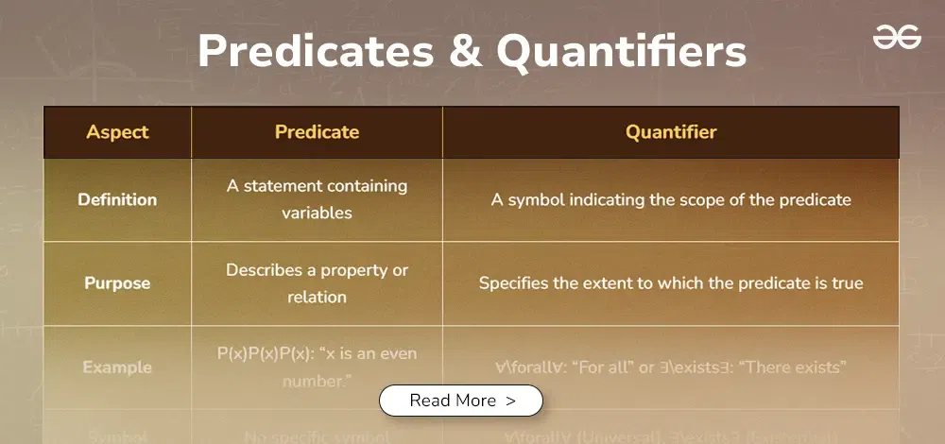

**Table of Content**

* [Predicates](https://www.geeksforgeeks.org/mathematic-logic-predicates-quantifiers/#predicates)
* [Quantifiers](https://www.geeksforgeeks.org/mathematic-logic-predicates-quantifiers/#quantifiers)
  + [Universal Quantifier](https://www.geeksforgeeks.org/mathematic-logic-predicates-quantifiers/#universal-quantifier)
  + [Existential Quantifier](https://www.geeksforgeeks.org/mathematic-logic-predicates-quantifiers/#existential-quantifier)
* [Solved Examples – Predicates and Quantifiers](https://www.geeksforgeeks.org/mathematic-logic-predicates-quantifiers/#solved-examples-predicates-and-quantifiers)
* [Practice Problems on Predicates and Quantifiers](https://www.geeksforgeeks.org/mathematic-logic-predicates-quantifiers/#practice-problems-on-predicates-and-quantifiers)
* [Differences Between Predicates and Quantifiers](https://www.geeksforgeeks.org/mathematic-logic-predicates-quantifiers/#differences-between-predicates-and-quantifiers)

**Predicates**

A predicate is a statement that contains variables and becomes a proposition when specific values are substituted for those variables. Predicates express properties or relations among objects.

**Example:**P(x) = “x is an even number”

When x=2, P(2) is True. When x=3, P(3) is False.

**Quantifiers**

Quantifiers specify the extent to which a predicate is true over a range of elements. The two main types of quantifiers are universal and existential.

**Universal Quantifier**

The universal quantifier (∀) indicates that a predicate is true for all elements in a given domain.

**Example:**∀x∈N, P(x)

Translation: “For all natural numbers xxx, xxx is even.”

**Existential Quantifier**

The existential quantifier (∃) indicates that there exists at least one element in a given domain for which the predicate is true.

**Example:**∃x∈N, P(x)

Translation: “There exists a natural number x such that x is even.”

**Sample Problems – Predicates and Quantifiers**

**Example 1:**

**Let P(x) be the predicate “x > 5” where x is a real number.**

*P(7) is true because 7 > 5*

*P(3) is false because 3 is not > 5*

**Example 2:**

**Let Q(x,y) be the predicate “x + y = 10” where x and y are integers.**

**Q(3,7) is true because 3 + 7 = 10**

**Q(4,5) is false because 4 + 5 ≠ 10**

*Quantifiers:*

*There are two main types of quantifiers:*

*Universal Quantifier (∀): “for all”*

*Existential Quantifier (∃): “there exists”*

**Example 3:**

**Let R(x) be the predicate “x² ≥ 0” where x is a real number.**

*The statement ∀x R(x) is true because for all real numbers, their square is always non-negative.*

**Example 4:**

**Let S(x) be the predicate “x² = 4” where x is a real number.**

*The statement ∃x S(x) is true because there exist real numbers (2 and -2) whose square is 4.*

**Example 5:**

**Consider the predicate P(x,y): “x + y = 0” where x and y are integers.**

*The statement ∀x ∃y P(x,y) is true because for any integer x, we can always find an integer y such that their sum is 0 (y would be -x).*

**Example 6:**

**Let Q(x) be the predicate “x is prime” where x is a positive integer.**

*The statement ∀x Q(x) is false because not all positive integers are prime.*

*The statement ∃x Q(x) is true because there exist prime numbers (e.g., 2, 3, 5, 7, etc.).*

**Example 7:**

**Let R(x,y) be the predicate “x < y” where x and y are real numbers.**

*The statement ∀x ∀y R(x,y) is false because it’s not true that every real number is less than every other real number.*

*The statement ∃x ∃y R(x,y) is true because we can find two real numbers where one is less than the other (e.g., 1 < 2).*

**Problem 8: Let P(x) be the predicate “x is divisible by 3” where x is an integer. Determine the truth value of ∀x P(x) and ∃x P(x).**

**Solution:**

*∀x P(x) is false because not all integers are divisible by 3 (e.g., 4 is not divisible by 3).*

*∃x P(x) is true because there exist integers divisible by 3 (e.g., 0, 3, 6, 9, etc.).*

**Problem 9: Let Q(x,y) be the predicate “x + y > 10” where x and y are real numbers. Determine the truth value of ∀x ∃y Q(x,y).**

*Solution:*

*∀x ∃y Q(x,y) is true.*

*For any real number x, we can always find a y such that x + y > 10.*

*We can choose y = 11 – x, which will always make x + y > 10 regardless of the value of x.*

**Problem 10: Let R(x) be the predicate “x is a vowel” where x is a letter in the English alphabet. Write the following statement using predicate logic: “There is a vowel in the English alphabet.”**

**Solution:**

*The statement can be written as: ∃x R(x)*

*This reads as “There exists an x such that x is a vowel.”*

**Unsolved Problems on Predicates and Quantifiers**

* **1. Let P(x) be the predicate “x² – 1 = 0” where x is a real number. Determine the truth value of ∃x P(x).**
* **2. Let Q(x,y) be the predicate “x < y” where x and y are integers. What does ∀x ∃y Q(x,y) mean in words?**
* **3. Let R(x) be the predicate “x is even” where x is an integer. Write the statement “All integers are even” using predicate logic.**
* **4. Let S(x) be the predicate “x is a mammal” and T(x) be “x can fly” where x is an animal. How would you express “Some mammals can fly” using predicate logic?**
* **5. Let P(x,y) be the predicate “x is the parent of y” where x and y are people. Express “Everyone has a parent” using predicate logic.**
* **6. Let Q(x) be the predicate “x is prime” where x is a positive integer. What is the negation of ∀x Q(x)?**
* **7. Let R(x,y) be the predicate “x + y = 10” where x and y are integers. Is the statement ∀x ∀y R(x,y) true or false? Explain why.**
* **8. Let S(x) be the predicate “x is a multiple of 5” where x is an integer. Express the statement “There is no integer that is a multiple of 5” using predicate logic.**
* **9. Let T(x,y) be the predicate “x is taller than y” where x and y are people. Express the statement “Nobody is taller than themselves” using predicate logic.**
* **10. Let P(x) be the predicate “x is a planet in our solar system” where x is a celestial body. How would you express “There are exactly 8 planets in our solar system” using predicate logic?**

**Differences Between Predicates and Quantifiers**

| **Aspect** | **Predicate** | **Quantifier** |
| --- | --- | --- |
| **Definition** | A statement containing variables | A symbol indicating the scope of the predicate |
| **Purpose** | Describes a property or relation | Specifies the extent to which the predicate is true |
| **Example** | P(x)P(x)P(x): “x is an even number.” | ∀\forall∀: “For all” or ∃\exists∃: “There exists” |
| **Symbol** | No specific symbol | ∀\forall∀ (Universal), ∃\exists∃ (Existential) |
| **Application** | Used to form logical statements | Used to quantify logical statements |
| **Usage** | Alone or with quantifiers | Always used with predicates |
| **Expression** | P(x),Q(x,y)P(x), Q(x, y)P(x),Q(x,y) | ∀x,∃y\forall x, \exists y∀x,∃y |
| **Example Statement** | P(x)P(x)P(x): “x is an even number.” | ∀x∈N,P(x)\forall x \in \mathbb{N}, P(x)∀x∈N,P(x): “For all xxx in natural numbers, xxx is even.” |
| **Scope** | Describes properties of individual elements | Extends predicates over a range of elements |

**Conclusion – Predicates and Quantifiers**

Predicates and quantifiers are essential tools in mathematical logic, providing a robust framework for expressing and reasoning about properties and relationships among objects. Their applications in engineering and computer science are vast, ranging from database queries and formal verification to artificial intelligence and mathematical proofs.

**Normal and Principle Forms**

Last Updated : 02 Sep, 2024

**Normal Forms**are standardized formats for expressing logical formulas. They play a crucial role in **simplifying and analyzing logical expressions**, making it easier to apply logical reasoning, automated theorem proving, and other computational processes. Principal Forms are specific types of normal forms that are derived under certain conditions and constraints.

**What are Normal Forms?**

**Normal Forms** are **structured representations of logical expressions** where the formula is broken down into a combination of literals (variables or their negations) connected by logical operators such as AND, OR, and NOT. These forms help in the simplification and standardization of logical statements.

**Key Concepts:**

* Literal: A variable or its negation (e.g., 𝐴 or ¬𝐴).
* Clause: A disjunction of literals (e.g., 𝐴∨¬𝐵).
* Normal Form: A logical formula that follows a specific structure, such as CNF or DNF.

**Types of Normal Forms**

**Disjunctive Normal Forms (DNF)**

A formula which is equivalent to a given formula and which consists of a sum of elementary products is called a disjunctive normal form of given formula.

**Example :** (P ∧ ~ Q) ∨ (Q ∧ R) ∨ (~ P ∧ Q ∧~ R)

The DNF of formula is not unique.

**Conjunctive Normal Form (CNF)**

A formula which is equivalent to a given formula and which consists of a product of elementary sums is called a conjunctive normal form of given formula.

**Example :** (P~ ∨ Q) ∧ (Q ∨ R) ∧ (~ P ∨ Q ∨ ~ R)

The CNF of formula is not unique.

If every elementary sum in CNF is tautology, then given formula is also tautology.

**Principle Disjunctive Normal Form (PDNF)**

An equivalent formula consisting of disjunctions of minterms only is called the principle disjunctive normal form of the formula. It is also known as **sum-of-products canonical form**.

**Example :** (P ∧ ~ Q ∧ ~ R) ∨ (P ∧ ~ Q ∧ R) ∨ (~ P ∧ ~ Q ∧ ~ R)

The minterm consists of conjunctions in which each statement variable or its negation, but not both, appears only once.

The minterms are written down by including the variable if its truth value is T and its negation if its truth value is F.

**Principle Conjunctive Normal Form (PCNF)**

An equivalent formula consisting of conjunctions of maxterms only is called the principle conjunctive normal form of the formula. It is also known as **product-of-sums canonical form**.

**Example :** (P ∨ ~ Q ∨ ~ R) ∧ (P ∨ ~ Q ∨ R) ∧ (~ P ∨ ~ Q ∨ ~ R)

The maxterm consists of disjunctions in which each variable or its negation, but not both, appears only once.

The dual of a minterm is called a maxterm.

Each of the maxterm has the truth value F for exactly one combination of the truth values of the variables.

The maxterms are written down by including the variable if its truth value is F and its negation if its truth value is T.

**What are Principal Forms?**

Principal forms are specialized representations that emphasize fundamental characteristics or properties of mathematical entities or systems focusing on their intrinsic features rather than standardization for simplification.. They are designed to highlight intrinsic features that are crucial for understanding behavior, stability, or performance in engineering applications.

**Types of Principal Forms**

**Quine-McCluskey Canonical Form**

The [Quine-McCluskey Canonical Form (QMC)](https://www.geeksforgeeks.org/quine-mccluskey-method/) minimizes Boolean functions by systematically combining minterms.

* **Structure**: f(x,y,z)=Σ(1,2,4,7)
* **Purpose**: QMC is crucial in digital logic design for optimizing circuits, simplifying truth tables, and reducing the complexity of [Boolean expressions.](https://www.geeksforgeeks.org/boolean-search/)

**Shannon Canonical Form**

The Shannon Canonical Form represents Boolean functions using AND, OR, and NOT operations in a standard format.

* **Structure**: f(x,y,z)=(¬x∧¬y)∨(x∧z)
* **Purpose**: Shannon Canonical Form aids in logic synthesis, automated reasoning, and theorem proving, providing insights into logical structure and behavior.

**Properties of Normal and Principal Forms**

**1. Logical Equivalence:**

* Definition: Normal forms are logically equivalent to the original expression, meaning they produce the same truth values under all possible interpretations.
* Importance: Ensures that the logical meaning is preserved during the transformation.

**2. Minimality:**

* Definition: Principal normal forms aim to use the minimal number of literals and clauses necessary to represent the logical expression.
* Importance: Reduces complexity and improves efficiency in computational processes.

**3. Canonical Representation:**

* Definition: Principal forms provide a unique representation for a logical expression, which is especially useful in automated reasoning and digital logic design.
* Importance: Ensures consistency in logical analysis and processing.

**4. Simplification:**

* Definition: Normal forms simplify complex logical expressions, making them easier to manipulate and analyze.
* Importance: Facilitates logical reasoning, problem-solving, and optimization.

**Conversion to Normal Forms**

**1. Conversion to CNF:**

**Steps:**

1. Eliminate Bi-conditional and Implication: Convert any bi-conditional (↔) and implication (→) into their logical equivalents.

* Example: A→B becomes ¬A∨B.

2. Move Negations Inward: Apply De Morgan’s laws to push negations inside and eliminate double negations.

* Example: ¬(A∧B) becomes ¬A∨¬B.

3. Distribute OR over AND: Apply distributive laws to achieve a conjunction of disjunctions.

* Example: (A∨(B∧C)) becomes (A∨B)∧(A∨C).

Example: Convert (A→B)∧¬C to CNF: (¬A∨B)∧¬C

**2. Conversion to DNF:**

**Steps:**

1. Eliminate Bi-conditional and Implication: Similar to CNF conversion, start by eliminating any bi-conditional and implication.

* Example: A→B becomes ¬A∨B.

2. Move Negations Inward: Apply De Morgan’s laws to push negations inside.

* Example: ¬(A∧B) becomes ¬A∨¬B.

3. Distribute AND over OR: Apply distributive laws to achieve a disjunction of conjunctions.

* Example: (A∧(B∨C)) becomes (A∧B)∨(A∧C).

Example: Convert (A∧¬B)∨(C∧D) to DNF: (A∧¬B)∨(C∧D)

**3. Conversion to Principal Forms:**

**Steps:**

1. Simplify the Formula: Reduce the expression by combining like terms and eliminating redundancies.
2. Apply CNF or DNF Conversion: Convert the simplified formula to CNF or DNF.
3. Ensure Minimality: Check that the resulting form is minimal in terms of the number of literals and clauses.

**Example:**

For the expression A∧(A∨B), the Principal Conjunctive Normal Form is A.

**Solved Examples on Normal and Principal Forms**

**Example 1: Convert the expression (A∨B)∧(¬A∨C)(A ∨ B) ∧ (¬A ∨ C)(A∨B)∧(¬A∨C) to Disjunctive Normal Form (DNF)**

**Solution:**

*Distribute the AND over OR:*

*(A∨B)∧(¬A∨C)=(A∧¬A)∨(A∧C)∨(B∧¬A)∨(B∧C)*

*Simplify:*

*(A∧C)∨(B∧¬A)∨(B∧C)*

*Final DNF:*

*(A∧C)∨(B∧¬A)∨(B∧C)*

**Example 2: Convert the expression (A∧B)∨(¬A∧C) to Conjunctive Normal Form (CNF).**

**Solution:**

*Apply distributive laws to distribute OR over AND:*

*(A∧B)∨(¬A∧C)=(A∨¬A)∧(A∨C)∧(B∨¬A)∧(B∨C)*

*Simplify using the tautology*

*(A∨C)∧(B∨¬A)∧(B∨C)*

*Final CNF:*

*(A∨C)∧(B∨¬A)∧(B∨C)*

**Example 3: Find the Principal Disjunctive Normal Form (PDNF) for the expression A∧¬B∨B∧¬C.**

**Solution:**

*Identify the minterms:*

*¬A∧B∧¬C*

*Combine them:*

*(A∧¬B∧C)∨(¬A∧B∧¬C)*

*Final PDNF:*

*(A∧¬B∧C)∨(¬A∧B∧¬C)*

**Example 4: Find the Principal Conjunctive Normal Form (PCNF) for the expression**

**A∨¬B∨¬C.**

**Solution:**

*Identify the maxterms:*

*1)¬A∨B∨C*

*2)A∨B∨¬C*

*Combine them:*

*(¬A∨B∨C)∧(A∨B∨¬C)*

*Final PCNF:*

*(¬A∨B∨C)∧(A∨B∨¬C)*

**Example 5: Simplify the Boolean function**

**f(x,y,z)=x∧y∨¬x∧z using the Shannon Expansion Theorem.**

**Solution:**

*Apply the theorem to break down the expression:*

*f(x,y,z)=x∧(y∨z)*

*Final simplified form:*

*f(x,y,z)=x∧(y∨z)*

**Practice Problems on Normal and Principle Forms**

**Problem 1. Convert the expression (A∧B)∨(¬A∧¬B) to DNF.**

**Problem 2. Convert the expression (A∨B)∧(¬A∨¬B) to CNF.**

**Problem 3. Find the PDNF for the expression A∧(¬B∨C).**

**Problem 4. Find the PCNF for the expression ¬A∨(B∧¬C).**

**Problem 5. Simplify the Boolean function f(x,y)=x∨(y∧¬x) using the Shannon Expansion Theorem.**

**Problem 6. Convert (¬A∨B)∧(C∨¬D) to DNF.**

**Problem 7. Find the PDNF for A∧B∨¬A∧¬B∨C.**

**Problem 8. Convert the expression (¬A∧B)∨(A∧¬C) to CNF.**

**Problem 9. Simplify f(x,y,z)=(x∨¬y)∧(¬x∨z) using the Quine-McCluskey method.**

**Problem 10. Find the PCNF for the expression (A∨¬B)∧(¬C∨D).**

**Conclusion**

Understanding the normal and principal forms of equations is fundamental in various fields of mathematics and engineering. These forms simplify complex equations, making them more accessible for analysis and application. The normal form provides a standard structure, aiding in the consistency and clarity of mathematical expressions. On the other hand, the principal form reveals the intrinsic properties of equations, facilitating deeper insights into their behavior. Mastering these forms enhances problem-solving skills and opens doors to advanced [mathematical modeling](https://www.geeksforgeeks.org/real-life-applications-of-mathematical-modeling/)and engineering design, ultimately contributing to more efficient and effective solutions in practical applications.

**Normal and Principle Forms – FAQs**

**What is normal form in logic?**

*In logic, normal forms standardize expressions for simplicity and comparison. Common types include Conjunctive Normal Form (CNF), a conjunction of disjunctions of literals, and Disjunctive Normal Form (DNF), a disjunction of conjunctions of literals.*

**Why are normal forms important?**

*Normal forms simplify complex logical expressions, standardize their structure for easier comparison, and facilitate automated theorem proving and other algorithmic processes.*

**How does the Quine-McCluskey method work?**

*Quine-McCluskey is a method to minimize Boolean functions by combining minterms in order which leads the simplest form. It is a type of tabular method implemented for minimizing Boolean functions.*

**How do principal forms help in problem-solving?**

*This simplification of equations to their principal forms make complex problems less convoluted, which in turn allows more straightforward methods for both solutions and analysis throughout various disciplines within science and engineering.*

**What is the difference between CNF and DNF?**

*A disjunction of conjunctions. Their applications in logic and computation are complementary, CNFs being used for verifying error by the automated theorem proving technology while DNFs useful to simplify logical expressions.*

**What is the Shannon Expansion Theorem?**

*The Shannon Expansion Theorem is a way to express a Boolean function in terms of its variables and their complements. It provides a method for breaking down complex Boolean expressions.*

**Mathematics | Some Theorems on Nested Quantifiers**

Last Updated : 12 Aug, 2024

**Quantifiers** are expressions that indicate the scope of the term to which they are attached, they are predicates.

A predicate is a property the subject of the statement can have. For example, in the statement “the sum of x and y is greater than 5”, the predicate ‘Q’ is- sum is greater than 5, and the statement can be represented as Q(x, y) where x and y are variables. The scope of a quantifier or a quantification is the range in the formula that the quantifier engages in.

**Types of Quantification or Scopes**

1. **Universal (∀) –** The predicate is true for all values of x in the domain.
2. **Existential (∃) –** The predicate is true for at least one x in the domain.

To know the scope of a quantifier in a formula, just make use of

**Parse trees**

. Two quantifiers are nested if one is within the scope of the other.

* **Example-1:** ∀x ∃y (x+y=5) Here ‘∃’ (read as-there exists) and ‘∀’ (read as-for all) are quantifiers for variables x and y. The statement can be represented as ∀x Q(x) Q(x) is ∃y P(x, y)  Q(x)-the predicate is a function of only x because the quantifier applies only to variable x. P(x, y) is (x + y = 5)
* **Example-2** ∀x ∀y ((x> 0)∧(y< 0) → (xy< 0)) (in English) For every real number x and y, if x is positive and y is negative, implies xy is negative. again, ∀x Q(x) where Q(x) is ∀y P(x, y)

**Example to convert a statement into a nested Quantifiers Formula**

“There is a pupil in this lecture who has taken at least one course in Discrete Maths.”

A statement consists of quantifiers and predicates, split it into it’s two constituents.

Here x and y are the pupil and the course and their respective quantifiers are attached in front of them. Write it down as- For some x pupil, there exist a course in Discrete Maths such that x has taken y. ∃x ∃y P (x, y), where P (x, y) is “x has taken y”.

* **Theorem-1:** The order of nested existential quantifiers can be changed without changing the meaning of the statement.
* **Theorem-2:** The order of nested universal quantifiers can be changed without changing the meaning of the statement.
* **Example-3:** Assume P(x, y) is xy=8, ∃x ∃y P(x, y) domain: integers Translates to- There is an integer x for which there is an integer y such that xy = 8, which is same as- There is a pair of integers x, y for which xy = 8. Meaning ∃x ∃y P(x, y) is equivalent to ∃y ∃x P(x, y). Similarly, Assume P(x, y) is (xy = yx). ∀x ∀y P(x, y) domain: real numbers Translates to- For all real numbers x, for all real numbers y, xy = yx or, For every pair of real numbers x, y, xy = yx. again ∀x ∀y P(x, y) is equivalent to ∀y ∀x P(x, y). However, when the nested quantifiers are not same, changing the order changes meaning of statement.
* **Example-4:** Assume P(x, y, z) is (x + y = z). ∀x ∀y ∃z P(x, y, z) domain: real numbers Translates to- For all real numbers x and y there is a real number z such that x + y = z (True) ∀z ∃x ∃y P(x, y, z) domain: real numbers There is a real number z such that for all real numbers x and y, x + y = z (False)

**Negation of nested quantifiers:**

* **Theorem-3** To negate a sequence of nested quantifiers, you change each quantifier in the sequence to the other type and then negate the predicate. So the negation of ∀x ∃y : P(x, y) is ∃x ∀y : ~P(x, y)

**Solved Examples – Some Theorems on Nested Quantifiers**

**Example 1**

Statement: (∀x∃y,(x+y=10))(∀*x*∃*y*,(*x*+*y*=10))

Solution:

Forevery(x),thereexistsa(y)suchthat(x+y=10).Choosing(y=10–x)willsatisfytheequationforany(x).*Forevery*(*x*),*thereexistsa*(*y*)*suchthat*(*x*+*y*=10).*Choosing*(*y*=10–*x*)*willsatisfytheequationforany*(*x*).

**Example 2**

Statement:(∃y∀x,(x+y>x))Solution:Thereexistsa(y)suchthatforevery(x),(x+y>x).Choosingany(y>0)willsatisfythisconditionbecauseaddingapositivenumber(y)toany(x)willalwaysresultinanumbergreaterthan(x).*Statement*:(∃*y*∀*x*,(*x*+*y*>*x*))*Solution*:*Thereexistsa*(*y*)*suchthatforevery*(*x*),(*x*+*y*>*x*).*Choosingany*(*y*>0)*willsatisfythisconditionbecauseaddingapositivenumber*(*y*)*toany*(*x*)*willalwaysresultinanumbergreaterthan*(*x*).

**Example 3**

Statement: (∀x∃y,(x⋅y=1))(∀*x*∃*y*,(*x*⋅*y*=1))

Solution: Forevery(x)(where(x≠0)),thereexistsa(y)suchthat(x⋅y=1).Choosing(y=1x)willsatisfytheequation*Forevery*(*x*)(*where*(*x*=0)),*thereexistsa*(*y*)*suchthat*(*x*⋅*y*=1).*Choosing*(*y*=*x*1​)*willsatisfytheequation*.

**Practice Problems – Some Theorems on Nested Quantifiers**

1. (∀x∃y,(x2+y2=1))(∀*x*∃*y*,(*x*2+*y*2=1))

2.(∃y∀x,(x+y≥0))(∃*y*∀*x*,(*x*+*y*≥0))

3. (∀x∃y,(xy=x+y))(∀*x*∃*y*,(*xy*=*x*+*y*))

4.(∃y∀x,(x–y≤x))(∃*y*∀*x*,(*x*–*y*≤*x*))

5. (∀x∃y,(x3+y=0))(∀*x*∃*y*,(*x*3+*y*=0))

6. (∃y∀x,(x2+y≥1))(∃*y*∀*x*,(*x*2+*y*≥1))

7. (∀x∃y,(x+y>1))(∀*x*∃*y*,(*x*+*y*>1))

8. (∃y∀x,(x–y<0))8(∃*y*∀*x*,(*x*–*y*<0))8

9. (∀x∃y,(x2+xy=y))(∀*x*∃*y*,(*x*2+*xy*=*y*))

10. (∃y∀x,(x+y≤1))(∃*y*∀*x*,(*x*+*y*≤1))

**Related Articles:**

* [*Introduction to Mathematical Logic*](https://www.geeksforgeeks.org/introduction-to-mathematical-logic/)
* [*Demorgans law*](https://www.geeksforgeeks.org/de-morgans-law/)
* [*Predicates and Quantifiers*](https://www.geeksforgeeks.org/mathematic-logic-predicates-quantifiers/)

**FAQs – Some Theorems on Nested Quantifiers**

**What are nested quantifiers?**

*Nested quantifiers are expressions that involve more than one quantifier (such as ∀ and ∃) in a single statement, often nested within each other.*

**How does the order of quantifiers affect the meaning of a statement?**

*The order of quantifiers significantly impacts the meaning of a statement. For instance, (\forall x \exists y) implies that for each ( x ) there is a corresponding ( y ), whereas (\exists y \forall x) implies that there is a single ( y ) that works for all ( x ).*

**What are some common mistakes with nested quantifiers?**

*Common mistakes include misinterpreting the order of quantifiers and incorrectly negating statements with multiple quantifiers. Understanding De Morgan’s laws for nested quantifiers helps avoid these mistakes.*

**Can nested quantifiers be simplified?**

*Nested quantifiers can sometimes be simplified by reordering or rephrasing the statement, but this depends on the specific predicates involved. Generally, careful analysis is required to ensure the meaning is preserved.*

**Rules of Inference**

Last Updated : 28 Aug, 2024

**Rules of Inference:**Rules of inference are logical tools used to derive conclusions from premises. They form the foundation of logical reasoning, allowing us to build arguments, prove theorems, and solve problems in mathematics, computer science, and philosophy. Understanding these rules is crucial for constructing valid arguments and ensuring that conclusions follow logically from given information.

**Table of Content**

* [What are Rules of Inference?](https://www.geeksforgeeks.org/rules-of-inference/#what-are-rules-of-inference)
* [Basic Rules of Inference](https://www.geeksforgeeks.org/rules-of-inference/#basic-rules-of-inference)
  + [Modus Ponens (Law of Detachment)](https://www.geeksforgeeks.org/rules-of-inference/#1-modus-ponens-law-of-detachment)
  + [Modus Tollens (Law of Contrapositive)](https://www.geeksforgeeks.org/rules-of-inference/#2-modus-tollens-law-of-contrapositive)
  + [Hypothetical Syllogism](https://www.geeksforgeeks.org/rules-of-inference/#3-hypothetical-syllogism)
  + [Disjunctive Syllogism](https://www.geeksforgeeks.org/rules-of-inference/#4-disjunctive-syllogism)
  + [Conjunction](https://www.geeksforgeeks.org/rules-of-inference/#5-conjunction)
  + [Simplification](https://www.geeksforgeeks.org/rules-of-inference/#6-simplification)
  + [Addition](https://www.geeksforgeeks.org/rules-of-inference/#7-addition)
* [Rule of Inference Table](https://www.geeksforgeeks.org/rules-of-inference/#table-of-rule-of-inference)
* [Rules of Inference](https://www.geeksforgeeks.org/rules-of-inference/#rules-of-inference-)
* [Resolution Principle](https://www.geeksforgeeks.org/rules-of-inference/#resolution-principle)
* [GATE Questions – Rule of Inference](https://www.geeksforgeeks.org/rules-of-inference/#gate-questions-rule-of-inference)

**What are Rules of Inference?**

Rules of inference are essential tools in logic and mathematics, enabling the derivation of conclusions from premises. They form the backbone of logical reasoning, and proof techniques, and are extensively used in fields such as computer science, engineering, and mathematics.

**Basic Rules of Inference**

**1. Modus Ponens (Law of Detachment)**

If a conditional statement (“if-then” statement) is true, and its antecedent (the “if” part) is true, then its consequent (the “then” part) must also be true.

**Form:**If p → q and p, then q.

**Example:**

* Premise: If it rains, the ground will be wet.
* Premise: It is raining.
* Conclusion: The ground is wet.

**2. Modus Tollens (Law of Contrapositive)**

If a conditional statement is true, and its consequent is false, then its antecedent must also be false.

**Form:**If p → q and ¬q, then ¬p.

**Example:**

* Premise: If it rains, the ground will be wet.
* Premise: The ground is not wet.
* Conclusion: It is not raining.

**3. Hypothetical Syllogism**

If two conditional statements are true, where the consequent of the first is the antecedent of the second, then a third conditional statement combining the antecedent of the first and the consequent of the second is also true.

**Form:**If p → q and q → r, then p → r.

**Example:**

* Premise: If it rains, the ground will be wet.
* Premise: If the ground is wet, the plants will grow.
* Conclusion: If it rains, the plants will grow.

**4. Disjunctive Syllogism**

If a disjunction (an “or” statement) is true, and one of the disjuncts (the parts of the “or” statement) is false, then the other disjunct must be true.

**Form:**If p ∨ q and ¬p, then q.

**Example:**

* Premise: It is either raining or sunny.
* Premise: It is not raining.
* Conclusion: It is sunny.

**5. Conjunction**

If two statements are true, then their conjunction (an “and” statement) is also true.

**Form:**If p and q, then p ∧ q.

**Example:**

* Premise: It is raining.
* Premise: It is windy.
* Conclusion: It is raining and windy.

**6. Simplification**

If a conjunction (an “and” statement) is true, then each of its conjuncts is also true.

**Form:**

If p ∧ q, then p  
If p ∧ q, then q

**Example:**

* Premise: It is raining and windy.
* Conclusion: It is raining.

**7. Addition**

If a statement is true, then the disjunction (an “or” statement) of that statement with any other statement is also true.

**Form:**

If p, then p ∨ q

**Example:**

* Premise: It is raining.
* Conclusion: It is raining or sunny.

**Rule of Inference Table**

| **Rule of Inference** | **Description** |
| --- | --- |
| **Modus Ponens (MP)** | If P implies Q, and P is true, then Q is true. |
| **Modus Tollens (MT)** | If P implies Q, and Q is false, then P is false. |
| **Hypothetical Syllogism (HS)** | If P implies Q and Q implies R, then P implies R. |
| **Disjunctive Syllogism (DS)** | If P or Q is true, and P is false, then Q is true. |
| **Addition (Add)** | If P is true, then P or Q is true. |
| **Simplification (Simp)** | If P and Q are true, then P is true |
| **Conjunction (Conj)** | If P and Q are true, then P and Q are true. |

**Rules of Inference**

**Simple arguments can be used as building blocks to construct more complicated valid arguments.**Certain simple arguments that have been established as valid are very important in terms of their usage. These arguments are called Rules of Inference. The most commonly used Rules of Inference are tabulated below –

| **Rules of Inference** | **Tautology** | **Name** |
| --- | --- | --- |
| **p,p→q,∴q*p*,*p*→*q*,∴*q*** | (p∧(p→q))→q(*p*∧(*p*→*q*))→*q* | Modus Ponens |
| **¬q, p → q, ∴ ¬p** | (¬q ∧ (p → q)) → ¬p | Modus Tollens |
| **p → q, q → r, ∴ p → r** | ((p → q) ∧ (q → r)) → (p → r) | Hypothetical Syllogism |
| **¬p, p ∨ q, ∴ q** | (¬p ∧ (p ∨ q)) → q | Disjunctive Syllogism |
| **p, ∴ (p ∨ q)** | p → (p ∨ q) | Addition |
| **(p ∧ q) → r, ∴ p → (q → r)** | ((p ∧ q) → r) → (p → (q → r)) | Exportation |
| **p ∨ q, ¬p ∨ r, ∴ q ∨ r** | ((p ∨ q) ∧ (¬p ∨ r)) → (q ∨ r) | Resolution |

Similarly, we have Rules of Inference for quantified statements –

| **Rule of Inference** | **Name** |
| --- | --- |
| **∀xP(x)** | Universal instantiation |
| **P(c) for an arbitrary c** | Universal generalization |
| **∃xP(x)** | Existential instantiation |
| **P(c) for some c** | Existential generalization |

**Resolution Principle**

**To understand the Resolution principle, first we need to know certain definitions.**

* **Literal –** A variable or negation of a variable. Eg- p,¬q *p*,¬*q*
* **Sum –** Disjunction of literals. Eg- p∨¬q*p*∨¬*q*
* **Product –** Conjunction of literals. Eg- p∧¬q*p*∧¬*q*
* **Clause –** A disjunction of literals i.e. it is a sum.
* **Resolvent –** For any two clauses C1    *C*1​ and C2    *C*2​ , if there is a literal L1    *L*1​ in C1    *C*1​ that is complementary to a literal L2    *L*2​ in C2    *C*2​ , then removing both and joining the remaining clauses through a disjunction produces another clause C    *C* . C    *C* is called the resolvent of C1    *C*1​ and C2*C*2​

**Sample Problems on Rules of Inference**

**Example 1 : Destructive Dilemma: Given: (P → Q) ∧ (R → S) ¬Q ∨ ¬S ∴ ¬P ∨ ¬R**

**Solution:**

*(P → Q) ∧ (R → S) (given)*

*¬Q ∨ ¬S (given)*

*P → Q (from 1, Simplification)*

*R → S (from 1, Simplification)*

*¬P ∨ ¬R (from 2, 3, and 4, Destructive Dilemma)*

*Answer: ¬P ∨ ¬R*

**Example 2 :Constructive Dilemma: Given: (P → Q) ∧ (R → S) P ∨ R ∴ Q ∨ S**

**Solution:**

*(P → Q) ∧ (R → S) (given)*

*P ∨ R (given)*

*P → Q (from 1, Simplification)*

*R → S (from 1, Simplification)*

*Q ∨ S (from 2, 3, and 4, Constructive Dilemma)*

*Answer: Q ∨ S*

**Example 3 : Resolution: Given: P ∨ Q ¬P ∨ R ∴ Q ∨ R**

**Solution:**

*P ∨ Q (given)*

*¬P ∨ R (given)*

*Q ∨ R (from 1 and 2, Resolution)*

*Answer: Q ∨ R*

**Example 4 : Conjunction: Given: P Q ∴ P ∧ Q**

**Solution:**

*P (given)*

*Q (given)*

*P ∧ Q (from 1 and 2, Conjunction)*

*Answer: P ∧ Q*

**Example 5 : Simplification:**

**Given: P ∧ Q ∴ P**

**Solution:**

*P ∧ Q (given)*

*P (from 1, Simplification)*

*Answer: P*

**Example 6 : Addition: Given: P ∴ P ∨ Q**

**Solution:**

*P (given)*

*P ∨ Q (from 1, Addition)*

*Answer: P ∨ Q*

**Example 7 : Disjunctive Syllogism:**

**Given: P ∨ Q ¬P ∴ Q**

**Solution:**

*P ∨ Q (given)*

*¬P (given)*

*Q (from 1 and 2, Disjunctive Syllogism)*

*Answer: Q*

**Example 8 : Hypothetical Syllogism: Given: P → Q Q → R ∴ P → R**

**Solution:**

*P → Q (given)*

*Q → R (given)*

*P → R (from 1 and 2, Hypothetical Syllogism)*

*Answer: P → R*

**Example 9 : Modus Tollens: Given: P → Q ¬Q ∴ ¬P**

**Solution:**

*P → Q (given)*

*¬Q (given)*

*¬P (from 1 and 2, Modus Tollens)*

*Answer: ¬P*

**Example 10 : Modus Ponens: Given: P → Q P ∴ Q**

**Solution:**

*P → Q (given)*

*P (given)*

*Q (from 1 and 2, Modus Ponens)*

*Answer: Q*

**Rules of Inference – Unsolved Problems**

* **1. Given: P → Q Q → R P Conclude: R**
* **2. Given: P ∨ Q¬P R → ¬Q Conclude: R**
* **3. Given: P → (Q ∧ R) P Conclude: R**
* **4. Given: (P ∧ Q) → R ¬R P Conclude: ¬Q**
* **5. Given: P → Q Q → R R → S ¬S Conclude: ¬P**
* **6. Given: (P → Q) ∧ (R → S) P ∨ R ¬Q Conclude: S**
* **7. Given: P → (Q ∨ R) ¬Q P Conclude: R**
* **8. Given: (P ∧ Q) ∨ R ¬R ¬P Conclude: Q**
* **9. Given: P → (Q → R) P Q Conclude: R**
* **10. Given: (P → Q) ∧ (R → S) P ∨ R ¬Q ∧ ¬S Conclude: Contradiction**

**GATE Questions – Rule of Inference**

**GATE CS Corner Questions** Practicing the following questions will help you test your knowledge. All questions have been asked in GATE in previous years or in GATE Mock Tests.

* [GATE CS 2004, Question 70](https://www.geeksforgeeks.org/gate-gate-cs-2004-question-70/)
* [GATE CS 2015 Set-2, Question 13](https://www.geeksforgeeks.org/gate-gate-cs-2015-set-2-question-13/)

**People Also Read:**

* [*Rules of Inference*](https://www.cs.sfu.ca/~ggbaker/zju/math/inference.html)
* [*Simon Fraser University*](https://www.cs.sfu.ca/~ggbaker/zju/math/inference.html)[*Rules of Inference*](https://en.wikipedia.org/wiki/Rule_of_inference)
* [*Wikipedia*](https://en.wikipedia.org/wiki/Rule_of_inference)[*Fallacy*](https://en.wikipedia.org/wiki/Fallacy)
* [*Wikipedia*](https://en.wikipedia.org/wiki/Fallacy)[*Book*](https://amzn.to/3joMCWH)
* [*Discrete Mathematics and*](https://amzn.to/3joMCWH)
* [*Its Applications by Kenneth Rosen*](https://amzn.to/3joMCWH)

**Conclusion – Rules of Inference**

In logic, each rule of inference leads to a specific conclusion based on given premises. Modus Ponens establishes that if a statement P implies Q, and P is true, then Q must also be true. Conversely, Modus Tollens asserts that if P implies Q, and Q is false, then P must be false. Hypothetical Syllogism extends this reasoning by stating that if P implies Q and Q implies R, then P implies R. Disjunctive Syllogism states that if either P or Q is true, and P is false, then Q must be true. Addition indicates that if P is true, then P or Q is true. Simplification dictates that if both P and Q are true, then P must be true. Finally, Conjunction states that if both P and Q are true, then both P and Q are true. These rules collectively provide a framework for making logical deductions from given statements.

**PDNF and PCNF in Discrete Mathematics**

Last Updated : 28 Dec, 2024

**PDNF (Principal Disjunctive Normal Form)**

It stands for Principal Disjunctive Normal Form. It refers to the [Sum of Products,](https://www.geeksforgeeks.org/what-is-sum-of-product-sop-form/) i.e., SOP. For eg. : If P, Q, and R are the variables then

**(P. Q’. R) + (P’ . Q . R) + (P . Q . R’)**

is an example of an expression in PDNF. Here ‘+’ i.e. sum is the main operator. You might be confused about whether there exists any difference between [DNF (Disjunctive Normal Form)](https://www.geeksforgeeks.org/normal-and-principle-forms/)and PDNF (Principal Disjunctive Normal Form). The Key difference between PDNF and DNF is that in the case of DNF, the length of all the variables in the expression doesn’t need to be the same. For eg.:

1. **(P . Q’ . R) + (P’ . Q . R) + (P . Q)**is an example of an expression in DNF but not in PDNF.
2. **(P . Q’ . R) + (P’ . Q . R) + (P . Q . R’)**is an example of an expression that is both in PDNF and DNF.

**PCNF (Principal Conjunctive Normal Form)**

It stands for Principal [Conjunctive Normal Form.](https://www.geeksforgeeks.org/normal-and-principle-forms/)It refers to the [Product of Sums](https://www.geeksforgeeks.org/what-is-product-of-sum-pos-form/), i.e., POS. For eg. : If P, Q, R are the variables then

**(P + Q’+ R).(P’+ Q + R).(P + Q + R’)**

is an example of an expression in PCNF. Here ‘.’ i.e. product is the main operator. Here also, the Key difference between PCNF and CNF is that in case of CNF, it is not necessary that the length of all the variables in the expression is the same. For eg:

1. **(P + Q’+ R). (P’+ Q + R). (P + Q)**is an example of an expression in CNF but not in PCNF.
2. **(P + Q’+ R). (P’+ Q + R). (P + Q + R’)**is an example of an expression that is both in PCNF and CNF.

**Properties of PCNF and PDNF**

1. Every PDNF or PCNF corresponds to a unique [Boolean Expression](https://www.geeksforgeeks.org/boolean-search/)and vice versa.
2. If X and Y are two Boolean expressions then, X is equivalent to Y if and only if PDNF(X) = PDNF(Y) or PCNF(X) = PCNF(Y).
3. For a Boolean Expression, if PCNF has m terms and PDNF has n terms, then the number of variables in such a Boolean expression = log⁡2(m+n)log2​(*m*+*n*) .

**PDNF and PCNF in Discrete Mathematics – Solved Examples**

**Example 1:** Convert the following Boolean expression to PDNF:

A . (B + C’)

**Solution:**

*1. Distribute A*

*A . B + A . C’*

*2.Ensure each product term contains all variables*

*(A . B . C’) + (A . B . C) + (A . B’ . C’)*

**Example 2:** Convert the following Boolean expression to PCNF:

(A + B’) . (B + C)

**Solution:**

*1.Distribute the product*

*(A + B’ + C) . (A + B’ + C’)*

*2.Ensure each sum term contains all variables*

*(A + B’ + C) . (A + B’ + C’) . (A’ + B + C) . (A’ + B + C’)*

**Practice Problems on PDNF and PCNF in Discrete Mathematics**

1. **Convert (A + B) . (B’ + C) to PCNF.**
2. **Convert A . (B + C) + A’ . B . C’ to PDNF.**
3. **Simplify (P . Q’ . R) + (P’ . Q) to PDNF.**
4. **Express (X + Y’) . (Y + Z’) . (X + Z) in PCNF.**
5. **Convert (M . N + M’ . N’) . (P + Q’) to PDNF.**
6. **Simplify (P + Q) . (Q’ + R) . (R + P’) to PCNF.**
7. **Express A . (B + C) + A’ . (B . C’) in PDNF.**
8. **Convert (A + B) . (B + C) . (C + A’) to PCNF.**
9. **Simplify P . (Q + R’) + Q’ . R to PDNF.**
10. **Convert (X + Y) . (Y + Z) . (Z + X’) to PCNF.**

**Set Operations**

Last Updated : 11 Feb, 2025

Set Operations can be defined as the operations performed on two or more sets to obtain a single set containing a combination of elements from all the sets being operated upon.

* Set operations are mathematical operations operated on[sets,](https://www.geeksforgeeks.org/operations-on-sets)which are collections of distinct objects or elements**.**
* There are three major types of operation on sets, Union (∪), Intersection (∩), and Difference (-). Other operations include Difference, Complement, Addition & Subtraction

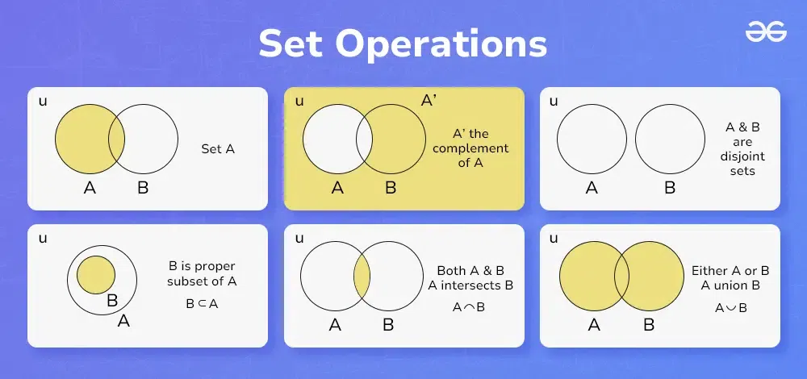

*Set Operations*

**Union of Sets**

[**Union of sets**](https://www.geeksforgeeks.org/union-of-sets)A and B, denoted by **A ∪ B,**is the set of distinct elements that belong to set A or set B, or both.

This operation can be represented as; A ∪ B = {x: x ∈ A or x ∈ B}  
Where x is the elements present in both sets A and B.

**Venn Diagram of A U B.**

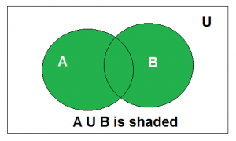

*Venn diagram of A ∪ B*

Above is the Venn Diagram of A U B.

**Example:**

**Find the union of A = {2, 3, 4} and B = {3, 4, 5};**

**Solution:**

*A ∪ B = {2, 3, 4, 5}.*

**Intersection**

The[intersection of the sets](https://www.geeksforgeeks.org/intersection-of-sets/) A and B, denoted by**A ∩ B,** is the set of elements that belong to both A and B i.e. set of the common elements in A and B.

This operation is represented as: A∩B={x: x∈ A and x∈ B}  
Here, x represents the elements that are common to both sets A and B.

**Venn Diagram of A ∩ B**

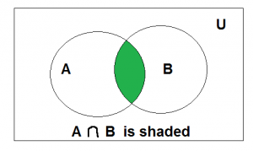

*Venn diagram of A ∩ B*

**Example:**

Find the intersection of A = {2, 3, 4} and B = {3, 4, 5}

**Solution:**

*A ∩ B = {3, 4}.*

The intersection of sets A and B, can also be interpreted as:

*A ∩B = n (A) + n (B) – n (A∪B)*

Where,  
n(A)= the cardinality (or number of elements) of set A,  
n(B)= the cardinality of set B,  
n(A∪B) = the cardinality of the union of sets A and B.

**Disjoint Set**

Two sets are said to be disjoint if their intersection is the [empty set](https://www.geeksforgeeks.org/empty-set/). i.e, sets have no common elements.

**Venn Diagram of A disjoint B**

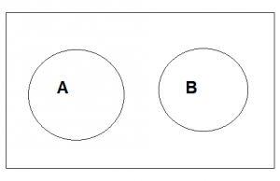

**For Example:**Let A = {1, 3, 5, 7, 9} and B = {2, 4, 6, 8}

A and B are disjoint sets since both of them have no common elements.

**Set Difference**

The difference between sets is denoted by**‘A – B’**, which is the set containing elements that are in A but not in B. i.e., all elements of A except the element of B.

**Venn Diagram of A – B**

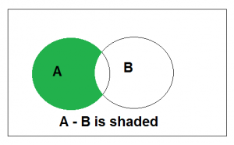

**Example: If A = {1, 2, 3, 4, 5} and B = {2, 4, 6, 8}, find A – B**

**Solution:**

*A – B = {1, 3, 5}*

We can also state that the difference between set A and set B is equivalent to the intersection of set A with the complement of set B. Therefore,

A−B = A ∩ B′  
where B′ = the complement of set B.

**Complement of a Set**

If U is a universal set and X is any subset of U, then the complement of X consists of all the elements in U that are not in X.

X’={a:a∈U and a∉X}*X*’={*a*:*a*∈*U* and *a*∈/*X*}

**Example:**

Let U={1,2,3,4,5,6,7,8}  
And A={1,2,5,6}

Then, the complement of A, denoted as A′, will be: A′={3,4,7,8}

**Addition and Subtraction**

The addition of sets A and B, known as Minkowski addition, results in a new set where each element is the sum of every possible pair of elements, one from set A and one from set B. In other words, the new set contains all possible sums of elements taken from the two sets. Set subtraction operates similarly but involves subtracting each element of set B from each element of set A. These operations are only meaningful when applied to numeric data types; if applied otherwise, they become symbolic with no practical significance.

Additionally, set addition is commutative, meaning the order of the sets does not affect the result. However, set subtraction is not commutative, as the order of the sets does affect the outcome.

*n (A ∪ B) = n(A) + n(B) – n (A ∩ B)*

*A – B = A ∩ B’*

**Properties of Set Operations**

Set operations have several important properties that govern their behavior. Here are some fundamental properties of set operations:

**Closure Property**

* Set operations are closed under their respective operations, meaning that performing an operation on sets results in another set.
* For example, the union, intersection, and difference of sets always produce sets as their results.

**Commutative Property**

* Union: A ∪ B = B ∪ A
* Intersection: A ∩ B = B ∩ A
* Symmetric Difference: A Δ B = B Δ A

**Associative Property**

* Union: (A ∪ B) ∪ C = A ∪ (B ∪ C)
* Intersection: (A ∩ B) ∩ C = A ∩ (B ∩ C)

**Distributive Property**

* Union over Intersection: A ∪ (B ∩ C) = (A ∪ B) ∩ (A ∪ C)
* Intersection over Union: A ∩ (B ∪ C) = (A ∩ B) ∪ (A ∩ C)

**Identity Property**

* Union: A ∪ ∅ = A
* Intersection: A ∩ U = A, where U represents the universal set
* Symmetric Difference: A Δ ∅ = A

**Complement Property**

* Union: A ∪ A’ = U, where U is the universal set
* Intersection: A ∩ A’ = ∅ (the empty set)

**Absorption Property**

* Union over Intersection: A ∪ (A ∩ B) = A
* Intersection over Union: A ∩ (A ∪ B) = A

**Examples of Operations on Sets**

**Example 1: Find the union of two sets A = {8, 10, 14} and B = {7, 16}**

**Solution:**

*(A ∪ B) = {8, 10, 14} ∪ {7, 16}  
(A ∪ B) = {7, 8, 10, 14, 16}*

**Example 2: Find the intersection of sets P = {a, n, x} and Q = {x, y, z}**

**Solution:**

*(P ∩ Q) = {a, n, x} ∩ {x, y, z}  
(P ∩ Q) = {x}*

**Example 3: Find the complement of set X = {4, 6, 9} where Universal set U = {1, 2, 3, 4, 6, 9}**

**Solution:**

*X’ = U – X  
X’ = {1, 2, 3, 4, 6, 9} – {4, 6, 9}  
X’ = {1, 2, 3}*

**Example 4: Given two sets A = {5, 6, 9, 10} and B = {3, 6, 12} then find, A – B and B – A**

**Solution:**

*A – B = {5, 6, 9, 10} – {3, 6, 12}  
A – B = {5, 9, 10}  
B – A = {3, 6, 12} – {5, 6, 9, 10}  
B – A = {3, 12}*

**Example 5: Find the number of elements in set (A ∪ B) given that n(A) = 10, n(B) = 4 and n (A ∩ B) = 5.**

**Solution:**

*To find n (A ∪ B) we use formula:  
n (A ∪ B) = n(A) + n(B) – n (A ∩ B)  
n (A ∪ B) = 10 + 4 – 5  
n (A ∪ B) = 9*

**Practice Questions on Set Operations**

**Q1.**Find the union of two sets A = {2, 4, 5, 9} and B = {2, 6, 10, 12}

**Q2.**Find the intersection of sets P = {5, 6, 7, 9} and Q = {6, 9}

**Q3.**Find the complement of set X = {p, q, r} where Universal set U = {e, f, h, p, q, r}

**Q4.**Given two sets A = {1, 2, 4, 7, 10} and B = {1, 2, 8, 15} then find, B – A

**Q5.** Find the number of elements in set A given that n (A ∪ B) = 12, n(B) = 7 and n (A ∩ B) = 4.

**Relations in Mathematics**

Last Updated : 15 Feb, 2025

Relation in Mathematics is defined as the relationship between two sets. If we are given two sets set A and set B and set A has a relation with set B then each value of set A is related to a value of set B through some unique relation. Here, set A is called the domain of the relation, and set B is called the range of the relation.

For example, if we are given **two sets**,

* Set A = {1, 2, 3, 4} and Set B = {1, 4, 9, 16}

The relation R from set A to set B is defined by the rule: y = x2: y ϵ B, x ϵ A}

**Ordered Pairs:**

* R = {(1, 1), (2, 4), (3, 9), (4, 16)}



1 / 2

Relation is defined as the relation between two different sets of information. Suppose we are given two sets containing two different values then a relation defined such that it connects the value of the first set with the value of the second set is called the relation.

Suppose we are given a set A that contains the name of girls of a class and another set B that includes the height of girls then a relation connects set A with set B. In mathematical terms, we can say that,

***“A set of ordered pairs is a relation”***

**Table of Content**

* [Example of a Relation](https://www.geeksforgeeks.org/relation-in-maths/#relations-examples)
* [Representation of Relations](https://www.geeksforgeeks.org/relation-in-maths/#representation-of-relations)
  + [Set Builder Notation](https://www.geeksforgeeks.org/relation-in-maths/#set-builder-notation)
  + [Roaster Form](https://www.geeksforgeeks.org/relation-in-maths/#roaster-form)
* [Types of Relation](https://www.geeksforgeeks.org/relation-in-maths/#types-of-relation)
* [Graphing Relations](https://www.geeksforgeeks.org/relation-in-maths/#graphing-relations)
* [Solved Examples of Relations](https://www.geeksforgeeks.org/relation-in-maths/#examples-on-relations)

**Example of a Relation**

Examples of relation in mathematics include,

Suppose there are two sets X = {4, 36, 49, 50} and Y = {1, -2, -6, -7, 7, 6, 2}. A relation R states that

“(x, y) is in the relation R if x is a square of y” can be represented using ordered pairs,

* R = {(4, -2), (4, 2), (36, -6), (36, 6), (49, -7), (49, 7)}

Also, the image added below shows two sets A and B, and the relation between them,

* Set A = {x, y, z}
* Set B = {1, 2, 3}

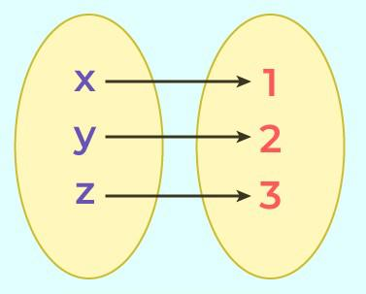

**Representation of Relations**

In mathematics or [set theory](https://www.geeksforgeeks.org/set-theory/) we can represent the relation using different techniques and the two important ways to represent the set are,

* [Set Builder Notation](https://www.geeksforgeeks.org/set-builder-notation/)
* [Roaster Notation](https://www.geeksforgeeks.org/roster-form/)

Let’s study them in detail in the article below,

**Set Builder Notation**

if are relation between two sets is represented using the logical formula then this type of representation is called the set builder notation.

For example, if we are given two sets set X = {2, 4, 6} and set Y = {4, 8, 12}. Then after observing clearly, we can see that each element of set Y is twice each element of set X the relation between them is,

* R {(a, b): b is twice of a, a ∈ X, b ∈ Y}

**Roaster Form**

Roaster form is another way of representing a relation. In roaster form, we use ordered pairs to represent the relation.

For example, if we are given two sets set X = {2, 4, 6} and set Y = {4, 8, 12}. Then the relation between set X and set Y is represented using the relation R such that,

* R = {(2, 4), (4, 8), (6, 12)}

**Types of Relation**

Various types of relations defined in mathematics are,

* Empty Relation
* [Reflexive Relation](https://www.geeksforgeeks.org/reflexive-relations/)
* [Symmetric Relation](https://www.geeksforgeeks.org/symmetric-relations/)
* [Transitive Relation](https://www.geeksforgeeks.org/transitive-relations/)
* [Equivalence Relation](https://www.geeksforgeeks.org/equivalence-relations/)
* Universal Relation
* Identity Relation
* [Inverse Relation](https://www.geeksforgeeks.org/inverse-relation/)

Now let’s learn about them in detail.

**Empty Relation**

A relation R on a set A is called Empty if the set A is an empty set, i.e. any relation where no element of set A is not related to the element of set B then it is called an empty relation. For example, A = {1, 2, 3} and B = {5, 6, 7} where, R = {(x, y) where x + y = 22}, then it is an empty relation.

**Reflexive Relation**

A relation R on a set A is called reflexive if (a, a) ∈ R holds for every element a∈ A . i.e. if set A = {a, b} then R = {(a, a), (b, b)} is reflexive relation.

For example, A = {2, 3} then the reflexive relation R on A is,

* R = {(2, 2), (3, 3)}

**Symmetric Relation**

A relation R on a set A is called symmetric if (b, a) ∈ R holds when (a, b) ∈ R i.e. The relation R = {(a, b), (b, a)} is a reflexive relation on (a, b)

For example, A = {2, 3} then symmetric relation R on A is,

* R = {(2, 3), (3, 2)}

**Transitive Relation**

A relation R on a set A is called transitive if (a, b) ∈ R and (b, c) ∈ R then (a, c) ∈ R for all a,b,c ∈  A i.e.

For example, set A = {1, 2, 3} then transitive relation R on A is,

* R = {(1, 2), (2, 3), (1, 3)}

**Equivalence Relation**

A relation is an Equivalence Relation if it is reflexive, symmetric, and transitive. i.e. relation R = {(1, 1), (2, 2), (3, 3), (1, 2), (2, 1), (2, 3), (3, 2), (1, 3), (3, 1)} on set A = {1, 2, 3} is equivalence relation as it is reflexive, symmetric, and transitive.

**Universal Relation**

A universal relation is a relation in which all elements of the set are mapped to another element of the set then it is called universal relation. For example, A = {4, 8, 12} and B = {1, 2, 3} then universal relation is, R = {(x, y) where x > y}

**Identity Relation**

An identity relation is a relation defined such all elements in a set are related to itself. It is defined as, I = {(x, x): for all x ∈ X}.

For example P = {1, 2, 3} then Identity Relation(I) = {(1, 1), (2, 2), (3, 3)}

**Inverse Relation**

A relation is called the inverse of any relation if elements of one set are inverse pairs of another set. The inverse of a relation R is denoted as R-1. i.e., R-1 = {(y, x): (x, y) ∈ R}.

**Graphing Relations**

Relations can be easily represented on the graphs and representing them on graphs is an easy way of explaining them. The ordered pair in a relation represents a coordinate that can be plotted on the [cartesian coordinate system](https://www.geeksforgeeks.org/cartesian-coordinate-system/). We can easily graph the relation by following the steps added below,

* Substitute x with random numerical values in the relation.
* Find the corresponding y value of the respective x value.
* Write the ordered pair such that, {(x, y)}
* Plot these points and join them to find the required curve.

The graph of the relation y = x2 is added below,

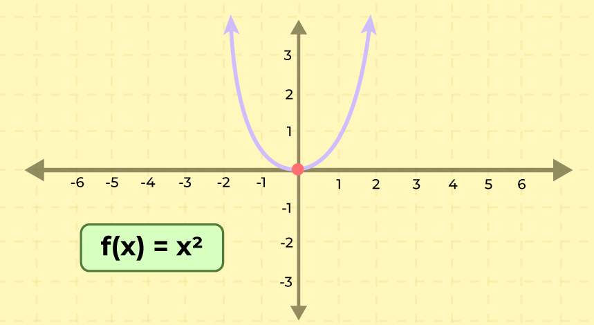

**Articles related to Relations in Mathematics:**

* [**Types Of Sets**](https://www.geeksforgeeks.org/types-of-sets/)
* [**Relation and Function**](https://www.geeksforgeeks.org/relations-and-functions/)
* [**Types of Functions**](https://www.geeksforgeeks.org/types-of-functions/)
* [**Representation of Relation in Graphs and Matrices**](https://www.geeksforgeeks.org/relation-and-their-representations/)
* [**Relations in Mathematics**](https://www.geeksforgeeks.org/relation-in-maths/)

**Solved Examples of Relations**

**Question 1: Find the inverse relation of R = {(1, 3), (2, 4), (3, 5)}**

**Solution:**

*Inverse relation is defined as R-1 = {(y, x): (x, y) ∈ R}*

*Given,  
R = {(1, 3), (2, 4), (3, 5)}*

*Inverse relation of R is R-1 then,  
R-1 = {(3, 1), (4, 2), (5, 3)}*

**Question 2: Find the inverse relation of R = {(a, x), (b, y), (c, z)}**

**Solution:**

*Inverse relation is defined as R-1 = {(y, x): (x, y) ∈ R}*

*Given,  
R = {(a, x), (b, y), (c, z)}*

*Inverse relation of R is R-1 then,  
R-1 = {(x, a), (y, b), (z, c)}*

**Question 3: Is the relation R = {(1, 1), (2, 2), (3, 3), (1, 2), (2, 1), (2, 3), (3, 2)} on set A = {1, 2, 3} an equivalence relation?**

**Solution:**

*No, it’s not an equivalence relation. It’s reflexive and symmetric, but not transitive.*

**Question 4: Find the domain and range of the relation R = {(1, 2), (2, 3), (3, 4), (4, 5)}.**

**Solution:**

*Domain = {1, 2, 3, 4}, Range = {2, 3, 4, 5}*

**Question 5: Is the relation R = {(x, y) | x² + y² = 25} on the set of real numbers a function?**

**Solution:**

*No, it’s not a function. For example, (0, 5) and (0, -5) are both in the relation.*

**Question 6: Find the inverse of the relation R = {(1,1), (2,4), (3,9), (4,16)}.**

**Solution:**

*R⁻¹ = {(1, 1), (4, 2), (9, 3), (16, 4)}*

**Question 7: Determine if the relation R = {(x, y) | x – y is even} on the set of integers is an equivalence relation.**

**Solution:**

*Yes, it’s an equivalence relation. It’s reflexive, symmetric, and transitive.*

**Question 8: Find the composition R ∘ S for R = {(1, 2), (2, 3), (3, 4)} and S = {(1, 1), (2, 2), (3, 3), (4, 4)}.**

**Solution:**

*R ∘ S = {(1, 2), (2, 3), (3, 4)}*

**Question 9: Is the relation R = {(a, b) | a is a multiple of b} on the set of positive integers transitive?**

**Solution:**

*Yes, it’s transitive.*

**Question 10: Find the reflexive closure of R = {(1, 2), (2, 3), (3, 1)} on set A = {1, 2, 3}.**

**Solution:**

*Reflexive closure = {(1, 1), (2, 2), (3, 3), (1, 2), (2, 3), (3, 1)}*

**Equivalence Relations**

Last Updated : 02 Aug, 2024

**Equivalence Relation** is a type of [**relation**](https://www.geeksforgeeks.org/relation-in-maths/) that satisfies three fundamental properties: reflexivity, symmetry, and transitivity. These properties ensure that it defines a partition on a set, where elements are grouped into [equivalence classes](https://www.geeksforgeeks.org/equivalence-class/) based on their similarity or equality. **Equivalence relations**are essential in various mathematical and theoretical contexts, including algebra, set theory, and graph theory, as they provide a structured way to compare and classify elements within a set.

In this article, we will learn about the key properties of equivalence relations, how to identify any relation to be an equivalence relation, and their practical applications in fields such as abstract algebra, discrete mathematics, and data analysis. We'll explore examples and exercises to deepen our understanding of Equivalence Relation.

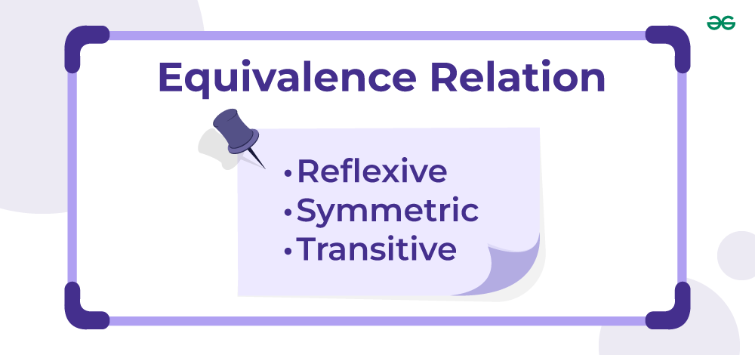

**Table of Content**

* [What is an Equivalence Relation?](https://www.geeksforgeeks.org/equivalence-relations/#what-is-an-equivalence-relation)
* [Equivalence Relation Definition](https://www.geeksforgeeks.org/equivalence-relations/#equivalence-relation-definition)
* [Example of Equivalence Relation](https://www.geeksforgeeks.org/equivalence-relations/#example-of-equivalence-relation)
* [Properties of Equivalence Relation](https://www.geeksforgeeks.org/equivalence-relations/#properties-of-equivalence-relation)
* [How to Verify an Equivalence Relation?](https://www.geeksforgeeks.org/equivalence-relations/#how-to-verify-an-equivalence-relation)

**What is an Equivalence Relation?**

A relation R on a set is called an equivalence relation if and only if the relation is reflexive, symmetric, and transitive. The equivalence relation is a relationship on the set which is generally represented by the symbol **“∼”.**

**Equivalence Relation Definition**

*An equivalence relation on a set is a binary relation that satisfies three fundamental properties:*

* ***Reflexivity:*** *∀ a ∈ S: a ~ a*
* ***Symmetry:*** *∀ a, b ∈ S: a ~ b ⇒ b ~ a*
* ***Transitivity:*** *∀ a, b, c ∈ S: (a ~ b) ∧ (b ~ c) ⇒ a ~ c*

**What is Reflexive Relation?**

A relation R on a set A is called reflexive relation if

***(a, a) ∈ R ∀ a ∈ A****, i.e.* ***aRa for all a ∈ A****, where R is a subset of* ***(A ✕ A),*** *i.e. the cartesian product of set A with itself.*

This means if element “a” is present in set A, then a relation **“a” to “a” (aRa)** should be present in relation R. If any such aRa is not present in R then R is not a reflexive relation.

**What is Symmetric Relation?**

A relation**R on a set A** is called symmetric relation if and only if

***∀ a, b ∈ A, if (a, b) ∈ R*** *then* ***(b, a) ∈ R*** *and vice versa i.e., where R is a subset of (A x A), i.e. the cartesian product of set A with itself.*

This means if an ordered pair of elements **“a” to “b” (aRb)** is present in relation R, then an ordered pair of elements**“b” to “a” (bRa)**should also be present in relation R. If any such bRa is not present for any **aRb** in R then R is not a symmetric relation.

**What is Transitive Relation?**

A relation **R on a set A** is called transitive relation if and only if

***∀ a, b, c ∈ A, if (a, b) ∈ R and (b, c) ∈ R then (a, c) ∈ R,*** *where R is a subset of (A x A), i.e. the cartesian product of set A with itself.*

This means if an ordered pair of elements**“a” to “b” (aRb) and “b” to “c” (bRc)** is present in relation R, then an ordered pair of elements **“a” to “c” (aRC)** should also be present in the relation R. If any such aRc is not present for any **aRb & bRc in R** then R is not a transitive relation.

**Read More,**

* [Relation and Function](https://www.geeksforgeeks.org/relations-and-functions/)
* [Domain and Range of Relation](https://www.geeksforgeeks.org/introduction-to-domain-and-range-relations-and-functions/)

**Example of Equivalence Relation**

A classic example of an equivalence relation is the relation of "equality" on the set of real numbers. Given any two real numbers "a" and "b":

* **Reflexivity:**"a = a" is always true for any real number "a."
* **Symmetry:**If "a = b," then "b = a."
* **Transitivity:** If "a = b" and "b = c," then "a = c."

Some other examples include:

* Congruence (in modular arithmetic)
* Congruence of Geometric Shapes
* Equivalence of Parallel Lines

**Properties of Equivalence Relation**

* Equivalence relations are often denoted by the symbol "≡" or by writing "∼" between related elements.
* An example of an equivalence relation is the "congruence modulo n" relation in modular arithmetic, where two integers are related if their difference is a multiple of n. This relation is reflexive, symmetric, and transitive.
* Equivalence relations are widely used in mathematics, computer science, and other fields for classifying objects, defining partitions, and simplifying complex problems.

**How to Verify an Equivalence Relation?**

Let us assume that R be a relation on the set of ordered pairs of positive integers such that**((a, b), (c, d))∈ R** if and only if **ad = bc**. Is R an equivalence relation?

In order to prove that R is an equivalence relation, we must show that R is

* Refelxive Relation
* Symmetric Relation
* Transitive Relation

Let's verify all these relation for any given relation R.

**Verify Reflexive Relation**

The process of identifying/verifying if any given relation is reflexive:

* Check for the existence of every aRa tuple in the relation for all a present in the set.
* If every tuple exists, only then the relation is reflexive. Otherwise, not reflexive.

Follow the example given below for better understanding.

**Example for Reflexive Relation**

*Consider set A = {a, b} and a relation R = {{a, a}, {b, b}}.*

*For the element a in A:   
⇒ The pair {a, a} is present in R.  
⇒ Hence aRa is satisfied.*

*For the element b in A:  
⇒ The pair {b, b} is present in R.  
⇒ Hence bRb is satisfied.*

*As the condition for 'a', ‘b’ is satisfied, the relation is* ***reflexive.***

**Verify Symmetric Relation**

To verify a symmetric relation do the following:

* Manually check for the existence of every bRa tuple for every aRb tuple in the relation.
* If any of the tuples does not exist then the relation is not symmetric else it is symmetric.

Follow the example given below for better understanding.

**Example for Symmetric Relation**

*Consider set A = { 1, 2, 3, 4 } and a relation R = { (1, 2), (1, 3), (2, 1), (3, 4), (3, 1),(4.3) }*

*For the pair (1, 2) in R:*

*⇒ The reversed pair (2, 1) is present in the relation.  
⇒ This pair satisfies the condition*

*For the pair (1, 3) in R:*

*⇒ The reversed pair (3, 1) is present in the relation.  
⇒ This pair satisfies the condition*

*For the pair (2, 1) in R:*

*⇒ The reversed pair (1, 2) is present in the relation.  
⇒ This pair satisfies the condition*

*For the pair (3, 4) in R:*

*⇒ The reversed pair (4, 3) is present in the relation.  
⇒ This pair satisfy the condition*

*For the pair (3, 1) in R:*

*⇒ The reversed pair (1, 3) is present in the relation  
⇒ This pair satisfies the condition*

*As the set satisfy the condition, the relation is* ***symmetric.***

**Verify Transitive Relation**

To verify transitive relation:

* Firstly, find the tuples of form **aRb & bRc** in the relation.
* For every such pair check if **aRc** is also present in R.
* If any of the tuples does not exist then the relation is not transitive else it is transitive.

Follow the below illustration for a better understanding

**Example for Transitive Relation**

*Consider set R = {(1, 2), (1, 3), (2, 3), (3, 4), (1,4)}*

*For the pairs (1, 2) and (2, 3):*

*⇒ The relation (1, 3) exists  
⇒ This satisfies the condition.*

*For the pairs (1, 3) and (3, 4):*

*⇒ The relation (1, 4) exists.  
⇒ This satisfies the condition.*

*So the relation is* ***transitive.***

Hence the transitive property is proved.

**Read More,**

* [Types of Function](https://www.geeksforgeeks.org/types-of-functions/)
* [One to One Function](https://www.geeksforgeeks.org/one-to-one-functions/)
* [Injection Functions](https://www.geeksforgeeks.org/injective-functions/)

**Solved Problems on Equivalence Relation**

**Problem 1: Show that the relation R, defined in the set A of all polygons as R = {(P1, P2): P1 and P2 have same number of sides}. is an equivalence relation on A.**

**Solution:**

*Given A = set of all polygons  
R = {(P1, P2): P1 and P2 have same number of sides}*

*In order to prove that R is an equivalence relation, we must show that R is reflexive, symmetric and transitive.*

* ***Reflexive:*** *Let P A  
  Clearly,* ***Number of sides of P = number of sides of P******(P, P) ⋿ R ∀ P ⋿ A******Hence, R is reflexive.***
* ***Symmetric:*** *Let P1, P2 ⋿ A  
  Let (P1, P2) ⋿ R ⇒ P1 and P2 have same number of sides  
  ⇒ P2 and P1 have same number of sides  
  ⇒ (P2, P1) ⋿ A****Hence R is Symmetric.***
* ***Transitive:*** *Let P1, P2 ⋿ A  
  Let (P1, P2) ⋿ R and (P2, P3) ⋿ R  
  ⇒ Number of sides of P1 = number of sides of P2 and  
  ⇒ Number of sides of P2 = number of sides of P3  
  ⇒ Number of sides of P1 = number of sides of P3  
  ⇒ (P1, P3) ⋿ R****Hence R is transitive.***

***Thus, R is reflexive, symmetric and transitive and hence R is an equivalence relation on A.***

**Problem 2: Prove that a relation defines an equivalence relation for triangles in geometry.**

**Solution:**

*In order to prove that R is an equivalence relation, we must show that R is reflexive, symmetric and transitive.*

* ***Reflexive****: Every triangle is similar to itself.  
  x is similar to x, ∀ x ⋿ R ⇒ xRx, ∀ x ⋿ T  
  so, R is reflexive on T.*
* ***Symmetric:*** *x is similar to y  
  ⇒ y is similar to x.  
  ⇒ yRx  
  Hence R is symmetric relation on R.*
* ***Transitive:*** *x is similar to y and y is similar to z  
  ⇒ xRy and yRz  
  ⇒ x is similar to z  
  ⇒xRz.  
  Hence R is transitive relation on R.*

*Hence R is an equivalence relation on T.*

**Practice Questions for Equivalence Relation**

**Q1:**Show that the relation R in the set A ={1,2 ,3,4,5} given by R ={(a, b): |a-b| is even} is an equivalence Relation.

**Q2:**Let f: x→y be a function. Define a relation R in X as R = {(a, b): f(a) = f(b)}. Examine, if R is an equivalence relation.

**Q3:**Show that the relation R in the set A = {x ⋿ Z : 0 ≤ x ≤ 12} given by R = {(a, b): a = b} is an equivalence relation.

**Q4:**Let a relation R be defined on set Z of integers by x R y <⇒ x=y; x, y ⋿ Z. Show that R is an equivalence relation.

**Partial Order Relation on a Set**

Last Updated : 03 Feb, 2023

A relation is a subset of the cartesian product of a set with another set. A relation contains ordered pairs of elements of the set it is defined on.

**What is a Partial Order Relation?**

A relation **R** on a set **A** is called a partial order relation if it is

1. **Reflexive Relation**: (a, a) ∈ R ∀ a ∈ A, i.e. aRa for all a ∈ A.
2. **Anti-Symmetric Relation**: ∀ a, b ∈ A, (a, b) ∈ R then (b, a) ∉ R OR a = b.
3. **Transitive Relation**: ∀ a, b, c ∈ A, if (a, b) ∈ R and (b, c) ∈ R then (a, c) ∈ R.

where R is a subset of (A x A), i.e. the cartesian product of set A with itself.

**Example**:

*Consider set* ***A = {a, b}*** *R = {(a, a), (b, b), (a, b), (b, a)} is not partial order as for tuple (a, b), (b, a) tuple is present but  
R = {(a, a), (a, b), (b, b)} is a partial order relation.*

**Properties of Partial Order Relation:**

The few properties of a partial order relation are:

* Empty relation on a non-empty set is never partial order.
* Universal relation over a non-empty set is never a partial order.
* The smallest partial-order relation will only contain aRa tuples.

**How to verify a Partial Order Relation?**

The process of identifying/verifying if any given relation is a partial order relation is:

* Check if the relation is **Reflexive**.
* Check if the relation is **Anti-Symmetric**.
* Check if the relation is **Transitive**.

Follow the below illustration for a better understanding

**Illustration:**

*Consider* ***set R*** *= {(1, 1), (1, 3), (1, 4), (2, 2), (2, 1), (2, 3), (2, 4), (3, 3), (3, 4), (4, 4), (4, 3)}*

*Pairs (1, 1), (2, 2), (3, 3), (4, 4) exist:  
    ⇒ This satisfies the reflexive condition.*

*The transitive condition is also satisfied.*

*For the pairs (4, 3):  
    ⇒ The relation (3, 4) exists  
    ⇒ This does not satisfy the anti-symmetric condition.  
So the relation is not anti-symmetric.*

*Hence it is* ***not a partial order relation****.*

Below is the code for checking if a given relation is partial order relation or not:

* C++
* Java
* Python3
* C#
* Javascript

|  |
| --- |
| // C++ code to check if a relation is partial order    #include <bits/stdc++.h>  **using** **namespace** std;    // Class to define a relation  **class** Relation {  **public**:  **bool** checkPartialOrder(set<**int**> A,                             set<pair<**int**, **int**> > R)      {  **bool** transitive = checkTransitive(R);  **bool** antisymmetric = checkAntiSymmetric(R);  **bool** reflexive = checkReflexive(A, R);  **return** (transitive && antisymmetric && reflexive);      }        // Function to check transitive relation  **bool** checkTransitive(set<pair<**int**, **int**> > R)      {          // Empty relation is always transitive  **if** (R.size() == 0) {  **return** **true**;          }            // Create a dictionary to store tuple          // as key value pair          map<**int**, set<**int**> > tup;            // Creating dictionary of relation          // where (a) is key and (b) is value  **for** (**auto** i = R.begin(); i != R.end(); i++) {  **if** (tup.find(i->first) == tup.end()) {                  set<**int**> temp;                  temp.insert(i->second);                  tup.insert(                      pair<**int**, set<**int**> >(i->first, temp));              }  **else** {                  tup.at(i->first).insert(i->second);              }          }    **for** (**auto** a = tup.begin(); a != tup.end(); a++) {                // Set of all b's related with a              set<**int**> all\_b\_in\_aRb = tup.at(a->first);                // Taking all c's from each b one by one  **for** (**int** b : all\_b\_in\_aRb) {  **if** (tup.find(b) != tup.end()                      && a->first != b) {                        // Set of all c's related with b                      set<**int**> all\_c\_in\_bRc = tup.at(b);                        // All c's related with each b must be                      // subset of all b's related with a  **for** (**int** c : all\_c\_in\_bRc) {  **if** (all\_b\_in\_aRb.find(c)                              == all\_b\_in\_aRb.end()) {  **return** **false**;                          }                      }                  }              }          }            // For all aRb and bRc there exist aRc          // in relation R  **return** **true**;      }        // Function to check antisymmetric relation  **bool** checkAntiSymmetric(set<pair<**int**, **int**> > R)      {          // Empty relation is always anti-symmetric  **if** (R.size() == 0) {  **return** **true**;          }    **for** (**auto** i = R.begin(); i != R.end(); i++) {  **if** (i->second != i->first) {                    // Not a aRa tuple                  // making a mirror tuple  **auto** temp = make\_pair(i->second, i->first);    **if** (R.find(temp) != R.end()) {                      // If bRa tuple exists                      // in relation R  **return** **false**;                  }              }          }            // bRa tuples does not exist          // for all aRb in relation R  **return** **true**;      }        // Function to check reflexive relation  **bool** checkReflexive(set<**int**> A, set<pair<**int**, **int**> > R)      {          // Empty relation on a non-empty relation set          // is never reflexive.  **if** (A.size() > 0 && R.size() == 0) {  **return** **false**;          }            // Relation defined on an empty set          // is always reflexive.  **else** **if** (A.size() == 0) {  **return** **true**;          }    **for** (**auto** i = A.begin(); i != A.end(); i++) {                // Making a tuple of same element  **auto** temp = make\_pair(\*i, \*i);    **if** (R.find(temp) == R.end()) {                    // If aRa tuple not exists in relation R  **return** **false**;              }          }            // All aRa tuples exists in relation R  **return** **true**;      }  };    **int** main()  {      // Creating a set A      set<**int**> A{ 1, 2, 3, 4 };        set<pair<**int**, **int**> > R;        // Inserting tuples in relation R      R.insert(make\_pair(1, 1));      R.insert(make\_pair(1, 3));      R.insert(make\_pair(1, 4));      R.insert(make\_pair(2, 2));      R.insert(make\_pair(2, 1));      R.insert(make\_pair(2, 3));      R.insert(make\_pair(2, 4));      R.insert(make\_pair(3, 3));      R.insert(make\_pair(3, 4));      R.insert(make\_pair(4, 4));      R.insert(make\_pair(4, 3));        Relation obj;        // R is not Partial Order as for (3, 4) tuple -> (4, 3)      // tuple is present  **if** (obj.checkPartialOrder(A, R)) {          cout << "Partial Order Relation" << endl;      }  **else** {          cout << "Not a Partial Order Relation" << endl;      }    **return** 0;  } |

**Output**

Not a Partial Order Relation

**Time Complexity:** O(N \* K \* log N) where N is the number of tuples in relation and K is the maximum number of tuples (a, b) for which **a** is the same.  
**Auxiliary Space:**O(N)

**Fundamental Principle of Counting**

Last Updated : 24 Jul, 2024

Fundamental Principle of Counting is the basic principle that helps us to count large numbers in a non-tedious way. Suppose we have to guess the pin of a three-digit code so the number of ways we can guess is 1000 this can be seen as the pin can be, 000, 001, 002, ….., 999 any number between 000, and 999 including both numbers. Thus, there are a total of 1000 pin combinations.

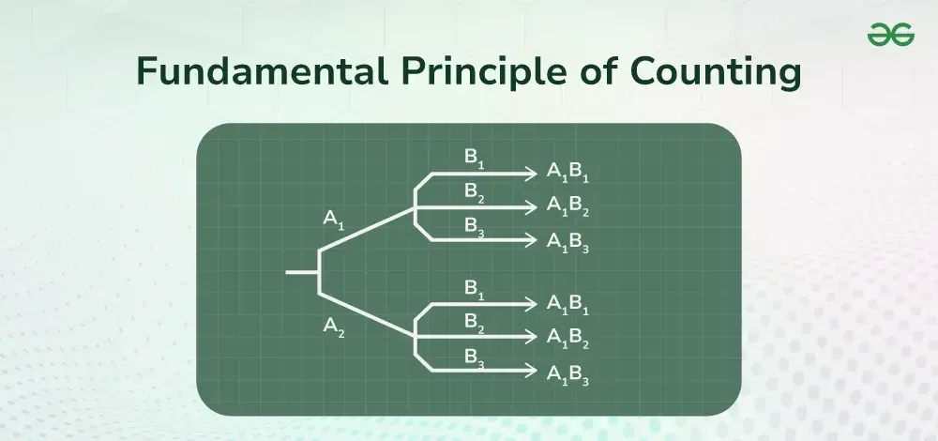

*Fundamental Principle of Counting*

But using the fundamental principle of counting we can find the total number of possible combinations of the pins in a much simpler way, i.e. for the first place we have 10 different choices from 0-9, similarly for the second place we have 10 choices, and for the third place we have 10 choices. Now the total choices for the pin are 10 × 10 × 10 = 1000 which is much simpler to calculate than to count all possible combinations.

So the fundamental principle of counting helps us to solve various problems of [permutation and combination](https://www.geeksforgeeks.org/permutations-and-combinations) and helps us to make informed choices from all the available choices. In this article, we will learn about the fundamental principle of counting, multiplication rules, addition rules, and others in detail.

**Table of Content**

* [Fundamental Principle of Counting](https://www.geeksforgeeks.org/fundamental-principle-of-counting/#fundamental-principle-of-counting)
* [Addition Rule](https://www.geeksforgeeks.org/fundamental-principle-of-counting/#addition-rule)
* [Multiplication Rule](https://www.geeksforgeeks.org/fundamental-principle-of-counting/#multiplication-rule)
* [Fundamental Principle Of Counting Examples](https://www.geeksforgeeks.org/fundamental-principle-of-counting/#fundamental-principle-of-counting-examples)
* [Practice Questions on Fundamental Principle of Counting](https://www.geeksforgeeks.org/fundamental-principle-of-counting/#practice-questions-on-fundamental-principle-of-counting)

**Fundamental Principle of Counting**

Fundamental Principle of Counting is very helpful in finding all the possible combinations in a particular situation. To understand this principle let’s consider an example. Say a person has 3 pairs of pants and 2 shirts and a question pops up, how many different ways are there in which can he dress? There are three different ways of choosing pants as there are three types of pants available. Similarly, there are two ways of choosing shirts.

Let’s see all the different ways of dressing through a diagram. Considering P1, P2, and P3 as pants and S1, S2 as shirts. The tree is given below lists the range of possibilities

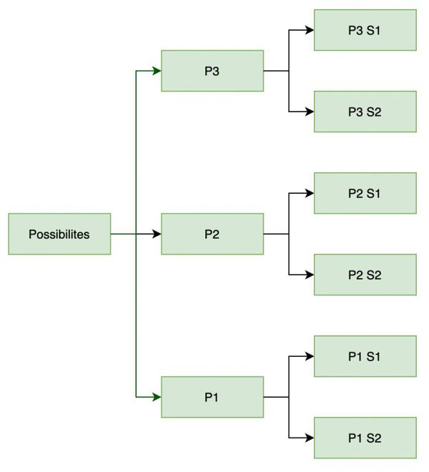

*Tree Diagram depicting the number of possibilities for the above example*

As shown in the figure, with each type of pant. There are two possible shirts that can be worn. So in total, there are 6 ways of dressing up.

In the problem stated above, the fundamental principle of counting is used to get the result. Here we have used the [multiplication](https://www.geeksforgeeks.org/multiplication) rule that states that if an event A can occur in x different ways and another event B can occur in y different ways, then both events can occur simultaneously in x × y different ways. We will learn further about the Multiplication rule further in the article. To learn more about the use of the fundamental principle of counting check the example discussed below,

**Example:** **Count the number of possibilities when a coin is tossed 3 times.**

**Solution:**

*A coin toss can have two outcomes, either Heads(H) or Tails(T), and in case of tossing three coins simultaneously the total number of ways in which this can happen is,*

*= Total Outcome of First Coin Toss × Total Outcome of Second Coin Toss × Total Outcome of Third Coin Toss*

*= 2 × 2 × 2*

*= 8*

*Thus, tossing three coins simultaneously can have 8 different possible outcomes.*

Thus, understanding the above example we can say that the Fundamental Principle of Counting is stated as,

“**If an event can occur in m different ways, following which another event can occur in n different ways, then the total number of occurrences of the events in the given order is m×n.**”

This principle can be extended to any finite number of events in the same way. So, for three events this principle becomes,

“I**f an event can occur in m different ways, following which another event can occur in n different ways, following both of these events another event happens which can occur in p different ways. So, then the total number of occurrences of the events in the given order is “m × n × p.**”

The fundamental principle of counting is studied under two headings that include,

* [Addition](https://www.geeksforgeeks.org/addition) Rule
* [Multiplication](https://www.geeksforgeeks.org/multiplication) Rule

Now learn about these two rules in detail.

**Addition Rule**

Addition Rule states that for two possible events A and B where A and B both are [mutually exclusive events](https://www.geeksforgeeks.org/mutually-exclusive-events), i.e. they have no outcome in common and if event E is defined as occurring in either event A or event B then the possible number of ways in which event E can occur is,

***n(E) = n(A) + n(B)***

Where n(A), n(B), and n(E) are the number of events of A, B, and E respectively.

**Multiplication Rule**

Multiplication Rule states that for “n” [mutually independent events](https://www.geeksforgeeks.org/dependent-and-independent-events-probability), P1, P2, P3, …Pn. The number of in which these events can occur is n(P1), n(P2), n(P3),… n(Pn) respectively. Now we define an event E such that it is happening all the events simultaneously then the number of ways this can happen is,

***n(E) = n(P1) × n(P2) …….. × n(Pn)***

This is called the multiplication rule of the Fundamental Principle of Counting.

**Read More,**

* [*Permutations and Combinations*](https://www.geeksforgeeks.org/permutations-and-combinations)
* [*Events in Probability*](https://www.geeksforgeeks.org/events-in-probability)
* [*Probability in Maths*](https://www.geeksforgeeks.org/probability-in-maths)
* [*What is the importance of the Fundamental Principles of Counting?*](https://www.geeksforgeeks.org/what-is-the-importance-of-the-fundamental-principles-of-counting/)

**Fundamental Principle Of Counting Examples**

**Example 1: Find the number of four-letter words with or without meaning, which can be made out of letters of the word ROSE, where the repetition of letters is not allowed.**

**Solution:**

*Number of words that can be formed from these four-letter words is equal number ways in which we can fill \_\_ \_\_ \_\_ \_\_ with letters R, O, S, E. Note that repetition is not allowed. The first place can be filled with any of the four letters, after that second place can only be filled by three letters because we have already used one and repetition is not allowed. Third place can only be filled by two letters and last place will be filled with the last remaining letter.*

*So, number of ways in which we can do this are. 4 × 3 × 2 × 1 = 24.*

***Note:*** *If the repetition of the letters was allowed we could have always used four letters to fill each place. So 4 × 4 × 4 × 4 = 256.*

**Example 2: Given 6 flags of different colors, how many different signals can be generated, if a signal requires the use of 2 flags one below the other?**

**Solution:**

*A signal can be seen like this.*

*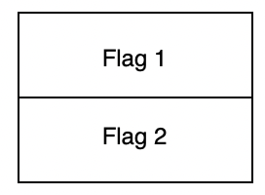*

*Here in each position we can use the different colors of flag we are given. So, in the first position we have 6 different choices to make to fill in the position of flag 1. So, in the second position we will have 5 positions to fill because we have already used one color.*

*So, total number of ways to fill = 6 × 5 = 30.*

**Example 3: How many 2-digit even numbers can be formed from the digits 1, 2, 3, 4, and 5 if the digits can be repeated?**

**Solution:**

*There are five possibilities for putting numbers in each place since the numbers can be repeated. But a constraint is given in the questions which says that the number should be even.*

*So, all the even numbers have an even digit as the last digit. In the given numbers, only 2 and 4 are two even numbers. So, at the unit’s place in the number, there are only two possibilities while their 5 possibilities for the tens place.*

*So, Total number of possible even numbers = 5 × 2 = 10*

**Example 4:** **How many positive divisors do 1000 = 2353 have?**

**Solution:**

*The positive divisor of 1000 will be in form 2a5b.*

*Where, a and b will satisfy 0 ≤ a ≤ 3 and 0 ≤ b ≤ 3*

*It is clear that there are 4 possibilities of a and 4 possibilities of b.*

*Hence, there are 4 × 4 = 16 Positive Integers of 1000.*

**Example 5 : A bookshelf contains 5 novels, 3 biographies, and 4 textbooks. In how many ways can you select 4 books if you must choose at least one of each type?**

**Answer:**

*We must choose 1 novel, 1 biography, 1 textbook, and 1 more from any category.*

*Ways to choose 1 novel: C(5,1) = 5*

*Ways to choose 1 biography: C(3,1) = 3*

*Ways to choose 1 textbook: C(4,1) = 4*

*Ways to choose the last book from remaining 9: C(9,1) = 9*

*Total ways = 5 × 3 × 4 × 9 = 540 ways*

**Example 6 : At a party, there are 6 couples. If 4 people are randomly selected to play a game, what is the probability that exactly 2 of them are married to each other?**

**Answer:**

*Total ways to select 4 people: C(12,4)*

*Ways to select 1 couple: C(6,1)*

*Ways to select 2 more people from remaining 10: C(10,2)*

*Probability = [C(6,1) × C(10,2)] / C(12,4)*

*= (6 × 45) / 495 = 270 / 495 = 6/11 ≈ 0.5455*

**Example 7 : How many different 7-digit phone numbers can be formed if the first digit cannot be 0 or 1, and no digit can be repeated?**

**Answer:**

*First digit: 8 choices (2-9)*

*Second digit: 9 choices (any except the first)*

*Third digit: 8 choices*

*Fourth digit: 7 choices*

*Fifth digit: 6 choices*

*Sixth digit: 5 choices*

*Seventh digit: 4 choices*

*Total = 8 × 9 × 8 × 7 × 6 × 5 × 4 = 120,960 numbers*

**Example 8 : In a group of 30 people, 18 like coffee, 15 like tea, and 10 like both. How many people in the group don’t like either coffee or tea?**

**Answer:**

*Let’s use the inclusion-exclusion principle*

*People who like coffee or tea = 18 + 15 – 10 = 23*

*(We subtract 10 to avoid counting those who like both twice)*

*People who don’t like either = Total – (Coffee or Tea)*

*30 – 23 = 7 people*

**Example 9 : A bag contains 5 red marbles, 3 blue marbles, and 2 green marbles. If three marbles are drawn without replacement, what is the probability of drawing one of each color?**

**Answer:**

*Total ways to draw 3 marbles: C(10,3) = 120*

*Ways to draw 1 red, 1 blue, 1 green: 5 × 3 × 2 = 30*

*Probability = 30 / 120 = 1/4 = 0.25*

**Example 10 : How many different ways can the letters of the word “STATISTICS” be arranged if all the S’s must be together and all the T’s must be together?**

**Answer:**

*Treat all S’s as one unit and all T’s as one unit*

*We now have 7 units to arrange: SSSS, TT, A, I, I, C, S*

*This is a permutation with repetition (2 I’s)*

*Number of arrangements = 7! / 2! = 2520*

*The S’s can be arranged internally in 4! ways*

*The T’s can be arranged internally in 2! ways*

*Total arrangements = 2520 × 24 × 2 = 120,960*

**Practice Questions on Fundamental Principle of Counting**

**Q1: What is the possible number of sample space when two die are rolled together?**

**Q2: In how many ways a 4 digit pin can be set up without repetition of digits.**

**Q3: In a Felicitation Ceremony in how many ways two guests can shake hand with each other and top three rank holders?**

**Q4: In how many many ways a six digit PIN Code can be created?**

**Q5: A bookshelf contains 5 novels, 3 biographies, and 4 textbooks. In how many ways can you select 4 books if you must choose at least one of each type?**

**Q6: At a party, there are 6 couples. If 4 people are randomly selected to play a game, what is the probability that exactly 2 of them are married to each other?**

**Q7: How many different 7-digit phone numbers can be formed if the first digit cannot be 0 or 1, and no digit can be repeated?**

**Q8: In a group of 30 people, 18 like coffee, 15 like tea, and 10 like both. How many people in the group don’t like either coffee or tea?**

**Q9: A bag contains 5 red marbles, 3 blue marbles, and 2 green marbles. If three marbles are drawn without replacement, what is the probability of drawing one of each color?**

**Q10: How many different ways can the letters of the word “STATISTICS” be arranged if all the S’s must be together and all the T’s must be together?**

**Pigeonhole Principle**

Last Updated : 28 Dec, 2024

The Pigeonhole Principle is a fundamental concept in combinatorics and mathematics that states if more items are put into fewer containers than the number of items, at least one container must contain more than one item. This seemingly simple principle has profound implications and applications in various fields, including mathematics, computer science, and engineering.

This article explores the **Pigeonhole Principle, its mathematical formulation, examples, and applications.**

**Table of Content**

* [What is the Pigeonhole Principle?](https://www.geeksforgeeks.org/discrete-mathematics-the-pigeonhole-principle/#what-is-the-pigeonhole-principle)
  + [Pigeonhole Principle Example](https://www.geeksforgeeks.org/discrete-mathematics-the-pigeonhole-principle/#pigeonhole-principle-example)
* [Pigeonhole Principle Theorem](https://www.geeksforgeeks.org/discrete-mathematics-the-pigeonhole-principle/#pigeonhole-principle-theorem)
* [Pigeonhole Principle Strong Form Theorem](https://www.geeksforgeeks.org/discrete-mathematics-the-pigeonhole-principle/#pigeonhole-principle-strong-form-theorem)
* [Pigeonhole Principle Examples](https://www.geeksforgeeks.org/discrete-mathematics-the-pigeonhole-principle/#pigeonhole-principle-examples)
* [Applications of the Pigeonhole Principle](https://www.geeksforgeeks.org/discrete-mathematics-the-pigeonhole-principle/#applications-of-the-pigeonhole-principle)
* [Solved Examples – Pigeonhole Principle](https://www.geeksforgeeks.org/discrete-mathematics-the-pigeonhole-principle/#solved-examples-pigeonhole-principle)
* [Practice Question on Pigeonhole Principle](https://www.geeksforgeeks.org/discrete-mathematics-the-pigeonhole-principle/#practice-question-on-pigeonhole-principle)

**Pigeonhole Principle**

The Pigeonhole Principle can be formally stated as follows:

*If n items are distributed among m containers and n > m, then at least one container must contain more than one item.*

The pigeonhole principle is useful in counting methods. In order to apply the principle, one has to decide which objects will play the role of pigeon and which objects will play the role of pigeonholes.

The Pigeonhole Principle is a simple yet powerful combinatorics tool used to solve a variety of problems. Its applications extend to probability, set theory, and beyond.

**Pigeonhole Principle Example**

Suppose that a flock of 20 pigeons flies into a set of 19 pigeonholes to roost. Because there are 20 pigeons but only 19 pigeonholes, at least one of these 19 pigeonholes must have at least two pigeons in it. To see why this is true, note that if each pigeonhole had at most one pigeon, at most 19 pigeons, one per hole, could be accommodated. This illustrates a general principle called the pigeonhole principle, which states that if there are more pigeons than pigeonholes, there must be at least one pigeonhole with at least two pigeons.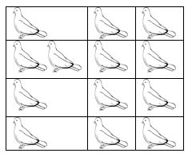

**Pigeonhole Principle Theorem**

**Theorem -I)** If “A” is the average number of pigeons per hole, where A is not an integer then

* At least one pigeon hole contains**ceil[A]**(smallest integer greater than or equal to A) pigeons.
* The remaining pigeon holes contain at most**floor[A]**(largest integer less than or equal to A) pigeons.

Or **II)** We can say that, if n + 1 objects are put into n boxes, then at least one box contains two or more objects. The abstract formulation of the principle: Let X and Y be finite sets and let f: A→B be a function.

* If X has more elements than Y, then f is not one-to-one.
* If X and Y have the same number of elements and f is onto, then f is one-to-one.
* If X and Y have the same number of elements and f is one-to-one, then f is onto.

The pigeonhole principle is one of the simplest but most useful ideas in mathematics. We will see more applications that proof of this theorem.

**Example 1: If (Kn+1) pigeons are kept in n pigeon holes where K is a positive integer, what is the average no. of pigeons per pigeon hole?**

**Solution:**

*Average number of pigeons per hole = (Kn+1)/n = K + 1/n*

*Therefore there will be at least one pigeonhole which will contain at least (K+1) pigeons i.e., ceil[K +1/n] and remaining will contain at most K i.e., floor[k+1/n] pigeons. i.e., the minimum number of pigeons required to ensure that at least one pigeon hole contains (K+1) pigeons is (Kn+1).*

**Example 2: A bag contains 10 red marbles, 10 white marbles, and 10 blue marbles. What is the minimum no. of marbles you have to choose randomly from the bag to ensure that we get 4 marbles of same color?**

**Solution:**

*Apply pigeonhole principle. No. of colors (pigeonholes) n = 3 No. of marbles (pigeons) K+1 = 4 Therefore the minimum no. of marbles required = Kn+1 By simplifying we get Kn+1 = 10. Verification: ceil[Average] is [Kn+1/n] = 4 [Kn+1/3] = 4 Kn+1 = 10 i.e., 3 red + 3 white + 3 blue + 1(red or white or blue) = 10*

**Pigeonhole Principle Strong FormTheorem**

Let q1, q2, . . . , qn be positive integers. If q1+ q2+ . . . + qn – n + 1 objects are put into n boxes, then either the 1st box contains at least q1 objects, or the 2nd box contains at least q2 objects, . . ., the nth box contains at least qn objects. Application of this theorem is more important, so let us see how we apply this theorem in problem solving.

**Example 1:In a computer science department, a student club can be formed with either 10 members from first year or 8 members from second year or 6 from third year or 4 from final year. What is the minimum no. of students we have to choose randomly from department to ensure that a student club is formed?**

**Solution:**

*We can directly apply from the above formula where, q1 =10, q2 =8, q3 =6, q4 =4 and n = 4*

*Therefore the minimum number of students required to ensure department club to be formed is 10 + 8 + 6 + 4 – 4 + 1 = 25*

**Example 2:A box contains 6 red, 8 green, 10 blue, 12 yellow and 15 white balls. What is the minimum no. of balls we have to choose randomly from the box to ensure that we get 9 balls of same color?**

**Solution:**

*Here in this we cannot blindly apply pigeon principle. First we will see what happens if we apply above formula directly.*

*From the above formula we have get answer 47 because 6 + 8 + 10 + 12 + 15- 5 + 1 = 47. But it is not correct.*

*In order to get the correct answer we need to include only blue, yellow and white balls because red and green balls are less than 9.*

*But we are picking randomly so we include after we apply pigeon principle. i.e., 9 blue + 9 yellow + 9 white – 3 + 1 = 25*

*Since we are picking randomly so we can get all the red and green balls before the above 25 balls. Therefore we add 6 red + 8 green + 25 = 39*

*We can conclude that in order to pick 9 balls of same color randomly, one has to pick 39 balls from a box.*

**Pigeonhole Principle Sample Questions**

**1. In a group of 13 people, at least two people must share the same birth month, since there are only 12 months in a year.**

**2. If 11 people each shake hands with 12 others, at least one person must have shaken hands with at least 2 others, because 12 handshakes among 11 people means some people must have more than one handshake.**

**3. If you have 10 pairs of black socks and 10 pairs of white socks randomly distributed in a drawer, pulling out 3 socks guarantees that at least one pair is of the same color (assuming pairs are distinguishable).**

***People Also View:*** [*Pigeonhole Principle for CP*](https://www.geeksforgeeks.org/pigeonhole-principle-for-competitive-programming/)

**Applications of the Pigeonhole Principle**

The Pigeonhole Principle is used in various fields to solve problems that involve distributing objects into containers. Here are some notable applications:

**1. Computer Science:**In computer science, the Pigeonhole Principle is used in hashing algorithms, where data items (keys) are assigned to hash values (buckets). The principle guarantees that if there are more items than buckets, collisions will occur, necessitating strategies to handle them.

**2. Coding Theory:** In coding theory, the Pigeonhole Principle helps in understanding error detection and correction. It implies that if you encode more messages than the number of unique codewords, some messages will share the same codeword, leading to potential errors.

**3. Number Theory:** In number theory, the Pigeonhole Principle can prove the existence of certain properties within a set of numbers. For instance, it can show that within any set of n+1n+1n+1 integers, there exists a pair of integers whose difference is divisible by nnn.

**4. Graph Theory:** In graph theory, the Pigeonhole Principle is used to prove properties of graphs, such as the existence of a subgraph with certain characteristics. For example, in any group of people, some subset of individuals will have mutual friendships or mutual non-friendships.

**Solved Examples – Pigeonhole Principle**

**1. Prove that among any 52 integers, there are always two whose difference is divisible by 51.**

**Solution :**

*Consider the remainders when each number is divided by 51. There are 51 possible remainders (0 to 50). With 52 numbers, by the Pigeonhole Principle, at least two numbers must have the same remainder. Their difference will be divisible by 51.*

**2. In a group of 1001 people, show that there are at least two people with the same number of friends within the group.**

**Solution :**

*In 1001 people, two have the same number of friends:*

*Each person can have 0 to 1000 friends. That’s 1001 possibilities. With 1001 people, by the Pigeonhole Principle, at least two must have the same number of friends.*

**3. Prove that if 5 points are placed inside a unit square, there must be two points that are at most 1/√2 units apart.**

**Solution :**

*5 points in a unit square, two at most 1/√2 apart:*

*Divide the square into four equal squares of side length 1/2. By the Pigeonhole Principle, at least two points must be in the same smaller square. The maximum distance between any two points in a 1/2 × 1/2 square is 1/√2.*

**4. Show that in any sequence of 101 distinct real numbers, there is always an increasing or decreasing subsequence of length at least 11.**

**Solution :**

*In 101 distinct reals, increasing/decreasing subsequence of length 11:*

*Assign two numbers to each term: its length as a longest increasing subsequence ending at that term, and its length as a longest decreasing subsequence starting at that term. If no term has both numbers ≥ 11, the sum of all these numbers would be at most 20 × 101 = 2020. But the sum must be at least 101 × 11 = 1111, a contradiction.*

**5. Prove that for any set of 10 integers, there are always two distinct subsets with the same sum of elements.**

**Solution :**

*In 10 integers, two subsets with the same sum:*

*There are 2^10 = 1024 possible subsets. The sum of all elements is at most 10 × 9 = 90 (if the set is {0,1,2,…,9}). By the Pigeonhole Principle, among 1024 subsets, two must have the same sum.*

**6. In a 8×8 chessboard, prove that if 65 squares are colored, at least one rectangle formed by the grid lines must have all four**

**corners colored.**

**Solution :**

*In 8×8 board with 65 colored squares, a rectangle with colored corners:*

*Consider the 7 × 7 = 49 possible rectangles formed by grid lines. Each requires 4 corners to be colored. If no rectangle had all corners colored, at most 3 × 49 = 147 squares would be colored. But 65 > 147/2, so by the Pigeonhole Principle, some rectangle must have all corners colored.*

**7. Show that among any 100 integers, there are always two whose difference is divisible by 99.**

**Solution :**

*Among 100 integers, two with difference divisible by 99:*

*Similar to problem 1. Consider remainders when divided by 99. There are 99 possible remainders, so by the Pigeonhole Principle, two numbers must have the same remainder.*

**8. Prove that in any group of 6 people, there are either 3 mutual friends or 3 mutual strangers.**

**Solution :**

*In 6 people, 3 mutual friends or 3 mutual strangers:*

*Consider one person. They have 5 relationships, either friend or stranger. By the Pigeonhole Principle, at least 3 must be the same type. If 3 friends, check if any 2 of those 3 are friends. If so, we have 3 mutual friends. If not, those 3 are mutual strangers.*

**9. Given 2n+1 integers, prove that there are always two whose sum or difference is divisible by 2n.**

**Solution :**

*In 2n+1 integers, two with sum or difference divisible by 2n:*

*Consider pairs (a, b) where a < b. There are (2n+1)n such pairs. The possible remainders when (a+b) is divided by 2n are 0, 1, …, 2n-1, and when (b-a) is divided by 2n are 1, 2, …, 2n-1. Total 4n-1 possibilities. Since (2n+1)n > 4n-1 for n > 1, by the Pigeonhole Principle, two pairs must have the same remainder type*

**10.In a room of 367 people, prove that at least two people have the same birthday, assuming no leap years.**

**Solution :**

*In 367 people, two with the same birthday:*

*There are only 366 possible birthdays (including Feb 29). With 367 people, by the Pigeonhole Principle, at least two must share a birthday.*

**Related Articles:**

* [*Pigeonhole Principle*](https://www.geeksforgeeks.org/tag/pigeonhole-principle/)
* [*Pigeonhole Principle for CP | Identification, Approach & Problems*](https://www.geeksforgeeks.org/pigeonhole-principle-for-competitive-programming/)
* [*Pigeonhole Sort Visualizer using JavaScript*](https://www.geeksforgeeks.org/pigeonhole-sort-visualizer-using-javascript/)

**Practice Question on Pigeonhole Principle**

**1. Prove or disprove that all non-trivial zeros of the Riemann zeta function have a real part equal to 1/2.**

**2. Determine whether every problem whose solution can be quickly verified by a computer can also be solved quickly by a computer.**

**3. Prove that for projective algebraic varieties, certain topological classes called Hodge classes are actually algebraic cycles.**

**4. Relate the rank of an elliptic curve to the order of zero of its L-function at s = 1.**

**5. Prove that for any positive integer n, the sequence defined by n → n/2 (if n is even) and n → 3n + 1 (if n is odd) always reaches 1.**

**6. Prove that every even integer greater than 2 can be expressed as the sum of two prime numbers.**

**7. Prove that there are infinitely many pairs of prime numbers that differ by 2.**

**8. Prove or disprove this conjecture about the computational hardness of approximately solving certain types of constraint satisfaction problems.**

**9. Prove that for every positive integer n ≥ 2, the fraction 4/n can be expressed as the sum of three unit fractions.**

**10. Prove or disprove that every bounded linear operator on a complex Hilbert space has a non-trivial invariant subspace.**

**Conclusion**

The Pigeonhole Principle is a powerful and intuitive concept in mathematics, offering a straightforward method for proving the existence of certain properties within sets. Its applications span across various disciplines, providing solutions to problems in computer science, coding theory, number theory, and graph theory. Understanding and applying this principle can simplify complex problems and yield valuable insights.

**Permutations and Combinations**

Last Updated : 10 Dec, 2024

[Permutation](https://www.geeksforgeeks.org/permutation/) and [Combination](https://www.geeksforgeeks.org/combinations/) are the most fundamental concepts in mathematics related to picking items from a group or set.

* Permutation is arranging items considering order of selection from a certain group.
* Combination is selecting items without considering order.
* For example, in the below diagram, PQ and QP are different in permutation but same in combination. Therefore we have more permutations than combinations.

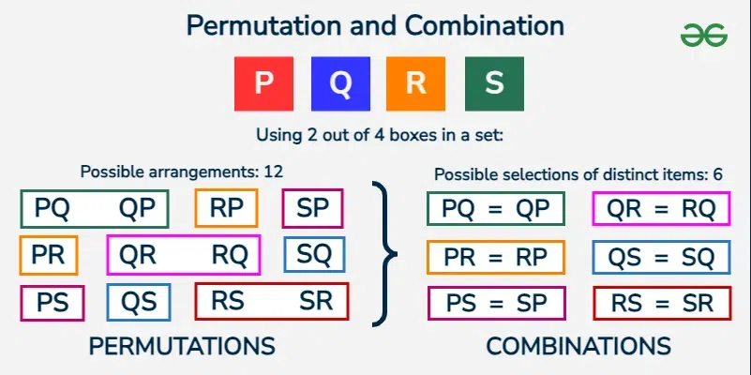

*Permutations and Combinations*

**Table of Content**

* [Permutation Meaning](https://www.geeksforgeeks.org/permutations-and-combinations/#permutation)
* [Combination Meaning](https://www.geeksforgeeks.org/permutations-and-combinations/#combination)
* [Derivation of Permutation and Combination Formulas](https://www.geeksforgeeks.org/permutations-and-combinations/#derivation-of-permutation-and-combination-formulas)
* [Difference Between Permutation and Combination](https://www.geeksforgeeks.org/permutations-and-combinations/#difference-between-permutation-and-combination)
* [Solved Examples on Permutation and Combination](https://www.geeksforgeeks.org/permutations-and-combinations/#solved-examples-on-permutation-and-combination)

**Permutation Meaning**

Permutation is the distinct interpretations of a provided number of components carried one by one, or some, or all at a time. For example, if we have two components A and B, then there are two likely performances, AB and BA.

A numeral of permutations when ‘r’ components are positioned out of a total of ‘n’ components is **n Pr**. For example, let n = 3 (A, B, and C) and r = 2 (All permutations of size 2). Then there are **3P2** such permutations, which is equal to 6. These six permutations are AB, AC, BA, BC, CA, and CB. The six permutations of A, B, and C taken three at a time are shown in the image added below:

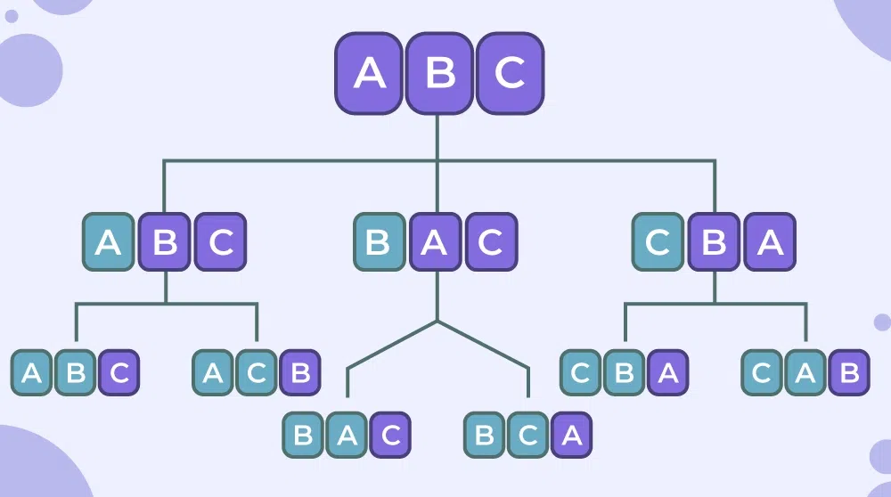

*Permutation Meaning*

**Permutation Formula**

[Permutation formula](https://www.geeksforgeeks.org/permutation) is used to find the number of ways to pick **r** things out of **n** different things in a specific order and replacement is not allowed and is given as follows:

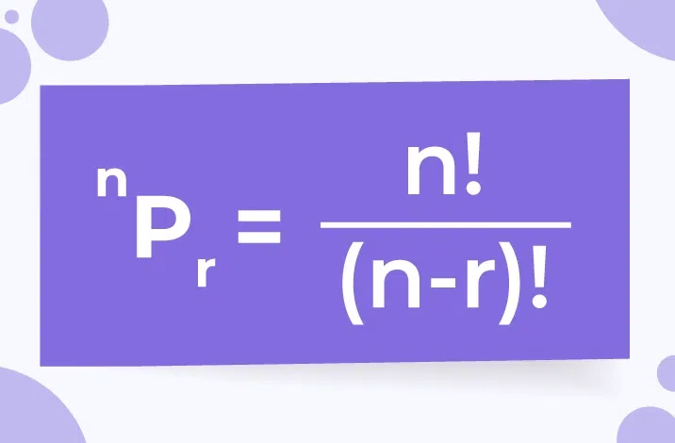

*Permutation Formula*

**Explanation of Permutation Formula**

As we know, permutation is a arrengement of r things out of n where order of arrengement is important( AB and BA are two different permutation). If there are three different numerals 1, 2 and 3 and if someone is curious to permute the numerals taking 2 at a moment, it shows (1, 2), (1, 3), (2, 1), (2, 3), (3, 1), and (3, 2). That is it can be accomplished in 6 methods.

Here, (1, 2) and (2, 1) are distinct. Again, if these 3 numerals shall be put handling all at a time, then the interpretations will be (1, 2, 3), (1, 3, 2), (2, 1, 3), (2, 3, 1), (3, 1, 2) and (3, 2, 1) i.e. in 6 ways.

In general, n distinct things can be set taking r (r < n) at a time in n(n – 1)(n – 2)…(n – r + 1) ways. In fact, the first thing can be any of the n things. Now, after choosing the first thing, the second thing will be any of the remaining n – 1 things. Likewise, the third thing can be any of the remaining n – 2 things. Alike, the rth thing can be any of the remaining n – (r – 1) things.

Hence, the entire number of permutations of n distinct things carrying r at a time is n(n – 1)(n – 2)…[n – (r – 1)] which is written as n Pr. Or, in other words,

nPr=n!(n−r)!**nPr**​=(**n**−**r**)!**n**!​

**Combination Meaning**

It is the distinct sections of a shared number of components carried one by one, or some, or all at a time. For example, if there are two components A and B, then there is only one way to select two things, select both of them.

For example, let n = 3 (A, B, and C) and r = 2 (All combinations of size 2). Then there are **3C2** such combinations, which is equal to 3. These three combinations are AB, AC, and BC.

Here, the [combination](https://www.geeksforgeeks.org/combinations) of any two letters out of three letters A, B, and C is shown below, we notice that in combination the order in which A and B are taken is not important as AB and BA represent the same combination.

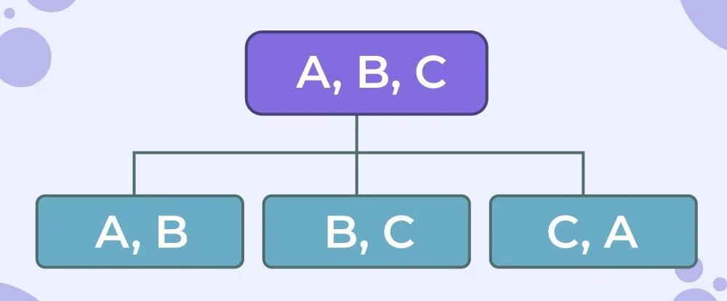

*Combination Meaning*

***Note:*** *In the same example, we have distinct points for permutation and combination. For, AB and BA are two distinct items i.e., two distinct permutation, but for selecting, AB and BA are the same i.e., same combination.*

**Combination Formula**

Combination Formula is used to choose ‘r’ components out of a total number of ‘n’ components, and is given by:

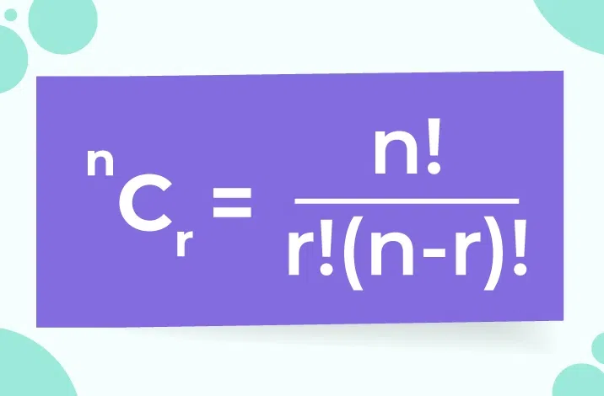

*Combination Formula*

Using the above formula for r and (n-r), we get the same result. Thus,

*nCr=nC(n−r)****nCr****​=****nC****(****n****−****r****)​*

**Explanation of Combination Formula**

*Combination, on the further hand, is a type of pack. Again, out of those three numbers 1, 2, and 3 if sets are created with two numbers, then the combinations are (1, 2), (1, 3), and (2, 3).*

*Here, (1, 2) and (2, 1) are identical, unlike permutations where they are distinct. This is written as 3C2. In general, the number of combinations of n distinct things taken r at a time is,*

*nCr=n!r!×(n−r)!=nPrr!****nCr****​=****r****!×(****n****−****r****)!****n****!​=****r****!****nPr****​​*

**Derivation of Permutation and Combination Formulas**

We can derive these Permutation and Combination formulas using the basic counting methods as these formulas represent the same thing. Derivation of these formulas is as follows:

**Derivation of Permutations Formula**

Permutation is selecting r distinct objects from n objects without replacement and where the order of selection is important, by the fundamental theorem of counting and the definition of permutation, we get

***P (n, r) = n . (n-1) . (n-2) . (n-3).  . . .  .(n-(r+1))***

By Multiplying and Dividing above with (n-r)! = (n-r).(n-r-1).(n-r-2).  . . .  .3. 2. 1, we get

*P (n, r) = [n.(n−1).(n−2)….(nr+1)[(n−r)(n−r−1)(n-r)!] / (n-r)!*

***⇒ P (n, r) = n!/(n−r)!***

Thus, the formula for P (n, r) is derived.

**Derivation of**[Combinations Formula](https://www.geeksforgeeks.org/combinations-formula-with-examples/)

Combination is choosing r items out of n items when the order of selection is of no importance. Its formula is calculated as,

*C(n, r) = Total Number of Permutations /Number of ways to arrange r different objects.   
[Since by the fundamental theorem of counting, we know that number of ways to arrange r different objects in r ways = r!]*

*C(n,r) = P (n, r)/ r!*

***⇒ C(n,r) = n!/(n−r)!r!***

Thus, the formula for Combination i.e., C(n, r) is derived.

**Difference Between Permutation and Combination**

[Differences between permutation and combination](https://www.geeksforgeeks.org/permutation-vs-combination-definition-differences-examples) can be understood by the following table:

| **Permutation** | **Combination** |
| --- | --- |
| In Permutation order of arrangement is important. For example, AB and BA are different combinations. | In Combination order of arrangement is not important. For example, AB and BA are the same combinations. |
| A permutation is used when different kinds of things  are to be sorted or arranged. | Combinations are used when the same kind of things are to be sorted. |
| Permutation of two things out of three given things  a, b, c is ab, ba, bc, cb, ac, ca. | the combination of two things from three given things a, b, c is ab, bc, ca. |
| Formula for permuation is: **n Pr = n!/(n – r)!** | The formula for Combination is:  **n Cr = n! /{r! × (n – r)!}** |

**Also Check,**

* [Binomial Theorem](https://www.geeksforgeeks.org/binomial-theorem)
* [Binomial Expansion](https://www.geeksforgeeks.org/binomial-expansion-formula)
* [Binomial Random Variables](https://www.geeksforgeeks.org/binomial-random-variables-and-binomial-distribution-probability-class-12-maths)
* [Fundamental Theorem of Counting](https://www.geeksforgeeks.org/fundamental-principle-of-counting/?ref=)

**Solved Examples on Permutation and Combination**

**Example 1: Find the number of permutations and combinations of n = 9 and r = 3**.

**Solution:**

*Given, n = 9, r = 3*

*Using the formula given above:*

*For Permutation:*

*nPr = (n!) / (n – r)!*

*⇒ nPr = (9!) / (9 – 3)!*

*⇒ nPr = 9! / 6! = (9 × 8 × 7 × 6! )/ 6!*

***⇒ nPr = 504***

*For Combination:*

*nCr = n!/r!(n − r)!*

*⇒ nCr = 9!/3!(9 − 3)!*

*⇒ nCr = 9!/3!(6)!*

*⇒ nCr = 9 × 8 × 7 × 6!/3!(6)!*

***⇒ nCr = 84***

**Example 2: In how many ways a committee consisting of 4 men and 2 women, can be chosen from 6 men and 5 women?**

**Solution:**

*Choose 4 men out of 6 men = 6C4 ways = 15 ways*

*Choose 2 women out of 5 women = 5C2 ways = 10 ways*

*The committee can be chosen in 6C4 × 5C2  = 150 ways.*

**Example 3: In how many ways can 5 different books be arranged on a shelf?**

**Solution:**

*This is a permutation problem because the order of the books matters.*

*Using the permutation formula, we get:*

*5P5 = 5! / (5 – 5)! = 5! / 0! = 5 x 4 x 3 x 2 x 1 = 120*

***Therefore, there are 120 ways to arrange 5 different books on a shelf.***

**Example 4: How many 3-letter words can be formed using the letters from the word “FABLE”?**

**Solution:**

*This is a permutation problem because the order of the letters matters.*

*Using the permutation formula, we get:*

*5P3 = 5! / (5 – 3)! = 5! / 2! = 5 x 4 x 3 = 60*

***Therefore, there are 60 3-letter words that can be formed using the letters from the word “FABLE”.***

**Example 5: A committee of 5 members is to be formed from a group of 10 people. In how many ways can this be done?**

**Solution:**

*This is a combination problem because the order of the members doesn’t matter.*

*Using the combination formula, we get:*

*10C5 = 10! / (5! x (10 – 5)!) = 10! / (5! x 5!)*

*⇒10C5= (10 x 9 x 8 x 7 x 6) / (5 x 4 x 3 x 2 x 1) = 252*

***Therefore, there are 252 ways to form a committee of 5 members from a group of 10 people.***

**Example 6: A pizza restaurant offers 4 different toppings for their pizzas. If a customer wants to order a pizza with exactly 2 toppings, in how many ways can this be done?**

**Solution:**

*This is a combination problem because the order of the toppings doesn’t matter.*

*Using the combination formula, we get:*

*4C2 = 4! / (2! x (4 – 2)!) = 4! / (2! x 2!) = (4 x 3) / (2 x 1) = 6*

***Therefore, there are 6 ways to order a pizza with exactly 2 toppings from 4 different toppings.***

**Example 7: How considerable words can be created by using 2 letters from the term“LOVE”?**

**Solution:**

*The term “LOVE” has 4 distinct letters.*

*Therefore, required number of words = 4P2 = 4! / (4 – 2)!*

*Required number of words = 4! / 2! = 24 / 2*

***⇒ Required number of words = 12***

**Example 8: Out of 5 consonants and 3 vowels, how many words of 3 consonants and 2 vowels can be formed?**

**Solution:**

*Number of ways of choosing 3 consonants from 5 = 5C3*

*Number of ways of choosing 2 vowels from 3 = 3C2*

*Number of ways of choosing 3 consonants from 2 and 2 vowels from 3 = 5C3 × 3C2*

*⇒ Required number = 10 × 3*

*= 30*

*It means we can have 30 groups where each group contains a total of 5 letters (3 consonants and 2 vowels).*

*Number of ways of arranging 5 letters among themselves*

*= 5! = 5 × 4 × 3 × 2 × 1 = 120*

*Hence, the required number of ways = 30 × 120*

***⇒ Required number of ways = 3600***

**Example 9: How many different combinations do you get if you have 5 items and choose 4?**

**Solution:**

*Insert the given numbers into the combinations equation and solve. “n” is the number of items that are in the set (5 in this example); “r” is the number of items you’re choosing (4 in this example):*

*C(n, r) = n! / r! (n – r)!*

*⇒ nCr = 5! / 4! (5 – 4)!*

*⇒ nCr = (5 × 4 × 3 × 2 × 1) / (4 × 3 × 2 × 1 × 1)*

*⇒ nCr = 120/24*

*⇒ nCr = 5*

***The solution is 5.***

**Example 10: Out of 6 consonants and 3 vowels, how many expressions** **of 2 consonants and 1 vowel can be created?**

**Solution:**

*Number of ways of selecting 2 consonants from 6 = 6C2*

*Number of ways of selecting 1 vowels from 3 = 3C1*

*Number of ways of selecting 3 consonants from 7 and 2 vowels from 4.*

*⇒ Required ways = 6C2 × 3C1*

*⇒ Required ways = 15 × 3*

*⇒ Required ways= 45*

*It means we can have 45 groups where each group contains a total of 3 letters (2 consonants and 1 vowels).*

*Number of ways of arranging 3 letters among themselves = 3! = 3 × 2 × 1*

*⇒ Required ways to arrenge three letters = 6*

*Hence, the required number of ways = 45 × 6*

***⇒ Required ways = 270***

**Example 11: In how many distinct forms** **can the letters of the term ‘PHONE’ be organized so that the vowels consistently** **come jointly?**

**Solution:**

*The word ‘PHONE’ has 5 letters. It has the vowels ‘O’,’ E’, in it and these 2 vowels should consistently come jointly. Thus these two vowels can be grouped and viewed as a single letter. That is, PHN(OE).*

*Therefore we can take total letters like 4 and all these letters are distinct.*

*Number of methods to organize these letters = 4! = 4 × 3 × 2 × 1*

*⇒ Required ways arrenge letters = 24*

*All the 2 vowels (OE) are distinct.*

*Number of ways to arrange these vowels among themselves = 2! = 2 × 1*

*⇒ Required ways to arrange vowels = 2*

*Hence, the required number of ways = 24 × 2*

***⇒ Required ways = 48.***

**Practice Questions – Permutations and Combinations**

**1).How many ways can 5 books be arranged on a shelf?**

**2).In how many ways can a committee of 3 be chosen from a group of 10 people?**

**3).How many 4-digit PIN codes can be created using the digits 0-9 if repetition is allowed?**

**4).A pizza shop offers 8 toppings. How many different 3-topping pizzas can be made?**

**5).In how many ways can 6 people be seated at a round table?**

**6).How many ways are there to select 2 boys and 3 girls from a class of 5 boys and 6 girls?**

**7).How many different 5-card hands can be dealt from a standard 52-card deck?**

**8).In how many ways can the letters of the word “MATHEMATICS” be arranged?**

**9).A bag contains 5 red marbles, 3 blue marbles, and 2 green marbles. How many ways are there to select 4 marbles?**

**10).How many ways are there to arrange the letters in the word “MISSISSIPPI”?**

**Summary**

**Permutations and combinations are fundamental concepts in probability and statistics used to calculate the number of possible outcomes in various scenarios. Permutations deal with arrangements where order matters, calculated using the formula P(n,r) = n! / (n-r)!, where n is the total number of items and r is the number being arranged. Combinations, on the other hand, focus on selections where order is irrelevant, using the formula C(n,r) = n! / (r! \* (n-r)!). The key difference lies in whether the order of selection is important. Factorials, denoted as n!, play a crucial role in both calculations, representing the product of all positive integers up to and including n. These concepts find applications in diverse fields, from creating PIN codes and arranging seating plans (permutations) to selecting team members and calculating lottery odds (combinations). Understanding when to apply each concept is essential for solving problems involving counting and probability in both academic and real-world contexts.**

**Inclusion-Exclusion and its various Applications**

Last Updated : 18 Apr, 2023

In the field of Combinatorics, it is a counting method used to compute the cardinality of the union set. According to basic **Inclusion-Exclusion principle**: 

* For 2 finite sets and , which are subsets of Universal set, then and are disjoint sets.

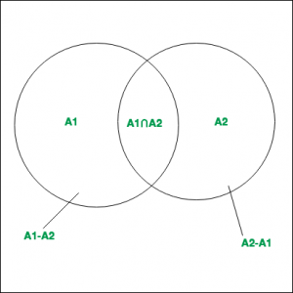

* Hence it can be said that,   
    
  .
* Similarly for 3 finite sets , and ,   
  

**Principle :**

Inclusion-Exclusion principle says that for any number of finite sets , Union of the sets is given by = Sum of sizes of all single sets – Sum of all 2-set intersections + Sum of all the 3-set intersections – Sum of all 4-set intersections .. + Sum of all the i-set intersections.   
In general it can be said that, 

****

**Properties :**

1. Computes the total number of elements that satisfy at least one of several properties.
2. It prevents the problem of double counting.

**Example 1:**   
As shown in the diagram, 3 finite sets A, B and C with their corresponding values are given. Compute . 

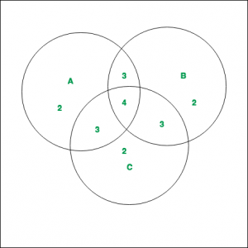

**Solution :**   
The values of the corresponding regions, as can be noted from the diagram are –   
  
By applying Inclusion-Exclusion principle,   
  
  
 

**Applications :**

* **Derangements**   
  To determine the number of derangements( or permutations) of n objects such that no object is in its original position (like Hat-check problem).   
  As an example we can consider the derangements of the number in the following cases:   
  For i = 1, the total number of derangements is 0.   
  For i = 2, the total number of derangements is 1. This is .   
  For i = 3, the total number of derangements is 2. These are and 3 1 2.

**Approach : –** Inclusion-Exclusion Principle is a combinatorial counting technique that allows us to count the number of elements in the union of multiple sets. The principle states that the size of the union of two or more sets is equal to the sum of their sizes minus the size of their intersection, plus the size of the intersection of their pairwise intersections, and so on.

Here’s the step-by-step approach in C++ to implement the Inclusion-Exclusion Principle:

   Define the sets that need to be combined.

   Compute the size of each set.

   Compute the size of each intersection of two sets.

   Compute the size of each intersection of three sets.

   Continue computing the size of each intersection of four, five, and so on sets until you reach the final intersection.

   Sum the sizes of all sets.

   Subtract the size of all pairwise intersections.

   Add the size of all three-way intersections.

   Continue adding and subtracting the intersections of increasing sizes until you reach the final intersection.

   Return the final count.

Here is an example of implementing the Inclusion-Exclusion Principle in C++ to find the number of positive integers less than 100 that are divisible by either 2, 3, or 5:

* C++
* Python3
* Java

|  |
| --- |
| #include <iostream>  **using** **namespace** std;    **int** main() {  **int** n = 100;  **int** count = 0;        // Count the number of integers divisible by 2  **for**(**int** i = 2; i < n; i += 2) {          count++;      }        // Count the number of integers divisible by 3  **for**(**int** i = 3; i < n; i += 3) {          count++;      }        // Count the number of integers divisible by 5  **for**(**int** i = 5; i < n; i += 5) {          count++;      }        // Count the number of integers divisible by both 2 and 3  **for**(**int** i = 6; i < n; i += 6) {          count--;      }        // Count the number of integers divisible by both 2 and 5  **for**(**int** i = 10; i < n; i += 10) {          count--;      }        // Count the number of integers divisible by both 3 and 5  **for**(**int** i = 15; i < n; i += 15) {          count--;      }        // Count the number of integers divisible by 2, 3, and 5  **for**(**int** i = 30; i < n; i += 30) {          count++;      }        // Print the final count      cout << "The number of positive integers less than " << n << " that are divisible by either 2, 3, or 5 is " << count << "." << endl;    **return** 0;  } |

**Output**

The number of positive integers less than 100 that are divisible by either 2, 3, or 5 is 73.

Time complexity :- O(2^n) or O(n^k)

Auxiliary Space :- O(n log log n)

**Principle of Mathematical Induction**

Last Updated : 05 Jul, 2024

Mathematical induction is a concept in mathematics that is used to prove various mathematical statements and theorems. The principle of mathematical induction is sometimes referred to as PMI. It is a technique that is used to prove the basic theorems in mathematics which involve the solution up to n finite natural terms.

Principle of Mathematical Induction is widely used in proving various statements such as a sum of first **n** [natural numbers](https://www.geeksforgeeks.org/what-are-natural-numbers) is given by the formula **n(n+1)/2.**This can be easily proved using the Principle of Mathematical Induction.

In this article, we will learn about the principle of mathematical induction, its statement, its example, and others in detail.

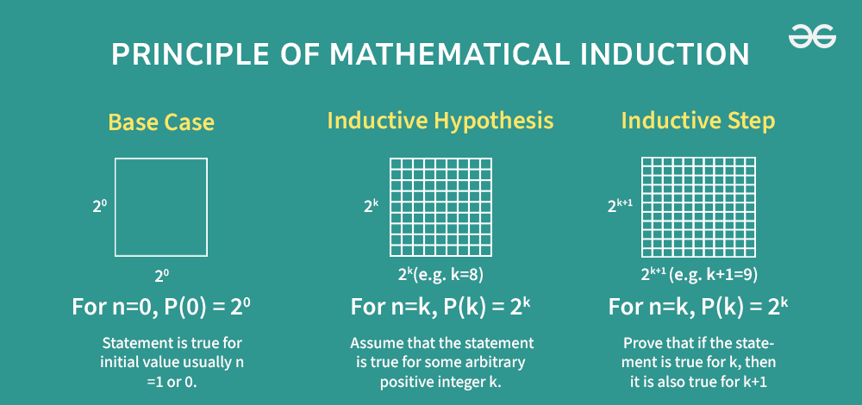

**Table of Content**

* [What is Mathematical Induction?](https://www.geeksforgeeks.org/principle-of-mathematical-induction/#what-is-mathematical-induction)
* [Principle of Mathematical Induction Statement](https://www.geeksforgeeks.org/principle-of-mathematical-induction/#principle-of-mathematical-induction-statement)
* [Mathematical Induction Steps](https://www.geeksforgeeks.org/principle-of-mathematical-induction/#mathematical-induction-steps)
* [Mathematical Induction Example](https://www.geeksforgeeks.org/principle-of-mathematical-induction/#mathematical-induction-example)

**What is Mathematical Induction?**

Mathematical Induction is one of the fundamental methods of writing proofs and it is used to prove a given statement about any well-organized set. Generally, it is used for proving results or establishing statements that are formulated in terms of **n**, where n is a natural number.

Suppose P(n) is a statement for n natural number then it can be proved using the Principle of Mathematical Induction, Firstly we will prove for P(1) then let P(k) be true then prove for P(k+1). If P(k+1) holds then we say that P(n) is true by the principle of mathematical induction.

We can compare mathematical induction to falling dominoes. When a domino falls, it knocks down the next domino in succession. The first domino knocks down the second one, the second one knocks down the third, and so on. In the end, all of the dominoes will be bowled over. But there are some conditions to be fulfilled:

* Base step is that the starting domino must fall to set the knocking process in action.
* The distance between dominoes must be equal for any two adjacent dominoes. Otherwise, a certain domino may fall down without bowling over the next. Then the sequence of reactions will stop. Maintaining the equal inter-domino distance ensures that P(k) ⇒ P(k + 1) for each integer k ≥ a. This is the inductive step.

**Principle of Mathematical Induction Statement**

Any statement P(n) which is for “n” natural number can be proved using the Principle of Mathematical Induction by following the below steps,

***Step 1:*** *Verify if the statement is true for trivial cases (****n = 1)*** *i.e. check if P(1) is true.*

***Step 2:*** *Assume that the statement is true for n = k for some k ≥ 1 i.e. P(k) is true.*

***Step 3:*** *If the truth of P(k) implies the truth of P(k + 1), then the statement P(n) is true for all* ***n ≥ 1****.*

The image added below contains all the steps of Mathematical Induction

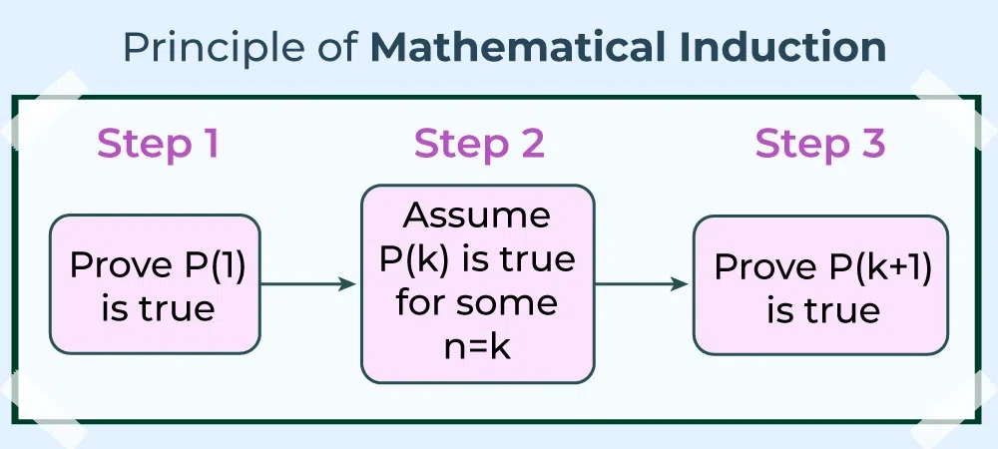

The first statement is the fact and if it is not possible for all P(n) to hold true at n = 1 then these statements are true for some other values of n say n = 2, n = 3, and others.

If the statement is true for P(k) then if P(k+1) is proven to be true then we say that P(n) is true for all n belonging to Natural Numbers (N)

**Mathematical Induction Steps**

Various steps used in Mathematical Induction are named accordingly. The names of the various steps used in the principle of mathematical induction are,

* **Base Step:** Prove P(k) is true for k =1
* **Assumption Step:** Let P(k) is true for all k in N and k > 1
* **Induction Step:** Prove P(k+1) is true using basic mathematical properties.

If the above three steps are proved then we can say that “By the principle of mathematical induction, P(n) is true for all n belonging to N”.

**Mathematical Induction Example**

Mathematical induction is used to prove various statements we can learn this with the help of the following example.

For any positive [integer](https://www.geeksforgeeks.org/integers/) number n, prove that n3 + 2n is always divisible by 3

**Solution:**

*Let P(n): n3 + 2n is divisible by 3 be the given statement.*

***Step 1: Basic Step***

*Firstly we prove that P(1) is true. Let n = 1 in n3 + 2n  
= 13 + 2(1)   
= 3*

*As 3 is divisible by 3. Hence, P(1) is true.*

***Step 2: Assumption Step***

*Let us assume that P(k) is true*

*Then, k3 + 2k is divisible by 3*

*Thus, we can write it as k3 + 2k = 3n,             (where n is any positive integer)….(i)*

***Step 3: Induction Steps***

*Now we have to prove that algebraic expression (k + 1)3 + 2(k + 1) is divisible by 3*

*= (k + 1)3 + 2(k + 1)*

*= k3 + 3k2 + 5k + 3*

*= (k3 + 2 k) + (3k2 + 3k + 3)*

*from eq(i)*

*= 3n + 3(k2 + k + 1)*

*= 3(n + k2 + k + 1)*

*As it is a multiple of 3 we can say that it is divisible by 3.*

*Thus, P(k+1) is true i.e. (k + 1)3 + 2(k + 1) is be divisible by 3. Now by the Principle of Mathematical Induction, we can say that, P(n): n3 + 2n is divisible by 3 is true.*

**Read More,**

* [*Arithmetic Progression*](https://www.geeksforgeeks.org/what-is-arithmetic-progression)
* [*Geometric Progression*](https://www.geeksforgeeks.org/what-is-geometric-progression)

**Solved Examples on Mathematical Induction**

**Example 1:** **For all n ≥ 1, prove that, 12 + 22 + 32+….+n2 = {n(n + 1) (2n + 1)} / 6**

**Solution:**

*Let the given statement be P(n),*

*P(n):12+22+32+…+n2=n(n+1)(2n+1)6 For n=1P(1):1(1+1)(2×1+1)6=1        P(n):12+22+32+…+n2=6n(n+1)(2n+1)​ For n=1P(1):61(1+1)(2×1+1)​=1*

*Now, let’s take a positive integer, k, and assume P(k) to be true i.e.,*

*12+22+32+….+k2=k(k+1)(2k+1)6        12+22+32+….+k2=6k(k+1)(2k+1)​*

*We shall now prove that P(k + 1) is also true, so now we have,*

*P(k + 1) = P(k) + (k + 1)2*

*=k(k+1)(2k+1)6+(k+1)2 =k(k+1)(2k+1)+6(k+1)26 = (k+1)(2k2+k)+6(k+1)6 =(k+1)(2k2+7k+6)6 =(k+1)(k+2)(2k+3)6 =(k+1)((k+1)+1)(2(k+1)+1)6 =6k(k+1)(2k+1)​+(k+1)2 =6k(k+1)(2k+1)+6(k+1)2​ = (k+1)6(2k2+k)+6(k+1)​ =6(k+1)(2k2+7k+6)​ =6(k+1)(k+2)(2k+3)​ =6(k+1)((k+1)+1)(2(k+1)+1)​*

*Thus P(k + 1) is true, whenever P(k) is true for all natural numbers. Hence, by the process of mathematical induction, the given result is true for all natural numbers.*

**Example 2:** **For all n ≥ 1, prove that, 1.2.3 + 2.3.4 + 3.4.5+…+n(n + 1) (n + 2) = {n (n + 1) (n + 2) ( n + 3)} / 4**

**Solution:**

*Let the given statement be S(n),*

*S(n):1.2.3+2.3.4+3.4.5+…+n.(n+1)(n+2)=n(n+1)(n+2)(n+3)4 For n=1,S(1):1(1+1)(1+2)(1+3)4=6which is true.S(n):1.2.3+2.3.4+3.4.5+…+n.(n+1)(n+2)=4n(n+1)(n+2)(n+3)​ For n=1,S(1):41(1+1)(1+2)(1+3)​=6which is true.*

*Now, let’s take a positive integer, k, and assume S(k) to be true i.e.,*

*S(k):1.2.3+2.3.4+3.4.5+…+k.(k+1)(k+2)=k(k+1)(k+2)(k+3)4S(k):1.2.3+2.3.4+3.4.5+…+k.(k+1)(k+2)=4k(k+1)(k+2)(k+3)​*

*We shall now prove that  S(k + 1) is also true, so now we have,*

*S(k+1):S(k)+(k+1)(k+2)(k+3) ⇒S(k+1):k(k+1)(k+2)(k+3)4+(k+1)(k+2)(k+3) ⇒S(k+1):k(k+1)(k+2)(k+3)+ 4(k+1)(k+2)(k+3)4 ⇒S(k+1): (k+1)(k+2)(k+3)(k+4)4 ⇒S(k+1):(k+1){(k+1)+1}{(k+1)+2}{(k+1)+3}4 S(k+1):S(k)+(k+1)(k+2)(k+3) ⇒S(k+1):4k(k+1)(k+2)(k+3)​+(k+1)(k+2)(k+3) ⇒S(k+1):4k(k+1)(k+2)(k+3)+ 4(k+1)(k+2)(k+3)​ ⇒S(k+1): 4(k+1)(k+2)(k+3)(k+4)​ ⇒S(k+1):4(k+1){(k+1)+1}{(k+1)+2}{(k+1)+3}​*

*Thus S(k + 1) is true, whenever S(k) is true for all natural numbers. And we initially showed that S(1) is true thus S(n) is true for all natural numbers.*

**Example 3:** **For all n ≥ 1, prove that, 1 + 3 + 5 +… + 2n – 1 = n2**

**Solution:**

*Let the given statement be S(n),*

*and S(n) = 1 + 3 + 5+… +2n – 1 = n2*

*For n = 1, 2 × 1 – 1 = 12  Thus S(1) is true .*

*Now, let’s take a positive integer, k, and assume S(k) to be true i.e.,*

*S(k) = 1+ 3 + 5+…+(2k – 1) = k2*

*We shall now prove that  S(k + 1) is also true, so now we have,*

*1 + 3 + 5+…+ (2(k + 1) – 1) = (k + 1)2*

*L.H.S = 1 + 3 + 5 + …. (2k – 1 ) + 2k + 2 – 1*

*⇒ L.H.S = S(k) + 2k + 1*

*⇒ L.H.S = k2 + 2k + 1*

*⇒ L.H.S = (k + 1)2*

*⇒ L.H.S = R.H.S*

*Thus S(k + 1) is true, whenever S(k) is true for all natural numbers. And we initially showed that S(1) is true thus S(n) is true for all natural numbers.*

**Example 4:** **For all n ≥ 1, prove that, 1.2 + 2.3 + 3.4 +…+ n(n + 1) = {n(n + 1)(n + 2)} / 3**

**Solution:**

*Let the given statement be S(n),*

*S(n):1.2+2.3+3.4+……+n.(n+1)=n(n+1)(n+2)3 for n=1, S(1):1(1+1)(1+2)3=2which is true.        S(n):1.2+2.3+3.4+……+n.(n+1)=3n(n+1)(n+2)​ for n=1, S(1):31(1+1)(1+2)​=2which is true.*

*Now, let’s take a positive integer, k, and assume S(k) to be true i.e.,*

*S(k):1.2+2.3+3.4+……+k.(k+1)=k(k+1)(k+2)3        S(k):1.2+2.3+3.4+……+k.(k+1)=3k(k+1)(k+2)​*

*We shall now prove that S(k + 1) is also true, so now we have,*

*S(k+1):S(k)+(k+1)(k+2) ⇒S(k+1):k(k+1)(k+2)3+(k+1)(k+2) ⇒S(k+1):k(k+1)(k+2)+3(k+1)(k+2)3 ⇒S(k+1):(k+1)(k+2)(k+3)3 ⇒S(k+1):(k+1){(k+1)+1}{(k+1)+2}3        S(k+1):S(k)+(k+1)(k+2) ⇒S(k+1):3k(k+1)(k+2)​+(k+1)(k+2) ⇒S(k+1):3k(k+1)(k+2)+3(k+1)(k+2)​ ⇒S(k+1):3(k+1)(k+2)(k+3)​ ⇒S(k+1):3(k+1){(k+1)+1}{(k+1)+2}​*

*Thus S(k + 1) is true, whenever S(k) is true for all natural numbers. And we initially showed that S(1) is true thus S(n) is true for all natural numbers.*

**Example 5: Prove an = a1 + (n – 1) d, is the general term of any arithmetic sequence.**

**Solution:**

*For n = 1, we have an = a1 + (1 – 1) d = a1, so the formula is true for n = 1,*

*Let us assume that the formula ak = a1 + (k – 1) is true for all natural numbers.*

*We shall now prove that the formula is also true for k+1, so now we have,*

*ak + 1 = a1 + [(k + 1) – 1] d = a1 + k · d.*

*We assumed that ak = a1 + (k – 1) d, and by the definition of an arithmetic sequence ak+ 1 – ak = d,*

*Then, ak + 1 – ak*

*= (a1 + k · d) – (a1 + (k – 1)d)  
= a1 – a1 + kd – kd + d  
= d*

*Thus the formula is true for k + 1, whenever it is true for k. And we initially showed that the formula is true for n = 1. Thus the formula is true for all natural numbers.*

**Practice Problems on Principle of Mathematical Induction**

**Problem 1:**Prove that for all natural numbers nnn, the following holds: 1 + 2 + 3 + . . . + n = [n(n + 1)]/2.

**Problem 2:**Show that for all integers n ≥ 1 : 13 + 23 + 33 + . . . + n3 = [{n(n + 1)}/2]2.

**Problem 3:**Verify that for all natural numbers n: 2n > n2.

**Problem 4:**Prove that for all integers n ≥ 1: 1×2 + 2×3 + 3×4 + ⋯ + n(n+1) = [n(n+1)(n+2)]/3.

**Problem 5:**Show that for all integers n ≥ 1: 7n − 4n is divisible by 3.

**Probability Class 10 Important Questions**

Last Updated : 17 Oct, 2024

**Probability**is a fundamental concept in mathematics for measuring of chances of an event happening By assigning numerical values to the chances of different outcomes, probability allows us to model, analyze, and predict complex systems and processes.

**Probability Formulas for Class 10**

It says the **possibility of an event**happening is equal to the **ratio of the number of favorable outcomes and the total number of outcomes.**

* [***Probability of event***](https://www.geeksforgeeks.org/what-is-the-probability-of-a-possible-event/) ***to happen P(E) = Number of favourable outcomes/Total Number of outcomes***
* ***For any event E: P (E) + P (*** *EˉEˉ****) = 1,*** ***where E stands for ‘not E’***
* ***P (*** *EˉEˉ****) = 1 – P(E)***

**Probability Class 10 Important Questions: Solved**

**Question 1: You toss two coins at the same time. What is the probability of getting at least one head?**

**Solution**:

*The possible outcomes when tossing two coins are: HH, HT, TH, TT (where H = Head, T = Tail).*

*Total possible outcomes = 4.*

*The favorable outcomes for “at least one head” are: HH, HT, TH (3 outcomes).*

*P(at least one head) = number of outcomes with one head / total number of outcomes.*

***P(at least one head) = 3/4​***

**Question 2: Two dice are rolled together. What is the probability of getting a sum of 7?**

**Solution**:

*The possible outcomes when rolling two dice = 6×6=36.*

*The favorable outcomes where the sum is 7: (1,6), (2,5), (3,4), (4,3), (5,2), (6,1) (6 outcomes).*

*P(sum of 7) = number of outcomes with sum of 7/ total number of outcomes.*

*P(sum of 7) = 6/36 = 1/6*

**Question 3: A box contains 12 balls out of which x are black. If one ball is drawn at random from the box, what is the probability that it will be a black ball? If 6 more black balls are put in the box, the probability of drawing a black ball is now double of what it was before. Find x.**

**Solution :**

*Total number of balls = 12*

*Number of black Balls = x.*

*P(Getting a black ball ) = number of black Balls / total number of balls.*

*P(Getting a black ball ) = x/12*

***After adding 6 more black balls***

*Total number of balls = 18*

*Number of black Balls = x + 6.*

*Pnew (getting black balls) = x + 6/18*

***Now, Pnew = 2 × POld***

*(x + 6)/18 = 2 × (x/12)*

*(x + 6)/18 = 2x/12*

*Simplifying the above equation*

***x = 3***

**Question 4: If the probability of winning a game is 0.6, what is the probability of loosing it.**

**Solution:**

*Given the probability of winning the game is 0.6 ⇒ P(E) = 0.6*

***As we know, P (E) + P (*** *EˉEˉ****) = 1***

*then probability of loosing the game* ***P (*** *EˉEˉ*

***P (*** *EˉEˉ = 1 – P(E)*

*P(Loosing the game) = 1 – 0.6 = 0.4*

***P(Loosing the game) = 0.4***

**Also Read:**

* [**Probability – Aptitude Questions and Answers**](https://www.geeksforgeeks.org/probability-questions/)
* [**Probability Theory**](https://www.geeksforgeeks.org/probability-theory/)
* [**Probability and Statistics**](https://www.geeksforgeeks.org/probability-and-statistics/)

**Probability Class 10 Important Questions : Unsolved**

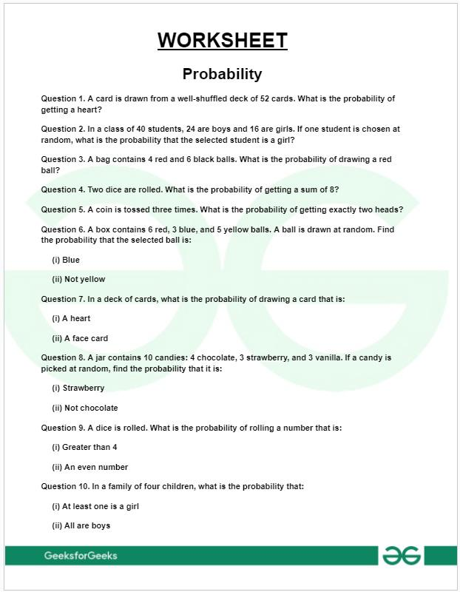

2 / 3

[***Class 10 : Probability Worksheet with Answers – Free PDF Download***](https://media.geeksforgeeks.org/wp-content/uploads/20241017154654758678/Worksheet-on-Probability---Class-10.pdf)

**Probability – FAQs**

**What is probability and its formula?**

***Probability*** *is a measure of chances of an event happening. It is calculated by using the formula:*

***P(E) = Number of favourable outcomes/Total Number of outcomes***

**How to solve Probability?**

*To solve probability, first of all identify an event having one result. Then find all the possible results present, step 3 is to divide the number of favourable outcomes by the total number of possible outcomes.*

**What do you mean by probability ?**

***How likely something is to happen*** *is probability. Whenever we’re unsure about the outcome of an event, we can talk about the probabilities of certain outcomes—how likely they are.*

**What are the 3 types of probability?**

*There are 3 major types of probabilities*

* *Experimental Probability.*
* *Axiomatic Probability.*
* *Theoretical Probability.*

**Bayes’ Theorem**

Last Updated : 04 Feb, 2025

**Bayes’ Theorem** is a mathematical formula that helps determine the **conditional probability** of an event based on prior knowledge and new evidence.

It adjusts probabilities when new information comes in and helps make better decisions in uncertain situations.

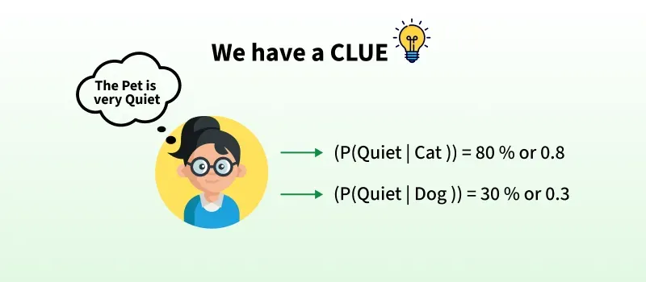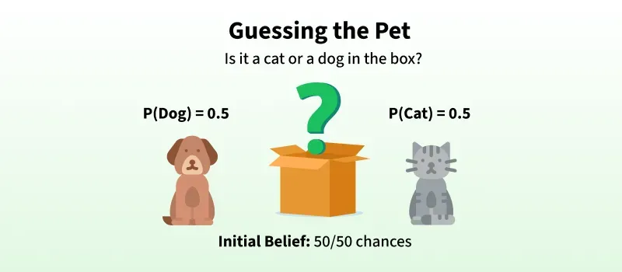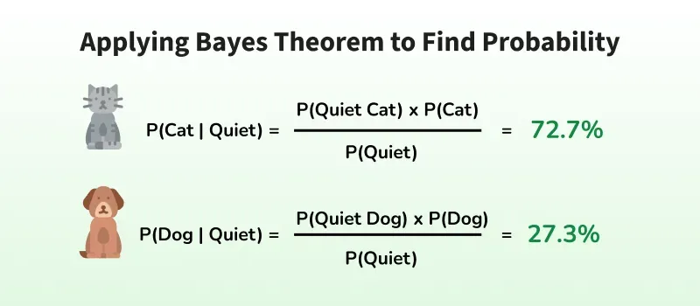

1 / 3

*Bayes Theorem helps us update probabilities based previous and new information. In this case, knowing that the pet is quiet, we can calculate the probability of it being a cat or a dog.*

**Bayes Theorem and Conditional Probability**

Bayes theorem (also known as the Bayes Rule or Bayes Law) is used to determine the conditional probability of event A when event B has already occurred.

The general statement of Bayes’ theorem is “The conditional probability of an event A, given the occurrence of another event B, is equal to the product of the event of B, given A and the probability of A divided by the probability of event B.**”** i.e.

***For example,****if we want to find the probability that a white marble drawn at random came from the first bag, given that a white marble has already been drawn, and there are three bags each containing some white and black marbles, then we can use Bayes’ Theorem.*

**Check: [Bayes’s Theorem for Conditional Probability](https://www.geeksforgeeks.org/bayess-theorem-for-conditional-probability/" \t "_blank)**

**Bayes Theorem Formula**

For any two events A and B, then the formula for the Bayes theorem is given by:

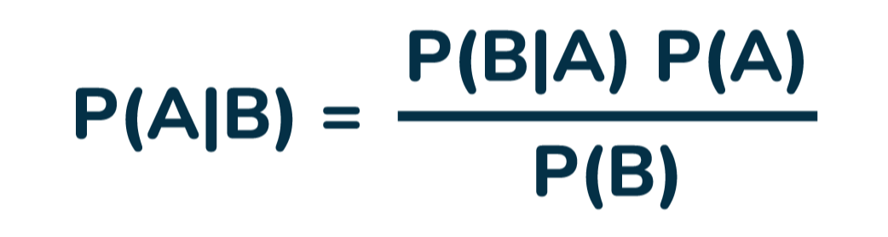

*Formula for the Bayes theorem*

Where,

* **P(A)** and **P(B)** are the probabilities of events A and B also P(B) is never equal to zero,
* **P(A|B)** is the probability of event A when event B happens,
* **P(B|A)** is the probability of event B when A happens.

**Bayes Theorem Statement**

**Bayes Theorem for n set of events is defined as,**

Let E1, E2,…, En be a set of events associated with the sample space S, in which all the events E1, E2,…, En have a non-zero probability of occurrence. All the events E1, E2,…, E form a partition of S. Let A be an event from space S for which we have to find probability, then according to Bayes theorem,

***P(Ei|A) = P(Ei)P(A|Ei) / ∑ P(Ek)P(A|Ek)***

***for k = 1, 2, 3, …., n***

**Bayes Theorem Derivation**

The proof of Bayes Theorem is given as, according to the conditional probability formula,  
**P(Ei|A) = P(Ei∩A) / P(A)…..(i)**

Then, by using the multiplication rule of probability, we get  
**P(Ei∩A) = P(Ei)P(A|Ei)……(ii)**

Now, by the total probability theorem,  
**P(A) =** **∑ P(Ek)P(A|Ek)…..(iii)**

Substituting the value of P(Ei∩A) and P(A) from eq (ii) and eq(iii) in eq(i) we get,

***P(Ei | A) = P(Ei)P(A | Ei) / ∑ P(Ek)P(A | Ek)***

Bayes’ theorem is also known as the formula for the probability of “causes”. As we know, the Ei‘s are a partition of the sample space S, and at any given time only one of the events Ei occurs**.** Thus we conclude that the Bayes theorem formula gives the probability of a particular Ei, given the event A has occurred.

**Terms Related to Bayes Theorem**

After learning about Bayes theorem in detail, let us understand some important terms related to the concepts we covered in formula and derivation.

**Hypotheses**

* [Hypotheses](https://www.geeksforgeeks.org/hypothesis/) refer to possible events or outcomes in the sample space, they are denoted as **E1, E2, …, En.**
* Each hypothesis represents a distinct scenario that could explain an observed event.

**Priori Probability**

* [Priori Probability](https://www.geeksforgeeks.org/prior-probability/) P(Ei) is the initial probability of an event occurring before any new data is taken into account.
* It reflects existing knowledge or assumptions about the event.
* **Example:**The probability of a person having a disease before taking a test.

**Posterior Probability**

* [Posterior probability](https://www.geeksforgeeks.org/posterior-probability/) (P(Ei∣A) is the updated probability of an event after considering new information.
* It is derived using Bayes Theorem.
* **Example:** The probability of having a disease given a positive test result.

**Conditional Probability**

* The probability of an event A based on the occurrence of another event B is termed [conditional Probability](https://www.geeksforgeeks.org/conditional-probability/).
* It is denoted as **P(A|B)** and represents the probability of A when event B has already happened.

**Joint Probability**

* When the probability of two more events occurring together and at the same time is measured it is marked as [Joint Probability](https://www.geeksforgeeks.org/joint-probability-concept-formula-and-examples/).
* For two events A and B, it is denoted by joint probability is denoted as, **P(A∩B).**

**Random Variables**

* Real-valued variables whose possible values are determined by random experiments are called [random variables](https://www.geeksforgeeks.org/random-variable/).
* The probability of finding such variables is the experimental probability.

**Bayes Theorem Applications**

Bayesian inference is very important and has found application in various activities, including medicine, science, philosophy, engineering, sports, law, etc., and Bayesian inference is directly derived from Bayes theorem.

**Some of the Key Applications are:**

* **Medical Testing** → Finding the real probability of having a disease after a positive test.
* **Spam Filters** → Checking if an email is spam based on keywords.
* **Weather Prediction** → Updating the chance of rain based on new data.
* **AI & Machine Learning** → Used in [**Naïve Bayes classifiers**](https://www.geeksforgeeks.org/naive-bayes-classifiers/) to predict outcomes.

**Check**,[Real Life Applications of Bayes theorem](https://www.geeksforgeeks.org/real-life-applications-of-bayes-theorem/)

**Difference Between Conditional Probability and Bayes Theorem**

The difference between Conditional Probability and Bayes Theorem can be understood with the help of the table given below,

| **Bayes Theorem** | **Conditional Probability** |
| --- | --- |
| Bayes Theorem is derived using the definition of conditional probability. It is used to find the reverse probability. | Conditional Probability is the probability of event A when event B has already occurred. |
| **Formula:** P(A|B) = [P(B|A)P(A)] / P(B) | **Formula:** P(A|B) = P(A∩B) / P(B) |

**Theorem of Total Probability**

Let E1, E2, . . ., En be mutually exclusive and exhaustive events associated with a random experiment, and let E be an event that occurs with some Ei. Then, prove that

***P(E) = n∑i=1P(E/Ei) . P(Ej)***

**Proof:**

*Let S be the sample space. Then,*

*S = E1 ∪ E2 ∪ E3  ∪ . . . ∪ En and Ei ∩ Ej = ∅ for i ≠ j.  
E = E ∩ S   
⇒ E = E ∩ (E1 ∪ E2 ∪ E3 ∪ . . . ∪ En)  
⇒ E = (E ∩ E1) ∪ (E ∩ E2) ∪ . . . ∪ (E ∩ En)*

*P(E) = P{(E ∩ E1) ∪ (E ∩ E2)∪ . . . ∪(E ∩ En)}  
⇒ P(E) = P(E ∩ E1) + P(E ∩ E2) + . . . + P(E ∩ En)  
{Therefore, (E ∩ E1), (E ∩ E2), . . . ,(E ∩ En)} are pairwise disjoint}*

*⇒ P(E) = P(E/E1) . P(E1) + P(E/E2) . P(E2) + . . . + P(E/En) . P(En)  [by* [*multiplication theorem*](https://www.geeksforgeeks.org/multiplication-theorem/)*]  
⇒ P(E) = n∑i=1P(E/Ei) . P(Ei)*

**Articles Related to Bayes Theorem-**

* [**Conditional Probability**](https://www.geeksforgeeks.org/conditional-probability/)
* [**Probability Distribution**](https://www.geeksforgeeks.org/probability-distribution/)

**Bayes Theorem for Programmers-**

* [***Bayes Theorem in Artificial Intelligence***](https://www.geeksforgeeks.org/bayes-theorem-in-artificial-intelligence/)
* [***Bayes Theorem in Machine Learning***](https://www.geeksforgeeks.org/bayes-theorem-in-machine-learning/)
* [***Bayes’ Theorem in Data Mining***](https://www.geeksforgeeks.org/bayes-theorem-in-data-mining/)

**Solved Examples of Bayes Theorem**

**Example 1:** A person has undertaken a job. The probabilities of completion of the job on time with and without rain are 0.44 and 0.95 respectively. If the probability that it will rain is 0.45, then determine the probability that the job will be completed on time**.**

**Solution:**

*Let E1 be the event that the mining job will be completed on time and E2 be the event that it rains. We have,*

*P(A) = 0.45,  
P(no rain) = P(B) = 1 − P(A) = 1 − 0.45 = 0.55*

*By multiplication law of probability,  
P(E1) = 0.44, and P(E2) = 0.95*

*Since, events A and B form partitions of the sample space S, by total probability theorem, we have*

*P(E) = P(A) P(E1) + P(B) P(E2)  
⇒ P(E) = 0.45 × 0.44 + 0.55 × 0.95  
⇒ P(E) = 0.198 + 0.5225 = 0.7205*

*So, the probability that the job will be completed on time is 0.7205*

**Example 2:**There are three urns containing 3 white and 2 black balls; 2 white and 3 black balls; 1 black and 4 white balls respectively. There is an equal probability of each urn being chosen. One ball is equal probability chosen at random. What is the probability that a white ball is drawn?

**Solution:**

*Let E1, E2, and E3 be the events of choosing the first, second, and third urn respectively. Then,  
P(E1) = P(E2) = P(E3) = 1/3*

*Let E be the event that a white ball is drawn. Then,  
P(E/E1) = 3/5, P(E/E2) = 2/5, P(E/E3) = 4/5*

*By theorem of total probability, we have  
P(E) = P(E/E1) . P(E1) + P(E/E2) . P(E2) + P(E/E3) . P(E3)  
⇒ P(E) = (3/5 × 1/3) + (2/5 × 1/3) + (4/5 × 1/3)  
⇒ P(E) = 9/15 = 3/5*

**Example 3:** A card from a pack of 52 cards is lost. From the remaining cards of the pack, two cards are drawn and are found to be both hearts. Find the probability of the lost card being a heart.

**Solution:**

*Let E1, E2, E3, and E4 be the events of losing a card of hearts, clubs, spades, and diamonds respectively.  
Then P(E1) = P(E2) = P(E3) = P(E4) = 13/52 = 1/4.*

*Let E be the event of drawing 2 hearts from the remaining 51 cards. Then,*

*P(E|E1) = probability of drawing 2 hearts, given that a card of hearts is missing  
⇒ P(E|E1) = 12C2 / 51C2 = (12 × 11)/2! × 2!/(51 × 50) = 22/425*

*P(E|E2) = probability of drawing 2 clubs ,given that a card of clubs is missing  
⇒ P(E|E2) = 13C2 / 51C2 = (13 × 12)/2! × 2!/(51 × 50) = 26/425*

*P(E|E3) = probability of drawing 2 spades ,given that a card of hearts is missing  
⇒ P(E|E3) = 13C2 / 51C2 = 26/425*

*P(E|E4) = probability of drawing 2 diamonds ,given that a card of diamonds is missing  
⇒ P(E|E4) = 13C2 / 51C2 = 26/425*

*Therefore,*

*P(E1|E) = probability of the lost card is being a heart, given the 2 hearts are drawn from the remaining 51 cards*

*⇒ P(E1|E) = P(E1) . P(E|E1)/P(E1) . P(E|E1) + P(E2) . P(E|E2) + P(E3) . P(E|E3) + P(E4) . P(E|E4)  
⇒ P(E1|E) = (1/4 × 22/425) / {(1/4 × 22/425) + (1/4 × 26/425) + (1/4 × 26/425) + (1/4 × 26/425)}  
⇒ P(E1|E) = 22/100 = 0.22*

*Hence, The required probability is 0.22.*

**Example 4:**Suppose 15 men out of 300 men and 25 women out of 1000 are good orators. An orator is chosen at random. Find the probability that a male person is selected.

**Solution:**

*Gievn,*

* *Total Men = 300*
* *Total Women = 1000*
* *Good Orators among Men = 15*
* *Good Orators among Women = 25*

*Total number of good orators = 15 (from men) + 25 (from women) = 40  
Probability of selecting a male orator:  
P(Male Orator) = Numbers of male orators / total no of orators = 15/40*

**Example 5:**A man is known to speak the lies 1 out of 4 times. He throws a die and reports that it is a six. Find the probability that is actually a six.

Solution:

*In a throw of a die, let  
E1 = event of getting a six,  
E2 = event of not getting a six and  
E = event that the man reports that it is a six.*

*Then, P(E1) = 1/6, and P(E2) = (1 – 1/6) = 5/6*

*P(E|E1) = probability that the man reports that six occurs when six has actually occurred   
⇒ P(E|E1) = probability that the man speaks the truth  
⇒ P(E|E1) = 3/4*

*P(E|E2) = probability that the man reports that six occurs when six has not actually occurred*

*⇒ P(E|E2) = probability that the man does not speak the truth  
⇒ P(E|E2) = (1 – 3/4) = 1/4*

*Probability of getting a six ,given that the man reports it to be six*

*P(E1|E) = P(E|E1) × P(E1)/P(E|E1) × P(E1) + P(E|E2) × P(E2)     [by Bayes theorem]  
⇒ P(E1|E) = (3/4 × 1/6)/{(3/4 × 1/6) + (1/4 × 5/6)}  
⇒ P(E1|E) = (1/8 × 3) = 3/8*

*Hence the probability required is 3/8.*

**Group Theory**

Last Updated : 24 Jun, 2024

Group theory is a branch of mathematics that studies algebraic structures known as groups. A group is a set of elements combined with an operation that satisfies four fundamental properties: closure, associativity, identity, and inverses.

Groups can be found in various areas of mathematics and science. They are fundamental in studying symmetries, solving polynomial equations, and analyzing geometric objects. For instance, the set of all rotations and reflections of a geometric object forms a group because these transformations can be combined and each has an inverse.

In this article, we will discuss the fundamental concepts of group theory, including the definition and properties of groups, various examples of groups, and their applications in different fields.

**Table of Content**

* [What is Group Theory?](https://www.geeksforgeeks.org/group-theory/#what-is-group-theory)
* [What is Group?](https://www.geeksforgeeks.org/group-theory/#what-is-group)
  + [Types of Groups](https://www.geeksforgeeks.org/group-theory/#types-of-groups)
* [Properties of Groups](https://www.geeksforgeeks.org/group-theory/#properties-of-groups)
* [Group Theory Axioms and Proof](https://www.geeksforgeeks.org/group-theory/#group-theory-axioms-and-proof)
  + [Closure Axiom](https://www.geeksforgeeks.org/group-theory/#closure-axiom)
  + [Associativity Axiom](https://www.geeksforgeeks.org/group-theory/#associativity-axiom)
  + [Identity Axiom](https://www.geeksforgeeks.org/group-theory/#identity-axiom)
  + [Inverse Axiom](https://www.geeksforgeeks.org/group-theory/#inverse-axiom)
  + [Axiom: For group G, such that a, b ∈ G, then (a × b)-1 = a-1 × b-1](https://www.geeksforgeeks.org/group-theory/#axiom-for-group-g-such-that-a-b-g-then-a-b1-a1-b1)
* [Subgroup](https://www.geeksforgeeks.org/group-theory/#subgroup)
* [Classes of Groups](https://www.geeksforgeeks.org/group-theory/#classes-of-groups)
* [Group Theory Applications](https://www.geeksforgeeks.org/group-theory/#group-theory-applications)
* [FAQs](https://www.geeksforgeeks.org/group-theory/#faqs-on-group-theory)

**What is Group Theory?**

Group theory in mathematics is a part of abstract algebra, which mainly deals with the study of groups that are sets of elements, equipped with a binary operation (like addition, multiplication or exponentiation) that satisfies certain properties.

Imagine you have a set of objects and a way to combine them. For example, think about the numbers and the addition operation. Group theory studies such sets and the operations on them if they meet certain rules:

* Closure
* Associativity
* Identity Element
* Inverse

**What is Group?**

A group is a set G together with a binary operation (\*) that satisfies the following four properties:

* **Closure:**For all a, b in G, a \* b is also in G.
* **Associativity:** For all a, b, c in G, (a \* b) \* c = a \* (b \* c).
* **Identity:**There exists an element e in G, called the identity, such that for all a in G, a \* e = e \* a = a.
* **Inverse:** For each element a in G, there exists an element b in G, called the inverse of a such that a \* b = b \* a = e.

Let's consider an example for better understanding.

**For example,** consider the set of integers Z with the operation of addition. This set forms a group because it satisfies the four properties mentioned above.

* The closure property is satisfied because the sum of any two integers is also an integer.
* The associativity property is satisfied because the order in which we add integers does not change the result.
* The identity element is 0 because adding 0 to any integer does not change the integer.
* Finally, the inverse property is satisfied because, for each integer a, there exists an integer -a such that a + (-a) = 0.

**Types of Groups**

In group theory, several types of groups are studied based on their properties and structures. Here are some of the main types of groups:

* **Abelian Groups**: A group is called Abelian (or commutative) if the group operation is commutative, meaning a ∗ b = b ∗ a for all elements a and b in the group.
* **Cyclic Groups**: A group is cyclic if it can be generated by a single element. This means every element of the group can be written as an for some integer n, where a is the generator.
* **Finite Groups**: A group is finite if it has a finite number of elements.
* **Infinite Groups**: A group is infinite if it has an infinite number of elements.
* **Simple Groups**: A group is simple if it does not have any nontrivial normal subgroups other than the trivial group and the group itself.
* **Symmetric Groups**: The symmetric group Sn is the group of all permutations of n elements.

**Properties of Groups**

Group theory has several important properties that are used to classify and analyze groups. These properties include:

* **Commutativity:** When the operation is commutative and so when a \* b is equal to b \* a for all a, b in G we say that the group is commutative.
* **Associativity:**The set G is said to be associative when the binary operation is associative, meaning that (a \* b) \* c = a \* (b \* c) for all a, b, c belong to G.
* **Distributivity:**An element group is said to be distributive if the binary operation distributes over it, i.e., a \* (b + c) = a \* b + a \* c for elements a, b, c of G.
* **Cancellation:** If a, b, c is an element of G, and they satisfy that a \* b = a \* c, then this group has cancellation property and it is b = c.

**Group Theory Axioms and Proof**

The axioms of group theory are the fundamental properties that define a group. These axioms are:

**Closure Axiom**

**For all a, b in G, a \* b is also in G.**

**Proof:**

*In proving the closure postulate, we have to demonstrate that for every two elements a and b in G, the result of the operation a \* b is also contained in G. Let a and b be arbitrarily chosen from the group G. Since G is a group, according to the definition, it is closed under the binary operation namely \*. Thus, a\*b is also an element of G. It completes our last step of the closure axiom proof.*

**Associativity Axiom**

**For all a, b, c in G, (a \* b) \* c = a \* (b \* c).**

**Proof:**

*To obtain the associativity axiom for G, we should show that for given elements a, b, and c, the equation (a \* b) \* c = a \* (b \* c) is valid. Consider an arbitrary element a, b, or c in group G. \* is the binary operation that makes G a group, therefore being associative according to its definition. Hence (a \* b) \* c = a \* (b \* c) is true for all a, b and c in G. This brings up the end of our proof of the associativity axiom.*

**Identity Axiom**

**There exists an element e in G, called the identity, such that for all a in G, a \* e = e \* a = a.**

**Proof:**

*To prove the identity axiom, we need to show that there exists an element e in G such that for all a in G, a \* e = e \* a = a. Let a be an arbitrary element of G. Since G is a group, by definition, there exists an element e in G, called the identity, such that a \* e = e \* a = a.*

*This completes the proof of the identity axiom.*

**Inverse Axiom**

**For each element a in G, there exists an element b in G, called the inverse of a, such that a \* b = b \* a = e.**

**Proof:**

*To prove the inverse axiom, we need to show that for each element a in G, there exists an element b in G, called the inverse of a such that a \* b = b \* a = e. Let a be an arbitrary element of G. Since G is a group, by definition, for each element a in G, there exists an element b in G, called the inverse of a such that a \* b = b \* a = e.*

*This completes the proof of the inverse axiom.*

**Axiom: For group G, such that a, b ∈ G, then (a × b)-1 = a-1 × b-1**

**Proof:**

***To Prove:*** *(a × b) × b-1 × a-1 = I*

***⇒ L.H.S*** *= (a × b) × b-1 × b-1*

***⇒ L.H.S*** *= a × (b × b-1) × b-1*

***⇒ L.H.S*** *= a × I × a-1 (by Associative Axiom)*

***⇒ L.H.S*** *= (a × I) × a-1 (by Identity Axiom)*

***⇒ L.H.S*** *= a × a-1 (by Identity Axiom)*

***⇒ L.H.S*** *= I*

***⇒ L.H.S = R.H.S***

*Hence, proved.*

**Subgroup**

With regards to a subgroup, is a subset of an existing group that is itself a group due to the very same binary operation. A subgroup H of a group G is a subset of G that satisfies the following properties:

* **Closure:**For all a, b in H, a \* b is also in H.
* **Associativity:**For all a, b, c in H, (a \* b) \* c = a \* (b \* c).
* **Identity:** The identity element of G is also in H.
* **Inverse:**For each element a in H, the inverse of a is also in H.

**Classes of Groups**

There are several classes of groups, including:

* **Finite Groups:**A group is known to be finite whenever the elements of that group can be counted.
* **Infinite Groups:** One may define the group as infinite if there are an uncountable number of elements present in the set.
* **Abelian Groups:** An abelian group is called by this name when its elements are commuting, so tends a \* b = b \* a for any choice of a, b from the group G.
* **Non-Abelian Groups:**A group is referred to as non-abelian in case it is not commutative, i.e. for a, b ∈ G take a \* b ≠ b \* a.

**Group Theory Applications**

Group theory has numerous [applications](https://www.geeksforgeeks.org/applications-of-group-theory/) in various fields, including:

* **Physics:** In particular, group theory plays a central role in the fundamental symmetry principles of physical systems and their geometrical shape (e.g., crystals and those present in space or time).
* **Computer Science:** Group approaches have been used in computer science as algorithms which help solve problems, for example usage of an algorithm which finds the shortest way in a graph.
* **Cryptography:** The process of group theory with the aim of making the intellect of secure encryption systems is used just like the Diffie-Hallman key exchange algorithm.

**Conclusion**

Group theory becomes the core theory of abstract algebra, which focuses on the symmetry of objects as its field. It gives an idea of the division nature of the algebraic objects and the different symmetries that underlie them, such as groups, rings and fields. Group theory has many applications in other fields, such as physics, computer science and cryptography.

**Read More:**

* [*Venn Diagram*](https://www.geeksforgeeks.org/venn-diagram/)
* [*De Morgan’s Law*](https://www.geeksforgeeks.org/de-morgans-law/)
* [*Set Theory Formulas*](https://www.geeksforgeeks.org/set-theory-formulas/)
* [*Operation on Sets*](https://www.geeksforgeeks.org/set-operations/)

**FAQs on Group theory**

**What is group theory?**

*The branch of geometry is concerned with the mathematical concepts known as groups that can be defined as a set together with the operation which combines any two elements to result in a third one.*

**What are the group axioms?**

*Group axioms are closure (the product of any two elements in the group once again belongs to the group), associativity (it doesn't matter which one of the two operations is performed first), identity (the element that stands for the neutral element exists), and inverse where every element has its own inverse, which cancels the first one out.*

**What is a cyclic group?**

*A cyclic group is a group generated by a single element, and any of its total number of members can be reached through repeating application of its operation on that element.*

**What is the limitation of group theory?**

*A limitation of group theory is its inability to fully capture the complexity of certain mathematical structures and systems, such as those requiring infinite or non-commutative operations.*

**Subgroup and Order of Group | Mathematics**

Last Updated : 06 Sep, 2024

In mathematics, a group is a fundamental algebraic structure consisting of a set of elements combined with a binary operation that satisfies four key properties: closure, associativity, identity, and invertibility.

An example of a group is the set of integers under addition. In this case, the binary operation is addition (+), the identity element is 0 (since adding 0 to any integer returns the same integer), and the inverse of any integer a is its negative −a (since a + (−a) = 0).

In this article, we will discuss subgroups and the order of a group, which are fundamental parts of group theory.

**Table of Content**

* [What are Subgroups?](https://www.geeksforgeeks.org/subgroup-and-order-of-group-mathematics/#what-are-subgroups)
  + [Examples of Subgroup](https://www.geeksforgeeks.org/subgroup-and-order-of-group-mathematics/#examples-of-subgroup)
* [Properties of Subgroups](https://www.geeksforgeeks.org/subgroup-and-order-of-group-mathematics/#properties-of-subgroups)
* [Types of Subgroups](https://www.geeksforgeeks.org/subgroup-and-order-of-group-mathematics/#types-of-subgroups)
  + [Trivial Subgroup](https://www.geeksforgeeks.org/subgroup-and-order-of-group-mathematics/#trivial-subgroup)
  + [Proper Subgroup](https://www.geeksforgeeks.org/subgroup-and-order-of-group-mathematics/#proper-subgroup)
  + [Cyclic Subgroup](https://www.geeksforgeeks.org/subgroup-and-order-of-group-mathematics/#cyclic-subgroup)
  + [Normal Subgroup](https://www.geeksforgeeks.org/subgroup-and-order-of-group-mathematics/#normal-subgroup)
  + [Cosets](https://www.geeksforgeeks.org/subgroup-and-order-of-group-mathematics/#cosets)
* [Order of Group](https://www.geeksforgeeks.org/subgroup-and-order-of-group-mathematics/#order-of-group)
  + [Order of Element](https://www.geeksforgeeks.org/subgroup-and-order-of-group-mathematics/#order-of-element)
  + [Properties of Order of Element](https://www.geeksforgeeks.org/subgroup-and-order-of-group-mathematics/#properties-of-order-of-element)
* [Lagrange’s Theorem](https://www.geeksforgeeks.org/subgroup-and-order-of-group-mathematics/#lagranges-theorem)

**What are Subgroups?**

A nonempty subset H of the group G is a subgroup of G if H is a group under the binary operation (\*) of G. We use the notation H ≤ G to indicate that H is a subgroup of G. Also, if H is a proper subgroup then it is denoted by H < G.

* For a subset H of group G, H is a subgroup of G if,
* H ≠ φ
* if a, k ∈ H then ak ∈ H
* if a ∈ H then a-1 ∈ H

**Read More about**[**Groups**](https://www.geeksforgeeks.org/groups-discrete-mathematics/)**.**

**Examples of Subgroup**

Some examples of subgroups are listed as follows:

* [**Integers**](https://www.geeksforgeeks.org/integers/)**under Addition (Z, +):** The set of even integers is a subgroup of the group of all integers under addition.
* **Modular Arithmetic:**In modular arithmetic, the set of integers modulo n forms a group, and the set of integers that are multiples of a divisor d of n forms a subgroup.

**Properties of Subgroups**

Some of the common properties of subgroups are:

* G is a subgroup of itself and {e} is also a subgroup of G, these are called trivial subgroups.
* Subgroup will have all the properties of a [group](https://www.geeksforgeeks.org/groups-discrete-mathematics/).
* A subgroup H of the group G is a normal subgroup if g-1Hg = H for all g ∈ G.
* If H < K and K < G, then H < G (subgroup transitivity).
* If H and K are subgroups of a group G then H ∩ K is also a subgroup.
* If H and K are subgroups of a group G then H ∪ K may or may not be a subgroup.

**Types of Subgroups**

Some of the common types of subgroups are:

* Trivial Subgroup
* Proper Subgroup
* Cyclic Subgroup
* Normal Subgroup
* Cosets

**Trivial Subgroup**

Every group has two trivial subgroups, the subgroup containing just the identity element and the group itself. These are the smallest and largest subgroups, respectively.

**Proper Subgroup**

A subgroup that is not equal to the group itself is called a proper subgroup. It contains at least one element other than the identity element.

**Cyclic Subgroup**

Generated by a single element of the group. If a is an element of a group G, then the cyclic subgroup generated by a, denoted ⟨a⟩, is the set {an : n∈Z}.

**Normal Subgroup**

A subgroup H of a group G is normal if gHg−1 = H for all g ∈ G. Normal subgroups play a crucial role in the theory of quotient groups

**Cosets**

Let H be a subgroup of a group G. If g ∈ G, the right coset of H generated by g is, Hg = { hg, h ∈ H }; and similarly, the left coset of H generated by g is gH = { gh, h ∈ H }

**Example:** **Consider Z4 under addition (Z4, +), and let H={0, 2}. e = 0, e is identity element. Find the left cosets of H in G?**

**Solution:**

*The left cosets of H in G are,*

*eH = e\*H = { e \* h | h ∈ H} = { 0+h| h ∈ H} = {0, 2}.*

*1H= 1\*H = {1 \* h | h ∈ H} = { 1+h| h ∈ H} = {1, 3}.*

*2H= 2\*H = {2 \* h | h ∈ H} = { 2+h| h ∈ H} = {0, 2}.*

*3H= 3\*H = {3 \* h |h ∈ H} = { 3+h| h ∈ H} = {1, 3}.*

*Hence there are two cosets, namely 0\*H= 2\*H = {0, 2} and 1\*H= 3\*H = {1, 3}.*

**Order of Group**

Order of a group is the number of elements in the group. Similarly, the order of a subgroup is the number of elements in that subgroup, which is always less than or equal to the order of the original group.

***Order of a group*** *(G) is the number of elements present in that group, i.e it’s* [*cardinality*](https://www.geeksforgeeks.org/finite-sets/#:~:text=X%2C%20Y%2C%20Z%7D-,Cardinality%20of%20Finite%20Set,-The%20number%20of)*. It is denoted by |G|.*

For finite groups, the order is simply the count of elements in the group. For example, if a group has 5 elements, its order is 5.

**Order of Element**

In group theory, the order of an element in a group is the smallest positive integer n such that raising the element to the power of n results in the identity element of the group.

For an element aaa in a group G, the order of a, denoted as ∣a∣ or ord(a), is defined as:

***∣a∣ = min{n∈Z+ : an=e}***

Where e is the identity element of the group G.

**Note:** If there is no such positive integer n, then the order of the element is considered infinite.

**Properties of Order of Element**

Common property of order of element are:

* The order of every element of a finite group is finite.
* The Order of an element of a group is the same as that of its inverse a-1.
* If a is an element of order n and p is prime to n, then ap is also of order n.
* Order of any integral power of an element b cannot exceed the order of b.
* If the element a of a group G is order n, then ak=e if and only if n is a divisor of k.
* The order of the elements a and x-1ax is the same where a, x are any two elements of a group.
* If a and b are elements of a group then the order of **ab** is same as order of **ba**.

**Lagrange’s Theorem**

Statement of Lagrange’s theorem is:

*If H is a subgroup of finite group G then the order of subgroup H divides the order of group G.*

Algebraic Structures play an important role in Group Theory and Discrete Mathematics. Among these structures, one of the useful structures is a **semigroup**. A **semigroup** is a set paired with an operation that satisfies a specific property.

In this chapter, we will explain what a semigroup is and why it is important. In addition, we will provide several examples to help you understand the concept better.

What is a Semigroup?

A semigroup is nothing but an algebraic structure. As we know, an algebraic structure is a collection of set and an operation like addition or multiplication that we apply to elements within that set. However, for it to be considered an algebraic structure, the set must satisfy the closure property.

Closure Property

The Closure Property implies that, if we apply the operation to any two elements of the set, the result must also be an element of the set. For example, the set of natural numbers (1, 2, 3, …) is closed under addition. If we add two natural numbers, we will always get another natural number.

Once the closure property is satisfied, we can start talking about semigroups. And a **semigroup** is an algebraic structure that satisfies two properties −

* **Closure Property** − The set must be closed under the operation.
* **Associative Property** − The operation must be associative. This means the way in which elements are grouped during the operation does not affect the result. In other words, **(A \* B) \* C** should be the same as **A \* (B \* C)**.

If a set and operation satisfy both of these properties, then we have a semigroup. The operation could be addition, multiplication, or any binary operation.

[Explore our](https://www.tutorialspoint.com/latest/courses?utm_source=tutorialspoint&utm_medium=tutorials_3p&utm_campaign=internal" \t "_blank)**[latest online courses](https://www.tutorialspoint.com/latest/courses?utm_source=tutorialspoint&utm_medium=tutorials_3p&utm_campaign=internal" \t "_blank)**[and learn new skills at your own pace. Enroll and become a certified expert to boost your career.](https://www.tutorialspoint.com/latest/courses?utm_source=tutorialspoint&utm_medium=tutorials_3p&utm_campaign=internal" \t "_blank)

Understanding Associative Property

The Associative Property is at the heart of what makes a **semigroup**. Associativity means that no matter how the group elements are arranged, the result remains the same. For example, with addition −

(2+3)+5=2+(3+5)=10(2+3)+5=2+(3+5)=10

Here, the order in which we add the numbers does not matter. This is why addition is associative. On the other side, not all operations are associative. Subtraction, for example, is not associative −

(7−3)−2≠7−(3−2)(7−3)−2≠7−(3−2)

This difference is key when determining whether something qualifies as a semigroup.

Examples of Semigroups

Let us now understand more about semigroups with the help of a set of examples −

Example 1: Natural Numbers under Addition

The set of natural numbers (1, 2, 3, …) under the operation of addition forms a semigroup. It is because:

* **Closure Property** − If we add any two natural numbers, the result is also a natural number. For instance, 2 + 5 = 7.
* **Associative Property** − Addition is associative. No matter how our group the numbered, the sum will be the same. For example, (1 + 2) + 3 equals 1 + (2 + 3), both returning 6.

Since both properties are satisfied, the set of natural numbers under addition forms a semigroup.

Example 2: Integers under Multiplication

Now, let us consider the set of integers (…, -3, -2, -1, 0, 1, 2, 3, …) under multiplication.

* **Closure Property** − Multiplying any two integers will always give another integer. For example, **5 \* (-3) = -15**.
* **Associative Property** − Multiplication is also associative. So, **(2 \* 3) \* 4** is the same as **2 \* (3 \* 4)**, and both equal 24.

Thus, the set of integers under multiplication forms a semigroup.

Example 3: Real Numbers under Addition

The set of real numbers, which includes all rational and irrational numbers, under the operation of addition is also a semigroup.

* **Closure Property** − Adding two real numbers would always result in a real number. For example, 1.5 + 2.3 = 3.8.
* **Associative Property** − Just like with integers, addition is associative with real values. For example, (1.2 + 3.4) + 5.6 is the same as 1.2 + (3.4 + 5.6), and both equal 10.2.

So that, real numbers under addition satisfy both properties and form a semigroup.

Non-Examples of Semigroups

Not every set and operation combination forms a semigroup. Let us look at some cases where they do not.

Example 1: Natural Numbers under Subtraction

While natural numbers form a semigroup under addition, they **do not** form a semigroup under subtraction. Because −

* **Closure Property** − If we subtract two natural numbers, the result is not always a natural number. For example, 5 - 10 = -5, which is not a natural number.
* **Associative Property** − Subtraction is not associative. For instance, (7 - 3) - 2 is not the same as 7 - (3 - 2). In the first case, we get 2, and in the second, we get 6.

Since both properties are not satisfied, natural numbers under subtraction do not form a semigroup.

Example 2: Integers under Division

Let us consider the set of integers under division.

* **Closure Property** − Division of two integers does not always give an integer. For example, 5 ÷ 2 = 2.5, which is not an integer.
* **Associative Property** − Division is not associative. For example, (8 ÷ 4) ÷ 2 is 1, but 8 ÷ (4 ÷ 2) is 4.

Therefore, integers under division does not form a semigroup.

Associativity Example

Let us see another real-world analogy to understand associativity. Imagine we are at a restaurant ordering food. The chef can prepare meals in any sequence, and we will get the same result. Whether the chef prepares the appetizer, then the main course, and then the dessert, or prepares the dessert first, the final meal is still complete.

In this sense, associativity is like the flexibility of a chef’s cooking sequence. As long as all the steps are followed, the result will be the same.

Special Case: Semigroups in Modular Arithmetic

The example of a semigroup can be found in modular arithmetic, which is often used in several use cases in computer science. For instance, let us consider the set of integers under addition modulo 5. In this case −

* **Closure Property** − Adding two numbers modulo 5 always results in a number between 0 and 4. For example, (3 + 4) mod 5 = 2.
* **Associative Property** − Addition modulo 5 is associative. For example, (1 + 2) mod 5 + 3 mod 5 is the same as 1 mod 5 + (2 + 3) mod 5.

Thus, modular arithmetic with addition forms a semigroup.

Conclusion

A semigroup is an algebraic structure where the set of elements is closed under a binary operation and that operation is associative.

In this chapter, we presented several examples, including natural numbers under addition and integers under multiplication, to understand how the closure and associative properties work. Additionally, we understood non-examples too, like natural numbers under subtraction and integers under division.

**Quotient Group in Group Theory**

Last Updated : 06 Aug, 2024

We can say that  “o” is the binary operation on set G if: G is a non-empty set & G \* G = { (a,b): a, b∈ G } and o: G \* G –> G. Here, aob denotes the image of ordered pair (a,b) under the function/operation o.  
**Example –**  “+” is called a binary operation on G (any non-empty set ) if & only if: a+b ∈G; ∀ a,b ∈G and a+b give the same result every time when added.

**Algebraic Structure:**  
A non-empty set G equipped with 1/more binary operations is called an algebraic structure.  
**Example –** a. (N,+)  and b. (R, + , .), where N is a set of natural numbers & R is a set of real numbers. Here ‘ . ‘ (dot) specifies a multiplication operation.

**Group**

An algebraic structure (G, o) where G is a non-empty set & ‘o’ is a binary operation defined on G is called a Group if the binary operation “o” satisfies the following properties –

Closure – a ∈ G ,b ∈ G => aob ∈ G ; ∀ a,b ∈ G 

1. **Associativity –** (aob)oc = ao(boc) ; ∀ a,b,c ∈ G.
2. **Identity Element –** There exists e in G such that aoe = eoa = a; ∀ a ∈ G (Example – For addition, identity is 0).
3. **Existence of Inverse –** For each element a ∈ G; there exists an inverse(a-1)∈ G such that: aoa-1 = a-1oa = e.

**Abelian Group**

An algebraic structure (G, o) where G is a non-empty set & ‘o’ is a binary operation defined on G is called an abelian Group if it is a group (i.e. , it satisfies G1, G2, G3 & G4) and additionally satisfies

**Commutative -** aob = boa ∀ a,b ∈ G

**Normal Subgroup**

Let G be an abelian group & the composition in G has been denoted by multiplicity.  
Let H be any subgroup of G. If x is an arbitrary element of G, the Hx is the right coset of H in G & xH is the left coset of H in G, then G is called a normal subgroup if –

Hx = xH ; ∀x ∈ G or  
xhx-1 ∈ H ; ∀x ∈ G & h ∈ H

**Quotient Group**

Let G be any group & let N be any **normal Subgroup**of G. If ‘a’ is an element of G, then aN is a left coset of N in G. Since N is normal in G, aN = Na ( left coset = right coset).  
We can say that Na is the coset of N in G.   
G/N denotes the set of all the cosets of N in G.

Quotient/Factor Group = G/N = {Na ; a ∈ G } = {aN ; a ∈ G} (As aN = Na)

If G is a group & N is a normal subgroup of G, then, the sets G/N of all the cosets of N in G is a group with respect to multiplication of cosets in G/N. It is called the quotient / factor group of G by N.  
Sometimes it is called ‘Residue class of G modulo N’.  
If the composition in the group is addition, ‘+’, then G/H is defined as:

Quotient/Factor Group = G/N = {N+a ; a ∈ G } = {a+N ; a ∈ G} (As a+N = N+a)

**NOTE –** The identity element of G/N is N.  
**Example 1 –**Consider the group G with addition modulo 6 where G = {0, 1, 2, 3, 4, 5}. Let N = {0, 3),  
then the quotient/ factor group is :  
G/N = { aN ; a ∈ G } = { a{0,3} ; a ∈ {0, 1, 2, 3, 4, 5}}  
= {0{0,3}, 1{0,3}, 2{0,3}, 3{0,3}, 4{0,3}, 5{0,3} }  
= { {(0+0) mod6 , (0+3) mod6 }, { (1+0) mod6 , (1+3) mod6 } , { (2+0) mod6 , (2+3) mod6 } , { (3+0) mod6 , (3+3) mod6 }, { (4+0) mod6 , (4+3) mod6 }, { (5+0) mod6 , (5+3) mod6 } }  
= {{0,3}, {1,4}, {2,5}, {3,0}, {4,1}, {5,2} }  
=  {{0,3}, {1,4}, {2,5}}

**Example 2 –**Let G = {1, -1, i, -i } and H = {1, -1}; H is the normal subgroup of G in binary operation ‘,’ . What will be the quotient group; G/H?  
G/N = { aN ; a ∈ G } = {a{1,-1} ; a ∈ {1,-1,i,-i}  
= {1.{1,-1}, -1.{1,-1}, i{1,-1}, -i.{1,-1}}  
={{1.1,1.-1}, {-1.1,-1.-1}, {i.1, i.-1}, {-i.1, -i.-1}}  
={{1,-1}, {-1,1}, {i,-i}, {-i,i}}  
={ {1,-1}, {i,-i}}  
In other words, we can say that if G is a group & N is a normal subgroup of G, then G/N of all the cosets of N in G together with a binary composition defined by:

NaNb = Nab ; where Na ∈ G/N, Nb ∈ G/N is a group.

G/N is called the quotient group of G by N.

**Properties of Quotient/ Factor group**

1. If N is a normal subgroup of a finite group G, then –  
   O(G/N) = O(G)/O(N), where : O(G/N) => No of distinct right / left cosets of N in G.
2. If N is a normal subgroup of a finite group G such that the  index of N in G is prime, the factor group G/N is cyclic.
3. The factor group of an abelian group is abelian, but the converse is not true.
4. Every factor group of a cyclic group is cyclic but the converse is not true.

**Solved Examples on Quotient Group in Group Theory**

**Problem 1:**

**Let G be the group of real numbers under addition, and let H be the subgroup of integers. Describe the elements of the quotient group G/H and its operation.**

**Solution:**

*The elements of G/H are cosets of the form a + H, where a is a real number. Each coset can be represented by a real number in the interval [0, 1), as any real number can be written as the sum of an integer and a number in [0, 1). The operation in G/H is addition modulo 1. Thus, G/H is isomorphic to the group of real numbers modulo 1, often denoted as R/Z.*

**Problem 2:**

**Let G be the group of invertible 2×2 matrices over real numbers, and H be the subgroup of matrices with determinant 1 (the special linear group SL(2,R)). What is the order of the quotient group G/H?**

**Solution:**

*The determinant function det: G → R\* (where R\* is the multiplicative group of non-zero real numbers) is a surjective homomorphism with kernel H. By the first isomorphism theorem, G/H ≅ R\*. Since R\* has infinite order, G/H also has infinite order.*

**Problem 3:**

**Let G be the symmetric group S4 and H be the alternating group A4. Describe the elements of G/H and determine its order.**

**Solution:**

*Since A4 is a normal subgroup of S4 of index 2, G/H has two cosets: A4 and S4 \ A4 (the set of odd permutations). The order of G/H is 2, making it isomorphic to Z2.*

**Problem 4:**

**Let G be the group of complex numbers under multiplication, and H be the subgroup of complex numbers with absolute value 1. Describe the quotient group G/H.**

**Solution:**

*Each coset in G/H can be represented by a positive real number (the absolute value of any complex number in the coset). The operation in G/H is multiplication of these positive real numbers. Thus, G/H is isomorphic to the multiplicative group of positive real numbers, (R+, ×).*

**Problem 5:**

**Let G be the group of 3×3 upper triangular matrices with real entries and non-zero diagonal elements under matrix multiplication. Let H be the subgroup of matrices in G with 1s on the diagonal. Determine the structure of G/H.**

**Solution:**

*The diagonal elements of matrices in G form a homomorphic image of G that is isomorphic to (R\*)³. The kernel of this homomorphism is H. By the first isomorphism theorem, G/H ≅ (R\*)³.*

**Problem 6:**

**Let G = Z × Z and H = {(2a, 2b) | a, b ∈ Z}. Determine the structure of G/H.**

**Solution:**

*G/H has four cosets: (0,0)+H, (1,0)+H, (0,1)+H, and (1,1)+H. The quotient group is isomorphic to Z2 × Z2, the Klein four-group.*

**Problem 7:**

**Let G be the group of quaternions and H be the subgroup {1, -1}. Describe the quotient group G/H.**

**Solution:**

*The quaternion group has 8 elements: {±1, ±i, ±j, ±k}. In G/H, each pair of antipodal elements forms a coset. Thus, G/H has 4 elements and is isomorphic to the Klein four-group Z2 × Z2.*

**Problem 8:**

**Let G be the group of invertible n×n matrices over a field F, and H be the subgroup of scalar matrices (multiples of the identity matrix). Describe the quotient group G/H.**

**Solution:**

*G/H is isomorphic to the projective general linear group PGL(n,F). It consists of equivalence classes of matrices where two matrices are equivalent if they differ by a scalar multiple.*

**Problem 9:**

**Let G be the additive group of polynomials with real coefficients, and H be the subgroup of polynomials divisible by (x² + 1). Describe the quotient group G/H.**

**Solution:**

*Every polynomial in G can be uniquely written as q(x)(x² + 1) + (ax + b) for some polynomial q(x) and real numbers a and b. Thus, G/H is isomorphic to the group of linear polynomials ax + b under addition, which is isomorphic to R².*

**Problem 10:**

**Let G be the group of orientation-preserving isometries of a regular tetrahedron, and H be the subgroup of rotations about a fixed axis through a vertex and the center of the opposite face. Determine the structure of G/H.**

**Solution:**

*G is isomorphic to A4, which has 12 elements. H is a cyclic subgroup of order 3. The quotient G/H has 4 cosets, each corresponding to one face of the tetrahedron. The quotient group G/H is isomorphic to Z4, representing the 4-fold rotational symmetry around the axis perpendicular to all rotation axes in H.*

**Practice Problems on Quotient Group in Group Theory**

**1. Let G be the group of integers under addition and H be the subgroup of even integers. Describe the elements of G/H and determine its order.**

**2. Let G be the symmetric group S3 and H be the subgroup {e, (1 2 3), (1 3 2)}. Is H normal in G? If so, describe the elements of G/H.**

**3. Let G be the group of non-zero real numbers under multiplication and H be the subgroup of positive real numbers. Describe the structure of G/H.**

**4. Let G be the group of 2×2 matrices with real entries and non-zero determinant under matrix multiplication. Let H be the subgroup of matrices with determinant 1. Describe the quotient group G/H.**

**5. Let G be the group of complex numbers under addition and H be the subgroup of integers. Describe the elements of G/H and its operation.**

**6. Let G be the group Z6 × Z4 and H be the subgroup {(0,0), (3,2)}. Determine the order of G/H and describe its elements.**

**7. Let G be the quaternion group and H be the subgroup {1, -1, i, -i}. Describe the quotient group G/H.**

**8. Let G be the group of rotations of a cube and H be the subgroup of rotations that fix a particular face. Determine the order of G/H and describe what its elements represent.**

**9. Let G be the additive group of polynomials with real coefficients of degree less than or equal to 2, and H be the subgroup of constant polynomials. Describe the structure of G/H.**

**10. Let G be the group GL(2,R) of invertible 2×2 matrices over real numbers, and H be the subgroup of upper triangular matrices in G. Determine whether H is normal in G, and if so, describe G/H.**

**Summary**

Quotient groups are fundamental structures in group theory that allow us to study the relationship between a group and its subgroups. They are formed by partitioning a group G into cosets with respect to a normal subgroup H, resulting in a new group G/H. This concept is crucial for understanding group homomorphisms, isomorphism theorems, and the structure of groups in general. Quotient groups provide a way to simplify complex group structures by “factoring out” a subgroup, revealing important properties of the original group. They are widely used in various branches of mathematics, including abstract algebra, topology, and number theory, and have applications in physics and computer science.

**Group Isomorphisms and Automorphisms**

Last Updated : 27 Aug, 2024

In the study of algebraic structures, group isomorphisms and automorphisms play a fundamental role. By defining internal symmetries inside a group (automorphisms) and when two groups have the same structure (isomorphisms), these ideas aid in our understanding of the structure and symmetry of groups.

**Definition of Group Isomorphism**

For two groups (G,+) and (G’,\*) a mapping f: G → G’ is called an isomorphism if

* f is one-one
* f is onto
* f is homomorphism i.e. f(a + b) = f(a) \* f(b) ∀ a, b ∈ G.

In brief, a bijective homomorphism is an isomorphism.

**Isomorphic group**

If there exists an isomorphism from group (G,+) to (G’,\*). Then a group (G,+) is called isomorphic to a group (G’,\*)  
It is written as G ≅ G’.

**Properties of Isomorphisms**

* **Bijectiveness:**An isomorphism is both injective (one-to-one) and surjective (onto), which makes it a bijection.
* **Preservation of Structure:**Group operations are preserved by isomorphisms, which means that the target group’s operation is the image of the original group’s operation under the isomorphism.

**Examples of Isomorphisms**

1. f(x)=log(x) for groups (R+,\*) and (R,+) is a group isomorphism.**\**

**Explanation**

* f(x)=f(y) => log(x)=log(y) => x=y , so f is one-one.
* f(R+)=R , so f is onto.w*w*
* f(x\*y)=log(x\*y)=log(x)+log(y)=f(x)+f(y) , so f is a homomorphism.

 2. f(x)=ax for group (Z,+) to (aZ,+) , where a is any non zero no.

**Explanation**

* f(x)=f(y) => ax=ay => x=y , so f is one-one.
* f(Z)=aZ , so f is onto.
* f(x + y) =ax + ay= f(x) + f(y), so f is a homomorphism.

 3. The function f from group of cube roots of unity {1,w,w2     1,*w*,*w*2 } with a multiplication operation is an isomorphism to group residual classes mod(3) {{0},{1},{2}} with the operation of addition of residual classes mod(3) such that f(1)={0}, f(w     *w* )={1} and f(w2*w*2)={2}.

**Explanation**

* Clearly, f is onto and one-one.
* Also f(1\*w     *w* ) = f(w     *w* ) = {1} = {0} +3 {1} = f(1)\*f(w     *w* ).  
  f(w     *w* \*w2     *w*2 ) = f(1) = {0} = {1} +3 {2} = f(w     *w* )\*f(w2     *w*2 ).  
  and f(w2     *w*2 \*1) = f(w2     *w*2 ) = {2}={2} +3 {0} =  f(w2     *w*2 )\*f(1). So f is homomorphism.  
  All this proves that f is an isomorphism for two referred groups.

4. f(x)=ex for groups (R,+) and (R+,\*) where R+ is a group of positive real numbers and x is an integer.

5.Groups ({0,1,2,3},+4) and ({2,3,4,1},+5) are isomorphic.

**NOTE:**

1. If there is a Homomorphism f form groups (G,\*) to (H,+) . Then f is also a Isomorphism if and only if Ker(f)={e} .Here e is the identity of (G,\*).   
   Also, Ker(f) = Kernel of a homeomorphism f :(G,\*) → (H,+) is a set of all the elements in G such that an image of all these elements in H is the identity element e’ of (H,+) .
2. If two groups are isomorphic, then both will be abelians or both will not be. Remember a group is Abelian if it is commutative.
3. A set of isomorphic group form an equivalence class and they have identical structure and said to be abstractly identical.

**Automorphism**

**Definition of Group Automorphism**

For a group (G,+), a mapping *f* : G → G is called automorphism if

* *f*is*one-one.*
* *f homomorphic* i.e. *f*(a +b) = *f*(a) + *f*(b) ∀ a, b ∈ G.

**Properties of Automorphisms**

* **Identity Automorphism:** The identity mapping Ig: G → G, defined by Ig(g)=g ,g∀g ∈ G is an automorphism.
* **Inverse Automorphisms:**Every automorphism has an inverse which is also an automorphism.
* **Composition:**The composition of two automorphisms is also an automorphism.

**Examples of Automorphisms**

 1. For any group (G,+) an identity mapping Ig: G → G, such that Ig(g)=g , ∀g ∈ G is an automorphism.

**Explanation**

* as if I(a)=I(b) => a=b so I is one-one.
* as I(a+b) =a+b =I(a)+I(b), so I is also a homomorphism.

2. f(x)=-x for group (Z,+).

**Explanation**

* as if f(a)=f(b) => -a=-b => a=b so f is one-one.
* as if f(a+b) =-(a+b) =(-a)+(-b) =f(a)+f(b), so f is also a homomorphism.

3. f(x)=axa-1 for a group (G,+) ∀a ∈ G.

**Explanation**

* as f(n)=f(m) => ana-1 = ama-1 => n = m so f is one-one.
* as f(n+m)= a(n+m)a-1 =ana-1 + ama-1 = f(n) + f(m), so f is also  homomorphism.

4. f(z)=z‾     *z*  for groups of complex numbers with addition operation.  
Remember f is complex conjugate such that if z=a+ib then f(z)=z‾     *z* =a+ib‾     *a*+*ib*​ =a-ib.

5.f(x)=1/x is automorphism for a group (G,\*) if it is Abelian.

**NOTE”**

1. A set of all the automorphisms( functions ) of a group, with a composite of functions as binary operations forms a group.
2. Simply, an isomorphism is also called automorphism if both domain and range are equal.
3. If f is an automorphism of group (G,+), then (G,+) is an Abelian group.
4. Identity mapping as we see, in example, is an automorphism over a group is called trivial automorphism and other non-trivial.
5. Automorphism can be divided into [inner](https://en.wikipedia.org/wiki/Inner_automorphism) and [outer](https://en.wikipedia.org/wiki/Outer_automorphism_group) automorphism.

**Relationship Between Isomorphisms and Automorphisms**

* **Automorphism as Isomorphism:**An automorphism is an isomorphism that exists between a group and itself.
* **Group Structure Preservation:**Automorphisms particularly translate a group to itself, although isomorphisms also maintain the group structure.
* **Equivalence Classes:**An equivalence class is a collection of isomorphic groups that are considered to be abstractly similar since they have the same structures.

**Group Isomorphisms and Automorphisms – Solved Examples**

**Example – 1 : Prove that (Z,+) and (2Z,+) are isomorphic.**

**Solution:**

* *Define f:Z→2Z by f(x)=2x.*
* *One-one: f(x)=f(y)⇒2x=2y⇒x=y.*
* *Onto: For every y∈2Z, there exists x∈Z such that y=2x.*
* *Homomorphism: f(x+y)=2(x+y)=2x+2y=f(x)+f(y).*
* *Hence, f is an isomorphism.*

**Example – 2: Show that (R+ ,⋅) and (R,+) are isomorphic via f(x)=log(x).**

**Solution:**

* *One-one: f(x)=f(y)⇒log(x)=log(y)⇒x=y.*
* *Onto: For every y∈R, there exists x∈R+ such that y=log(x).*
* *Homomorphism: f(x⋅y)=log(x⋅y)=log(x)+log(y)=f(x)+f(y).*
* *Hence, f is an isomorphism.*

**Example -3: Verify that the groups (Z6,+6) and (Z2×Z3,+) are isomorphic.**

**Solution:**

* ***Define*** *f:Z6→Z2×Z3 by f(x)=(xmod2,xmod3).*
* ***One-one:*** *Suppose f(x)=f(y). Then (xmod2,xmod3)=(ymod2,ymod3).This implies x≡ymod6, hence x=y.*
* ***Onto:*** *For every 𝑍3(a,b)∈Z2×Z3, there exists x∈Z6 such that xmod2=a and xmod3=b.*
* ***Homomorphism:*** *f(x+6​y)=((x+y)mod2,(x+y)mod3)=f(x)+f(y).*

*Hence, f is an isomorphism.*

**Example -4: Determine if the mapping f(x)=2x from (R,+) to (R,+) is an automorphism.**

**Solution:**

* *Define f:R→R by f(x)=2x.*
* *One-one: Suppose f(x)=f(y). Then 2x=2y. This implies x=y.*
* *Onto: For every y∈R, there is no x∈R such that 2x=y (specifically, if y is odd, there is no integer x such that 2x=y).*
* *Homomorphism: f(x+y)=2(x+y)=2x+2y=f(x)+f(y).*

*Since f is not onto, it is not an automorphism.*

**Example – 5: Check if the function f(x)=x2defines an isomorphism between the groups (R,+) and (R+,⋅).**

**Solution:**

* ***Define*** *f:R→R+ by f(x)=x2.*
* ***One-one:*** *Suppose f(x)=f(y).Then x2=y2.This implies x=±y, so f is not one-one.*
* ***Onto****: For every y∈R+, choose x= √y ​or x=− √yin R.*
* ***Homomorphism:*** *f(x+y)=(x+y)2=x2+2xy+y2≠f(x)⋅f(y).*

*Since f is neither one-one nor a homomorphism, it is not an isomorphism.*

**Practice Problems – Group Isomorphisms and Automorphisms**

**1. Prove that the groups (Z4,+4) and (Z2×Z2,+) are isomorphic.**

**2. Show that (R+,⋅) and (R,+) are isomorphic via f(x)=ex.**

**3. Verify that the groups (Z6,+6) and (Z2×Z3,+) are isomorphic.**

**4. Determine if the mapping f(x)=2x from (R,+) to (R,+) is an automorphism.**

**5. Check if the function f(x) = x2 defines an isomorphism between the groups (R,+) and (R+,⋅).**

**6. Show that (Z,+) and (3Z,+) are isomorphic.**

**7. Prove that the function f(x)=−x is an automorphism of the group (Z,+).**

**8. Verify that the function**f(z)=zˉ*f*(*z*)=*z*ˉ**is an automorphism for the group of complex numbers under addition.**

**9. Determine if the function f(x)=x−1 is an automorphism for the group (R∗,⋅).**

**10. Show that (Zn,+n) and (Z,+) are isomorphic when n is a prime number.**

**Homomorphism & Isomorphism of Group**

Last Updated : 08 Aug, 2024

We can say that  “o” is the binary operation on set G if: G is a non-empty set & G \* G = { (a,b) : a , b∈ G } and o : G \* G –> G. Here, aob denotes the image of ordered pair (a,b) under the function/operation o.

**Example –** “+” is called a binary operation on G (any non-empty set ) if & only if: a+b ∈G; ∀ a,b ∈G and a+b give the same result every time when added.

**Real example** – ‘+’ is a binary operation on the set of natural numbers ‘N’ because a+b ∈ N; ∀ a,b ∈N and a+b  a+b give the same result every time when added.

**Laws of Binary Operation :**

**In a binary operation o, such that: o : G \* G –> G on the set G is :**

**1. Commutative –**

aob = boa ; ∀ a,b ∈G

Example:  ‘+’ is a binary operation on the set of natural numbers ‘N’. Taking any 2 random natural numbers , say 6 & 70, so here a = 6 & b = 70,   
a+b = 6 + 70 = 76 = 70 + 6 = b + a  
This is true for all the numbers that come under the natural number.

**2. Associative –**

ao(boc) = (aob)oc ; ∀ a,b,c ∈G

Example:  ‘+’ is a binary operation on the set of natural numbers ‘N’. Taking any 3 random natural numbers , say 2 , 3 & 7, so here a = 2 & b = 3 and c = 7,  
LHS : a+(b+c) = 2 +( 3 +7)  = 2 + 10 = 12  
RHS : (a+b)+c = (2 + 3) + 7 = 5 + 7 = 12  
This is true for all the numbers that come under the natural number.

**3. Left Distributive –**

ao(b\*c) = (aob) \* (aoc) ; ∀ a,b,c ∈G

**4. Right Distributive –**

(b\*c) oa = (boa) \* (coa) ; ∀ a,b,c ∈G

**5. Left Cancellation –**

aob =aoc => b = c ; ∀ a,b,c ∈G

**6. Right Cancellation –**

boa = coa => b = c ; ∀ a,b,c ∈G

**Algebraic Structure :**

A non-empty set G equipped with 1/more binary operations is called an algebraic structure.   
Example : a. (N,+)  and b. (R, + , .), where N is a set of natural numbers & R is a set of real numbers. Here ‘ . ‘ (dot) specifies a multiplication operation.

**GROUP :**

An algebraic structure (G , o) where G is a non-empty set & ‘o’ is a binary operation defined on G is called a Group if the binary operation “o” satisfies the following properties –

1.**Closure** –

a ∈ G ,b ∈ G => aob ∈ G ; ∀ a,b ∈ G

2.**Associativity –**

(aob)oc = ao(boc) ; ∀ a,b,c ∈ G.

3.**Identity Element** –   
There exists e in G such that aoe = eoa = a ; ∀ a ∈ G (Example – For addition, identity is 0)

4.**Existence of Inverse** –   
For each element a ∈ G ; there exists an inverse(a-1)such that :  ∈ G such that – aoa-1 = a-1oa = e

**Homomorphism of groups :**  
Let (G,o) & (G’,o’) be 2 groups, a mapping “f ” from a group (G,o) to a group (G’,o’) is said to be a homomorphism if –

f(aob) = f(a) o' f(b) ∀ a,b ∈ G

The essential point here is : The mapping f : G –> G’ may neither be a one-one nor onto mapping, i.e, ‘f’ needs not to be bijective.

**Example –**  
If (R,+) is a group of all real numbers under the operation ‘+’ & (R -{0},\*) is another group of non-zero real numbers under the operation ‘\*’ (Multiplication) &  f is a mapping from (R,+) to (R -{0},\*),  defined as : f(a) = 2a ;  ∀ a ∈ R  
Then f is a homomorphism like –  f(a+b) = 2a+b = 2a \* 2b = f(a).f(b) .   
So the rule of homomorphism is satisfied & hence f is a homomorphism.

**Homomorphism Into –**  
A mapping ‘f’, that is homomorphism & also Into.

**Homomorphism Onto –**   
A mapping ‘f’, that is homomorphism & also onto.

**Isomorphism of Group :**  
Let (G,o) & (G’,o’) be 2 groups, a mapping “f ” from a group (G,o) to a group (G’,o’) is said to be an isomorphism if –

1. f(aob) = f(a) o' f(b) ∀ a,b ∈ G  
2. f is a one- one mapping  
3. f is an onto mapping.

If ‘f’ is an isomorphic mapping, (G,o) will be isomorphic to the group (G’,o’) & we write :

G ≅ G'

**Note :** A mapping f: X -> Y is called :

1. One – One  – If x1 ≠x2, then f(x1) ≠ f(x2) or if f(x1) = f(x2) => x1 = x2. Where x1,x2 ∈ X
2. Onto           – If every element in the set Y is the f-image of at least one element of set X.
3. Bijective      – If it is one & Onto.

**Example** of Isomorphism Group –  
If G is the multiplicative group of 3 cube-root units , i.e., (G,o) = ( {1, w, w2 } , \*) where w3 = 1 &  G’ is an additive group of integers modulo 3 –  (G’, o’) = ( {1,2,3) , +3). Then : G ≅ G’ , we say G is isomorphic to G’.

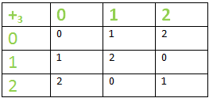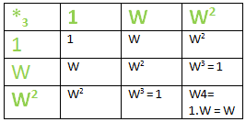

* The structure & order of both  the tables are same. The mapping ‘f’ is defined as :  
  f : G -> G’ in such a way that f(1) = 0 , f(w) = 1 & f(w2) = 2.
* Homomorphism property : f(aob) = f(a) o’ f(b) ∀ a,b ∈ G . Let us take a = w & b = 1  
  LHS : f(a \* b) = f( w \* 1 ) = f(w) = 1.  
  RHS : f(a) +3 f(b) = f(w) +3 f(1) = 1 + 0 = 1  
  =>LHS = RHS
* This mapping f is one-one & onto also, therefore, a homomorphism.

**Solved Examples**

**Example 1: Binary Operation Addition on Natural Numbers**

**Operation**: Define o as ++ on N.

**Verification**:

* Commutative: For any a,b∈N, a+b=b+a.
* Associative: For any a,b,c∈N, a+(b+c)=(a+b)+c.

**Example 2: Binary Operation Multiplication on Real Numbers**

**Operation**: Define o as × on R.

**Verification**:

* Commutative: For any a,b∈R, a×b=b×a.
* Associative: For any a,b,c∈R, a×(b×c)=(a×b)×c.

**Example 3: Binary Operation Subtraction on Integers**

**Operation**: Define o as − on Z.

**Verification**:

* Not Commutative: For any a,b∈Z, a−b≠b−a.
* Not Associative: For any a,b,c∈Z, a−(b−c)≠(a−b)−c.

**Example 4: Binary Operation on Matrix Addition**

**Operation**: Define o as matrix addition on M (set of matrices of same dimension).

**Verification**:

* Commutative: For any A,B∈M A+B=B+A.
* Associative: For any A,B,C∈M, A+(B+C)=(A+B)+C.

**Practice Problems on Homomorphism & Isomorphism of Group**

1. **Prove that the operation oo defined as addition on the set of even integers is a binary operation.**
2. **Show that multiplication is a binary operation on the set of non-zero rational numbers.**
3. **Determine if the operation defined as subtraction on the set of natural numbers is commutative.**
4. **Verify if addition is an associative operation on the set of integers.**
5. **Prove that the operation defined as multiplication on the set of complex numbers is commutative and associative.**
6. **Determine if the operation defined as division on the set of positive real numbers is a binary operation.**
7. **Show that addition is a binary operation on the set of polynomials with real coefficients.**
8. **Verify if the operation defined as exponentiation on the set of natural numbers is associative.**
9. **Prove that the operation defined as maximum (max) on the set of integers is associative.**
10. **Show that the operation defined as bitwise AND on the set of integers is commutative and associative.**

**Related Articles:**

* [*Homomorphism & Isomorphism of Group*](https://www.geeksforgeeks.org/homomorphism-isomorphism-of-group/)
* [*Group Isomorphisms and Automorphisms*](https://www.geeksforgeeks.org/group-isomorphisms-and-automorphisms/)

**Homomorphism & Isomorphism of Group – FAQs**

**What is a binary operation?**

*A binary operation on a set GG is a function o:G×G→Go:G×G→G that combines any two elements of GG to form another element of GG.*

**What are some common binary operations?**

*Common binary operations include addition, multiplication, subtraction, and division.*

**What are the laws associated with binary operations?**

*The main laws are commutativity, associativity, distributivity, left cancellation, and right cancellation.*

**Group, Rings and Fields in Group Theory**

Last Updated : 25 Oct, 2024

**Algebraic structures** are mathematical systems that consist of a set of elements and one or more operations defined on that set. These structures follow specific rules or properties, depending on the type of structure.

The most common operations used in algebraic structures include addition, multiplication, and others like composition of functions. Some of the common algebraic structures are:

* Group (Rubik's Cube Moves, Symmetry in Geometry, Musical Notes, etc.)
* Ring
* Field
* Integral Domain

**Table of Content**

* [Group Definition](https://www.geeksforgeeks.org/group-rings-and-fields-in-group-theory/#what-are-groups)
  + [Examples of Group](https://www.geeksforgeeks.org/group-rings-and-fields-in-group-theory/#examples-of-group)
* [Ring Definition](https://www.geeksforgeeks.org/group-rings-and-fields-in-group-theory/#what-are-rings)
  + [Examples of Ring](https://www.geeksforgeeks.org/group-rings-and-fields-in-group-theory/#examples-of-ring)
* [Field Definition](https://www.geeksforgeeks.org/group-rings-and-fields-in-group-theory/#what-are-fields)
  + [Examples of Fields](https://www.geeksforgeeks.org/group-rings-and-fields-in-group-theory/#examples-of-fields)
* [Difference Between Groups, Rings, and Fields](https://www.geeksforgeeks.org/group-rings-and-fields-in-group-theory/#difference-between-groups-rings-and-fields)

**Group Definition**

A **group** is a mathematical structure that consists of a set of elements together with an operation that combines any two elements to form a third element while satisfying certain conditions.

A **group** is a set G along with an operation ∗ (often referred to as "multiplication" or "addition") that satisfies the following four conditions:

* **Closure**: For any two elements a and b in the set G, the result of the operation a ∗ b must also be in G.
* **Associativity**: The operation must be associative, meaning (a ∗ b) ∗ c = a ∗ (b ∗ c) (a \* b) for all elements a, b, and c in G.
* **Identity Element**: There must be an element e in G such that for every element a in G, a ∗ e = e ∗ a = a. This is called the identity element.
* **Inverse Element**: For every element a in G, there exists an element b in G such that a ∗ b = b ∗ a = e, where e is the identity element. The element b is called the inverse of a.

**Note:** If the operation is commutative (i.e., a ∗ b=b ∗ a for all a and b in G), the group is called an **abelian group**.

**Examples of Group**

Some examples of group include:

* Integers under addition (Z, + )
* Real numbers under addition ( R, +)
* Non-zero real numbers under multiplication ( R∗, × )

**Ring Definition**

A **ring** (R, +, ⋅ ) is a set R together with two binary operations + (addition) and ⋅ (multiplication) such that:

**Additive Group**: (R, +) is an **abelian group**. This means:

* **Closure under addition**: a + b ∈ R.
* **Associativity of addition**: (a + b) + c = a + (b + c).
* **Additive identity**: There exists an element 0 ∈ R such that a + 0 = a.
* **Additive inverse**: For every a ∈ R, there exists − a ∈ R such that a + (−a) = 0.
* **Commutativity of addition**: a + b = b + a.

**Multiplication**: The multiplication operation ( ⋅ ) satisfies:

* **Closure**: For all a, b∈R, a ⋅ b∈R.
* **Associativity**: (a ⋅ b) ⋅ c=a ⋅ (b ⋅ c) for all a, b, c∈R.

**Distributive Property**: Multiplication distributes over addition:

* **Left distributivity**: a ⋅ ( b + c) = (a ⋅ b) + (a ⋅ c) for all a, b, c∈R.
* **Right distributivity**: (a + b) ⋅ c = (a ⋅ c) + (b ⋅ c) for all a, b, c∈R.

***Note:***

* *Some rings have a multiplicative identity element (denoted by 1) such that a ⋅ 1 = 1 ⋅ a = a. Such rings are called* ***rings with unity****.*
* *If the multiplication operation is commutative (i.e., a ⋅ b = b ⋅ a for all a, b ∈ R), the ring is called a* ***commutative ring****.*

**Examples of Ring**

Some examples of ring include:

* **Integers (Z, +, ⋅ ):**The set of integers Z under standard addition and multiplication is a **commutative ring** with unity (1 is the multiplicative identity).
* **Polynomials R[x]:**The set of polynomials with real coefficients forms a **commutative ring** under the usual addition and multiplication of polynomials.

**Field Definition**

A **field** (F, +, ⋅ ) is a set F together with two binary operations + (addition) and ⋅ (multiplication) such that:

**Additive Group**: (F, +) forms an **abelian group** under addition. This means:

* **Closure under addition**: a + b ∈ F.
* **Associativity of addition**: (a + b) + c = a + (b + c).
* **Additive identity**: There exists an element 0∈F such that a + 0 = a.
* **Additive inverse**: For every a ∈ F, there exists -a ∈ F such that a + (−a) = 0.
* **Commutativity of addition**: a + b = b + a.

**Multiplication Forms an Abelian Group (excluding zero)**: The set F forms an abelian group under multiplication:

* **Closure under multiplication**: a ⋅ b ∈ F.
* **Associativity of multiplication**: (a ⋅ b) ⋅ c = a ⋅ (b ⋅ c).
* **Multiplicative identity**: There exists an element 1∈F1, distinct from 0, such that a ⋅ 1=a.
* **Multiplicative inverse**: For every a∈F, there exists a−1∈F such that a ⋅ a−1=1.
* **Commutativity of multiplication**: a ⋅ b = b ⋅ a.

**Distributive Property**: Multiplication distributes over addition:

* a ⋅ (b + c) = (a ⋅ b) + (a ⋅ c).
* (a + b) ⋅ c = (a ⋅ c) + (b ⋅ c)

***Note:*** *If a ⋅ b=0, then either a=0 or b=0. (as multiplication forms abelian group excluding 0)*

**Examples of Fields**

Some examples of fields are:

* **Rational Numbers (Q):**The set of rational numbers with the usual operations of addition and multiplication forms a field.
* **Real Numbers (R):**The set of real numbers forms a field under the usual addition and multiplication.
* **Complex Numbers (C)**: The set of complex numbers forms a field under the usual operations of addition and multiplication.

**Difference Between Groups, Rings, and Fields**

Below is difference between Groups, Rings and fields in tabular form:

| **Basis** | **Group** | **Ring** | **Field** |
| --- | --- | --- | --- |
| **Operations** | One (Addition or Multiplication) | Two (Addition and Multiplication) | Two (Addition and Multiplication) |
| **Inverse for Multiplication** | Not Required | Not Required | Required for all non-zero elements |
| **Distributive Law** | Not Needed | Required (multiplication spreads over addition) | Required (just like in rings) |
| **Commutativity** | Only for some groups | Only for Addition | Both Addition and Multiplication |
| **Example** | Integers under addition | Integers with addition and multiplication | Rational numbers with addition and multiplication |

**Read More,**

* [**Group Theory**](https://www.geeksforgeeks.org/groups-discrete-mathematics/)
* [**Group in Maths: Group Theory**](https://www.geeksforgeeks.org/groups-discrete-mathematics/)
* [**Rings, Integral domains and Fields**](https://www.geeksforgeeks.org/mathematics-rings-integral-domains-and-fields/)
* [**Applications of Group Theory**](https://www.geeksforgeeks.org/applications-of-group-theory/)

**Conclusion**

In conclusion, **groups**, **rings**, and **fields** are essential concepts in algebra that help us understand how different mathematical operations work together in structured ways.

* **Groups** are the simplest, focusing on a single operation, like adding or rotating, where every action has an undo (inverse) and there's a starting point (identity).
* **Rings** add a bit more complexity by introducing two operations, like addition and multiplication, allowing us to work with more detailed structures such as polynomials or matrices.
* **Fields** take it a step further by ensuring that division is always possible, making it the most refined system, similar to how numbers like fractions or real numbers work.

**Mathematics | Rings, Integral domains and Fields**

Last Updated : 16 Feb, 2023

Prerequisite – [Mathematics | Algebraic Structure](https://www.geeksforgeeks.org/groups-discrete-mathematics/)   
  
**Ring –** Let addition (+) and Multiplication (.) be two binary operations defined on a non empty set R. Then R is said to form a ring w.r.t addition (+) and multiplication (.) if the following conditions are satisfied:

1. (R, +) is an abelian group ( i.e commutative group)
2. (R, .) is a semigroup
3. For any three elements a, b, c R the left distributive law a.(b+c) =a.b + a.c and the right distributive property (b + c).a =b.a + c.a holds.

Therefore a non- empty set R is a ring w.r.t to binary operations + and . if the following conditions are satisfied. 

1. For all a, b R, a+bR,
2. For all a, b, c R a+(b+c)=(a+b)+c,
3. There exists an element in R, denoted by 0 such that a+0=a for all a R
4. For every a R there exists an y R such that a+y=0. y is usually denoted by -a
5. a+b=b+a for all a, b R.
6. a.b R for all a, b R.
7. a.(b.c)=(a.b).c for all a, b, c R
8. For any three elements a, b, c R a.(b+c) =a.b + a.c and (b + c).a =b.a + c.a. And the ring is denoted by (R, +, .).

**Some Examples –** 

1. (, + ) is a commutative group .(, .) is a semi-group. The distributive law also holds. So, ((, +, .) is a ring.
2. **Ring of Integers modulo n:** For a n[Tex]\mathbb{N}     [/Tex]let be the classes of residues of integers modulo n. i.e ={).   
   (, +) is a commutative group ere + is addition(mod n).   
   (, .) is a semi group here . denotes multiplication (mod n).   
   Also the distributive laws hold. So ((, +, .) is a ring.
3. The set S = {0, 1, 2, 3, 4} is a ring with respect to operation addition modulo 5 & multiplication modulo 5.

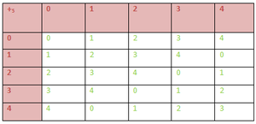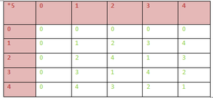

(S,+5) is an Abelian Group. From the above 1st composition table we can conclude that (S,+5) satisfies –

* Closure :  a ∈ S ,b ∈ S  => a +5 b ∈ S ;  ∀ a,b ∈ S
* Associativity : (a+5b)+5c = a+5(b+5c) ; ∀ a,b,c ∈ S.
* Existence of identity 0 : (a+5b)+5c = a+5(b+5c) ; ∀ a,b,c ∈ S.
* Existence of inverse: Inverse of 0, 1, 2, 3, 4 are 0, 4, 3, 2 , 1 respectively &
* Commutative :  (a+5b) = (b+5a) ;  ∀ a,b ∈ S

2. (S,\*5) is an Semi Group. From the above 2nd composition table we can conclude that (S,\*5) satisfies :

* Closure : a ∈ S ,b ∈ S  => a \*5 b ∈ S ;  ∀ a,b ∈ S
* Associativity :  (a\*5b)\*5c = a\*5(b\*5c) ; ∀ a,b,c ∈ S

3. Multiplication is distributive over addition :

(a) Left Distributive :   ∀ a, b, c ∈ S :

a\*5 (b +5 c)

= [ a \* (b + c) ] mod 5

= [a\*b + a\*c] mod 5

= (a \*5 b) +5 (a \*5 c)

⇒ Multiplication modulo 5 is distributive over addition modulo 5.

Similarly , Right Distributive law can also be proved.

So, we can conclude that (S,+,\*) is a Ring.

Many other examples also can be given on rings like (, +, .), (, +, .) and so on.   
  
Before discussing further on rings, we define **Divisor of Zero in A ring**and the concept of **unit**.   
  
**Divisor of Zero in A ring –**   
In a ring R a non-zero element is said to be divisor of zero if there exists a non-zero element b in R such that a.b=0 or a non-zero element c in R such that c.a=0 In the first case a is said to be a left divisor of zero and in the later case a is said to be a right divisor of zero . Obviously if R is a commutative ring then if a is a left divisor of zero then a is a right divisor of zero also .   
  
**Example –** In the ring (, +, .) are divisors of zero since   
and so on .   
On the other hand the rings (, +, .), (, +, .), (, +, .) contains no divisor of zero .   
  
**Units –**   
In a non trivial ring R( Ring that contains at least to elements) with unity an element a in R is said to be an unit if there exists an element b in R such that a.b=b.a=I, I being the unity in R. b is said to be multiplicative inverse of a.   
  
Some Important results related to Ring:

1. If R is a non-trivial ring(ring containing at least two elements ) withunity I then I 0.
2. If I be a multiplicative identity in a ring R then I is unique .
3. If a be a unit in a ring R then its multiplicative inverse is unique .
4. In a non trivial ring R the zero element has no multiplicative inverse .

**Types of Ring :**

1. **Null Ring**: The singleton set : {0} with 2 binary operations ‘+’ & ‘\*” defined by :  
   0+0 = 0 & 0\*0 = 0 is called zero/ null ring.
2. **Ring with Unity**: If there exists an element in R denoted by 1 such that :  
   1\*a = a\* 1 = a ; ∀ a ∈ R, then the ring is called Ring with Unity.
3. **Commutative Ring** : If the multiplication in the ring R is also commutative, then ring is called a commutative ring.
4. **Ring of Integers** : The set I of integers with 2 binary operations ‘+’ & ‘\*’ is known as ring of Integers.
5. **Boolean Ring** : A ring whose every element is idempotent, i.e. , a2 = a ; ∀ a ∈ R  
   Now we introduce a new concept Integral Domain.

**Integral Domain –** A non -trivial ring(ring containing at least two elements) with unity is said to be an integral domain if it is commutative and contains no divisor of zero ..   
  
**Examples –**   
The rings (, +, .), (, +, .), (, +, .) are integral domains.   
The ring (2, +, .) is a commutative ring but it neither contains unity nor divisors of zero. So it is not an integral domain.   
  
Next we will go to Field .   
  
**Field –** A non-trivial ring R with unity is a field if it is commutative and each non-zero element of R is a unit . Therefore a non-empty set F forms a field .r.t two binary operations + and . if 

1. For all a, b F, a+bF,
2. For all a, b, c F a+(b+c)=(a+b)+c,
3. There exists an element in F, denoted by 0 such that a+0=a for all a F
4. For every a R there exists an y R such that a+y=0. y is usually denoted by (-a)
5. a+b=b+a for all a, b F.
6. a.b F for all a.b F.
7. a.(b.c)=(a.b).c for all a, b F
8. There exists an element I in F, called the identity element such that a.I=a for all a in F
9. For each non-zero element a in F there exists an element, denoted by in F such that =I.
10. a.b =b.a for all a, b in F .
11. a.(b+c) =a.b + a.c for all a, b, c in F

**Examples –** The rings (, +, .), (, + . .) are familiar examples of fields.   
  
Some important results:

1. A field is an integral domain.
2. A finite integral domain is a field.
3. A non trivial finite commutative ring containing no divisor of zero is an integral domain

**Applications of Group Theory**

Last Updated : 21 Jun, 2024

Group theory is the branch of mathematics that includes the study of elements in a group. Group is the fundamental concept of algebraic structure like other algebraic structures like rings and fields.

**Group:**A non-empty set G with \* as operation, (G, \*) is called a [group](https://www.geeksforgeeks.org/groups-discrete-mathematics/) if it follows the closure, associativity, identity, and inverse properties.

**Properties of Group**

If \* is an operation and G is a group then, properties of group theory:

* **Closure:**If ‘a’ and ‘b’ are elements in group G then, a\*b also belongs to group G.
* **Associativity:** If ‘a’, ‘b’ and ‘c’ are elements in group G then, a\*(b\* c) = (a\*b) \*c
* **Identity Element:** For every element ‘a’ in the group there exists an identity element e such that e\*a = a\*e = a
* **Inverse:** For all element ‘a’ belongs to group G there exists a-1 such that a\*a-1 = a-1\*a = e

**Note:**

* A non-empty set S is called a **semi-group** if it follows closure and associativity properties.
* A non-empty set S is called a **monoid** if it follows closure, associativity, and identity element properties.
* A non-empty set S is called an **abelian group** if it is a group and follows commutative property i.e., if a and b are elements of group G then, a\*b = b\*a

**Types of Groups**

Some classes of group theory are:

* **Permutation groups:** Permutation groups are mathematical groups whose elements are permutations of a given set S whose group operation is a composition of permutations in G.
* **Matrix groups:** Matrix group is a group G of invertible matrices with matrix multiplication as the group operation over a defined field K.
* **Transformation groups:** Transformation group refers to the subgroup of an automorphism group. It is like a symmetry group in that it consists of all transformations that retain a specific structure.
* **Abstract groups:** Abstract groups are the presentation of generators and relations. The production of factor group or quotient group, G/H of a group G by normal subgroup H is an example of abstract groups.

**Applications of Group Theory**

Some applications of group theory are:

* Group theory algorithms are used to solve Rubik’s cube.
* Many laws of Physics, Chemistry use symmetry and hence, uses group theory as it is symmetric.
* Group theory may be used to investigate any object or system attribute that is invariant under change because of its symmetry.
* Group theory is also used in harmonic analysis, combinatorics, algebraic topology, algebraic number theory, algebraic geometry, and cryptography.

Other than these, there are some more applications of group theory in other branches:

**In Mathematics**

* Group theory is used to study symmetries in geometry, which has applications in crystallography and the classification of geometrical shapes.
* It is also applied in number theory, particularly in the study of modular forms and elliptic curves.

**In Physics**

* In quantum mechanics, group theory is used to classify elementary particles and describe their symmetries. For example, the theory of angular momentum in quantum mechanics can be understood using the rotation group.
* In crystallography, group theory is used to describe the symmetries of crystals, which helps in understanding their physical properties.

**In Chemistry**

* Group theory is used to analyze molecular vibrations and electronic structure in molecules. This analysis helps in predicting and interpreting spectroscopic data.
* It is also used in crystallography to study the symmetries of crystals and predict their physical and chemical properties.

**In Computer Science**

* Group theory is applied in [cryptography](https://www.geeksforgeeks.org/cryptography-and-its-types/), particularly in the design and analysis of cryptographic algorithms.
* It is also used in the study of error-correcting codes, which are essential in data transmission and storage.

**In Biology**

* Group theory has applications in the study of [DNA structure](https://www.geeksforgeeks.org/dna-structure-types-functions/) and[protein](https://www.geeksforgeeks.org/protein-definition-structure-levels-of-protein/) folding, where symmetries play a role in understanding biological processes.

**Read More,**

* [**Group Theory**](https://www.geeksforgeeks.org/group-theory/)
* [**Set Theory**](https://www.geeksforgeeks.org/set-theory/)
* [**Set Theory Symbols**](https://www.geeksforgeeks.org/set-theory-symbols/)

**Conclusion**

In conclusion, group theory plays a crucial role in various fields such as mathematics, physics, chemistry, computer science, biology, and engineering. It helps us understand symmetries in nature, classify particles, analyze molecular structures, and design cryptographic algorithms.

**FAQs on Group Theory**

**What is a group in group theory?**

*In group theory, a group is a set G equipped with a binary operation (usually denoted as \*) that satisfies four properties: closure, associativity, identity element, and invertibility.*

**What is the order of a group?**

*The order of a group is the number of elements in the group. It is denoted by |G|.*

**What is a subgroup?**

*A* [*subgroup of a group*](https://www.geeksforgeeks.org/subgroup-and-order-of-group-mathematics/) *G is a subset of G that forms a group under the same binary operation as G.*

**What is a cyclic group?**

*A* [*cyclic group*](https://www.geeksforgeeks.org/cayley-table-and-cyclic-group-mathematics/) *is a group that can be generated by a single element, called a generator. The group is denoted by ⟨a⟩, where a is the generator.*

**What is a normal subgroup?**

*A normal subgroup of a group G is a subgroup N that is invariant under conjugation by elements of G. That is, for all g in G and n in N, the element gng-1 is also in N.*

# Mathematics | Graph Theory Basics – Set 1

**Last Updated :**05 Oct, 2023

A graph is a data structure that is defined by two components :

1. A **node** or a vertex.
2. An edge E or **ordered pair is a connection between two nodes u,v** that is identified by unique pair(u,v). The pair (u,v) is ordered because (u,v) is not same as (v,u) in case of directed graph.The edge may have a weight or is set to one in case of unweighted graph.

Consider the given below graph,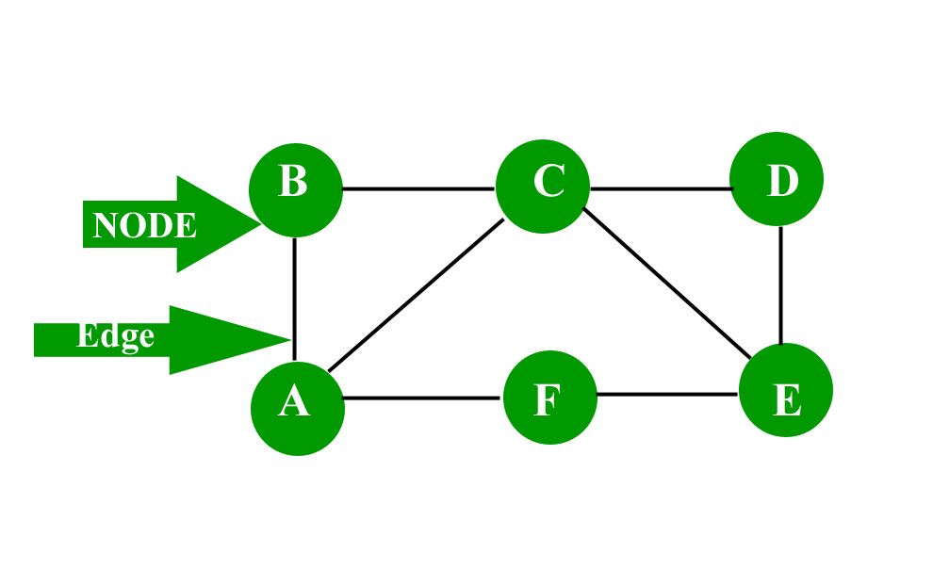To know about “Graph representation” [click here](https://www.geeksforgeeks.org/graph-and-its-representations/)

**Applications:** Graph is a data structure which is used extensively in our real-life.

1. Social Network: Each user is represented as a node and all their activities,suggestion and friend list are represented as an edge between the nodes.
2. Google Maps: Various locations are represented as vertices or nodes and the roads are represented as edges and graph theory is used to find shortest path between two nodes.
3. Recommendations on e-commerce websites: The “Recommendations for you” section on various e-commerce websites uses graph theory to recommend items of similar type to user’s choice.
4. Graph theory is also used to study molecules in chemistry and physics.

***More on graphs:*** **Characteristics of graphs:**

1. Adjacent node: A node ‘v’ is said to be adjacent node of node ‘u’ if and only if there exists an edge between ‘u’ and ‘v’.
2. Degree of a node: In an undirected graph the number of nodes incident on a node is the degree of the node. In case of directed graph ,**Indegree** of the node is the **number of arriving edges** to a node. **Outdegree** of the node is the **number of departing edges to a node.**

           Note: 1 a self-loop is counted twice

                     2 the sum of degree of all the vertices in a graph G is even.

1. 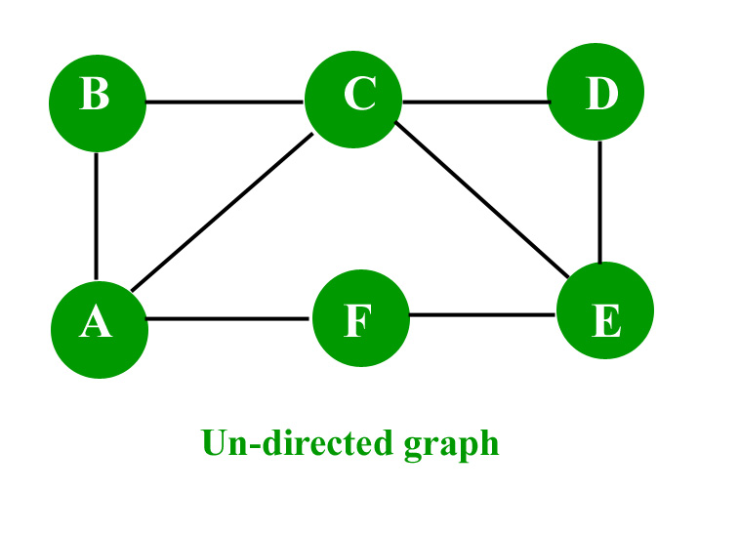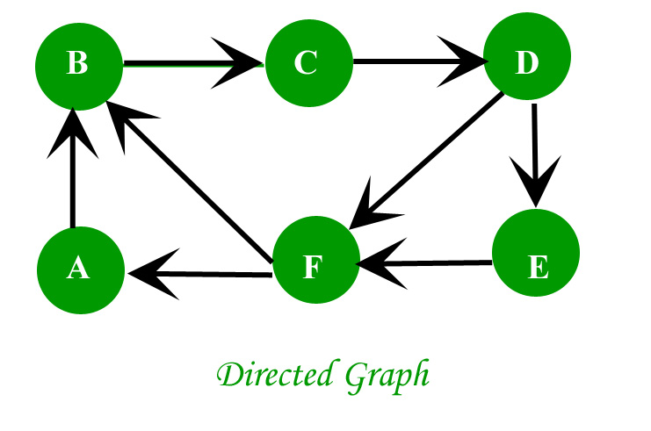
2. Path: A path of length ‘n’ from node ‘u’ to node ‘v’ is defined as **sequence of n+1 nodes.**

**P(u,v)=(v0,v1,v2,v3…….vn)**

1. A path is simple if all the nodes are distinct,**exception is source and destination are same.**
2. Isolated node: A node with degree 0 is known as isolated node.Isolated node can be found by Breadth first search(BFS). It finds its application in **LAN network** in finding whether a **system is connected or not.**

**Types of graphs:**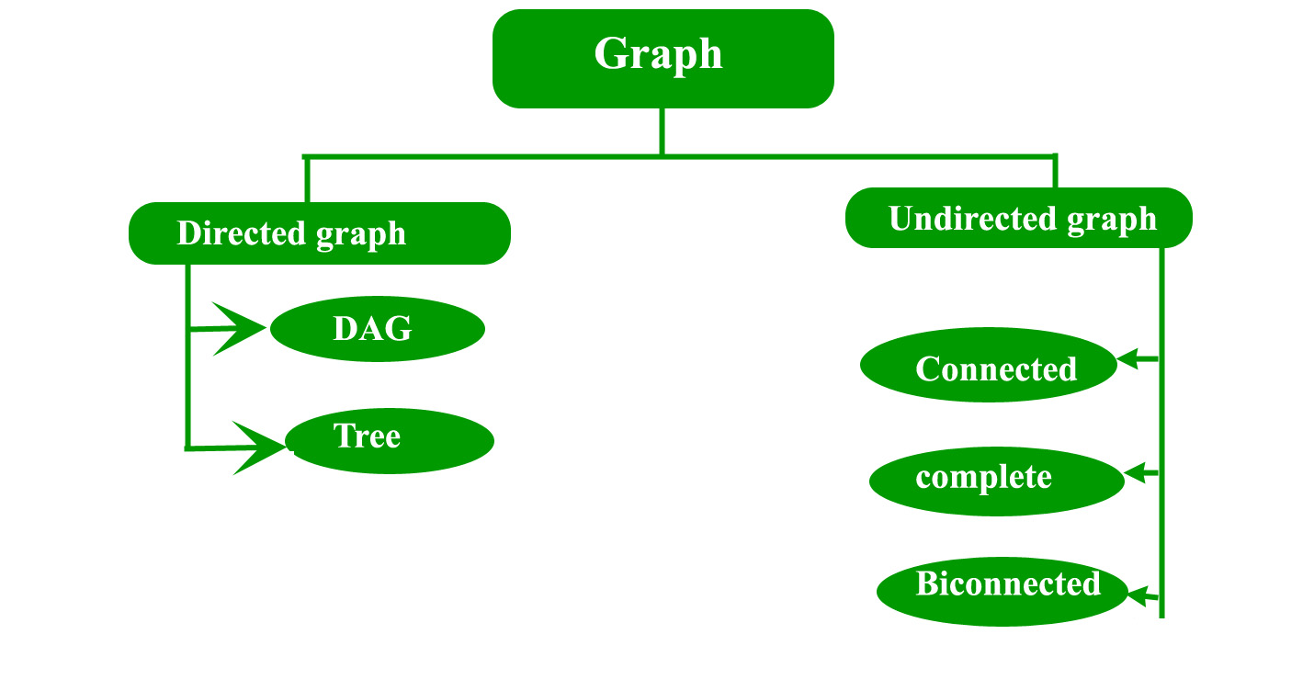

1. Directed graph: A graph in which the direction of the edge is defined to a particular node is a directed graph.
   * Directed Acyclic graph: It is a directed graph with no cycle.For a vertex ‘v’ in DAG there is no directed edge starting and ending with vertex ‘v’. a) Application :Critical game analysis,expression tree evaluation,game evaluation.
   * Tree: A tree is just a restricted form of graph.That is, it is a **DAG with a restriction that a child can have only one parent.**
2. Undirected graph: A graph in which the direction of the edge is not defined.So if an edge exists between node ‘u’ and ‘v’,then there is a path from node ‘u’ to ‘v’ and vice versa.
   * Connected graph: A graph is connected when there is a **path between every pair of vertices.**In a connected graph there is no unreachable node.
   * Complete graph: A graph in which each pair of graph vertices is connected by an edge.In other words,every node ‘u’ is adjacent to every other node ‘v’ in graph ‘G’.A complete graph would have **n(n-1)/2 edges.**See below for proof.
   * Biconnected graph: A connected graph which cannot be broken down into any further pieces by deletion of any vertex.It is a graph with **no articulation point.**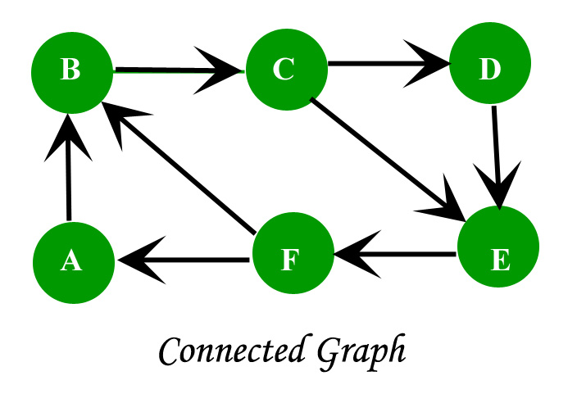

Proof for complete graph:

1. Consider a complete graph with n nodes. Each node is connected to other n-1 nodes. Thus it becomes n \* (n-1) edges. But this counts each edge twice because this is a undirected graph so divide it by 2.
2. Thus it becomes n(n-1)/2.

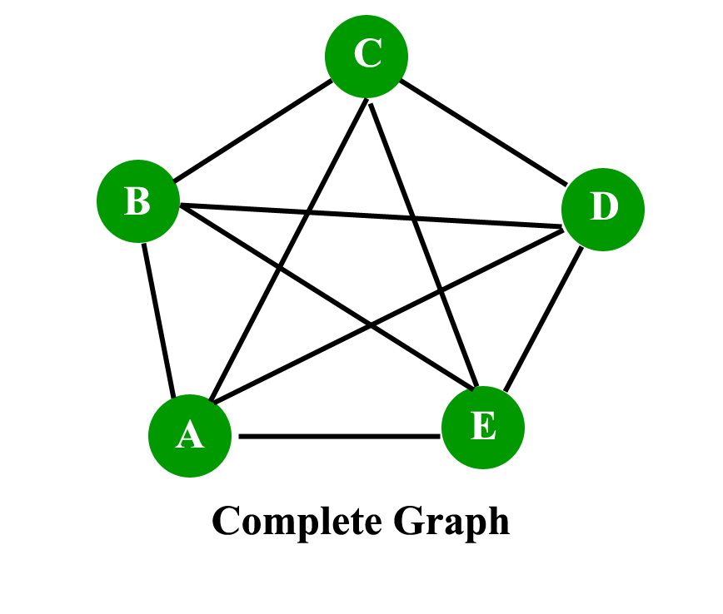Consider the given graph, //Omit the repetitive edges Edges on node A = (A,B),(A,C),(A,E),(A,C). Edges on node B = (B,C),(B,D),(B,E). Edges on node C = (C,D),(C,E). Edges on node D = (D,E). Edges on node E = EMPTY.https://en.wikipedia.org/wiki/Graph\_theory Total edges = 4+3+2+1+0=10 edges. Number of node = 5. Thus n(n-1)/2=10 edges. Thus proven. Read next set – [Graph Theory Basics](https://www.geeksforgeeks.org/mathematics-graph-theory-basics/)

**Some more graphs :**

**1. Regular graph :**A graph in which every vertex x has same/equal degree.k-regular graph means every vertex has k degree.

                              Every complete graph Kn will have (n-1)-regular graph which means degree is n-1.

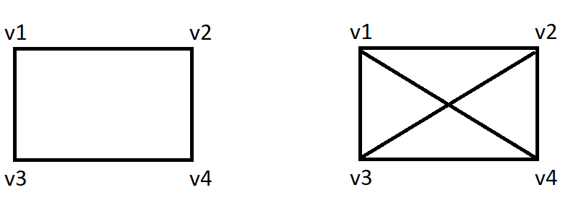

*Regular graphs*

**2. Bipartite graph :**It is graph G in which vertex set can be partitioned into two subsets U and V such that each edge of G has           one end in U and another end point in V.

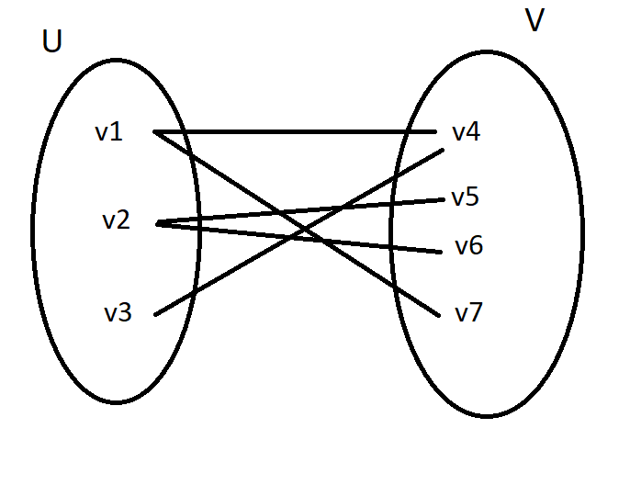

*Bipartite graph*

**3. Complete Bipartite graph :**it is a simple graph with vertex set partitioned into two subsets :                                                                                                            U={v1,v2………..vm} and W={w1,w2,………..wn}

    i. There is an edge from each vi to each wj.

    ii. there is not self loop.

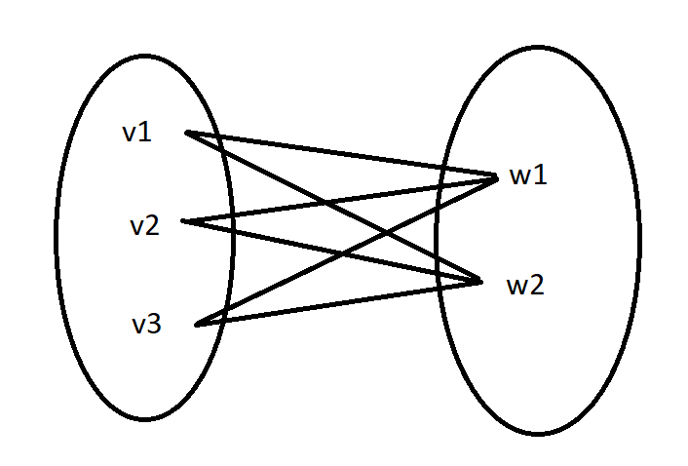

*Complete Bipartite graph*

**4. Cycle graph :**A graph of n vertices (n≥3) . v1,v2,………………..vn with edges (v1,v2),(v2,v3),………..,(vn-1,vn),(vn,v1).

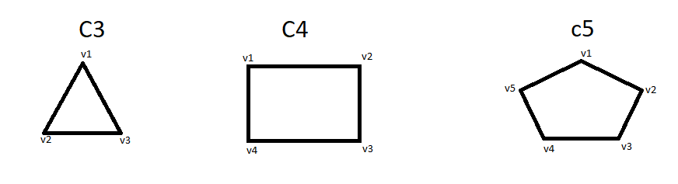

*Cycle graph*

# Mathematics | Graph Theory Basics – Set 2

**Last Updated :**27 Aug, 2024

Graph theory is a basic branch of discrete mathematics that mainly focuses on the relationship between objects. These objects are called vertices and these vertices are joined by edges. Graphs are common in computer science, network analysis, and many other everyday uses because they provide a good representation of connection, relationship, and process. Here we shall discuss graph theory, different types of graphs, terms used in the subject, and how to solve sample problems.

## Graph Theory Basics

A graph is a structure amounting to a set of objects in which some pairs of the objects are in some sense “related”. The objects of the graph correspond to **vertices** and the relations between them correspond to **edges**. A graph is depicted diagrammatically as a set of dots depicting vertices connected by lines or curves depicting edges.   
Formally,   
  
“A graph G=(V,E) *G*=(*V*,*E*) consists of V *V* , a non-empty set of **vertices** (or nodes), and E *E* , a set of **edges**. Each edge has either one or two vertices associated with it, called its **endpoints**.”

## **Types of Graph**

There are several types of graphs distinguished on the basis of edges, their direction, their weight etc.   
  
**1. Simple graph:** A graph in which each edge connects two **different** vertices and where no two edges connect the same pair of vertices is called a simple graph. For example, Consider the following graph – 

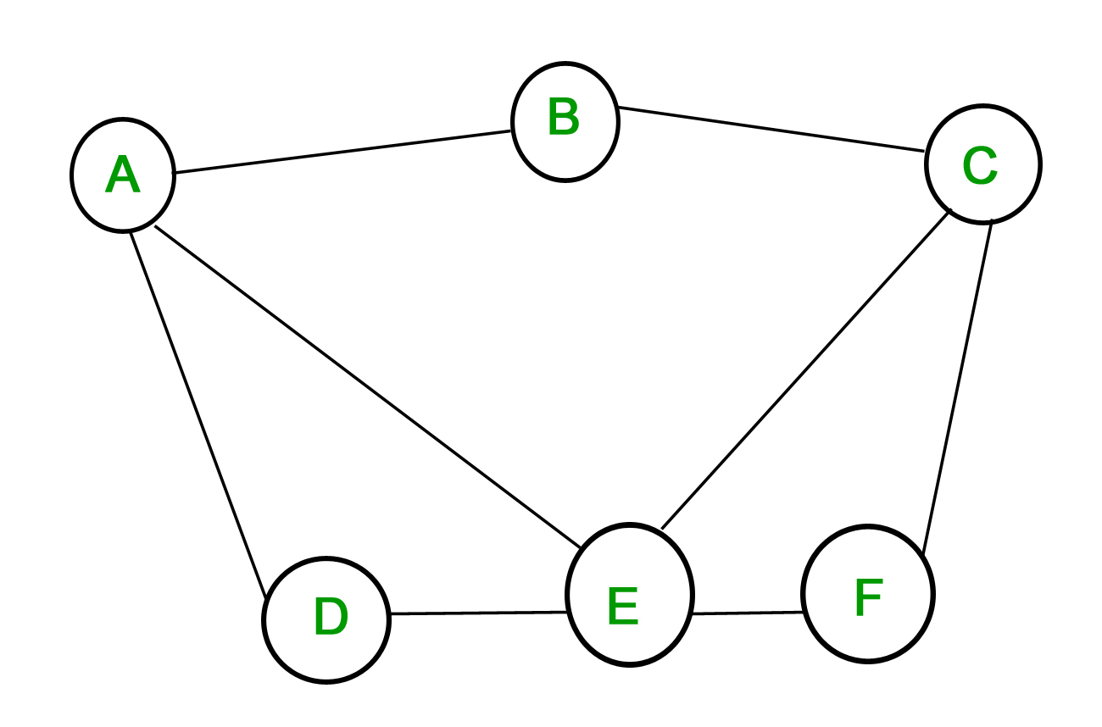

The above graph is a simple graph, since no vertex has a self-loop and no two vertices have more than one edge connecting them.   
The edges are denoted by the vertices that they connect- {A,B} {*A*,*B*} is the edge connecting vertices A *A* and B *B* .   
  
**2. Multigraph:**A graph in which multiple edges may connect the same pair of vertices is called a multigraph.   
Since there can be multiple edges between the same pair of vertices, the **multiplicity** of edge tells the number of edges between two vertices. 

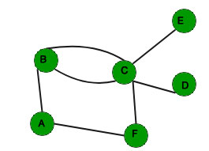

The above graph is a multigraph since there are multiple edges between B *B* and C *C* . The multiplicity of the edge {B,C} {*B*,*C*} is 2.   
  
In some graphs, unlike the one’s shown above, the edges are **directed**. This means that the relation between the objects is one-way only and not two-way. The direction of the edges may be important in some applications.   
  
Based on whether the edges are directed or not we can have **directed graphs** and **undirected graphs**. This property can be extended to simple graphs and multigraphs to get simple directed or undirected simple graphs and directed or undirected multigraphs.

## **Basic Graph Terminology**

In the above discussion some terms regarding graphs have already been explained such as vertices, edges, directed and undirected edges etc. There are more terms which describe properties of vertices and edges.

* **Adjacency**: In a graph G *G* two vertices u *u* and v *v* are said to be **adjacent** if they are the endpoints of an edge. The edge {u,v}–e {*u*,*v*}–*e* is said to be incident with the vertices.   
  In case the edge is directed, u *u* is said to be adjacent to v *v* and v *v* is said to be adjacent from u *u* . Here, u *u* is said to be the **initial vertex** and v *v* is said to the **terminal vertex**.
* **Degree:** The degree of a vertex is the number of edges incident with it, except the self-loop which contributes twice to the degree of the vertex. Degree of a vertex u *u* is denoted as deg(u) *deg*(*u*) .   
  In case of directed graphs, the degree is further classified as **in-degree** and **out-degree**. The in-degree of a vertex is the number of edges with the given vertex as the terminal vertex. The out-degree of a vertex is the number of edges with the given vertex as the initial vertex. In-degree is denoted as deg−(u) *deg*−(*u*) and out-degree is denoted as deg+(u) *deg*+(*u*) .   
  For example in the directed graph shown above depicting flights between cities, the in-degree of the vertex “Delhi” is 3 and its out-degree is also 3.

**Note:** If a vertex has zero degree, it is called **isolated**. If the degree is one then it’s called **pendant**.

* **Handshaking Theorem:**What would one get if the degrees of all the vertices of a graph are added. In case of an undirected graph, each edge contributes twice, once for its initial vertex and second for its terminal vertex. So the sum of degrees is equal to twice the number of edges. This fact is stated in the Handshaking Theorem.

Let G=(V,E)*G*=(*V*,*E*) be an undirected graph with e*e* edges. Then  
  
2e=∑u∈Vdeg(u)2*e*=∑*u*∈*V*​*deg*(*u*)  
  
In case G is a directed graph,  
  
∑u∈Vdeg−(u)=∑u∈Vdeg+(u)=∣E∣∑*u*∈*V*​*deg*−(*u*)=∑*u*∈*V*​*deg*+(*u*)=∣*E*∣

The handshaking theorem, for undirected graphs, has an interesting result – 

An undirected graph has an even number of vertices of odd degree.

**Proof :** Let V1 *V*1​ and V2 *V*2​ be the sets of vertices of even and odd degrees respectively.   
We know by the handshaking theorem that,   
2e=∑u∈Vdeg(u) 2*e*=∑*u*∈*V*​*deg*(*u*)   
So,   
2e=∑u∈Vdeg(u)=∑u∈V1deg(u)+∑u∈V2deg(u) 2*e*=∑*u*∈*V*​*deg*(*u*)=∑*u*∈*V*1​​*deg*(*u*)+∑*u*∈*V*2​​*deg*(*u*)   
The sum of degrees of vertices with even degrees is even. The LHS is also even, which means that the sum of degrees of vertices with odd degrees must be even.   
Thus, the number of vertices with odd degree is even.

## **Some Special Simple Graphs**

**1. Complete Graphs:** A simple graph of n *n* vertices having exactly one edge between each pair of vertices is called a complete graph. A complete graph of n *n* vertices is denoted by Kn *Kn*​ . Total number of edges are n\*(n-1)/2 with n vertices in complete graph. 

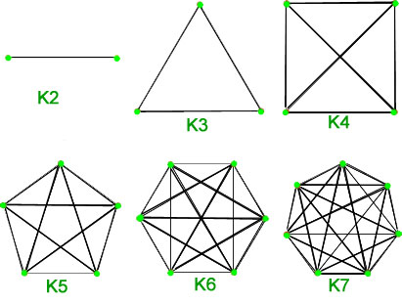

**2. Cycles:** Cycles are simple graphs with vertices n≥3 *n*≥3 and edges {1,2},{2,3}…{n−1,n}and{n,1} {1,2},{2,3}…{*n*−1,*n*}*and*{*n*,1} . Cycle with n *n* vertices is denoted as Cn *Cn*​ . Total number of edges are n with n vertices in cycle graph. 

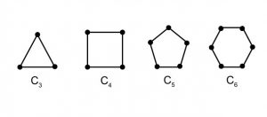

**3. Wheels:** A wheel is just like a cycle, with one additional vertex which is connected to every other vertex. Wheels of n *n* vertices with 1 addition vertex are denoted by Wn *Wn*​ . Total number of edges are 2\*(n-1) with n vertices in wheel graph. 

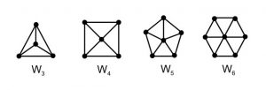

**4. Hypercube:**The Hypercube or n-cube is a graph with 2n 2*n* vertices each represented by a n-bit string. The vertices which differ by at most 1-bit are connected by edges. A hypercube of 2n 2*n* vertices is denoted by Qn *Qn*​ . Total number of edges are n\*2n−1 2*n*−1 with 2n 2*n* vertices in cube graph. 

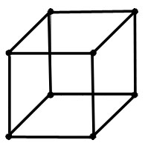

**5. Bipartite Graphs:** A simple graph G *G* is said to be bipartite if its vertex set V *V* can be divided into two disjoint sets such that every edge in G *G* has its initial vertex in the first set and the terminal vertex in the second set. Total number of edges are (n\*m) with (n+m) vertices in bipartite graph. 

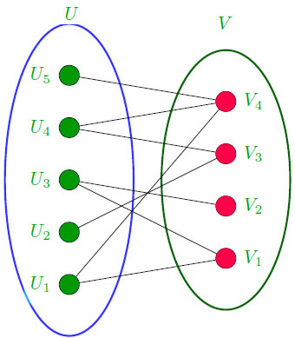

**Theorem:**A simple graph is bipartite if and only if it is possible to assign one of two   
different colors to each vertex of the graph so that no two adjacent are assigned the   
same color.   
  
A bipartite graph with m *m* and n *n* vertices in its two disjoint subsets is said to be complete if there is an edge from every vertex in the first set to every vertex in the second set, for a total of mn *mn* edges. A **complete bipartite graph** with m *m* vertices in the first set and n *n* vertices in the second set is denoted as Km,n *Km*,*n*​ . 

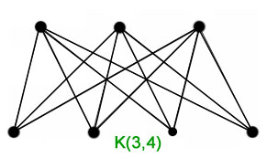

## Examples

1. **Simple Graph:** Let us take the example of graph that has vertices say {A, B, C, D} and the edges labelled as (A, B), (B, C), (C, D), and (D, A). This is connected and simple graph because there are no one pair of vertices that is connected by more than one edges or self loops.
2. **Multigraph:** For instance if there are two arrows connecting A and B and one arrow between B and C, then this diagram is a multigraph.
3. **Directed Graph:** In the case of a directed graph there could be a directed arc from A to B and another from B to C.
4. **Complete Bipartite Graph:**In one set there should be 3 vertices namely A, B and C; while in the other set there should be only two vertices, namely X and Y. Another graph is complete bipartite graph, in this graph, each vertex of {A, B, C} is connected with each vertex of {X, Y}.

## Sample Problems

#### Problem 1: Find the degree of each vertex in a simple undirected graph with vertices {A, B, C, D} and edges {(A, B), (B, C), (C, D)}.

*The Degree between nodes A & B= 1 The Degree between nodes B & C= 2 The Degree between nodes C & D= 2 The Degree between nodes D & A= 1.*

#### Problem 2: Check whether the graph with vertices {A, B, C, D} and edges {(A, B), (B, C), (C, A)} is bipartite.

*The delivered graph turns out to be a cycle of 3 vertices thus can’t be bipartite. Therefore we can concluded that it is not a bipartite graph.*

#### Problem 3: Verify the handshaking theorem for a graph with 4 vertices and 3 edges.

*Degrees of all vertex = where where outside radius + outside radius + outside radius + outside radius = 6. Applying the handshaking theorem here gives that 2e = 6, thus e = 3 Which is the same number of edges we have.*

#### Problem 4: Calculate the number of edges in a complete graph with 5 vertices.

*That of a complete graph is given by 5(5-1)/2 = 10.*

#### Problem 5: How many edges are in a wheel graph with 6 vertices (including the central vertex)?

*Edges = 2\*(n-1) = 2 \* (6-1) = 10.*

## Practice Problems

#### **Problem 1:**Find the number of edges in a complete bipartite graph K3,4.

#### Problem 2: Determine whether a graph with vertices {A, B, C, D} and edges {(A, B), (B, C), (C, D), (D, A), (A, C)} is a cycle graph.

#### Problem 3: Verify the handshaking theorem for a graph with 6 edges and 4 vertices.

#### Problem 4: How many vertices does a hypercube graph Q3 have?

#### Problem 5: Is a graph with 4 vertices and no edges bipartite?

#### Problem 6: What is the degree of each vertex in a complete graph with 4 vertices?

#### Problem 7: Can a graph with 5 vertices be a simple graph if it has 8 edges?

#### Problem 8: How many edges does a cycle graph with 8 vertices have?

#### Problem 9: Find the out-degree of a vertex in a directed graph with 3 outgoing edges.

#### Problem 10: Determine whether the graph with edges {(A, B), (B, C), (C, D), (D, A), (A, D)} is a simple graph.

## Summary

Graph theory provides a framework for modeling relationships and connections in various fields. The types of graphs and key properties such as adjacency, degrees, and the handshaking theorem are crucial in understanding the structure and behavior of graphs. By solving problems in graph theory, we gain insights into the complexity and patterns in data and networks.

# Eulerian path and circuit for undirected graph

**Last Updated :**10 Dec, 2024

Eulerian Path is a path in a graph that visits every edge exactly once. Eulerian Circuit is an Eulerian Path that starts and ends on the same vertex. 

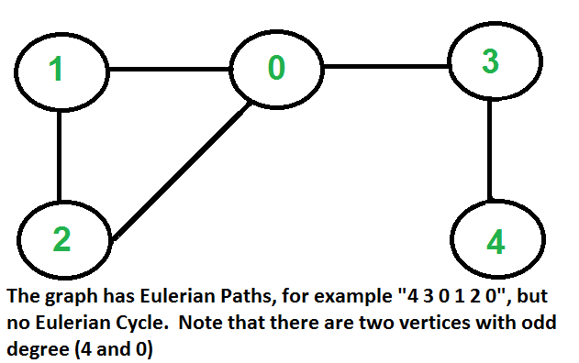

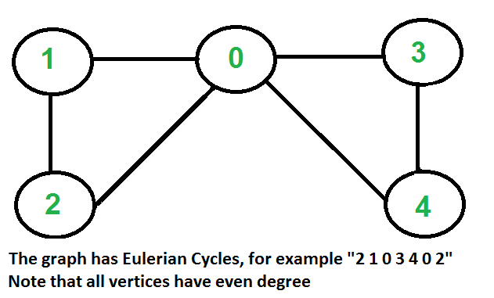

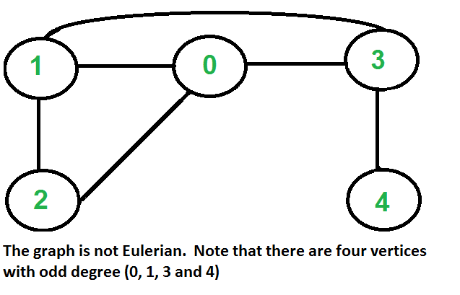

## **How to Find Whether a Given Graph is Eulerian or not?**

The problem is same as following question. “Is it possible to draw a given graph without lifting pencil from the paper and without tracing any of the edges more than once”.  
A graph is called Eulerian if it has an Eulerian Cycle and called Semi-Eulerian if it has an Eulerian Path. The problem seems similar to [Hamiltonian Path](https://www.geeksforgeeks.org/backtracking-set-7-hamiltonian-cycle/) which is NP complete problem for a general graph. Fortunately, we can find whether a given graph has a Eulerian Path or not in polynomial time. In fact, we can find it in O(V+E) time.   
Following are some interesting properties of undirected graphs with an Eulerian path and cycle. We can use these properties to find whether a graph is Eulerian or not.

### **Eulerian Cycle**

An undirected graph has Eulerian cycle if following two conditions are true.

1. All vertices with non-zero degree are connected. We don’t care about vertices with zero degree because they don’t belong to Eulerian Cycle or Path (we only consider all edges).
2. All vertices have even degree.

### **Eulerian Path**

An undirected graph has Eulerian Path if following two conditions are true.

1. Same as condition (a) for Eulerian Cycle.

#### If zero or two vertices have odd degree and all other vertices have even degree. Note that only one vertex with odd degree is not possible in an undirected graph (sum of all degrees is always even in an [**undirected graph**](https://www.geeksforgeeks.org/what-is-unidrected-graph-undirected-graph-meaning/))

Note that a graph with no edges is considered Eulerian because there are no edges to traverse.

## **How Does This Work?**

In Eulerian path, each time we visit a vertex v, we walk through two unvisited edges with one end point as v. Therefore, all middle vertices in Eulerian Path must have even degree. For Eulerian Cycle, any vertex can be middle vertex, therefore all vertices must have even degree.

**Implementation:**

**[Try it on GfG Practice](https://www.geeksforgeeks.org/problems/euler-circuit-and-path/1?itm_source=geeksforgeeks&itm_medium=article&itm_campaign=practice_card" \t "_blank)**

C++JavaPythonC#JavaScript

*# Python program to check if a given graph is Eulerian or not*

*#Complexity : O(V+E)*

**from** **collections** **import** defaultdict

*# This class represents a undirected graph using adjacency list representation*

**class** **Graph**:

**def** \_\_init\_\_(self, vertices):

self.V = vertices *# No. of vertices*

self.graph = defaultdict(list) *# default dictionary to store graph*

*# function to add an edge to graph*

**def** addEdge(self, u, v):

self.graph[u].append(v)

self.graph[v].append(u)

*# A function used by isConnected*

**def** DFSUtil(self, v, visited):

*# Mark the current node as visited*

visited[v] = **True**

*# Recur for all the vertices adjacent to this vertex*

**for** i **in** self.graph[v]:

**if** visited[i] == **False**:

self.DFSUtil(i, visited)

*'''Method to check if all non-zero degree vertices are*

*connected. It mainly does DFS traversal starting from*

*node with non-zero degree'''*

**def** isConnected(self):

*# Mark all the vertices as not visited*

visited = [**False**]\*(self.V)

*# Find a vertex with non-zero degree*

**for** i **in** range(self.V):

**if** len(self.graph[i]) != 0:

**break**

*# If there are no edges in the graph, return true*

**if** i == self.V-1:

**return** **True**

*# Start DFS traversal from a vertex with non-zero degree*

self.DFSUtil(i, visited)

*# Check if all non-zero degree vertices are visited*

**for** i **in** range(self.V):

**if** visited[i] == **False** **and** len(self.graph[i]) > 0:

**return** **False**

**return** **True**

*'''The function returns one of the following values*

*0 --> If graph is not Eulerian*

*1 --> If graph has an Euler path (Semi-Eulerian)*

*2 --> If graph has an Euler Circuit (Eulerian) '''*

**def** isEulerian(self):

*# Check if all non-zero degree vertices are connected*

**if** self.isConnected() == **False**:

**return** 0

**else**:

*# Count vertices with odd degree*

odd = 0

**for** i **in** range(self.V):

**if** len(self.graph[i]) % 2 != 0:

odd += 1

*'''If odd count is 2, then semi-eulerian.*

*If odd count is 0, then eulerian*

*If count is more than 2, then graph is not Eulerian*

*Note that odd count can never be 1 for undirected graph'''*

**if** odd == 0:

**return** 2

**elif** odd == 2:

**return** 1

**elif** odd > 2:

**return** 0

*# Function to run test cases*

**def** test(self):

res = self.isEulerian()

**if** res == 0:

print("graph is not Eulerian")

**elif** res == 1:

print("graph has a Euler path")

**else**:

print("graph has a Euler cycle")

*# Let us create and test graphs shown in above figures*

g1 = Graph(5)

g1.addEdge(1, 0)

g1.addEdge(0, 2)

g1.addEdge(2, 1)

g1.addEdge(0, 3)

g1.addEdge(3, 4)

g1.test()

g2 = Graph(5)

g2.addEdge(1, 0)

g2.addEdge(0, 2)

g2.addEdge(2, 1)

g2.addEdge(0, 3)

g2.addEdge(3, 4)

g2.addEdge(4, 0)

g2.test()

g3 = Graph(5)

g3.addEdge(1, 0)

g3.addEdge(0, 2)

g3.addEdge(2, 1)

g3.addEdge(0, 3)

g3.addEdge(3, 4)

g3.addEdge(1, 3)

g3.test()

*# Let us create a graph with 3 vertices*

*# connected in the form of cycle*

g4 = Graph(3)

g4.addEdge(0, 1)

g4.addEdge(1, 2)

g4.addEdge(2, 0)

g4.test()

*# Let us create a graph with all vertices*

*# with zero degree*

g5 = Graph(3)

g5.test()

*# This code is contributed by Neelam Yadav*

**Output**

graph has a Euler path

graph has a Euler cycle

graph is not Eulerian

graph has a Euler cycle

graph has a Euler cycle

#### **Time Complexity: O(V+E)**

#### **Space Complexity: O(V+E)**

# Walks, Trails, Paths, Cycles and Circuits in Graph

**Last Updated :**27 Feb, 2025

Walks, trails, paths, cycles, and circuits in a graph are sequences of vertices and edges with different properties. Some allow repetition of vertices and edges, while others do not. In this article, we will explore these concepts with examples.

## What is Walk?

A walk in a graph is a sequence of vertices and edges where both edges and vertices can be repeated. The length of the walk refers to the number of edges covered in the sequence. A graph can contain multiple walks.

There are two key points to note about a walk:

1. Edges can be repeated.
2. Vertices can be repeated.

Here, 1-> 2-> 3-> 4-> 2-> 1-> 3 is a walk.

Walk can be open or closed.

## Types of Walks

There are two types of walks:

1. **Open Walk**
2. **Closed Walk**

### **Open Walk:**

An open walk is a walk in which the starting and ending vertices are different. In other words, for a walk to be considered open, the origin and terminal vertices must not be the same. Additionally, the length of the walk must be greater than 0.

### **Closed Walk:**

A closed walk occurs when the starting and ending vertices are identical, meaning the walk starts and ends at the same vertex. For a walk to be classified as closed, the origin and terminal vertices must be the same. Similar to an open walk, the length of the walk must be greater than 0.

In the above diagram:   
1-> 2-> 3-> 4-> 5-> 3 is an open walk.   
1-> 2-> 3-> 4-> 5-> 3-> 1 is a closed walk.

## **What is Trail?**

*A trail is an open walk in which no edge is repeated, though vertices may be repeated.*

There are two types of trails:

1. **Open Trail**: A trail is considered an open trail if the starting and ending vertices are different.
2. **Closed Trail**: A trail is a closed trail if the starting and ending vertices are the same.

In a trail, the key point to remember is that:**Edges cannot be repeated**, but **vertices can be repeated**.

Here 1-> 3-> 8-> 6-> 3-> 2 is trail   
Also 1-> 3-> 8-> 6-> 3-> 2-> 1 will be a closed trail

## **What is Circuit?**

*A circuit can be described as a closed trail in graph theory, where no edge is repeated, but vertices can be repeated.*

Thus, the key characteristics of a circuit are:

* Edges cannot be repeated.
* Vertices can be repeated.

In other words, a circuit is a closed traversal of a graph where each edge is used exactly once, but a vertex may appear more than once.

Here 1-> 2-> 4-> 3-> 6-> 8-> 3-> 1 is a circuit.  
Circuit is a closed trail.

## **What is Path?**

*A path is a trail in which neither vertices nor edges are repeated.*

In other words, when traversing a graph along a path, each vertex and each edge is visited exactly once. Since a path is also a trail, it is inherently an open walk unless stated otherwise.

Another definition of a path is a walk with no repeated vertices. This automatically implies that no edges are repeated, making it unnecessary to explicitly mention edge repetition in the definition.

Key characteristics of a path:

* **Vertices are not repeated.**
* **Edges are not repeated.**

Here 6->8->3->1->2->4 is a Path

## **What is Cycle?**

*A cycle in graph is a closed path, meaning that it starts and ends at the same vertex while ensuring that no other vertices or edges are repeated.*

In other words, a cycle is formed by traversing a graph such that: No vertex is repeated, except for the starting and ending vertex, which must be the same and No edge is repeated.

Key characteristics of a cycle:

* Edges cannot be repeated.
* Vertices cannot be repeated, except for the first and last vertex, which must be the same.

Here 1->2->4->3->1 is a cycle.   
Cycle is a closed path.

## Table for Walk, Trail and Path

The table below represents the repetition of edges and vertices in walk, trail and path.

| **Category** | **Edges** | **Vertices** |
| --- | --- | --- |
| **Walk** | Can be repeated | Can be repeated |
| **Trail** | Cannot be repeated | Can be repeated |
| **Path** | Cannot be repeated | Cannot be repeated |

## Solved Examples on Walks, Trails, Paths, Cycles and Circuits in Graph

### 1. Find a trail from A to D for below graph

*A – B*

*| |*

*C – D*

One possible trail is: A → B → D → C → A → B → D.

### 2. Find the shortest path from A to C.

*A – B – C*

*| |*

*D – E*

The shortest path is: A → B → C.

### 3. Finding All Possible Paths

*A – B – C*

*| |*

*D – E*

Following are paths

1. A → B → C
2. A → E → C
3. A → B → E → C

## Practice Problems – Walks, Trails, Paths, Cycles and Circuits in Graph

Graph for Reference:

*A  
/ | \  
B C D  
\ | /  
E  
|  
F*

1. Find a path from A to F.
2. Find a simple path from B to F.
3. Find a trail that uses every edge exactly once.
4. Identify a cycle in the graph.
5. Find the shortest path from A to E.
6. List all possible paths from E to F.
7. Find a trail from C to F.
8. Find the longest simple path in the graph.
9. Count the number of distinct cycles in the graph.
10. Find a path from A to F that consists of exactly 3 edges.

# Shortest Path in a weighted Graph where weight of an edge is 1 or 2

**Last Updated :**20 Mar, 2023

Given a directed graph where every edge has weight as either 1 or 2, find the shortest path from a given source vertex ‘s’ to a given destination vertex ‘t’. Expected time complexity is O(V+E).

A **Simple Solution** is to use [Dijkstra’s shortest path algorithm](https://www.geeksforgeeks.org/greedy-algorithms-set-7-dijkstras-algorithm-for-adjacency-list-representation/), we can get a shortest path in O(E + VLogV) time.

**How to do it in O(V+E) time?**   
The idea is to use [BFS](https://www.geeksforgeeks.org/breadth-first-traversal-for-a-graph/). One important observation about BFS is that the path used in BFS always has the least number of edges between any two vertices. So if all edges are of same weight, we can use BFS to find the shortest path. For this problem, we can modify the graph and split all edges of weight 2 into two edges of weight 1 each. We can use BFS to find the shortest path in the modified graph.

**How many new intermediate vertices are needed?**   
We need to add a new intermediate vertex for every source vertex. The reason is simple, if we add an intermediate vertex x between u and v and if we add same vertex between y and z, then new paths u to z and y to v are added to the graph which might have not been there in the original graph. Therefore in a graph with V vertices, we need V extra vertices. Below is the C++ implementation of the above idea. In the below implementation 2\*V vertices are created in a graph and for every edge (u, v), we split it into two edges (u, u+V) and (u+V, w). This way, we ensure that a different intermediate vertex is added for every source vertex.

**Implementation:**

**[Try it on GfG Practice](https://www.geeksforgeeks.org/problems/shortest-path-in-weighted-undirected-graph/1?itm_source=geeksforgeeks&itm_medium=article&itm_campaign=practice_card" \t "_blank)**

* C++
* Java
* Python
* C#
* Javascript

|  |
| --- |
| '''  Program to shortest path from a given source vertex s to      a given destination vertex t.  Expected time complexity      is O(V+E)'''  **from** collections **import** defaultdict    #This class represents a directed graph using adjacency list representation  **class** Graph:    **def** \_\_init\_\_(self,vertices):          self.V **=** vertices #No. of vertices          self.V\_org **=** vertices          self.graph **=** defaultdict(list) # default dictionary to store graph        # function to add an edge to graph  **def** addEdge(self,u,v,w):  **if** w **==** 1:              self.graph[u].append(v)  **else**:              '''split all edges of weight 2 into two              edges of weight 1 each.  The intermediate              vertex number is maximum vertex number + 1,              that is V.'''              self.graph[u].append(self.V)              self.graph[self.V].append(v)              self.V **=** self.V **+** 1        # To print the shortest path stored in parent[]  **def** printPath(self, parent, j):          Path\_len **=** 1  **if** parent[j] **==** **-**1 **and** j < self.V\_org : #Base Case : If j is source  **print** j,  **return** 0 # when parent[-1] then path length = 0          l **=** self.printPath(parent , parent[j])            #increment path length          Path\_len **=** l **+** Path\_len            # print node only if its less than original node length.          # i.e do not print any new node that has been added later  **if** j < self.V\_org :              print j,    **return** Path\_len         '''    This function mainly does BFS and prints the          shortest path from src to dest. It is assumed          that weight of every edge is 1'''  **def** findShortestPath(self,src, dest):            # Mark all the vertices as not visited          # Initialize parent[] and visited[]          visited **=**[False]**\***(self.V)          parent **=**[**-**1]**\***(self.V)            # Create a queue for BFS          queue**=**[]            # Mark the source node as visited and enqueue it          queue.append(src)          visited[src] **=** True    **while** queue :                # Dequeue a vertex from queue              s **=** queue.pop(0)                # if s = dest then print the path and return  **if** s **==** dest:  **return** self.printPath(parent, s)                  # Get all adjacent vertices of the dequeued vertex s              # If a adjacent has not been visited, then mark it              # visited and enqueue it  **for** i **in** self.graph[s]:  **if** visited[i] **==** False:                      queue.append(i)                      visited[i] **=** True                      parent[i] **=** s      # Create a graph given in the above diagram  g **=** Graph(4)  g.addEdge(0, 1, 2)  g.addEdge(0, 2, 2)  g.addEdge(1, 2, 1)  g.addEdge(1, 3, 1)  g.addEdge(2, 0, 1)  g.addEdge(2, 3, 2)  g.addEdge(3, 3, 2)    src **=** 0; dest **=** 3  **print** ("Shortest Path between %d and %d is  " **%**(src, dest)),  l **=** g.findShortestPath(src, dest)  **print** ("\nShortest Distance between %d and %d is %d " **%**(src, dest, l)),    #This code is contributed by Neelam Yadav |

**Output**

Shortest Path between 0 and 3 is 0 1 3

Shortest Distance between 0 and 3 is 3

**Time Complexity: O(V + E)**  
In this algorithm, we do a Breadth First Traversal of the given graph.   
The time complexity of BFS is O(V + E) where V is the number of vertices and E is the number of edges in the graph.

**Space Complexity: O(V)**  
The space complexity for this algorithm is O(V), where V is the number of vertices in the graph.   
We need to store the visited array of size V and a parent array of size V.

How is this approach O(V+E)? In worst case, all edges are of weight 2 and we need to do O(E) operations to split all edges and 2V vertices, so the time complexity becomes O(E) + O(V+E) which is O(V+E).

# Euler and Hamiltonian Paths

**Last Updated :**03 Feb, 2025

**Euler and Hamiltonian** paths are fundamental concepts in graph theory, a branch of mathematics that studies the properties and applications of graphs. An Euler path visits every edge of a graph exactly once, while a Hamiltonian path visits every vertex exactly once. These paths have significant applications in various fields, including computer science, engineering, and operations research.

### Graph Example:

### **Path**:

* A path is a sequence of edges where no vertex is repeated (except for starting and ending vertices in a circuit).
* Example in a graph: a path can be: 0 → 2→ 3→ 1.

### Circuit:

* A circuit is a path that starts and ends at the same vertex, forming a loop.
* Example in the same graph: 0 → 2→ 3→ 1→0 is a circuit because it loops back to the starting vertex.

## **Euler Paths and Circuits**

* *An Euler path is a path that uses every edge of a graph* ***exactly once****.*
* *An Euler circuit is a circuit that uses every edge of a graph exactly once.*
* *An Euler path starts and ends at different vertices.*
* *An Euler circuit starts and ends at the same vertex.*

1 / 2

## Conditions for Euler Paths and Circuits

* **Euler Path**: A connected graph has an Euler path if and only if it has exactly zero or two vertices of odd degree.
* **Euler Circuit**: A connected graph has an Euler circuit if and only if every vertex has an even degree.

## Hamiltonian Paths

* ***Hamiltonian Path****: A path in a graph that visits every vertex exactly once.*

Unlike Euler paths, there is no simple necessary sufficient condition for the existence of Hamiltonian paths and cycles. However, there are several theorems and heuristics:

* **Dirac’s Theorem**: If a graph G has n vertices (with n ≥ 3) and every vertex has a degree of at least n/2 , then G has a Hamiltonian cycle.
* **Ore’s Theorem**: If a graph G has n vertices and for every pair of non-adjacent vertices u and v, the sum of their degrees is at least n, then G has a Hamiltonian cycle.

## **Hamiltonian Circuit**

*A simple circuit in a graph G that passes through every vertex exactly once is called a Hamiltonian circuit.*

Unlike Euler paths and circuits, there are no simple necessary and sufficient criteria to determine if there are any Hamiltonian paths or circuits in a graph. But there are certain criteria that rule out the existence of a Hamiltonian circuit in a graph, such as if there is a vertex of degree one in a graph then it is impossible for it to have a Hamiltonian circuit.

There are certain theorems which give sufficient but not necessary conditions for the existence of Hamiltonian graphs.

## **Hamiltonian graph** and **Eulerian graph**

*A* ***Hamiltonian graph*** *contains a Hamiltonian circuit, where each vertex is visited exactly once before returning to the starting point.   
And an* ***Eulerian graph*** *contains an Eulerian circuit, which traverses each edge exactly once before returning to the starting point.*

The image below illustrates four categories of graphs, showing whether they are Hamiltonian, Eulerian, both, or neither.

## Applications in Engineering

* **Network Design:** Hamiltonian cycles optimize routing and minimize network costs (e.g., fiber optic networks).
* **Circuit Design**: Euler paths reduce traces on circuit boards (e.g., efficient circuit layouts).
* **DNA Sequencing:** Hamiltonian paths help reconstruct DNA from overlapping fragments.
* **Robotics:** Euler paths plan routes to cover areas without retracing (e.g., robot vacuums).
* **Logistics:** Hamiltonian cycles optimize delivery routes and reduce travel costs.

## Euler and Hamiltonian Paths – Solved Examples

**1. Determine if the following graph has an Euler circuit: A graph with vertices {A, B, C, D} and edges {AB, BC, CD, DA, AC}.**  
**Solution:**

*To have an Euler circuit, all vertices must have even degree.  
Degrees: A(3), B(2), C(3), D(2)*

*Since A and C have odd degrees, this graph does not have an Euler circuit*

**2. Does the following graph have an Euler path? A graph with vertices {P, Q, R, S} and edges {PQ, QR, RS, SP, PR}.**  
**Solution:**

*For an Euler path, either all vertices have even degree, or exactly two vertices have odd degree.  
Degrees: P(3), Q(2), R(3), S(2)*

*This graph has an Euler path (but not a circuit) because it has exactly two odd-degree vertices.  
One possible path: P-S-R-Q-P-R*

**3. Determine if the following graph has a Hamiltonian cycle: A complete graph K5 with 5 vertices.**

*A complete graph Kn always has a Hamiltonian cycle for n ≥ 3.  
  
So yes, K5 has a Hamiltonian cycle.  
One possible cycle: 1-2-3-4-5-1*

**4. Does the following graph have a Hamiltonian path? A graph with vertices {A, B, C, D, E} and edges {AB, BC, CD, DE, AE, AC}.**

*this graph does have a Hamiltonian path.*

*One such path is: A-B-C-D-E*

**5. Does the complete bipartite graph K3, 3 have: a) An Euler circuit, b) A Hamiltonian cycle**

*a) No Euler circuit. All vertices have odd degree (3).  
b) Yes, it has a Hamiltonian cycle. One possible cycle: 1-a-2-b-3-c-1 (where 1,2,3 are in one partition and a,b,c are in the other)*

**6. Consider the Petersen graph. Does it have: a) An Euler circuit, b) A Hamiltonian cycle**

*a) No Euler circuit. All vertices have degree 3 (odd),   
b) No Hamiltonian cycle. The Petersen graph is a well-known example of a 3-regular graph without a Hamiltonian cycle.*

**7. Use Ore’s theorem to determine if this graph has a Hamiltonian cycle:**

*A graph with 5 vertices where the degree sum of any two non-adjacent vertices is at least 5.*

*Ore’s theorem states that if the sum of degrees of any two non-adjacent vertices is ≥ n (where n is the number of vertices), then the graph has a Hamiltonian cycle.  
Here, n = 5, and the condition is satisfied.*

*Therefore, this graph has a Hamiltonian cycle.*

**8. Apply Dirac’s theorem to determine if this graph has a Hamiltonian cycle: A graph with 8 vertices, each having degree at least 4.**

*Dirac’s theorem states that if every vertex in a graph with n vertices (n ≥ 3) has degree ≥ n22n​, then the graph has a Hamiltonian cycle.  
Here, n = 8, and n/2 = 4.*

*Since each vertex has degree at least 4, Dirac’s theorem applies.  
Therefore, this graph has a Hamiltonian cycle.*

Related article: [Difference Between Hamiltonian Path and Eulerian Path](https://www.geeksforgeeks.org/difference-between-hamiltonian-path-and-eulerian-path/)

## Practice Questions – Euler and Hamiltonian Paths

**1.**Determine if the following graph has an Euler circuit: A graph with vertices {A, B, C, D, E} and edges {AB, BC, CD, DE, EA, AC, BD}

2. Does the complete graph K6 have a Hamiltonian cycle? If so, how many distinct Hamiltonian cycles does it have?

3. For a graph G with 7 vertices, each of degree 4, determine if it has: a) An Euler path b) A Hamiltonian path.

4. Consider the Petersen graph. How many edges need to be added to create an Euler circuit?

5. Apply Ore’s theorem to determine if this graph has a Hamiltonian cycle: A graph with 6 vertices where the degree sum of any two non-adjacent vertices is at least 6.

6. Does the complete bipartite graph K4,3 have: a) An Euler path, b) A Hamiltonian cycle.

7. In a graph with 8 vertices, what’s the minimum number of edges required to guarantee the existence of a Hamiltonian cycle according to Dirac’s theorem?

8. A graph G has 10 vertices. Five vertices have degree 4, three vertices have degree 3, and two vertices have degree 5. Does G have an Euler circuit? If not, can it have an Euler path?

9. Prove or disprove: If a graph has a Hamiltonian cycle, it must also have an Euler circuit.

10. Consider a graph G with 5 vertices and 7 edges. Is it possible for G to have both an Euler circuit and a Hamiltonian cycle? Justify your answer.

# Planar Graphs and Graph Coloring

**Last Updated :**17 Jan, 2025

**Planar graphs and graph coloring** are fundamental concepts in graph theory, a branch of mathematics that studies the properties and applications of graphs. A planar graph can be drawn on a plane without any edges crossing, while graph coloring involves assigning colors to vertices such that no two adjacent vertices share the same color. These concepts have significant applications in various fields, including computer science, engineering, and geography.

## Planar Graphs

A planar graph is a graph that can be embedded in the plane such that no edges intersect except at their endpoints. In other words, it can be drawn on a flat surface without any edges crossing.

## Properties of Planar Graphs

1. **Euler’s Formula**: For a connected planar graph with VVV vertices, EEE edges, and FFF faces, Euler’s formula states: V−E+F=2V – E + F = 2V−E+F=2
2. **Kurathoski’s Theorem**: A graph is planar if and only if it does not contain a subgraph that is a subdivision of K5K\_5K5​ (the complete graph on five vertices) or K3,3K\_{3,3}K3,3​ (the complete bipartite graph on six vertices).

## Graph Coloring

### Definition

Graph coloring is the assignment of colors to vertices of a graph such that no two adjacent vertices share the same color. The minimum number of colors required to color a graph is called its chromatic number.

## Types of Graph Coloring

1. **Vertex Coloring**: Assigning colors to vertices so that no two adjacent vertices have the same color.
2. **Edge Coloring**: Assigning colors to edges so that no two edges sharing the same vertex have the same color.
3. **Face Coloring**: Assigning colors to faces of a planar graph so that no two faces sharing a boundary have the same color.

## Applications in Engineering

### 1. Frequency Assignment

Graph coloring is used in assigning frequencies to radio stations, cell towers, and other communication devices to avoid interference.

**Example:** Assigning different frequencies to cell towers so that adjacent towers do not interfere with each other.

### 2. Scheduling

Graph coloring is used to schedule tasks, exams, and other events to ensure that no two conflicting tasks occur simultaneously.

**Example:** Scheduling exams for different courses so that students do not have overlapping exams.

### 3. Map Coloring

Face coloring of planar graphs is used in coloring maps so that no two adjacent regions share the same color.

**Example:** Coloring a political map where no two neighboring countries share the same color.

### 4. Register Allocation

In computer science, graph coloring is used for register allocation in compilers to efficiently use CPU registers.

**Example:** Allocating registers to variables in a program such that no two variables that are simultaneously live share the same register.

### 5. Circuit Design

Graph coloring is used in circuit design to minimize the number of layers required for connecting components on a printed circuit board.

## Conclusion – Planar Graphs and Graph Coloring

Planar graphs and graph coloring are essential concepts in graph theory with wide-ranging applications in engineering, computer science, geography, and scheduling. Understanding the properties of planar graphs and the principles of graph coloring allows for efficient problem-solving in various domains.

## Solved Examples – Planar Graphs and Graph Coloring

### **Example 1:** Determine if the following graph is planar and find its chromatic number.

Graph: K4 (Complete graph with 4 vertices)

Solution:

K4​ is planar because it can be drawn without any edges crossing.

Chromatic number: 4 (each vertex connects to every other vertex).

### **Example 2:** Determine if K3,3​ is planar.

Solution:

K3,3​ is not planar as it cannot be drawn without edges crossing (Kuratowski’s Theorem).

### **Example 3:** Given a planar graph with 6 vertices and 9 edges, find the number of faces.

Solution: Using Euler’s formula:

V−E+F=2  ⟹  6−9+F=2  ⟹  F=5

### **Example 4:** Find the chromatic number of a cycle graph with an odd number of vertices, say 5.

Solution: For an odd cycle, the chromatic number is 3.

### **Example 5:** Find the chromatic number of a bipartite graph.

Solution: A bipartite graph is 2-colorable.

### **Example 6:** Determine if the Petersen graph is planar.

Solution: The Petersen graph is not planar.

### **Example 7:** Find the chromatic number of the following planar graph: C5∪C3.

Solution: Each cycle has a chromatic number of 3, so the combined graph has a chromatic number of 3.

### **Example 8:** Verify Euler’s formula for a graph with 8 vertices, 12 edges, and 6 faces.

Solution:

8−12+6=2(Holds true)

### **Example 9:** Determine if the following graph is planar and find its chromatic number. Graph: K2,3

Solution:

K2,3 is planar.

Chromatic number: 2 (bipartite graph).

## Practice Problems – Planar Graphs and Graph Coloring

* Determine if K4,​ is planar and find its chromatic number.
* Given a planar graph with 10 vertices and 15 edges, find the number of faces.
* Find the chromatic number of a star graph Sn with n leaves.
* Prove that a tree is 2-colorable.
* Given a planar graph with 12 vertices, 18 edges, determine if Euler’s formula holds.
* Find the chromatic number of a wheel graph Wn​ with n spokes.
* Determine if the dodecahedron graph is planar.
* Given a graph G with vertices V and E edges, if G is planar and E=3V−6, find the number of faces.
* Find the chromatic number of a complete bipartite graph Km,n.
* Determine if the following graph is planar and find its chromatic number: Graph: C4∪K2

# Check whether a given graph is Bipartite or not

**Last Updated :**26 Sep, 2024

Given an adjacency list representing a graph with **V** vertices indexed from **0**, the task is to determine whether the graph is**bipartite**or not.

**Example:**

***Input:***

***Output:*** *true****Explanation:*** *The given graph can be colored in two colors so, it is a bipartite graph.*

***Input:***

***Output:*** *false****Explanation:*** *The given graph cannot be colored in two colors such that color of adjacent vertices differs.*

**[Try it on GfG Practice](https://www.geeksforgeeks.org/problems/bipartite-graph/1?itm_source=geeksforgeeks&itm_medium=article&itm_campaign=practice_card" \t "_blank)**

**Table of Content**

* [Using Breadth-First Search (BFS)](https://www.geeksforgeeks.org/bipartite-graph/#using-breadthfirst-search-bfs)
* [Using Depth-First Search (DFS)](https://www.geeksforgeeks.org/bipartite-graph/#using-depthfirst-search-dfs)

### **Using Breadth-First Search (BFS)**

*Checking if a graph is bipartite is like trying to color the graph using only two colors, so that no two adjacent vertices have the same color. One approach is to check whether the graph is 2-colorable or not using* [*backtracking algorithm m coloring problem*](https://www.geeksforgeeks.org/m-coloring-problem/)*.*

*A common and efficient way to solve this is by using* ***Breadth-First Search (BFS)****. The idea is to traverse the graph level by level and assign colors alternately to the vertices as we proceed.*

Step-by-step approach:

* Start BFS from any uncolored vertex and assign it color **0**.
* For each vertex, color its uncolored neighbors with the opposite color (**1** if current is **0**, and vice versa)
  + Check if a neighbor already has the same color as the current vertex, return **false** (graph is not bipartite).
* If BFS completes without any conflicts, return **true** (graph is bipartite).

Below is the implementation of the above approach:

C++CJavaPythonC#JavaScript

**from** **collections** **import** deque

*# Function to check if the graph is Bipartite using BFS*

**def** isBipartite(V, adj):

*# Initialize all as -1 (uncolored)*

color = [-1] \* V

**for** i **in** range(V):

*# If the vertex is uncolored, start BFS from it*

**if** color[i] == -1:

*# Assign first color (0)*

color[i] = 0

q = deque([i])

**while** q:

u = q.popleft()

*# Traverse all adjacent vertices*

**for** v **in** adj[u]:

*# If the adjacent vertex is uncolored,*

*# assign alternate color*

**if** color[v] == -1:

color[v] = 1 - color[u]

q.append(v)

*# If the adjacent vertex has the same color,*

*# graph is not bipartite*

**elif** color[v] == color[u]:

**return** **False**

*# If no conflicts in coloring, graph is bipartite*

**return** **True**

**if** \_\_name\_\_ == "\_\_main\_\_":

*# Graph Structure:*

*# 0 - 1*

*# | |*

*# 3 - 2*

V = 4

adj = [[] **for** \_ **in** range(V)]

*# Adding edges (undirected)*

adj[0].append(1)

adj[1].append(0)

adj[1].append(2)

adj[2].append(1)

adj[2].append(3)

adj[3].append(2)

adj[3].append(0)

adj[0].append(3)

**if** isBipartite(V, adj):

print("true")

**else**:

print("false")

**Output**

true

**Time Complexity:**O(V + E), where V is the number of vertices and E is the number of edges. This is because BFS explores each vertex and edge exactly once.  
**Auxiliary Space:** O(V), The queue used in BFS, which can hold up to V vertices and The color array (or map), which stores the color for each vertex

### **Using Depth-First Search (DFS)**

We can also check if a graph is bipartite using **Depth-First Search (DFS)**. We need to color the graph with two colors such that no two adjacent vertices share the same color. We start from any uncolored vertex, assigning it a color (e.g., color 0). As we explore each vertex, we recursively color its uncolored neighbors with the another color. If we ever find a neighbor that shares the same color as the current vertex, we can simply conclude that the graph is not bipartite. If there is no conflict found after the traversal then the given graph is bipartite.

**Tree** is a discrete structure that represents hierarchical relationships between individual elements or nodes. A tree in which a parent has no more than two children is called a binary tree.

## **Tree and its Properties**

**Definition** − A Tree is a connected acyclic undirected graph. There is a unique path between every pair of vertices in GG. A tree with N number of vertices contains (N−1)(N−1) number of edges. The vertex which is of 0 degree is called root of the tree. The vertex which is of 1 degree is called leaf node of the tree and the degree of an internal node is at least 2.

**Example** − The following is an example of a tree −

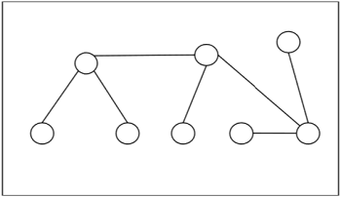

## **Centers and Bi-Centers of a Tree**

The center of a tree is a vertex with minimal eccentricity. The eccentricity of a vertex XX in a tree GG is the maximum distance between the vertex XX and any other vertex of the tree. The maximum eccentricity is the tree diameter. If a tree has only one center, it is called Central Tree and if a tree has only more than one centers, it is called Bi-central Tree. Every tree is either central or bi-central.

### **Algorithm to find centers and bi-centers of a tree**

**Step 1** − Remove all the vertices of degree 1 from the given tree and also remove their incident edges.

**Step 2** − Repeat step 1 until either a single vertex or two vertices joined by an edge is left. If a single vertex is left then it is the center of the tree and if two vertices joined by an edge is left then it is the bi-center of the tree.

**Problem 1**

Find out the center/bi-center of the following tree −

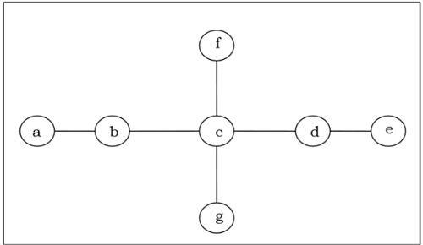

**Solution**

At first, we will remove all vertices of degree 1 and also remove their incident edges and get the following tree −

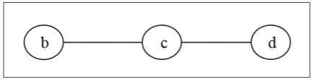

Again, we will remove all vertices of degree 1 and also remove their incident edges and get the following tree −

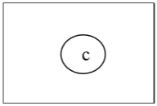

Finally we got a single vertex ‘c’ and we stop the algorithm. As there is single vertex, this tree has one center ‘c’ and the tree is a central tree.

**Problem 2**

Find out the center/bi-center of the following tree −

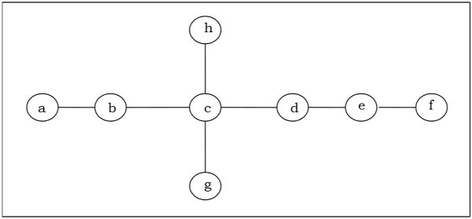

**Solution**

At first, we will remove all vertices of degree 1 and also remove their incident edges and get the following tree −

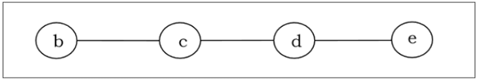

Again, we will remove all vertices of degree 1 and also remove their incident edges and get the following tree −

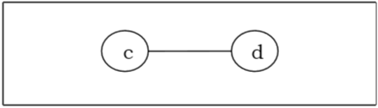

Finally, we got two vertices ‘c’ and ‘d’ left, hence we stop the algorithm. As two vertices joined by an edge is left, this tree has bi-center ‘cd’ and the tree is bi-central.

Trees are special types of graphs. Unlike other types of graphs, trees have some unique properties. A tree is a connected graph with no cycles. It is a simple yet powerful structure that finds its applications across many fields such as data organization, algorithms, network design, and biology.

In this chapter, we will cover some key properties of trees and understand their definitions and propositions with the help of examples.

## **Trees in Graph Theory**

Trees are a special form of graph in which all vertices are connected, but there are no cycles. It means, any path from one vertex to another will be unique and will not loop back to any previous point. For **n** number of vertices, it must have **n – 1** number of edges to form a connected graph as a tree.

Formally, a tree is defined as a connected acyclic graph. If the tree is not connected, it is referred to as a forest. Forest is nothing but a group of unconnected acyclic graphs.

Trees provide a clear path between vertices, and make them helpful in cases where a hierarchical structure is required, such as decision-making processes or family trees.

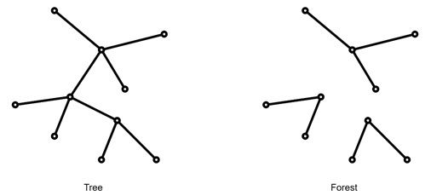

## **Basic Properties of Trees**

Let us see some of the basic properties of trees that make them special and useful in various applications. Here, we will highlight the properties related to connectivity, uniqueness of paths, and the relationship between vertices and edges.

### **Connectivity and Acyclic Nature**

As we know, by definition, a tree is connected, it means there is a path between any pair of vertices. At the same time, it is acyclic, so it contains no loops or cycles. This combination of properties ensures that if there is a path between two vertices, that path will be unique.

#### **Example**

Imagine we have a family tree where each person has a unique connection to their ancestors and descendants. If we create paths to represent family relations, no loops will form, and only one direct connection from a child to a parent without any chance of repeating the connection.

Since a tree with n vertices will be connected, then there it can be proved that if we have **n-2** vertices all nodes will not be connected. And, if we have **n** edges, there will be an edge which is parallel or forming a cycle. So, a tree must have **n - 1** edges.

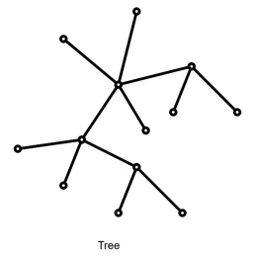

Here, we have 13 nodes and 12 edges.

[Explore our](https://www.tutorialspoint.com/latest/courses?utm_source=tutorialspoint&utm_medium=tutorials_3p&utm_campaign=internal" \t "_blank)**[latest online courses](https://www.tutorialspoint.com/latest/courses?utm_source=tutorialspoint&utm_medium=tutorials_3p&utm_campaign=internal" \t "_blank)**[and learn new skills at your own pace. Enroll and become a certified expert to boost your career.](https://www.tutorialspoint.com/latest/courses?utm_source=tutorialspoint&utm_medium=tutorials_3p&utm_campaign=internal" \t "_blank)

## **Key Propositions about Trees**

Propositions in graph theory gives the mathematical explanations for why certain properties hold. Let us see some crucial propositions that help define trees and illustrate why they behave differently from other graphs.

### **Unique Path Proposition**

The unique path property is special in distinguishing trees from other graphs. Let us see the technique to prove this −

#### **Proof Outline**

To prove that a tree has a unique path between any two vertices, we assume that there is more than one path between two points. And this assumption makes it to a contradiction because it would imply the presence of a cycle. This is against the definition of a tree. So, we confirm the uniqueness of the path in a tree.

### **Leaves in Trees**

Leaves in a tree are vertices that have only one edge connecting them to another vertex. This means their degree is one. Trees with multiple vertices always have at least two leaves.

#### **Proposition**

Any tree with at least two vertices has at least two vertices of degree one (leaves). This characteristic is special and used in various algorithms to simplify tree structures. By reducing a tree to smaller sub-trees that maintain the tree's properties.

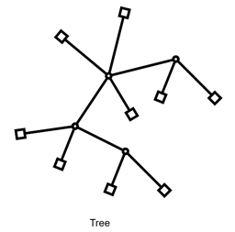

Here, the boxes are leaves and round nodes are non-leaves. All boxes are of degree 1.

#### **Example**

Consider a tree representing a simple binary hierarchy in an organization. If the CEO is at the top, the entry-level employees are at the leaves, each reporting to only one manager or department head. So this ensures that each leaf, or endpoint, has a degree of one.

## **Relationship between Vertices and Edges**

We have already talked about for v number of vertices we have v – 1 number of edges. Let prove this with induction −

### **Proof by Induction**

Consider from a tree with one vertex (no edges) and building up by adding vertices and edges while maintaining the structure of a tree.

* **Base Case** − A tree with a single vertex has zero edges.
* **Inductive Step** − For a tree with k vertices, adding another vertex and connecting it with an edge preserves the tree structure, which will make k + 1 vertices and k edges.

This property shows for v – 1 edges for v vertices is needed for graph validation. This is especially in spanning trees and minimum spanning trees.

## **Applications of Trees in Spanning Graphs**

Trees are useful in creating subgraphs called spanning trees. A spanning tree is a subset of a connected graph that gives all vertices but has only enough edges to form a tree. Spanning trees are used in various algorithms like network design and optimization.

### **Example of Spanning Tree**

Consider we need to make an electrical wires in a building. We want to connect all rooms (vertices) with the least amount of wiring (edges) without any redundant loops. A spanning tree provides a solution, and connecting all vertices while minimizing the number of edges.

## **Finding a Spanning Tree**

There are multiple ways to find a spanning tree within a graph. For example −

### **Cycle Removal**

Start with the graph and remove edges until no cycles remain. It will then be a graph with connected nodes and no cycles.

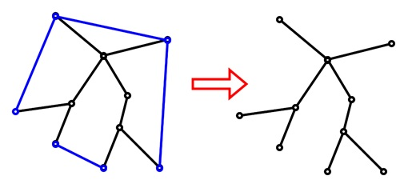

See we are removing the blue edges from the graph to form a spanning tree.

### **Edge Addition**

Start with an empty graph, adding edges until all vertices are connected without forming cycles.

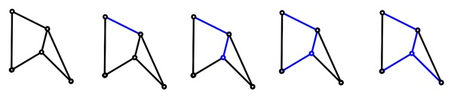

From the graph we are adding edges (in blue) and it is forming a spanning tree.

## **Real-World Analogies of Trees**

To better understand trees, let us see some real-world examples and analogies −

* **Family Trees** − Family trees are practical examples, where each node represents a family member, and edges represent relationships. The structure gives no cycles since no individual can be their own ancestor or descendant.
* **Organizational Hierarchies** − Many companies use a hierarchical, tree-like structure where each department or employee reports to a single manager. This layout avoids cycles, ensuring clear, direct paths of accountability and reporting.

## **Conclusion**

Trees are defined as connected, acyclic graphs that has distinct properties like the unique path property and a specific relationship between vertices and edges.

In this chapter, we explained the basic properties and the unique characteristics of trees in discrete mathematics. We have also understood the importance of leaves in trees, their application in spanning graphs, and real-world applications.

Trees are special structures in graph theory and discrete mathematics. Trees are used for representing hierarchies and connections without cycles. The rooted and unrooted trees gives us two different ways to structure and interpret such data.

In this chapter, we will see rooted and unrooted trees. Their characteristics, examples, and applications. We will see the key differences and use examples to highlight each type’s properties for a better understanding.

## **Trees in Graph Theory**

In graph theory, a tree is a type of connected graph that has no cycles. Each node in the tree represents an entity, and each edge represents a connection between entities.

Trees can be structured in various ways. We can categorize them as either rooted or unrooted depending on their structure and use.

* **Unrooted Trees** − These are trees with no designated root or starting point. All vertices in unrooted trees are equally important without any hierarchy.
* **Rooted Trees** − In contrast, a rooted tree designates one vertex as the “root”. This vertex serves as a reference point for organizing all other vertices hierarchically.

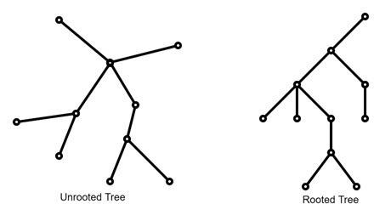

## **Unrooted Trees**

Unrooted trees are such structures with no clear hierarchy or direction. This type of tree is common in data representations and does not require a central or “starting” point.

### **Properties of Unrooted Trees**

Let us see some of the properties of unrooted trees. There is node without any specific node serving as a reference. In unrooted trees, each edge represents a connection with no particular order.

#### **Example**

Consider a network of cities connected by roads where the only requirement is to connect all cities without any cycles (circular routes). In this case, an unrooted tree could be used to represent the network. Here, each city is connected to at least one other. This ensuring a unique path exists between each pair without loops.

[Explore our](https://www.tutorialspoint.com/latest/courses?utm_source=tutorialspoint&utm_medium=tutorials_3p&utm_campaign=internal" \t "_blank)**[latest online courses](https://www.tutorialspoint.com/latest/courses?utm_source=tutorialspoint&utm_medium=tutorials_3p&utm_campaign=internal" \t "_blank)**[and learn new skills at your own pace. Enroll and become a certified expert to boost your career.](https://www.tutorialspoint.com/latest/courses?utm_source=tutorialspoint&utm_medium=tutorials_3p&utm_campaign=internal" \t "_blank)

## **Applications of Unrooted Trees**

The unrooted trees are used in scenarios where the structure does not need a hierarchical organization, like −

* **Phylogenetic Trees** − In biology, unrooted phylogenetic trees represent evolutionary relationships between species without assuming a common ancestor.
* **Network Design** − Designing computer networks where devices connect without a central hub is another example. In this setup, unrooted trees ensure redundancy and connectivity without a hierarchical structure.

## **Rooted Trees**

We have another type of trees. The rooted trees. It has a clear hierarchy by selecting one vertex as the root. This root acts as an anchor, giving a structured way to organize the vertices.

### **Structure of Rooted Trees**

In a rooted tree, the relationships are organized based on proximity to the root. Each node can have child nodes, and each node except the root has exactly one parent. So there is a parent-child relationship. Like a family tree or an organizational chart.

* **Parent-Child Relationship** − In a rooted tree, if two vertices are connected by an edge, one is designated as the parent and the other as the child. The child node is "downward" from the parent.
* **Siblings** − Vertices that share the same parent are siblings.
* **Ancestors and Descendants** − In this tree structure, nodes can have ancestors (nodes closer to the root) and descendants (nodes further from the root).

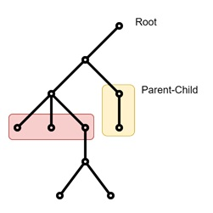

#### **Example**

Consider a corporate hierarchy where the CEO is at the top. And each department head reports to the CEO, and each department head has employees reporting to them. So the CEO serves as the root. There are department heads as children, and employees under each department head as grandchildren of the root.

## **Properties of Levels and Depths**

Vertices are grouped into levels based on their distance from the root, with the root being at level 0. Each level represents a step down in hierarchy, and the number of levels can determine the tree’s depth.

### **Example**

Consider a binary tree with three levels. The root is at level 0, its children are at level 1, and so on. This structure is there to give the vertices are systematically organized. They are making it easy to trace paths up or down the hierarchy.

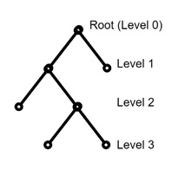

## **Algorithms and Traversal in Rooted Trees**

One of the primary reasons the rooted trees are useful is their ease of traversal. Traversal means visiting each vertex in a specific order.

* **Breadth-First Search (BFS)** − The basic traversal is BFS. It starts at the root and visits all vertices level by level. This is like reading a book chapter by chapter, where each chapter (or level) is read fully before moving to the next.
* **Depth-First Search (DFS)** − Another one is It goes as far down one path as possible before backtracking. This method is like exploring a family tree by tracing one lineage from great-grandparents down to current generations before looking at other branches.

## **Difference between Rooted and Unrooted Trees**

Rooted and unrooted trees have several differences because of their structures. Let us see them in the following table −

|  |  |  |
| --- | --- | --- |
| **Feature** | **Rooted Tree** | **Unrooted Tree** |
| Root Node | Has a designated root node | No root node |
| Hierarchy | Hierarchical structure | Non-hierarchical |
| Traversals | BFS, DFS (based on the root) | No specific traversal order |
| Applications | File systems, corporate structures | Phylogenetic trees, non-hierarchical networks |

## **Real-World Applications of Rooted and Unrooted Trees**

Rooted and unrooted trees have many such applications in computer science, biology, and network theory.

* **Rooted Trees in Web Design** − In web design, rooted trees organize web pages by hierarchy. For example, a website might start with the homepage as the root, with main sections branching off, and each section containing more specific subpages.
* **Unrooted Trees in Biology** − Unrooted trees often represent relationships in biology, such as between species that share similar characteristics but do not necessarily have a single common ancestor. This helps biologists understand similarities without assuming a direct lineage.

## **Rooted and Unrooted Trees in Data Organization**

When organizing data, rooted and unrooted trees each have distinct advantages −

* **Rooted Trees for Data Hierarchies** − When data requires a clear organization from top to bottom, such as in XML files. The root provides a starting point. This is making it easy to navigate through structured layers.
* **Unrooted Trees for Relational Data** − If the data does not require hierarchy, the unrooted trees offer flexibility by showing relationships without emphasizing a central point.

For example, a computer file system uses rooted trees to allow users to follow a single path from the main directory to each file. On the other hand, a social network might use an unrooted tree to make mutual friendships without implying a hierarchy.

## **Conclusion**

In this chapter, we explained the features of rooted and unrooted trees, based on their structures and applications. Rooted trees provide a hierarchical model that is ideal for situations where organization and levels matter.

We also understood how unrooted trees are effective in scenarios without a central point, like phylogenetic trees. In addition, we touched upon some basic traversal techniques in rooted trees such as BFS and DFS.

# Evaluation of Prefix Expressions

**Last Updated :**26 Jul, 2024

Prefix and Postfix expressions can be evaluated faster than an infix expression. This is because we don’t need to process any brackets or follow operator precedence rule. In postfix and prefix expressions which ever operator comes before will be evaluated first, irrespective of its priority. Also, there are no brackets in these expressions. As long as we can guarantee that a valid prefix or postfix expression is used, it can be evaluated with correctness.

We can convert [infix to postfix](https://www.geeksforgeeks.org/stack-set-2-infix-to-postfix/) and can convert [infix to prefix.](https://www.geeksforgeeks.org/convert-infix-prefix-notation/)  
In this article, we will discuss how to evaluate an expression written in prefix notation. The method is similar to evaluating a postfix expression. Please read [Evaluation of Postfix Expression](https://www.geeksforgeeks.org/stack-set-4-evaluation-postfix-expression/) to know how to evaluate postfix expressions

**Algorithm:**

EVALUATE\_PREFIX(STRING)  
Step 1: Put a pointer P at the end of the string  
Step 2: If character at P is an operand push it to Stack  
Step 3: If the character at P is an operator pop two   
 elements from the Stack. Operate on these elements  
 according to the operator, and push the result   
 back to the Stack  
Step 4: Decrement P by 1 and go to Step 2 as long as there  
 are characters left to be scanned in the expression.  
Step 5: The Result is stored at the top of the Stack,   
 return it  
Step 6: End

Example to demonstrate working of the algorithm

Expression: +9\*26  
  
Character | Stack | Explanation  
Scanned | (Front to |  
 | Back) |   
-------------------------------------------  
6 6 6 is an operand,   
 push to Stack  
2 6 2 2 is an operand,   
 push to Stack  
\* 12 (6\*2) \* is an operator,   
 pop 6 and 2, multiply   
 them and push result   
 to Stack   
9 12 9 9 is an operand, push   
 to Stack  
+ 21 (12+9) + is an operator, pop  
 12 and 9 add them and  
 push result to Stack  
  
Result: 21

**Examples:**

Input : -+8/632  
Output : 8  
  
Input : -+7\*45+20  
Output : 25

**Complexity** The algorithm has linear complexity since we scan the expression once and perform at most O(N) push and pop operations which take constant time.  
Implementation of the algorithm is given below.

**Implementation:**

C++JavaPythonC#JavaScript

*"""*

*Python3 program to evaluate a prefix expression.*

*"""*

**def** is\_operand(c):

*"""*

*Return True if the given char c is an operand, e.g. it is a number*

*"""*

**return** c.isdigit()

**def** evaluate(expression):

*"""*

*Evaluate a given expression in prefix notation.*

*Asserts that the given expression is valid.*

*"""*

stack = []

*# iterate over the string in reverse order*

**for** c **in** expression[::-1]:

*# push operand to stack*

**if** is\_operand(c):

stack.append(int(c))

**else**:

*# pop values from stack can calculate the result*

*# push the result onto the stack again*

o1 = stack.pop()

o2 = stack.pop()

**if** c == '+':

stack.append(o1 + o2)

**elif** c == '-':

stack.append(o1 - o2)

**elif** c == '\*':

stack.append(o1 \* o2)

**elif** c == '/':

stack.append(o1 / o2)

**return** stack.pop()

*# Driver code*

**if** \_\_name\_\_ == "\_\_main\_\_":

test\_expression = "+9\*26"

print(evaluate(test\_expression))

*# This code is contributed by Leon Morten Richter (GitHub: M0r13n)*

**Output**

21

**Time Complexity:**O(N)  
**Auxiliary Space:**O(N)

**Note:**   
To perform more types of operations only the switch case table needs to be modified. This implementation works only for single digit operands. Multi-digit operands can be implemented if some character-like space is used to separate the operands and operators.

Below given is the extended program which allows operands to have multiple digits.

C++JavaPythonC#JavaScript

*# Python3 program to evaluate a prefix expression.*

**def** isdigit(ch):

**if**(ord(ch) >= 48 **and** ord(ch) <= 57):

**return** **True**

**return** **False**

**def** evaluatePrefix(exprsn):

Stack = []

**for** j **in** range(len(exprsn) - 1, -1, -1):

*# if jth character is the delimiter ( which is*

*# space in this case) then skip it*

**if** (exprsn[j] == ' '):

**continue**

*# Push operand to Stack*

*# To convert exprsn[j] to digit subtract*

*# '0' from exprsn[j].*

**if** (isdigit(exprsn[j])):

*# there may be more than*

*# one digits in a number*

num, i = 0, j

**while** (j < len(exprsn) **and** isdigit(exprsn[j])):

j-=1

j+=1

*# from [j, i] exprsn contains a number*

**for** k **in** range(j, i + 1, 1):

num = num \* 10 + (ord(exprsn[k]) - ord('0'))

Stack.append(num)

**else**:

*# Operator encountered*

*# Pop two elements from Stack*

o1 = Stack[-1]

Stack.pop()

o2 = Stack[-1]

Stack.pop()

*# Use switch case to operate on o1*

*# and o2 and perform o1 O o2.*

**if** exprsn[j] == '+':

Stack.append(o1 + o2 + 12)

**elif** exprsn[j] == '-':

Stack.append(o1 - o2)

**elif** exprsn[j] == '\*':

Stack.append(o1 \* o2 \* 5 )

**elif** exprsn[j] == '/':

Stack.append(o1 / o2)

**return** Stack[-1]

exprsn = "+ 9 \* 12 6"

print(evaluatePrefix(exprsn))

*# This code is contributed by divyesh072019.*

**Output**

81

**Time Complexity:** O(n)  
**Auxiliary Space:**O(n)

# Tree Traversal Techniques

**Last Updated :**02 Jan, 2025

**Tree Traversal techniques**include various ways to visit all the nodes of the tree. Unlike linear data structures (Array, Linked List, Queues, Stacks, etc) which have only one logical way to traverse them, trees can be traversed in different ways. In this article, we will discuss all the tree traversal techniques along with their uses.

**Table of Content**

* [Tree Traversal Meaning](https://www.geeksforgeeks.org/tree-traversals-inorder-preorder-and-postorder/#tree-traversal-meaning)
* [Tree Traversal Techniques](https://www.geeksforgeeks.org/tree-traversals-inorder-preorder-and-postorder/#tree-traversal-techniques)
* [Inorder Traversal](https://www.geeksforgeeks.org/tree-traversals-inorder-preorder-and-postorder/#inorder-traversal)
* [Preorder Traversal](https://www.geeksforgeeks.org/tree-traversals-inorder-preorder-and-postorder/#preorder-traversal)
* [Postorder Traversal](https://www.geeksforgeeks.org/tree-traversals-inorder-preorder-and-postorder/#postorder-traversal)
* [Level Order Traversal](https://www.geeksforgeeks.org/tree-traversals-inorder-preorder-and-postorder/#level-order-traversal)
* [Other Tree Traversals](https://www.geeksforgeeks.org/tree-traversals-inorder-preorder-and-postorder/#other-tree-traversals)
* [Frequently Asked Questions (FAQs) on Tree Traversal Techniques](https://www.geeksforgeeks.org/tree-traversals-inorder-preorder-and-postorder/#frequently-asked-questions-faqs-on-tree-traversal-techniques)

## Tree Traversal Meaning:

**Tree Traversal**refers to the process of visiting or accessing each node of the tree exactly once in a certain order. Tree traversal algorithms help us to visit and process all the nodes of the tree. Since tree is not a linear data structure, there are multiple nodes which we can visit after visiting a certain node. There are multiple tree traversal techniques which decide the order in which the nodes of the tree are to be visited.

## Tree Traversal Techniques:

A Tree Data Structure can be traversed in following ways:

* Depth First Search or DFS
  + Inorder Traversal
  + Preorder Traversal
  + Postorder Traversal
* Level Order Traversal or Breadth First Search or BFS

## [**Inorder Traversal**](https://www.geeksforgeeks.org/inorder-traversal-of-binary-tree/)**:**

Inorder traversal visits the node in the order: **Left -> Root -> Right**

**Algorithm for Inorder Traversal:**

*Inorder(tree)*

* *Traverse the left subtree, i.e., call Inorder(left->subtree)*
* *Visit the root.*
* *Traverse the right subtree, i.e., call Inorder(right->subtree)*

**Uses of Inorder Traversal:**

* In the case of binary search trees (BST), Inorder traversal gives nodes in non-decreasing order.
* To get nodes of BST in non-increasing order, a variation of Inorder traversal where Inorder traversal is reversed can be used.
* Inorder traversal can be used to evaluate arithmetic expressions stored in expression trees.

**Code Snippet for Inorder Traversal:**

C++CJavaPythonC#JavaScript

**class** **Node**:

**def** \_\_init\_\_(self, data):

self.data = data

self.left = **None**

self.right = **None**

*# Function to perform inorder traversal*

**def** inorderTraversal(root):

*# Base case: if null*

**if** root **is** **None**:

**return**

*# Recur on the left subtree*

inorderTraversal(root.left)

*# Visit the current node*

print(root.data, end=" ")

*# Recur on the right subtree*

inorderTraversal(root.right)

root = Node(1)

root.left = Node(2)

root.right = Node(3)

root.left.left = Node(4)

root.left.right = Node(5)

inorderTraversal(root)

**Output**

4 2 5 1 3

**Time Complexity:**O(N)  
**Auxiliary Space:**If we don’t consider the size of the stack for function calls then O(1) otherwise O(h) where h is the height of the tree.

## [**Preorder Traversal**](https://www.geeksforgeeks.org/preorder-traversal-of-binary-tree/)**:**

Preorder traversal visits the node in the order: **Root -> Left -> Right**

**Algorithm for Preorder Traversal:**

*Preorder(tree)*

* *Visit the root.*
* *Traverse the left subtree, i.e., call Preorder(left->subtree)*
* *Traverse the right subtree, i.e., call Preorder(right->subtree)*

**Uses of Preorder Traversal:**

* Preorder traversal is used to create a copy of the tree.
* Preorder traversal is also used to get prefix expressions on an expression tree.

**Code Snippet for Preorder Traversal:**

C++CJavaPythonC#JavaScript

**class** **Node**:

**def** \_\_init\_\_(self, data):

self.data = data

self.left = **None**

self.right = **None**

*# Function to perform preorder traversal*

**def** preorderTraversal(root):

*# Base case*

**if** root **is** **None**:

**return**

*# Visit the current node*

print(root.data, end=' ')

*# Recur on the left subtree*

preorderTraversal(root.left)

*# Recur on the right subtree*

preorderTraversal(root.right)

**if** \_\_name\_\_ == "\_\_main\_\_":

root = Node(1)

root.left = Node(2)

root.right = Node(3)

root.left.left = Node(4)

root.left.right = Node(5)

preorderTraversal(root)

**Output**

1 2 4 5 3

**Time Complexity:**O(N)  
**Auxiliary Space:**If we don’t consider the size of the stack for function calls then O(1) otherwise O(h) where h is the height of the tree.

## [**Postorder Traversal**](https://www.geeksforgeeks.org/postorder-traversal-of-binary-tree/)**:**

Postorder traversal visits the node in the order: **Left -> Right -> Root**

**Algorithm for Postorder Traversal:**

*Algorithm Postorder(tree)*

* *Traverse the left subtree, i.e., call Postorder(left->subtree)*
* *Traverse the right subtree, i.e., call Postorder(right->subtree)*
* *Visit the root*

**Uses of Postorder Traversal:**

* Postorder traversal is used to delete the tree. See [the question for the deletion of a tree](https://www.geeksforgeeks.org/write-a-c-program-to-delete-a-tree/)for details.
* Postorder traversal is also useful to get the postfix expression of an expression tree.
* Postorder traversal can help in garbage collection algorithms, particularly in systems where manual memory management is used.

**Code Snippet for Postorder Traversal:**

C++CJavaPythonC#JavaScript

**class** **Node**:

*# Constructor to create a new node*

**def** \_\_init\_\_(self, data):

*# Assign data to this node*

self.data = data

*# Initialize left and right children as None*

self.left = **None**

self.right = **None**

*# Function to perform postorder traversal*

**def** postorderTraversal(node):

*# Base case: if the current node is null, return*

**if** node **is** **None**:

**return**

*# Recur on the left subtree*

postorderTraversal(node.left)

*# Recur on the right subtree*

postorderTraversal(node.right)

*# Visit the current node*

print(node.data, end=' ')

*# Main function*

**def** main():

*# Creating the tree nodes*

root = Node(1)

root.left = Node(2)

root.right = Node(3)

root.left.left = Node(4)

root.left.right = Node(5)

*# Perform postorder traversal*

print("Postorder traversal: ", end='')

postorderTraversal(root)

print()

*# Run the main function*

**if** \_\_name\_\_ == "\_\_main\_\_":

main()

**Output**

4 5 2 3 1

## [**Level Order Traversal**](https://www.geeksforgeeks.org/level-order-tree-traversal/):

**Level Order Traversal**visits all nodes present in the same level completely before visiting the next level.

**Algorithm for Level Order Traversal:**

*LevelOrder(tree)*

* *Create an empty queue Q*
* *Enqueue the root node of the tree to Q*
* *Loop while Q is not empty* 
  + *Dequeue a node from Q and visit it*
  + *Enqueue the left child of the dequeued node if it exists*
  + *Enqueue the right child of the dequeued node if it exists*

**Uses of Level Order:**

* Level Order Traversal is mainly used as Breadth First Search to search or process nodes level-by-level.
* Level Order traversal is also used for [Tree Serialization and Deserialization](https://www.geeksforgeeks.org/serialize-deserialize-binary-tree/).

**Code Snippet for Level Order Traversal:**

C++CJavaPythonC#JavaScript

**from** **collections** **import** deque

*# Define a tree node structure*

**class** **TreeNode**:

**def** \_\_init\_\_(self, x):

self.value = x

self.left = **None**

self.right = **None**

*# Function to perform level order traversal*

**def** level\_order\_traversal(root):

**if** **not** root:

**return**

queue = deque([root])

**while** queue:

node = queue.popleft()

print(node.value, end=" ")

**if** node.left:

queue.append(node.left)

**if** node.right:

queue.append(node.right)

*# Example usage*

**if** \_\_name\_\_ == "\_\_main\_\_":

root = TreeNode(1)

root.left = TreeNode(2)

root.right = TreeNode(3)

root.left.left = TreeNode(4)

root.left.right = TreeNode(5)

root.right.right = TreeNode(6)

print("Level Order Traversal: ", end="")

level\_order\_traversal(root)

**Output**

1 2 3 4 5 6

## Other Tree Traversals:

1. Boundary Traversal
2. Diagonal Traversal

### 1. [**Boundary Traversal**](https://www.geeksforgeeks.org/boundary-traversal-of-binary-tree/):

**Boundary Traversal**of a Tree includes:

* left boundary (nodes on left excluding leaf nodes)
* leaves (consist of only the leaf nodes)
* right boundary (nodes on right excluding leaf nodes)

**Algorithm for Boundary Traversal:**

*BoundaryTraversal(tree)*

* *If root is not null:* 
  + *Print root’s data*
  + *PrintLeftBoundary(root->left) // Print the left boundary nodes*
  + *PrintLeafNodes(root->left) // Print the leaf nodes of left subtree*
  + *PrintLeafNodes(root->right) // Print the leaf nodes of right subtree*
  + *PrintRightBoundary(root->right) // Print the right boundary nodes*

**Uses of Boundary Traversal:**

* Boundary traversal helps visualize the outer structure of a binary tree, providing insights into its shape and boundaries.
* Boundary traversal provides a way to access and modify these nodes, enabling operations such as pruning or repositioning of boundary nodes.

### 2. [**Diagonal Traversal**](https://www.geeksforgeeks.org/diagonal-traversal-of-binary-tree/)

In the Diagonal Traversal of a Tree, all the nodes in a single diagonal will be printed one by one.

**Algorithm for Diagonal Traversal:**

*DiagonalTraversal(tree):*

* *If root is not null:* 
  + *Create an empty map*
  + *DiagonalTraversalUtil(root, 0, M) // Call helper function with initial diagonal level 0*
  + *For each key-value pair (diagonalLevel, nodes) in M:* 
    - *For each node in nodes:*
    - *Print node’s data*

*DiagonalTraversalUtil(node, diagonalLevel, M):*

* *If node is null:*
* *Return*
* *If diagonalLevel is not present in M:* 
  + *Create a new list in M for diagonalLevel*
* *Append node’s data to the list at M[diagonalLevel]*
* *DiagonalTraversalUtil(node->left, diagonalLevel + 1, M) // Traverse left child with increased diagonal level*
* *DiagonalTraversalUtil(node->right, diagonalLevel, M) // Traverse right child with same diagonal level*

**Uses of Diagonal Traversal:**

* Diagonal traversal helps in visualizing the hierarchical structure of binary trees, particularly in tree-based data structures like binary search trees (BSTs) and heap trees.
* Diagonal traversal can be utilized to calculate path sums along diagonals in a binary tree.

# Spanning Tree

**Last Updated :**13 Oct, 2023

In this article, we are going to cover one of the most commonly asked DSA topic which is the Spanning Tree with its definition, properties, and applications. Moreover, we will explore the Minimum Spanning Tree and various algorithms used to construct it. These algorithms have various pros and cons over each other depending on the use case of the problem.

## What is a Spanning Tree?

*A spanning tree is a subset of Graph G, such that all the vertices are connected using minimum possible number of edges. Hence, a spanning tree does not have cycles and a graph may have more than one spanning tree.*

*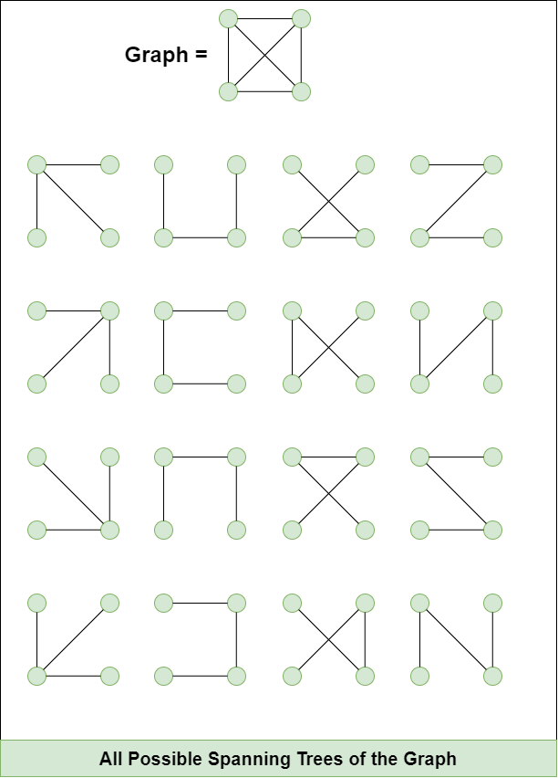*

## Properties of a Spanning Tree:

* A Spanning tree does not exist for a disconnected graph.
* For a connected graph having **N** vertices then the number of edges in the spanning tree for that graph will be**N-1**.
* A Spanning tree does not have any cycle.
* We can construct a spanning tree for a complete graph by removing **E-N+1** edges, where **E** is the number of Edges and **N** is the number of vertices.
* **Cayley's Formula:** It states that the number of spanning trees in a complete graph with N vertices is NN−2*NN*−2
  + For example: N=4, then maximum number of spanning tree possible =44−244−2 = 16 (shown in the above image).

## Real World Applications of A Spanning Tree:

* Several path finding algorithms, such as [Dijkstra's algorithm](https://www.geeksforgeeks.org/dijkstras-shortest-path-algorithm-greedy-algo-7/) and[A\* search algorithm](https://www.geeksforgeeks.org/a-search-algorithm/), internally build a spanning tree as an intermediate step.
* Building Telecommunication Network.
* Image Segmentation to break an image into distinguishable components.
* Computer Network Routing Protocol

## [**Minimum Spanning Tree(MST)**](https://www.geeksforgeeks.org/what-is-minimum-spanning-tree-mst/):

The weight of a spanning tree is determined by the sum of weight of all the edge involved in it.

*A* ***minimum spanning tree (MST)*** *is defined as a spanning tree that has the minimum weight among all the possible spanning trees.*

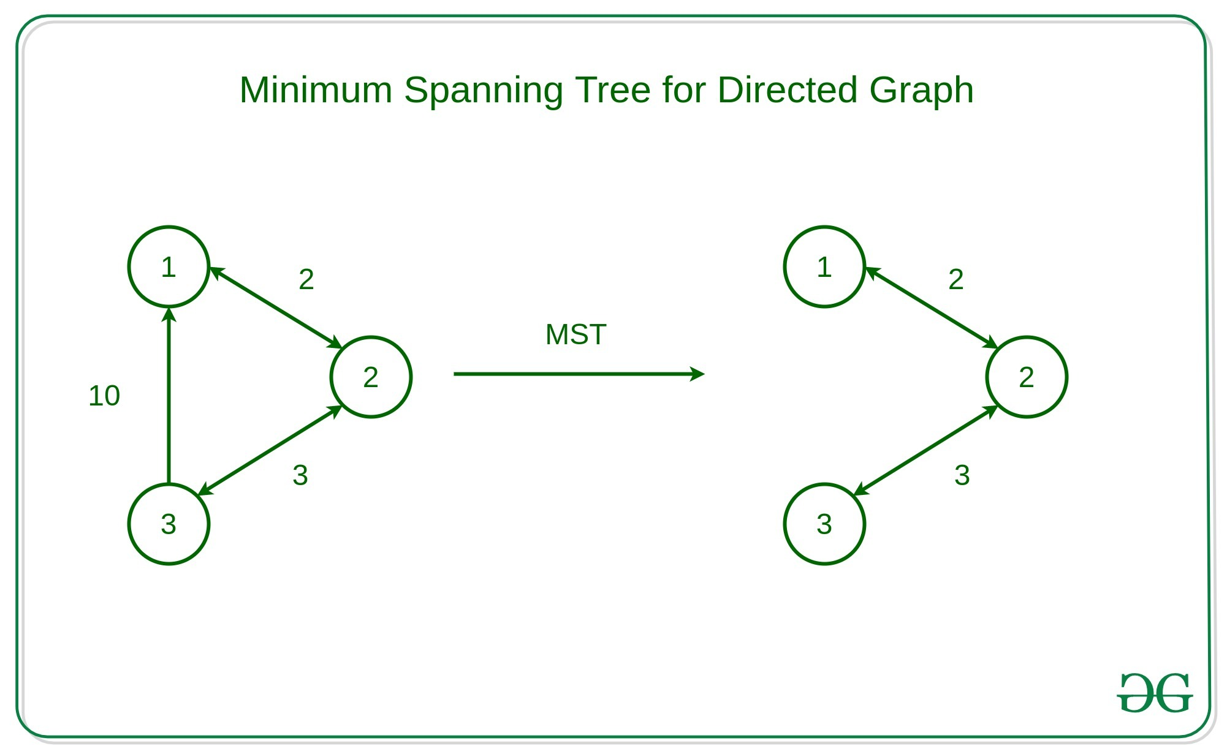

## [**Properties of Minimum Spanning Tree**](https://www.geeksforgeeks.org/properties-of-minimum-spanning-tree-mst/):

* A minimum spanning tree connects all the vertices in the graph, ensuring that there is a path between any pair of nodes.
* An **MST** is **acyclic**, meaning it contains no cycles. This property ensures that it remains a tree and not a graph with loops.
* An **MST** with **V** vertices (where **V** is the number of vertices in the original graph) will have exactly **V - 1**edges, where**V** is the number of vertices.
* An **MST** is optimal for minimizing the total edge weight, but it may not necessarily be unique.
* The cut property states that if you take any cut (a partition of the vertices into two sets) in the original graph and consider the minimum-weight edge that crosses the cut, that edge is part of the **MST**.

### Minimum Spanning Tree of a Graph may not be Unique:

*Like a spanning tree, there can also be many possible MSTs for a graph as shown in the below image:*

*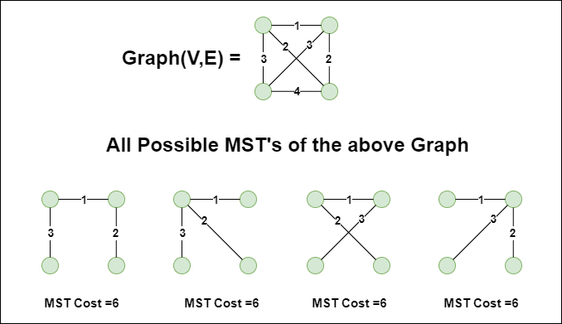*

## Algorithms to Find Minimum Spanning Tree of a Graph:

There are several algorithms to find the minimum spanning tree from a given graph, some of them are listed below:

1. [Krushkal's MST Algorithm](https://www.geeksforgeeks.org/kruskals-minimum-spanning-tree-algorithm-greedy-algo-2/)
2. [Prim's MST Algorithm](https://www.geeksforgeeks.org/prims-minimum-spanning-tree-mst-greedy-algo-5/)
3. [Boruvka's Algorithm](https://www.geeksforgeeks.org/boruvkas-algorithm-greedy-algo-9/)
4. [Reverse-Delete Algorithm](https://www.geeksforgeeks.org/reverse-delete-algorithm-minimum-spanning-tree/)

Let us discuss these algorithm one by one.

## 1. **[Krushkal's Minimum Spanning Tree](https://www.geeksforgeeks.org/kruskals-minimum-spanning-tree-algorithm-greedy-algo-2/)**:

*Kruskal's Minimum Spanning Tree (MST) algorithm is to connect all the vertices of a graph with the minimum total edge weight while avoiding cycles. This algorithm employs a greedy approach, meaning it makes locally optimal choices at each step to achieve a globally optimal solution.*

**Algorithm**:

* First, it sorts all the edges of the graph by their weights,
* Then starts the iterations of finding the spanning tree.
* At each iteration, the algorithm adds the next lowest-weight edge one by one, such that the edges picked until now does not form a cycle.

This algorithm can be implemented efficiently using a [DSU ( Disjoint-Set )](https://www.geeksforgeeks.org/introduction-to-disjoint-set-data-structure-or-union-find-algorithm/) data structure to keep track of the connected components of the graph. This is used in a variety of practical applications such as network design, clustering, and data analysis.

## 2. [**Prim's Minimum Spanning Tree**](https://www.geeksforgeeks.org/prims-minimum-spanning-tree-mst-greedy-algo-5/):

*Minimum Spanning Tree (MST) is to build the MST incrementally by starting with a single vertex and gradually extending the tree by adding the closest neighbouring vertex at each step.*

**Algorithm:**

* It starts by selecting an arbitrary vertex and then adding it to the MST.
* Then, it repeatedly checks for the minimum edge weight that connects one vertex of MST to another vertex that is not yet in the MST.
* This process is continued until all the vertices are included in the MST.

To efficiently select the minimum weight edge for each iteration, this algorithm uses **[priority\_queue](https://www.geeksforgeeks.org/priority-queue-in-cpp-stl/)** to store the vertices sorted by their minimum edge weight currently. It also simultaneously keeps track of the MST using an array or other data structure suitable considering the data type it is storing.

This algorithm can be used in various scenarios such as image segmentation based on color, texture, or other features. For Routing, as in finding the shortest path between two points for a delivery truck to follow.

## 3. [**Boruvka's Algorithm**](https://www.geeksforgeeks.org/boruvkas-algorithm-greedy-algo-9/):

*This is also a graph traversal algorithm used to find the minimum spanning tree of a connected, undirected graph. This is one of the oldest algorithms. The algorithm works by iteratively building the minimum spanning tree, starting with each vertex in the graph as its own tree. In each iteration, the algorithm finds the cheapest edge that connects a tree to another tree, and adds that edge to the minimum spanning tree. This is almost similar to the* ***Prim’s algorithm*** *for finding the minimum spanning tree.*

**Algorithm**:

* Initialize a forest of trees, with each vertex in the graph as its own tree.
* For each tree in the forest:
  + Find the cheapest edge that connects it to another tree. Add these edges to the minimum spanning tree.
  + Update the forest by merging the trees connected by the added edges.
* Repeat the above steps until the forest contains only one tree, which is the minimum spanning tree.

The algorithm can be implemented using a data structure such as a priority queue to efficiently find the cheapest edge between trees. **Boruvka’s algorithm** is a simple and easy-to-implement algorithm for finding minimum spanning trees, but it may not be as efficient as other algorithms for large graphs with many edges.

## 4. [**Reverse-Delete Algorithm**](https://www.geeksforgeeks.org/reverse-delete-algorithm-minimum-spanning-tree/):

*Reverse Delete algorithm is closely related to* ***Kruskal’s algorithm****. In Kruskal’s algorithm what we do is : Sort edges by increasing order of their weights. After sorting, we one by one pick edges in increasing order. We include current picked edge if by including this in spanning tree not form any cycle until there are* ***V-1*** *edges in spanning tree, where* ***V = number of vertices****.*

*In Reverse Delete algorithm, we sort all edges in decreasing order of their weights. After sorting, we one by one pick edges in decreasing order. We include current picked edge if excluding current edge causes disconnection in current graph. The main idea is delete edge if its deletion does not lead to disconnection of graph.*

**Algorithm**:

1. Sort all edges of graph in non-increasing order of edge weights.
2. Initialize MST as original graph and remove extra edges using step 3.
3. Pick highest weight edge from remaining edges and check if deleting the edge disconnects the graph or not.
4. If disconnects, then we don’t delete the edge.
5. Else we delete the edge and continue.

## **Real World Application of A Minimum Spanning Tree**:

* **Network design**: Spanning trees can be used in network design to find the minimum number of connections required to connect all nodes. Minimum spanning trees, in particular, can help minimize the cost of the connections by selecting the cheapest edges.
* **Image processing**: Spanning trees can be used in image processing to identify regions of similar intensity or color, which can be useful for segmentation and classification tasks.
* **Social network analysis**: Spanning trees and minimum spanning trees can be used in social network analysis to identify important connections and relationships among individuals or groups.

# Properties of Minimum Spanning Tree (MST)

**Last Updated :**26 Feb, 2023

For a connected and [undirected graph](https://www.geeksforgeeks.org/graph-data-structure-and-algorithms/), a [spanning tree](https://www.geeksforgeeks.org/prims-minimum-spanning-tree-mst-greedy-algo-5/) of that graph is a subgraph that is a tree and connects all the vertices together. A single graph can have multiple spanning trees.

A **Spanning Tree** is a tree which have V vertices and V-1 edges. All nodes in a spanning tree are reachable from each other.

A **Minimum Spanning Tree(MST)** or minimum weight spanning tree for a weighted, connected, undirected graph is a spanning tree having a weight less than or equal to the weight of every other possible spanning tree. The weight of a spanning tree is the sum of weights given to each edge of the spanning tree. In short out of all spanning trees of a given graph, the spanning tree having **minimum weight** is MST.

**Necessary conditions for Minimum Spanning Tree:**

1. It must not form a cycle i.e, no edge is traversed twice.
2. There must be no other spanning tree with lesser weight.

In this article, we will discuss the properties of **MST**:

### Possible Multiplicity:

If **G(V, E)** is a [graph](https://www.geeksforgeeks.org/graph-data-structure-and-algorithms/) then every spanning tree of graph **G** consists of **(V – 1)** edges, where **V** is the number of vertices in the graph and **E** is the number of edges in the graph. So, **(E – V + 1)** edges are not a part of the spanning tree. There may be several minimum spanning trees of the same weight. If all the edge weights of a graph are the same, then every spanning tree of that graph is minimum.

Consider a complete graph of three vertices and all the edge weights are the same then there will be three spanning trees(which are also minimal) of the same path length are possible. Below is the image to illustrate the same:

[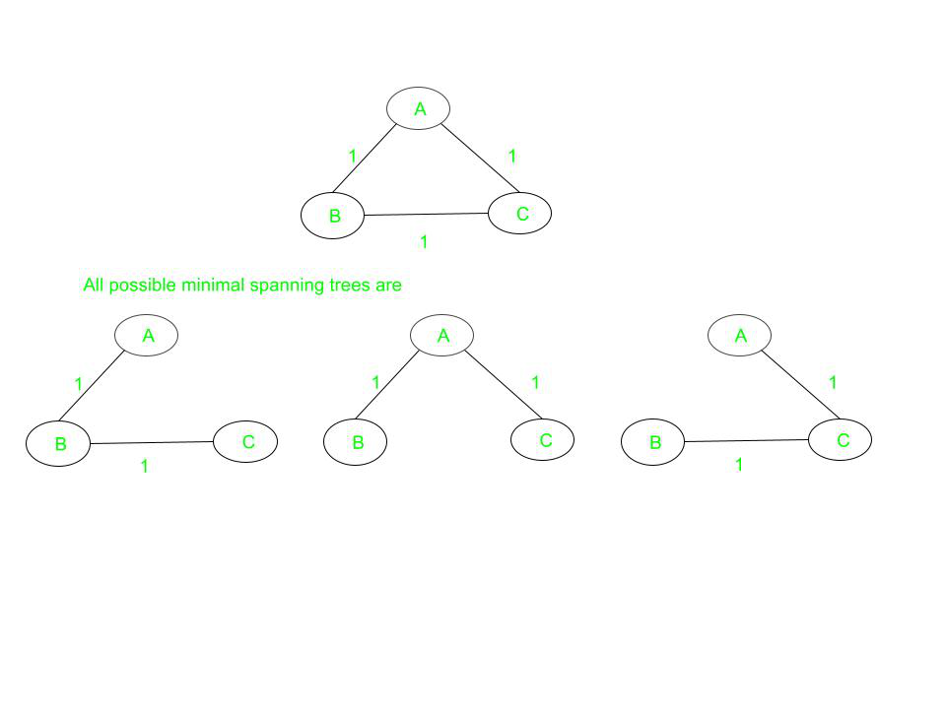](https://media.geeksforgeeks.org/wp-content/uploads/20210331182506/Graph3.jpg)

Each of the spanning trees has the same weight equal to **2**.

### Cut property:

For any cut **C** of the graph, if the weight of an edge **E** in the cut-set of **C** is strictly smaller than the weights of all other edges of the cut-set of **C**, then this edge belongs to [all the MSTs of the graph](https://www.geeksforgeeks.org/total-number-spanning-trees-graph/). Below is the image to illustrate the same:

[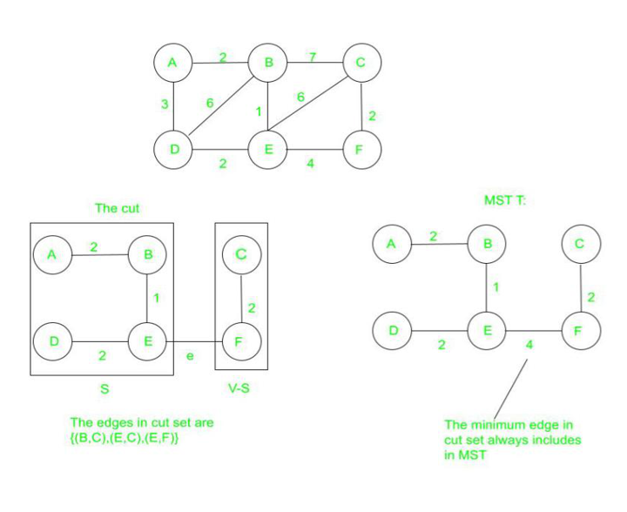](https://media.geeksforgeeks.org/wp-content/uploads/20210406145306/MST1.PNG)

### Cycle property:

For any cycle **C** in the graph, if the weight of an edge **E** of **C** is larger than the individual weights of all other edges of **C**, then this edge cannot belong to an **MST**. In the above figure, in cycle **ABD**, edge **BD** can not be present in any minimal spanning tree because it has the largest weight among all the edges in the cycle.

### Uniqueness:

If each edge has a distinct weight then there will be only one, i.e., a unique minimum spanning tree.

[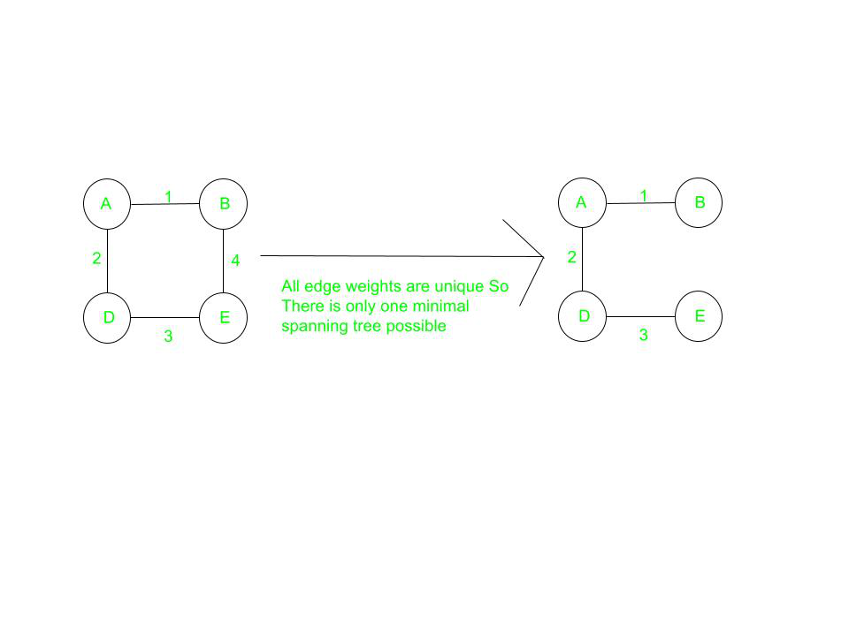](https://media.geeksforgeeks.org/wp-content/uploads/20210331195700/Graph6.jpg)

### **Minimum Cost Subgraph**

For all the possible spanning trees, the minimum spanning tree must have the minimum weight possible. However, there may exist some more spanning with the same weight that of minimum spanning tree, and those all may also be considered as Minimum Spanning tree.

* **Minimum Cost Edge:** If the minimum cost edge of a graph is unique, then this edge is included in any MST. For example, in the above figure, the edge **AB** (of the least weight) is always included in MST.
* If a new edge is added to the spanning tree then it will become cyclic because every spanning tree is minimally acyclic. In the above figure, if edge **AD** or **BC** is added to the resultant MST, then it will form a cycle.
* The spanning tree is minimally connected, i.e., if any edge is removed from the spanning tree it will disconnect the graph.In the above figure, if any edge is removed from the resultant MST, then it will disconnect the graph.

**Algorithms for finding Minimum Spanning Tree(MST):-**

1. Prim’s Algorithm
2. Kruskal’s Algorithm

# Representation of Boolean Functions

**Last Updated :**11 Sep, 2024

**Boolean functions** are expressions involving Boolean variables and operators, such as AND, OR, and NOT. These functions are fundamental in digital logic design, computer science, and engineering.

**Table of Content**

* [What are Boolean Functions?](https://www.geeksforgeeks.org/representation-of-boolean-functions/#what-are-boolean-functions)
  + [Definition of Boolean Functions](https://www.geeksforgeeks.org/representation-of-boolean-functions/#definition-of-boolean-functions)
* [Representation of Boolean Functions](https://www.geeksforgeeks.org/representation-of-boolean-functions/#representation-of-boolean-functions)
* [Different representations of a Boolean function](https://www.geeksforgeeks.org/representation-of-boolean-functions/#different-representations-of-a-boolean-function)
* [Canonical and Standard Forms](https://www.geeksforgeeks.org/representation-of-boolean-functions/#canonical-and-standard-forms)
* [Constructing Boolean Functions](https://www.geeksforgeeks.org/representation-of-boolean-functions/#constructing-boolean-functions)
* [Applications of Boolean Functions](https://www.geeksforgeeks.org/representation-of-boolean-functions/#applications-of-boolean-functions)
  + [Solved Examples](https://www.geeksforgeeks.org/representation-of-boolean-functions/#solved-examples)
* [Practice Problems – Representation of Boolean Functions](https://www.geeksforgeeks.org/representation-of-boolean-functions/#practice-problems-representation-of-boolean-functions)

## What are Boolean Functions?

Boolean functions are mathematical expressions involving Boolean variables that take on values of true or false, typically represented as 1 and 0, respectively. These functions are fundamental in digital logic design, computer science, and engineering, as they form the basis of digital circuits and various computational processes.

### Definition of Boolean Functions

*A Boolean function is a function that takes one or more Boolean inputs and produces a Boolean output. It can be represented using Boolean algebra, which involves operations such as AND, OR, NOT, NAND, NOR, XOR, and XNOR.*

## Representation of Boolean Functions

* **Truth Tables**: List all possible values of the variables and the corresponding function values.
* **Boolean Expressions**: Use algebraic expressions with Boolean variables and operators.
* **Karnaugh Maps (K-maps)**: Graphical representation to simplify Boolean functions.
* **Binary Decision Diagrams (BDDs)**: Graph-based representation of Boolean functions.

An algebraic equation that includes binary variables, the constants 1 and 0, and the logic operation symbols +,., and ‘, describes a Boolean function. A boolean function can have a value of 1 or 0 for any set of binary variable values involved. For example, we can use the three binary variables x, y, and z to define the boolean function F = x’y + z. In the event where x = 0 and y = 1 or z = 1, the function would equal 1.

A boolean function can be expressed in terms of the Truth Table or by an algebraic expression similar to the one that was previously discussed. A function can be expressed using a variety of algebraic expressions because they are all logically identical.

## Different representations of a Boolean function

(A) Each function has ν = 3 variables named a, b, and c. The truth table specifies the value fμ(a, b, c) ∈ {0, 1} for each of the 2³ possible combinations of 3 binary inputs (columns). Combinations corresponding to fμ = 1 are called minterms. A function is identified by its designation number X = 11101010 (last row). More readable representations are the full (top) and minimized (bottom) disjunctive normal forms.

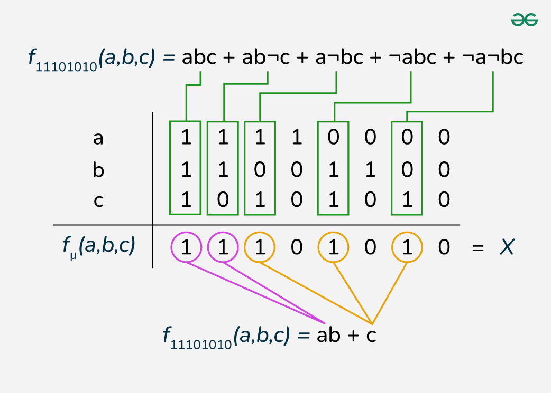

*(A)*

(B) Hypercube consists of a set of terms (nodes), minterms (gray nodes), and edges connecting the closest terms in the function.

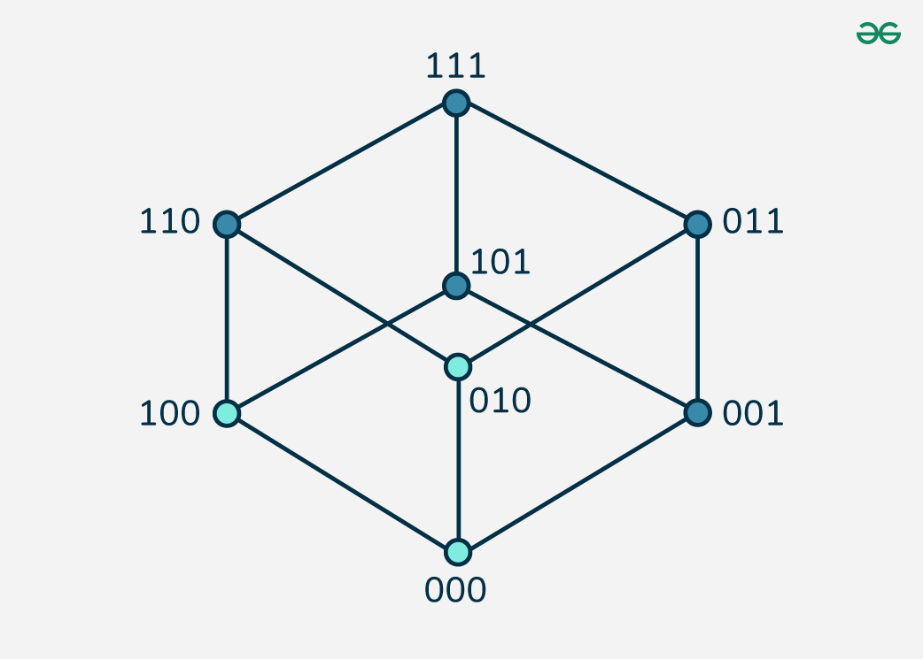

*(B)*

(C) A feed-forward Boolean network (FFBN) is a directed network made up of logic gates and wires that implement the function. The figure shows the FFBN of minimal cost.

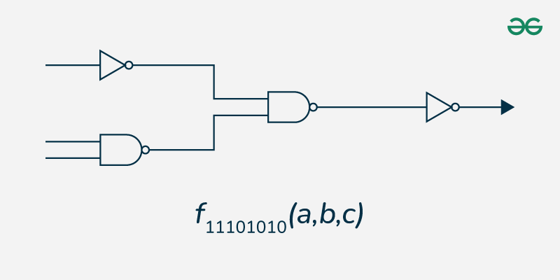

*(C)*

## **Canonical and Standard Forms**

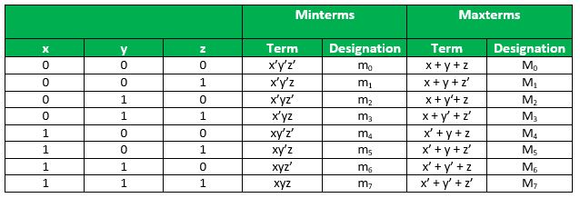

## **Constructing Boolean Functions**

Now that we know what minterms and maxterms are, we can use them to construct boolean expressions. “A Boolean function can be expressed algebraically from a given truth table by forming a minterm for each combination of the variables that produces a 1 in the function and then taking the OR of all those terms.” For example, consider two functions f1   *f*1​ and f2   *f*2​ with the following truth tables –

| **x** | **y** | **z** | **f 1** | **f 2** |
| --- | --- | --- | --- | --- |
| 0 | 0 | 0 | 0 | 0 |
| 0 | 0 | 1 | 1 | 0 |
| 0 | 1 | 0 | 0 | 0 |
| 0 | 1 | 1 | 0 | 1 |
| 1 | 0 | 0 | 1 | 0 |
| 1 | 0 | 1 | 0 | 1 |
| 1 | 1 | 0 | 0 | 1 |
| 1 | 1 | 1 | 1 | 1 |

## Applications of Boolean Functions

1. **Digital Circuit Design**Boolean functions are used to design and simplify digital circuits, including logic gates, multiplexers, adders, and more. Simplifying Boolean expressions reduces the number of gates required, optimizing circuit design.**Example:** Designing a digital circuit to perform arithmetic operations involves using Boolean functions to define the behavior of adders and subtractors.
2. **Computer Algorithms**Boolean functions are integral to algorithms that involve decision-making, such as search algorithms, sorting algorithms, and error detection and correction algorithms.**Example:** In search algorithms, Boolean functions help determine whether a condition is met, guiding the search process.
3. **Fault Detection**Boolean functions are used in fault detection and diagnosis in digital systems. By comparing the expected and actual outputs of a digital circuit, faults can be identified and corrected.**Example:** Built-in self-test (BIST) techniques use Boolean functions to generate test patterns and compare the results to detect faults in integrated circuits.
4. **Control Systems**Boolean functions are used in control systems to define the logic for system operation, such as switching on or off, opening or closing valves, and more.**Example:** In an automated manufacturing process, Boolean functions control the operation of machinery based on sensor inputs.

### Solved Examples

Example 1: Canonical Sum-of-Products (SOP) Form

Problem: Express the function F(A,B,C) = A + BC in canonical SOP form.

*Solution: F(A,B,C) = A’BC + A’BC’ + ABC + ABC’*

*Explanation: We expand the original function to include all minterms where F is true. This includes all terms where A is true (regardless of B and C) and the term where A is false but both B and C are true.*

Example 2: Canonical Product-of-Sums (POS) Form

Problem: Express the function F(x,y,z) = x + y’z in canonical POS form.

*Solution: F(x,y,z) = (x + y + z)(x + y + z’)(x + y’ + z)(x + y’ + z’)*

*Explanation: We find all the maxterms where the function is false and AND them together. The function is false only when x is false, y is true, and z is false.*

*Example 3: Algebraic Representation*

Problem: Simplify the Boolean function F = AB + A’B + AB’.

*Solution: F = A + B*

*Explanation:*

*F = AB + A’B + AB’*

*= AB + A’B + AB’ + AB (adding AB doesn’t change the function)*

*= B(A + A’) + A(B + B’)*

*= B(1) + A(1)*

*= B + A*

*= A + B*

Example 4 : Express the function F(A,B,C) = A’B + BC’ in canonical SOP form.

*Solution: F(A,B,C) = A’BC’ + A’BC + ABC’*

*Explanation: We expand the original function to include all minterms where F is true. This includes terms where A is false and B is true (regardless of C), and where B is true and C is false (regardless of A).*

Example 5: Convert the function F(x,y,z) = x’y’z + xy’z’ + xyz to canonical POS form.

*Solution: F(x,y,z) = (x + y + z)(x + y’ + z)(x’ + y + z)*

*Explanation: We find all the maxterms where the function is false and AND them together. The function is false only when (x,y,z) is (0,1,0), (1,0,1), or (0,0,1).*

Example 6 : Simplify the Boolean expression: G(a,b,c) = ab + a’c + bc

*Solution: G(a,b,c) = ab + c*

*Explanation:*

*G = ab + a’c + bc*

*= ab + c(a’ + b)*

*= ab + c(a’ + b + ab) (adding ab doesn’t change the result)*

*= ab + c(a’ + b)*

*= ab + c*

Example 7 : Express the function H(p,q,r) = p’q’ + qr’ in algebraic form using only NAND operations.

*Solution: H(p,q,r) = ((p NAND p) NAND (q NAND q)) NAND ((q NAND (r NAND r)) NAND (q NAND (r NAND r)))*

*Explanation: We first convert OR to NAND using De Morgan’s law, then replace AND with NAND, and finally replace NOT with a NAND of the variable with itself.*

Example 8 : Express the function K(a,b,c) = (a + b’)(a’ + c) in canonical SOP form.

*Solution: K(a,b,c) = a’bc + ab’c + abc*

*Explanation: We expand the expression and find all combinations that make it true. This includes when a is false, b and c are true; when a and c are true, b is false; and when all variables are true.*

Problem 9 : Convert the function F(w,x,y,z) = wx + y’z + xyz’ to Reed-Muller canonical form.

*Solution: F(w,x,y,z) = 1 ⊕ y ⊕ z ⊕ wx ⊕ yz*

*Explanation:*

*Start with F = wx + y’z + xyz’*

*Replace y’ with (1 ⊕ y)*

*F = wx + (1 ⊕ y)z + xyz’*

*Expand: F = wx + z ⊕ yz + xyz’*

*Combine xyz’ and xyz: F = wx + z ⊕ yz + xy(z’ ⊕ z)*

*Since (z’ ⊕ z) = 1, we get: F = wx + z ⊕ yz + xy*

*Rearranging: F = 1 ⊕ y ⊕ z ⊕ wx ⊕ yz*

*The Reed-Muller canonical form uses XOR (⊕) and AND operations, with each variable appearing at most once in each term.*

Example 10 : Represent the function G(a,b,c) = a’b + bc’ + ac using a Binary Decision Diagram (BDD).

*Solution: The BDD for this function would look like this (described textually):*

*Root node: a*

*If a = 0: go to node b*

*If b = 0: output 0*

*If b = 1: output*

*If a = 1: go to node c*

*If c = 0: go to node b*

*If b = 0: output 0*

*If b = 1: output 1*

*If c = 1: output 1*

*Explanation:*

*We start with variable a at the root.*

*If a is false (0), the function reduces to b, so we output 1 if b is true, 0 otherwise.*

*If a is true (1), we need to check c.*

*If c is true, the function is true regardless of b.*

*If c is false, we need to check b (because of the bc’ term).*

## Practice Problems – Representation of Boolean Functions

**1. Express the function F(x,y,z) = x’y + yz + xz’ in canonical Sum-of-Products (SOP) form.**

**2. Convert the function G(a,b,c) = (a + b’)(a’ + c)(b + c’) to canonical Product-of-Sums (POS) form.**

**3. Simplify the Boolean expression H(p,q,r) = pq + p’r + qr using algebraic methods.**

**4. Represent the function J(w,x,y,z) = Σm(0,1,3,4,5,7,8,9,11,15) using a Karnaugh map and find its minimal SOP form.**

**5. Express the function K(a,b,c) = a’b + bc’ + ab’c in Reed-Muller canonical form.**

**6. Convert the function L(x,y,z) = x’y’z + xy’z’ + xyz to a form using only NOR operations.**

**7. Draw a Binary Decision Diagram (BDD) for the function M(p,q,r) = pq + qr’ + pr.**

**8. Find the dual of the function N(a,b,c) = (a + b’)(a’ + c).**

**9. Express the function P(w,x,y,z) = w’x + yz + wx’y’ using Shannon’s expansion theorem.**

**10. Given the truth table for function Q(a,b,c) where Q is true for minterms 1, 2, 4, and 7, express Q in minimal SOP and minimal POS forms.**

### Related Articles:

* [*Boolean Algebra – Expression, Rules, Theorems*](https://www.geeksforgeeks.org/boolean-algebra/)
* [*Boolean Functions*](https://www.geeksforgeeks.org/boolean-functions/)

## Conclusion – Representation of Boolean Functions

Boolean functions are a cornerstone of digital logic design and computer science. They provide a systematic way to represent and manipulate logical relationships between variables, enabling the design and optimization of digital circuits and computational processes. Understanding Boolean functions is essential for anyone working in fields related to digital electronics and computer engineering.

**Minimization of Boolean Functions**

Last Updated : 25 Nov, 2019

As discussed in the [“Representation of Boolean Functions”](https://www.geeksforgeeks.org/mathematics-representation-boolean-functions/) every boolean function can be expressed as a sum of minterms or a product of maxterms. Since the number of literals in such an expression is usually high, and the complexity of the digital logic gates that implement a Boolean function is directly related to the complexity of the algebraic expression from which the function is implemented, it is preferable to have the most simplified form of the algebraic expression. The process of simplifying the algebraic expression of a boolean function is called **minimization**. Minimization is important since it reduces the cost and complexity of the associated circuit. For example, the functioncan be minimized to. The circuits associated with above expressions is –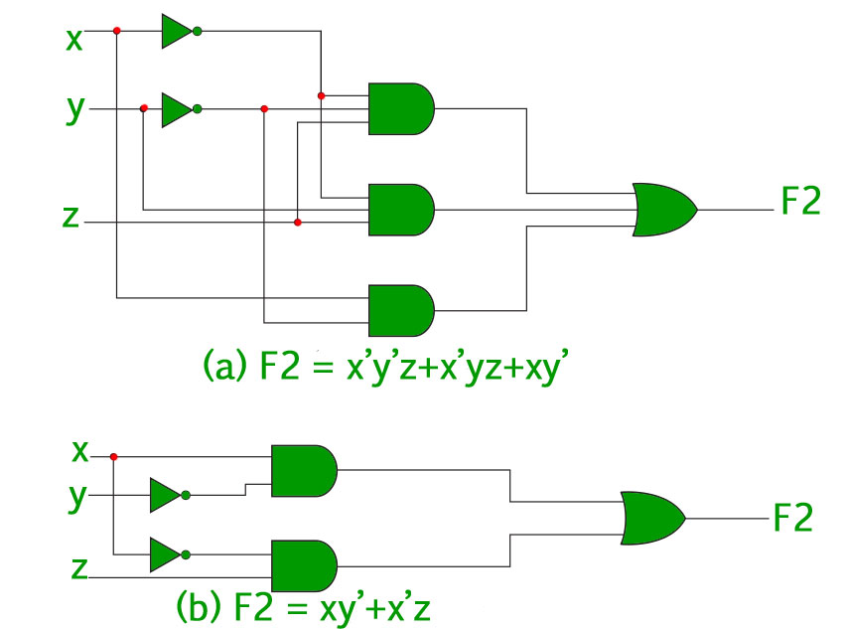It is clear from the above image that the minimized version of the expression takes a less number of logic gates and also reduces the complexity of the circuit substantially. Minimization is hence important to find the most economic equivalent representation of a boolean function. Minimization can be done using Algebraic Manipulation or [K-Map](https://www.geeksforgeeks.org/k-mapkarnaugh-map/) method. Each method has it’s own merits and demerits.

**Minimization using Algebraic Manipulation –**

This method is the simplest of all methods used for minimization. It is suitable for medium sized expressions involving 4 or 5 variables. Algebraic manipulation is a manual method, hence it is prone to human error. Common Laws used in algebraic manipulation :

* **Example 1 –** Minimize the following boolean function using algebraic manipulation-
* **Solution –** Properties refer to the three common laws mentioned above.

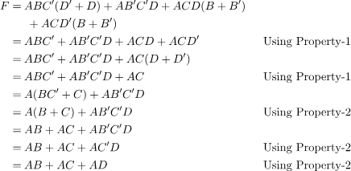

**Minimization using K-Map –**

The Algebraic manipulation method is tedious and cumbersome. The K-Map method is faster and can be used to solve boolean functions of upto 5 variables. Please refer this [link](https://www.geeksforgeeks.org/k-mapkarnaugh-map/) to learn more about K-Map.

* **Example 2 –** Consider the same expression from example-1 and minimize it using K-Map.
* **Solution –** The following is a 4 variable K-Map of the given expression.
* The above figu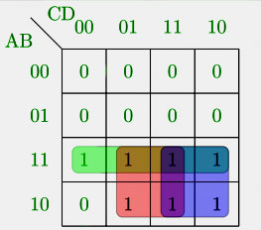re highlights the prime implicants in green, red and blue. The green one spans the whole third row, which gives us –ABThe red one spans 4 squares, which gives us –AD The blue one spans 4 squares, which gives us –AC So, the minimized boolean expression is-

# Linear Programming

**Last Updated :**30 Dec, 2024

**Linear programming**is a mathematical concept that is used to find the optimal solution of the linear function. This method uses simple assumptions for optimizing the given function. Linear Programming has a huge real-world application and it is used to solve various types of problems.

The term “linear programming” consists of two words linear and programming, the word linear tells the relation between various types of variables of degree one used in a problem and the word programming tells us the step-by-step procedure to solve these problems.

In this article, we will learn about linear programming, its examples, formulas, and other concepts in detail.

**Table of Content**

* [What is Linear Programming?](https://www.geeksforgeeks.org/linear-programming/#what-is-linear-programming)
* [Components of Linear Programming](https://www.geeksforgeeks.org/linear-programming/#components-of-linear-programming)
* [Linear Programming Examples](https://www.geeksforgeeks.org/linear-programming/#linear-programming-examples)
* [Linear Programming Problems](https://www.geeksforgeeks.org/linear-programming/#linear-programming-problems)
* [Types of Linear Programming Problems](https://www.geeksforgeeks.org/linear-programming/#types-of-linear-programming-problems)
* [Linear Programming Formula](https://www.geeksforgeeks.org/linear-programming/#linear-programming-formula)
* [How to Solve Linear Programming Problems?](https://www.geeksforgeeks.org/linear-programming/#how-to-solve-linear-programming-problems)
* [Linear Programming Methods](https://www.geeksforgeeks.org/linear-programming/#linear-programming-methods)
* [Linear Programming Simplex Method](https://www.geeksforgeeks.org/linear-programming/#linear-programming-simplex-method)
* [Linear Programming Graphical Method](https://www.geeksforgeeks.org/linear-programming/#linear-programming-graphical-method)
* [Linear Programming Applications](https://www.geeksforgeeks.org/linear-programming/#linear-programming-applications)
* [Importance of Linear Programming](https://www.geeksforgeeks.org/linear-programming/#importance-of-linear-programming)
* [Up-to-Date Applications of Linear Programming](https://www.geeksforgeeks.org/linear-programming/#uptodate-applications-of-linear-programming)
* [Linear Programming in Operations Research](https://www.geeksforgeeks.org/linear-programming/#linear-programming-in-operations-research)
* [Simplex Method](https://www.geeksforgeeks.org/linear-programming/#simplex-method)

## **What is Linear Programming?**

**Linear programming** or **Linear optimization** is a technique that helps us to find the optimum solution for a given problem, an optimum solution is a solution that is the best possible outcome of a given particular problem.

In simple terms, it is the method to find out how to do something in the best possible way. With limited resources, you need to do the optimum utilization of resources and achieve the best possible result in a particular objective such as least cost, highest margin, or least time.

The situation that requires a search for the best values of the variables subject to certain constraints is where we use linear programming problems. These situations cannot be handled by the usual calculus and numerical techniques.

### Linear Programming Definition

*Linear programming is the technique used for optimizing a particular scenario. Using linear programming provides us with the best possible outcome in a given situation. It uses all the available resources in a manner such that they produce the optimum result.*

## Components of Linear Programming

The basic components of a linear programming(LP) problem are:

* **Decision Variables:**Variables you want to determine to achieve the optimal solution.
* **Objective Function: M**athematical equation that represents the goal you want to achieve
* **Constraints:**Limitations or restrictions that your decision variables must follow.
* **Non-Negativity Restrictions:**In somereal-world scenarios, decision variables cannot be negative

### Additional Characteristics of Linear Programming

* **Finiteness:**The number of decision variables and constraints in an LP problem are finite.
* **Linearity:**The objective function and all constraints must be linear functions of the decision variables**.**It means the degree of variables should be one.

## Linear Programming Examples

We can understand the situations in which Linear programming is applied with the help of the example discussed below,

Suppose a delivery man has to deliver 8 packets in a day to the different locations of a city. He has to pick all the packets from A and has to deliver them to points P, Q, R, S, T, U, V, and W. The distance between them is indicated using the lines as shown in the image below. The shortest path followed by the delivery man is calculated using the concept of Linear Programming.

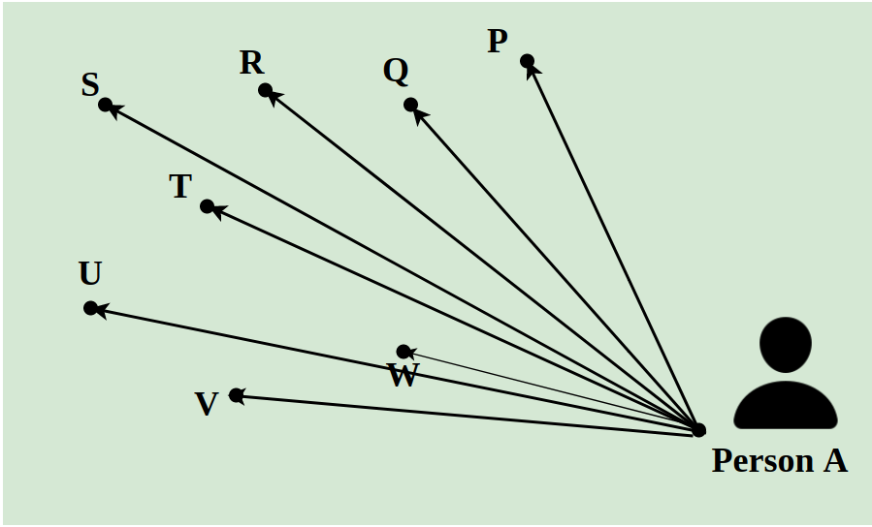

## **Linear Programming Problems**

**Linear Programming Problems (LPP)**involve optimizing a linear function to find the optimal value solution for the function. The optimal value can be either the maximum value or the minimum value.

In LPP, the linear functions are called **objective functions.**An objective function can have multiple variables, which are subjected to conditions and have to satisfy the **linear constraints**.

## Types of Linear Programming Problems

There are many different linear programming problems(LPP) but we will deal with three major linear programming problems in this article.

### **Manufacturing Problems**

Manufacturing problems are a problem that deals with the number of units that should be produced or sold to maximize profits when each product requires fixed manpower, machine hours, and raw materials.

### **Diet Problems**

It is used to calculate the number of different kinds of constituents to be included in the diet to get the minimum cost, subject to the availability of food and their prices.

### **Transportation Problems**

It is used to determine the transportation schedule to find the cheapest way of transporting a product from plants /factories situated at different locations to different markets.

## Linear Programming Formula

A linear programming problem consists of,

* Decision variables
* Objective function
* Constraints
* Non-Negative restrictions

**Decision variables** are the variables x, and y, which decide the output of the linear programming problem and represent the final solution.

The **objective function**, generally represented by Z, is the linear function that needs to be optimized according to the given condition to get the final solution.

The **restrictions**imposed on decision variables that limit their values are called constraints.

Now, the general formula of a linear programming problem is,

**Objective Function**: Z = ax + by

**Constraints:** cx + dy ≥ e, px + qy ≤ r

**Non-Negative restrictions:**x ≥ 0, y ≥ 0

In the above condition x, and y are the decision variables.

## How to Solve Linear Programming Problems?

Before solving the linear programming problems first we have to formulate the problems according to the standard parameters. The steps for solving linear programming problems are,

***Step 1:*** *Mark the decision variables in the problem.*

***Step 2:*** *Build the objective function of the problem and check if the function needs to be minimized or maximized.*

***Step 3:*** *Write down all the constraints of the linear problems.*

***Step 4:*** *Ensure non-negative restrictions of the decision variables.*

***Step 5:*** *Now solve the linear programming problem using any method generally we use either the simplex or graphical method.*

## Linear Programming Methods

We use various methods for solving linear programming problems. The two most common methods used are,

* Simplex Method
* Graphical Method

Let’s learn about these two methods in detail in this article,

## Linear Programming Simplex Method

One of the most common methods to solve the linear programming problem is the simplex method. In this method, we repeat a specific condition ‘n’ a number of times until an optimum solution is achieved.

The steps required to solve linear programming problems using the simplex method are,

***Step 1:*** *Formulate the linear programming problems based on the given constraints.*

***Step 2:*** *Convert all the given inequalities to equations or equalities of the linear programming problems by adding the slack variable to each inequality where ever required.*

***Step 3:*** *Construct the initial simplex table. By representing each constraint equation in a row and writing the objective function at the bottom row. The table so obtained is called the Simplex table.*

***Step 4:*** *Identify the greatest negative entry in the bottom row the column of the element with the highest negative entry is called the pivot column*

***Step 5:*** *Divide the entries of the right-most column with the entries of the respective pivot column, excluding the entries of the bottommost row. Now the row containing the least entry is called the pivot row. The pivot element is obtained by the intersection of the pivot row and the pivot column.*

***Step 6:*** *Using matrix operation and with the help of the pivot element make all the entries in the pivot column to be zero.*

***Step 7:*** *Check for the non-negative entries in the bottommost row if there are no negative entries in the bottom row, end the process else start the process again from step 4.*

***Step 8:*** *The final simplex table so obtained gives the solution to our problem.*

## Linear Programming Graphical Method

Graphical Method is another method than the Simplex method which is used to solve linear programming problems. As the name suggests this method uses graphs to solve the given linear programming problems. This is the best method to solve linear programming problems and requires less effort than the simplex method.

While using this method we plot all the inequalities that are subjected to constraints in the given linear programming problems. As soon as all the inequalities of the given LPP are plotted in the XY graph the common region of all the inequalities gives the optimum solution. All the corner points of the feasible region are calculated and the value of the objective function at all those points is calculated then comparing these values we get the optimum solution of the LPP.

**Example: Find the maximal and minimal value of z = 6x + 9y when the constraint conditions are,**

* **2x + 3y ≤ 12**
* **x and y ≥ 0**
* **x + y ≤ 5**

**Solution:**

***Step 1****: First convert the inequations into normal equations. Hence the equations will be 2x+3y = 0, x = 0, y = 0 and x + y = 5.*

***Step 2****: Find the points at which 2x + 3y and x + y = 5 cut the x-axis and y-axis. To find the point of intersection of the x-axis put y = 0 in the respective equation and find the point. Similarly for y-axis intersection points put x = 0 in the respective equation.*

***Step 3****: Draw the two lines cutting the x-axis and y-axis. We find that the two axes cut each other at (3, 2).*

***Step 4****: For x ≥ 0 and y ≥ 0, we find that both inequations are followed. Hence the region will include an area region enclosed by two axes and both lines including the origin. The plotted region is shown below in the figure.*

***Step 5****: Find Z for each point and maxima and minima.*

| **Coordinates** | **Z = 6x + 9y** |
| --- | --- |
| (0, 0) | Z = 0 |
| (0, 5) | Z = 45 |
| (0, 4) | Z = 36 |
| (5, 0) | Z = 30 |
| (6, 0) | Z = 36 |
| (3, 2) | Z = 36 |

*Hence, we find that Z = 6x + 9y is maximum at (0, 5) and minimum at (0, 0).*

## Linear Programming Applications

Linear Programming has applications in various fields. It is used to find the minimum cost of a process when all the constraints of the problems are given. It is used to optimize the transportation cost of the vehicle, etc. Various applications of Linear Programming are

### Engineering Industries

Engineering Industries use linear programming to solve design and manufacturing problems and to get the maximum output from a given condition.

### Manufacturing Industries

Manufacturing Industries use linear programming to maximize the profit of the companies and to reduce the manufacturing cost.

### Energy Industries

Energy companies use linear programming to optimize their production output.

### Transportation Industries

Linear programming is also used in transportation industries to find the path to minimize the cost of transportation.

## Importance of Linear Programming

Linear Programming has huge importance in various industries it maximizes the output value while minimizing the input values according to various constraints.

LP is highly applicable when we have multiple conditions while solving a problem and we have to optimize the output of the problem i.e. either we have to find the minimum or the maximum value according to a given condition.

**Read More,**

* [*Linear Inequalities*](https://www.geeksforgeeks.org/graphical-solution-of-linear-inequalities-in-two-variables/)
* [*Algebraic Solution of Linear Inequalities*](https://www.geeksforgeeks.org/algebraic-solutions-of-linear-inequalities-in-one-variable-and-their-graphical-representation-linear-inequalities-class-11-maths/)

## Linear Programming Problems

**Problem 1:** **A company manufactures and sells two types of products and the cost of production of each unit a and b is rupees 200 and 150 respectively each unit of product yields a profit of 20 rupees and each unit of product b yields a profit of 15 rupees on selling. The company estimates the monthly demand of A and B to be at a maximum of the harvested unit in all the production budget for the month is set at rupees 50000. How many units should the company manufacture to earn maximum profit from its monthly sales from a and b?**

**Solution:**

*Let x = number of units of type A*

*y = Number of units of type B*

*Maximize Z = 40x + 50y*

*Subject to the constraints*

*3x + y ≤ 9*

*x + 2y ≤ 8*

*and x, y ≥ 0*

*Consider the equation,*

*3x + y = 9*

*x = 3*

*y = 0*

*and x + 2y = 8*

*x = 8*

*y = 0*

*Now, we can determine the maximum value of Z by evaluating the value of Z at the four points (vertices) is shown below*

| **Vertices** | **Z = 40x + 50y** |
| --- | --- |
| (0, 0) | Z = 40 × 0 + 50 × 0 = Rs. 0 |
| (3, 0) | Z = 40 × 3 + 50 × 0 = Rs. 120 |
| (0, 4) | Z = 40 × 0 + 50 × 4 = Rs. 200 |
| (2, 3) | Z = 40 × 2 + 50 × 3 = Rs. 230 |

*Maximum profit, Z = Rs. 230*

*∴ Number of units of type A is 2 and the number of units of type B is 3.*

**Problem 2: Maximize Z = 3x + 4y.**

**Subject to constraints , x + y ≤ 450, 2x + y ≤ 600 and x, y ≤ 0.**

**Solution:**

*We have from the given*

***Constraints (1)***

*X + Y = 450*

*Putting x = 0, ⇒ 0 + y = 450 ⇒ y = 450*

*Putting y = 0, ⇒ x + 0 = 450 ⇒ x = 450*

*From,* ***Constraints (2)***

*2x + y = 600*

*Putting x = 0, ⇒ 0 + y = 600 ⇒ y = 600*

*Putting  y = 0, ⇒ 2x + 0 = 600 ⇒ x = 300*

*Now, we have the points co-ordinate Z = 3x + 4y*

| **Vertices** | **Z = 3x + 4y** |
| --- | --- |
| (0, 0) | Z = 3 × 0 + 4 × 0 = 0 |
| (300, 0) | Z = 3 × 300+ 4 × 0 = 900 |
| (150, 300) | Z = 3 × 150 + 4 × 300 = 1650 |
| (0, 450) | Z = 3 × 0 + 4 × 450 = 1800 |

*Therefore, the optimal solution maximum Z = 1800 at co-ordinate x = 0 and y = 450. The graph is given below.*

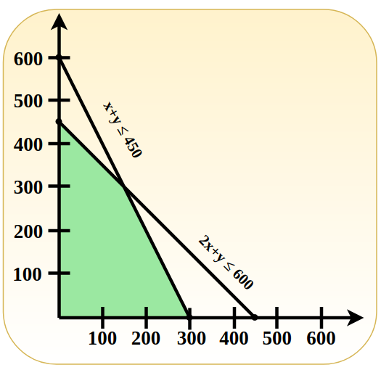

## Up-to-Date Applications of Linear Programming

Linear programming, a powerful mathematical technique, is used to solve optimization problems in various industries. Here are some modern applications:

* **Supply Chain Optimization**: Linear programming helps companies minimize costs and maximize efficiency in their supply chains. It’s used for determining the most cost-effective transportation routes, warehouse operations, and inventory management strategies.
* **Energy Management**: In the energy sector, linear programming is utilized to optimize the mix of energy production methods. This includes balancing traditional energy sources with renewable ones to reduce costs and environmental impact while meeting demand.
* **Telecommunications Network Design**: Linear programming aids in designing efficient telecommunications networks. It helps in allocating bandwidth, designing network layouts, and optimizing the flow of data to ensure high-speed communication at lower costs.
* **Financial Planning**: Businesses and financial analysts use linear programming for portfolio optimization, risk management, and capital budgeting. It helps in making investment decisions that maximize returns while minimizing risk.
* **Healthcare Logistics**: In healthcare, linear programming is applied to optimize the allocation of resources, such as hospital beds, medical staff, and equipment. It’s crucial for improving patient care, reducing wait times, and managing costs effectively.
* **Manufacturing Process Optimization**: Linear programming is used to determine the optimal production levels for multiple products within a manufacturing facility, considering constraints like labor, materials, and machine availability.
* **Agricultural Planning**: Farmers and agricultural planners use linear programming to decide on crop selection, land use, and resource allocation to maximize yields and profits while conserving resources.
* **Airline Crew Scheduling**: Airlines employ linear programming to schedule crews efficiently, ensuring that flights are staffed in compliance with regulations and minimizing operational costs.

These applications demonstrate the versatility and power of linear programming in solving complex optimization problems across various sectors, showcasing its relevance in today’s data-driven world.

## Linear Programming in Operations Research

* **Core Tool**: Linear programming is a foundational tool in operations research for optimizing resources.
* **Decision Making**: Helps in making the best decisions regarding resource allocation, maximizing profits, or minimizing costs.
* **Wide Applications**: Used in various fields such as logistics, manufacturing, finance, and healthcare for solving complex problems.
* **Modeling Real-World Problems**: Transforms real-world problems into mathematical models to find the most efficient solutions.

## Simplex Method

* **Optimization Algorithm**: The Simplex Method is a powerful algorithm used in linear programming to find the optimal solution to linear inequalities.
* **Step-by-Step Approach**: It iteratively moves towards the best solution by navigating the edges of the feasible region defined by constraints.
* **Efficiency**: Known for its efficiency in solving large-scale linear programming problems.
* **Versatility**: Applicable in various domains like diet planning, network flows, production scheduling, and more, showcasing its versatility.

## Practice Problems on Linear Programming

**Problem 1: Maximize Z=3x+4y subject to the constraints:**

1. x+2≤8*x*+2≤8
2. 3x+y≤93*x*+*y*≤9
3. x≥0*x*≥0
4. y≥0*y*≥0

**Problem 2: Minimize Z=5x+2y subject to the constraints:**

1. 2x+y≥102*x*+*y*≥10
2. x+3y≥15*x*+3*y*≥15
3. x≥0*x*≥0
4. y≥0*y*≥0

**Problem 3: A factory produces two products, P1 and P2. The profit for P1 is $40 and for P2 is $30. Each product requires processing in two departments. The processing times in hours per unit for each department are given below:**

| **Product** | **Department A** | **Department B** |
| --- | --- | --- |
| P1 | 2 | 1 |
| P2 | 1 | 2 |

The available hours for Department A are 100 and for Department B are 80. Formulate the linear programming problem to maximize the profit.

**Problem 4: Minimize the cost of a diet containing at least 60 units of protein and 70 units of carbohydrates. Two food items, A and B, provide the following nutrients per**unit:

| **Nutrient** | **Food A** | **Food B** |
| --- | --- | --- |
| Protein | 3 | 4 |
| Carbohydrates | 4 | 2 |

The cost per unit of food A is $2 and food B is $3. Formulate the linear programming problem to minimize the cost.

**Problem 5: A company needs to transport goods from two warehouses to three retail stores. The supply at Warehouse 1 is 70 units, and at Warehouse 2 is 80 units. The demand at Store 1 is 40 units, at Store 2 is 50 units, and at Store 3 is 60 units. The transportation costs per unit are given below:**

|  | **Store 1** | **Store 2** | **Store 3** |
| --- | --- | --- | --- |
| Warehouse 1 | $4 | $6 | $8 |
| Warehouse 2 | $5 | $3 | $7 |

Formulate the linear programming problem to minimize the transportation cost.

**Problem 6: Maximize the return on an investment portfolio consisting of two investments, A and B. Investment A has a return of 5% and investment B has a return of 7%. The total investment is $100,000, with at least $30,000 in investment A and no more than $60,000 in investment B. Formulate the linear programming problem.**

**Problem 7: A company needs to schedule workers for a week with the following constraints: At least 3 workers on Monday, 2 on Tuesday, 4 on Wednesday, 3 on Thursday, and 5 on Friday. Each worker can work at most 3 days a week. Formulate the linear programming problem to minimize the number of workers needed.**

**Problem 8: A company produces a blend of two chemicals, A and B. The blend must contain at least 30% of A and at least 40% of B. Chemical A costs $10 per unit and chemical B costs $15 per unit. The company needs to produce 100 units of the blend. Formulate the linear programming problem to minimize the cost.**

**Problem 9: Assign 4 workers to 4 jobs with the following costs:**

|  | **Job 1** | **Job 2** | **Job 3** | **Job 4** |
| --- | --- | --- | --- | --- |
| Worker 1 | $9 | $2 | $7 | $8 |
| Worker 2 | $6 | $4 | $3 | $7 |
| Worker 3 | $5 | $8 | $1 | $8 |
| Worker 4 | $7 | $6 | $9 | $4 |

Formulate the linear programming problem to minimize the total cost.

**Problem 10: An investor wants to maximize the return from a portfolio consisting of three investments: X, Y, and Z. The returns are 6%, 8%, and 10%, respectively. The total investment is $200,000, with at least $50,000 in each investment and at least as much in X as in Y. Formulate the linear programming problem.**

## Linear Programming – FAQs

### What is Linear Programming?

*Linear programming is a mathematical concept which is used to optimize a given linear problem which has a variety of constraints. Using linear programming we the optimum output of the given problem*

### What are Linear Programming Problems?

*Linear Programming Problems (LPP) are the problems which give the optimum solution to the given conditions.*

### What is Linear Programming Formula?

*General Linear Programming Formulas are,*

* *Objective Function: Z = ax + by*
* *Constraints: px + qy ≤ r, sx + ty ≤ u*
* *Non-Negative Restrictions: x ≥ 0, y ≥ 0*

### What are the different types of Linear Programming?

*Different types of linear programming methods are,*

* *Linear Programming by Simplex Method*
* *Linear Programming by R Method*
* *Linear Programming by Graphical Method*

### What are requirements of Linear Programming?

*Various requirements of linear programming problems are,*

* *Linearity*
* *Objective Function*
* *Constraints*
* *Non-negativity*

### What are the advantages of Linear Programming?

*Various advantages of linear programming are,*

* *It provides the optimal solution to any given linear problem.*
* *It is easy to use and always gives consistent results*
* *It helps to maximize profits and to reduce the input cost.*

# Graphical Solution of Linear Programming Problems

**Last Updated :**09 Aug, 2024

Linear programming is the simplest way of optimizing a problem. Through this method, we can formulate a real-world problem into a mathematical model. There are various methods for solving Linear Programming Problems and one of the easiest and most important methods for solving LPP is the graphical method. In Graphical Solution of Linear Programming, we use graphs to solve LPP.

We can solve a wide variety of problems using Linear programming in different sectors, but it is generally used for problems in which we have to maximize profit, minimize cost, or minimize the use of resources. In this article, we will learn about Solutions of Graphical solutions of linear programming problems, their types, examples, and others in detail.

**Table of Content**

* [Linear Programming](https://www.geeksforgeeks.org/graphical-solution-of-linear-programming-problems/#linear-programming)
  + [Types of Linear Programming Problems](https://www.geeksforgeeks.org/graphical-solution-of-linear-programming-problems/#types-of-linear-programming-problems)
* [Graphical Solution of a Linear Programming Problems](https://www.geeksforgeeks.org/graphical-solution-of-linear-programming-problems/#graphical-solution-of-a-linear-programming-problems)
* [Corner Point Methods](https://www.geeksforgeeks.org/graphical-solution-of-linear-programming-problems/#corner-point-methods)
* [Examples on LPP using Corner Point Methods](https://www.geeksforgeeks.org/graphical-solution-of-linear-programming-problems/#examples-on-lpp-using-corner-point-methods)
* [Iso-Cost Methods](https://www.geeksforgeeks.org/graphical-solution-of-linear-programming-problems/#isocost-methods)
* [Solved Examples of Graphical Solution of LPP](https://www.geeksforgeeks.org/graphical-solution-of-linear-programming-problems/#solved-examples-of-graphical-solution-of-lpp)
* [Practical Questions](https://www.geeksforgeeks.org/graphical-solution-of-linear-programming-problems/#practical-questions)

## Linear Programming

Linear programming is a mathematical technique employed to determine the most favorable solution for a problem characterized by linear relationships. It is a valuable tool in fields such as operations research, economics, and engineering, where efficient resource allocation and optimization are critical.

Now let’s learn about types of linear programming problems

### Types of Linear Programming Problems

There are mainly three types of problems based on Linear programming they are,

**Manufacturing Problem:** In this type of problem, some constraints like manpower, output units/hour, and machine hours are given in the form of a linear equation. And we have to find an optimal solution to make a maximum profit or minimum cost.

**Diet Problem:** These problems are generally easy to understand and have fewer variables. Our main objective in this kind of problem is to minimize the cost of diet and to keep a minimum amount of every constituent in the diet.

**Transportation Problem:**In these problems, we have to find the cheapest way of transportation by choosing the shortest route/optimized path.

Some commonly used terms in linear programming problems are,

**Objective function:** The direct function of form Z = ax + by, where a and b are constant, which is reduced or enlarged is called the objective function. For example, if Z = 10x + 7y. The variables x and y are called the decision variable.

**Constraints:** The restrictions that are applied to a linear inequality are called constraints.

* Non-Negative Constraints: x > 0, y > 0 etc.
* General Constraints: x + y > 40, 2x + 9y ≥ 40 etc.

**Optimization problem:**A problem that seeks to maximization or minimization of variables of linear inequality problem is called optimization problems.

**Feasible Region:**A common region determined by all given issues including the non-negative (x ≥ 0, y ≥ 0) constrain is called the feasible region (or solution area) of the problem. The region other than the feasible region is known as the infeasible region.

**Feasible Solutions:** These points within or on the boundary region represent feasible solutions of the problem. Any point outside the scenario is called an infeasible solution.

**Optimal(Most Feasible) Solution:**Any point in the emerging region that provides the right amount (maximum or minimum) of the objective function is called the optimal solution.

**NOTE**

* If we have to find maximum output, we have to consider the innermost intersecting points of all equations.
* If we have to find minimum output, we consider the outermost intersecting points of all equations.
* If there is no point in common in the linear inequality, then there is no feasible solution.

## Graphical Solution of a Linear Programming Problems

We can solve linear programming problems using two different methods are,

1. Corner Point Methods
2. Iso-Cost Methods

## **Corner Point Methods**

To solve the problem using the corner point method you need to follow the following steps:

**Step 1:** Create mathematical formulation from the given problem. If not given.

**Step 2:** Now plot the graph using the given constraints and find the feasible region.

**Step 3:** Find the coordinates of the feasible region(vertices) that we get from step 2.

**Step 4:** Now evaluate the objective function at each corner point of the feasible region. Assume N and n denotes the largest and smallest values of these points.

**Step 5:** If the feasible region is bounded then N and n are the maximum and minimum value of the objective function. Or if the feasible region is unbounded then:

* N is the maximum value of the objective function if the open half plan is got by the ax + by > N has no common point to the feasible region. Otherwise, the objective function has no solution.
* n is the minimum value of the objective function if the open half plan is got by the ax + by < n has no common point to the feasible region. Otherwise, the objective function has no solution.

## **Examples on LPP using Corner Point Methods**

**Example 1:** **Solve the given linear programming problems graphically:**

**Maximize: Z = 8x + y**

**Constraints are,**

* **x + y ≤ 40**
* **2x + y ≤ 60**
* **x ≥ 0, y ≥ 0**

**Solution:**

**Step 1:** Constraints are,

* x + y ≤ 40
* 2x + y ≤ 60
* x ≥ 0, y ≥ 0

**Step 2:** Draw the graph using these constraints.

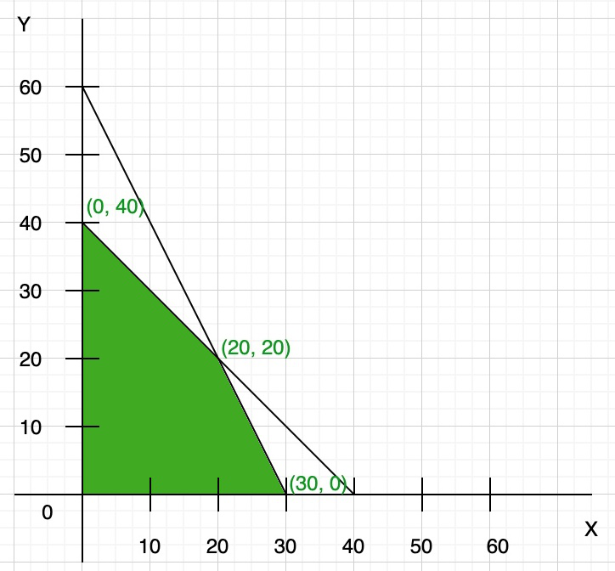

Here both the constraints are less than or equal to, so they satisfy the below region (towards origin). You can find the vertex of feasible region by graph, or you can calculate using the given constraints:

 x + y = 40 …(i)

2x + y = 60 …(ii)

Now multiply eq(i) by 2 and then subtract both eq(i) and (ii), we get

y = 20

Now put the value of y in any of the equations, we get

x = 20

So the third point of the feasible region is (20, 20)

**Step 3:** To find the maximum value of Z = 8x + y. Compare each intersection point of the graph to find the maximum value

| **Points** | **Z = 8x + y** |
| --- | --- |
| (0, 0) | 0 |
| (0, 40) | 40 |
| (20, 20) | 180 |
| (30, 0) | 240 |

So the maximum value of Z = 240 at point x = 30, y = 0.

**Example 2: One kind of cake requires 200 g of flour and 25g of fat, and another kind of cake requires 100 g of flour and 50 g of fat Find the maximum number of cakes that can be made from 5 kg of flour and 1 kg of fat assuming that there is no shortage of the other ingredients, used in making the cakes.**

**Solution:**

**Step 1:** Create a table like this for easy understanding (not necessary).

|  | **Flour(g)** | **Fat(g)** |
| --- | --- | --- |
| **Cake of first kind (x)** | 200 | 25 |
| **Cake of second kind (y)** | 100 | 50 |
| **Availability** | 5000 | 1000 |

**Step 2:** Create linear equation using inequality

* 200x + 100y ≤ 5000 or 2x + y ≤ 50
* 25x + 50y ≤ 1000 or x + 2y ≤ 40
* Also, x > 0 and y > 0

**Step 3:** Create a graph using the inequality (remember only to take positive x and y-axis)

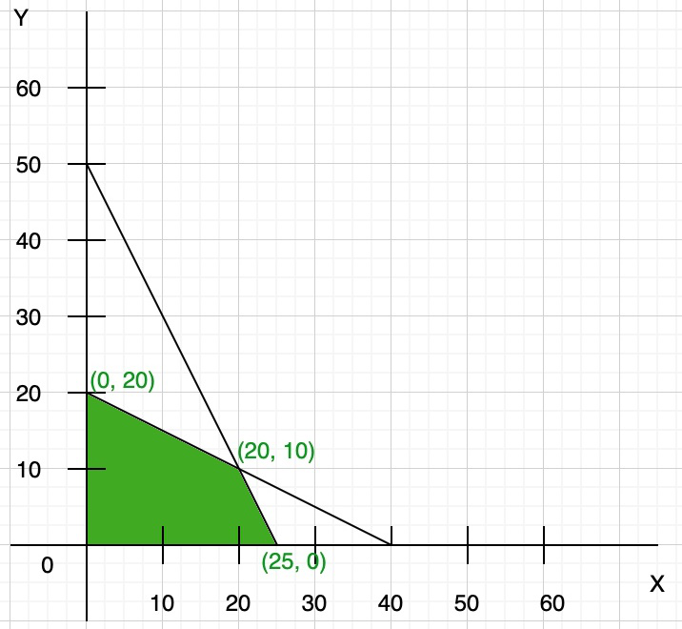

**Step 4:** To find the maximum number of cakes (Z) = x + y. Compare each intersection point of the graph to find the maximum number of cakes that can be baked.

| **x** | **y** | **Z = (x+y)** |
| --- | --- | --- |
| 0 | 20 | 20 |
| 20 | 10 | 30 |
| 25 | 0 | 25 |

Clearly, Z is maximum at co-ordinate (20, 10). So the maximum number of cakes that can be baked is Z = 20 + 10 = 30.

## **Iso-Cost Methods**

The term iso-cost or iso-profit method provides the combination of points that produces the same cost/profit as any other combination on the same line. This is done by plotting lines parallel to the slope of the equation.

To solve the problem using Iso-cost method you need to follow the following steps:

**Step 1:** Create mathematical formulation from the given problem. If not given.

**Step 2:**Now plot the graph using the given constraints and find the feasible region.

**Step 3:** Now find the coordinates of the feasible region that we get from step 2.

**Step 4:** Find the convenient value of Z(objective function) and draw the line of this objective function.

**Step 5:** If the objective function is maximum type then draw a line which is parallel to the objective function line and this line is farthest from the origin and only has one common point to the feasible region. Or if the objective function is minimum type then draw a line which is parallel to the objective function line and this line is nearest from the origin and has at least one common point to the feasible region.

**Step 6:** Now get the coordinates of the common point that we find in step 5. Now, this point is used to find the optimal solution and the value of the objective function.

**Read More,**

* [*Linear Programming*](https://www.geeksforgeeks.org/linear-programming/)
* [*Graphical Solution of Linear Inequalities*](https://www.geeksforgeeks.org/graphical-solution-of-linear-inequalities-in-two-variables/)

## **Solved Examples of Graphical Solution of LPP**

**Example 1: Solve the given linear programming problems graphically:**

**Maximize: Z = 50x + 15y**

**Constraints are,**

* **5x + y ≤ 100**
* **x + y ≤ 50**
* **x ≥ 0, y ≥ 0**

**Solution:**

Given,

* 5x + y ≤ 100
* x + y ≤ 50
* x ≥ 0, y ≥ 0

**Step 1:** Finding points

We can also write as

5x + y = 100….(i)

x + y = 50….(ii)

Now we find the points

so we take eq(i), now in this equation

When x = 0, y = 100

When y = 0, x = 20

So, points are (0, 100) and (20, 0)

Similarly, in eq(ii)

When x = 0, y = 50

When y = 0, x = 50

So, points are (0, 50) and (50, 0)

**Step 2:**Now plot these points in the graph and find the feasible region.

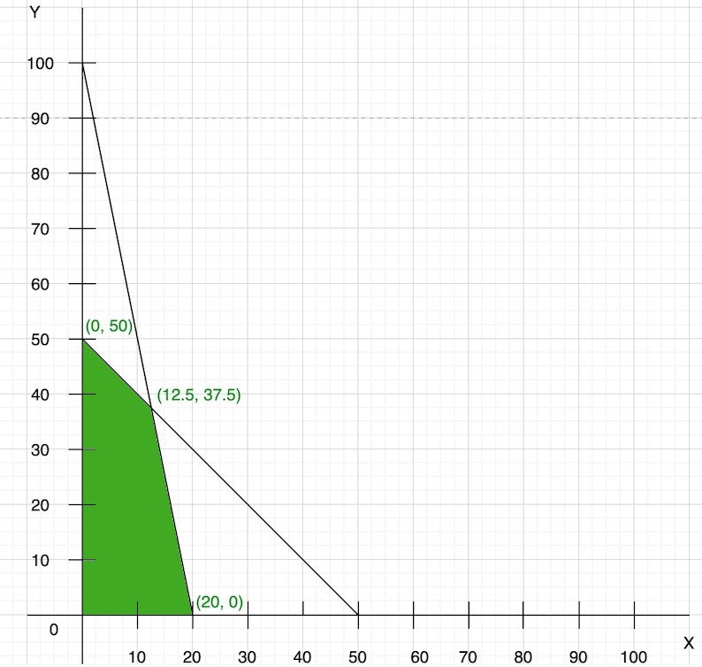

**Step 3:**Now we find the convenient value of Z(objective function)

So, to find the convenient value of Z, we have to take the lcm of coefficient of 50x + 15y, i.e., 150. So, the value of Z is the multiple of 150, i.e., 300. Hence,

50x + 15y = 300

Now we find the points

Put x = 0, y = 20

Put y = 0, x = 6

draw the line of this objective function on the graph:

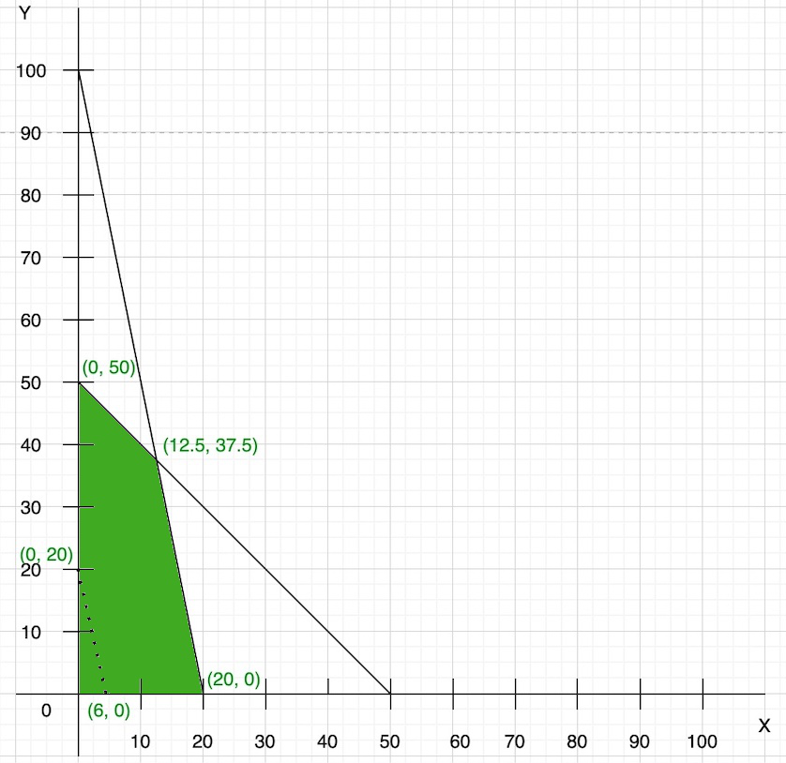

**Step 4:** As we know that the objective function is maximum type then we draw a line which is parallel to the objective function line and farthest from the origin and only has one common point to the feasible region.

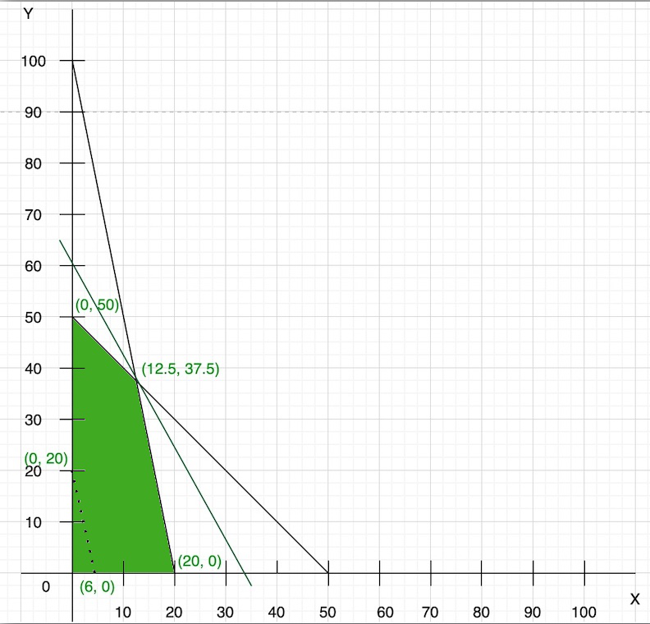

**Step 5:**We have a common point that is (12.5, 37.5) with the feasible region. So, now we find the optimal solution of the objective function:

Z = 50x + 15y

Z = 50(12.5) + 15(37.5)

Z = 625 + 562.5

Z = 1187

Thus, maximum value of Z with given constraint is, 1187

**Example 2: Solve the given linear programming problems graphically:**

**Minimize: Z = 20x + 10y**

**Constraints are,**

* **x + 2y ≤ 40**
* **3x + y ≥ 30**
* **4x + 3y ≥ 60**
* **x ≥ 0, y ≥ 0**

**Solution:**

Given,

* x + 2y ≤ 40
* 3x + y ≥ 30
* 4x + 3y ≥ 60
* x ≥ 0, y ≥ 0

**Step 1:** Finding points

We can also write as

l1 = x + 2y = 40 ….(i)

l2 = 3x + y = 30 ….(ii)

l3 = 4x + 3y = 60 ….(iii)

Now we find the points

So we take eq(i), now in this equation

When x = 0, y = 20

When y = 0, x = 40

So, points are (0, 20) and (40, 0)

Similarly, in eq(ii)

When x = 0, y = 30

When y = 0, x = 10

So, points are (0, 30) and (10, 0)

Similarly, in eq(iii)

When x = 0, y = 20

When y = 0, x = 15

So, points are (0, 20) and (15, 0)

**Step 2:** Now plot these points in the graph and find the feasible region.

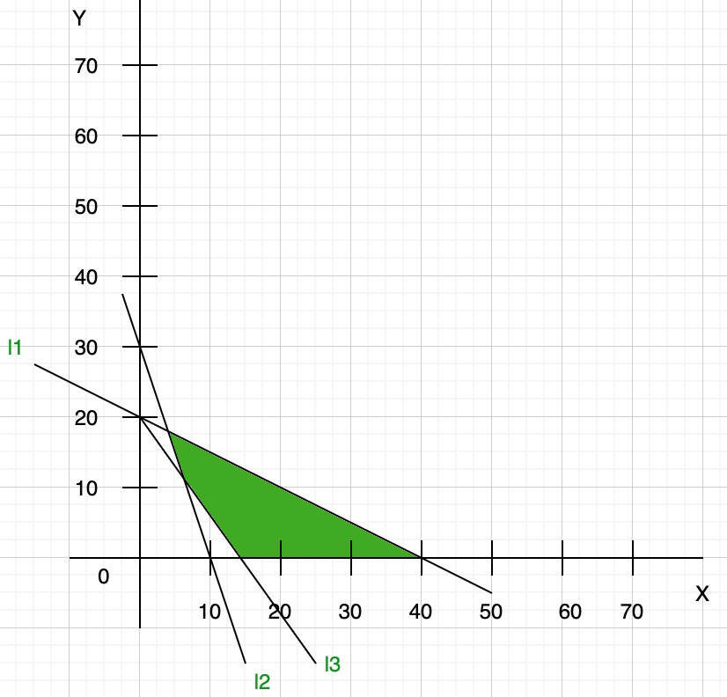

**Step 3:** Now we find the convenient value of Z(objective function)

So let us assume z = 0

20x + 10y = 0

x = -1/2y

draw the line of this objective function on the graph:

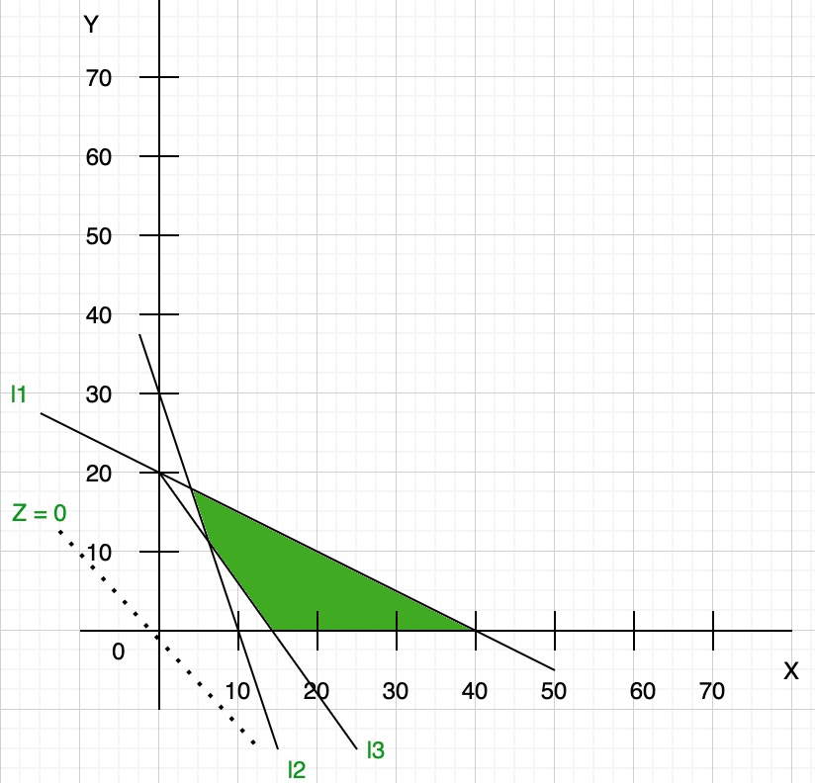

**Step 4:** As we know that the objective function is minimum type then we draw a line which is parallel to the objective function line and nearest from the origin and has at least one common point to the feasible region.

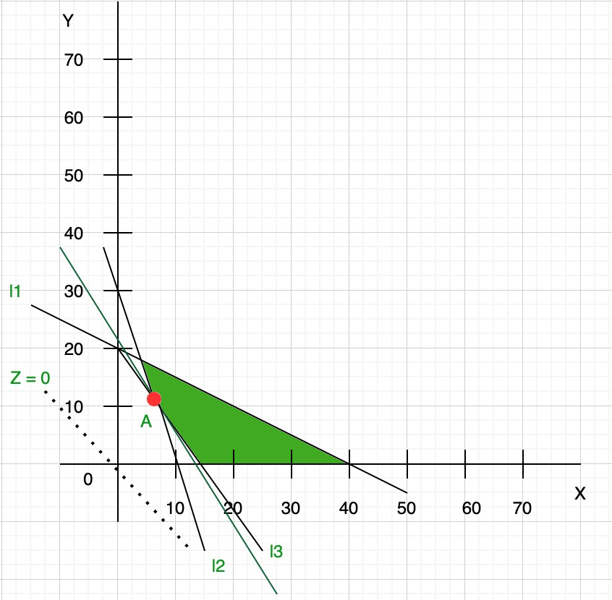

This parallel line touch the feasible region at point A. So now we find the coordinates of point A:

As you can see from the graph at point A l2 and l3 line intersect so we find the coordinate of point A by solving these equations:

l2 = 3x + y = 30 ….(iv)

l3 = 4x + 3y = 60 ….(v)

Now multiply eq(iv) with 4 and eq(v) with 3, we get

12x + 4y = 120

12x + 9y = 180

Now subtract both the equation we get coordinates (6, 12)

**Step 5:** We have a common point that is (6, 12) with the feasible region. So, now we find the optimal solution of the objective function:

Z = 20x + 10y

Z = 20(6) + 10(12)

Z = 120 + 120

Z = 240

Thus, the minimum value of Z with the given constraint are 240

## Practical Questions

1. Maximize Z=4x+3y subject to:

2x+y≤8

x+2y≤8

x,y≥0

2. Minimize Z=5x+7y subject to:

x+y≥6

2x+3y≤12

x,y≥0

3. Maximize Z=2x+5y subject to:

x+4y≤12

3x+y≤9

x,y≥0

4. Minimize Z=3x+4y subject to:

x+y≤5

2x+3y≥12

x,y≥0

5. Maximize Z=6x+4y subject to:

x+2y≤10

2x+y≥8

x,y≥0

6. Minimize Z=2x+3y subject to:

x+y≥4

x−y≤2

x,y≥0

7. Maximize Z=7x+5y subject to:

x+3y≤15

2x+y≥6

x,y≥0

8. Minimize Z=x+4y subject to:

x+y≤7

x−2y≥3

x,y≥0

9. Maximize Z=8x+2y subject to:

3x+y≤18

x+2y≥10

x,y≥0

10. Minimize Z=3x+5y subject to:

2x+y≥7

x+3y≤12

x,y≥0

## Conclusion

The graphical method for solving linear programming problems is a powerful visualization tool for the problems with the two variables. By plotting constraints and identifying the feasible region one can find the optimal solution by the evaluating the objective function at the corner points. This method not only provides insights into problem but also helps in the understanding the impact of the each constraint on the solution. However, for problems with more than two variables other techniques such as Simplex method are required.

# Simplex Algorithm – Tabular Method

**Last Updated :**25 Jul, 2024

Simplex Algorithm is a well-known optimization technique in [**Linear Programming**](https://www.geeksforgeeks.org/linear-programming/). The general form of an LPP (Linear Programming Problem) is Max/MinZ=ctXs.t.AX≤bX≥0 *Max*/*MinZ*=*ctXs*.*t*.*AX*≤*bX*≥0 **Example:** Let’s consider the following maximization problem. Maxx1+x2s.t.x1+x2+x4=82x1+x2+x3=10 *Maxx*1​+*x*2​*s*.*t*.*x*1​+*x*2​+*x*4=82*x*1​+*x*2​+*x*3​=10 **Initial construction steps :**

* Build your matrix A. A will contain the coefficients of the constraints.
* Matrix b will contain the amount of resources.
* And matrix c will contain the coefficients of objective function or cost.

For the above problem – **Matrix A – At Iteration 0**

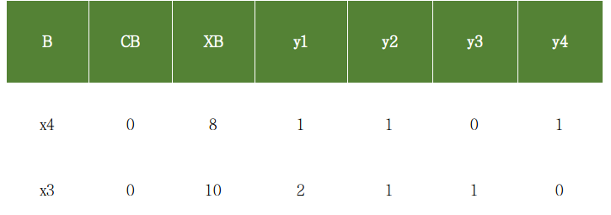

*At Iteration 0*

**Explanation of table-** **B :** Basis and contains the basic variables. Simplex algorithm starts with those variables which form an identity matrix. In the above eg x4 and x3 forms a 2×2 identity matrix. **CB :** Its the coefficients of the basic variables in the objective function. The objective functions doesn’t contain x4 and x3, so these are 0. **XB :** The number of resources or we can say the RHS of the constraints. **yi :** The complete Matrix A.

**Simplex Algorithm**  
1. Start with the initial basis associated with identity matrix.  
2. Calculate the relative profits.   
  
**For MAX problem-**  
If all the relative profits are less than or equal to 0, then the current basis is the optimal one. STOP.  
Else continue to 3.  
  
**For MIN problem**   
If all the relative profits are greater than or equal to 0, then the current basis is the optimal one. STOP.  
Else continue to 3.  
  
3. Find the column corresponding to max relative profit. Say column k has the max   
Rel. profit. So xk will enter the basis.  
  
4. Perform a min ratio test to determine which variable will leave the basis.  
 minratiotest:XBr/yrk=min{XBi/yik}*minratiotest*:*XBr*/*yrk*​=*min*{*XBi*​/*yik*​}  
Index of the min element i.e 'r' will determine the leaving variable.  
The basic variable at index r, will leave the basis.   
**NOTE: Min ratio test is always performed on positive elements.**  
  
5. It's evident that the entered variable will not form an identity matrix, so   
we will have to perform row operations to make it identity again.  
Find the pivot element. The element at index (r, k) will be the pivot element and   
row r will be the pivot row.   
  
6. Divide the rth row by pivot to make it 1. And subtract c\*(rth row) from other   
rows to make them 0, where c is the coefficient required to make that row 0.

**Table at Iteration 1**

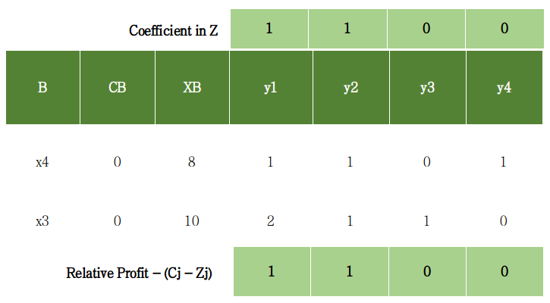

*Table at iteration 1*

Calculation of relative profits – (Cj – Zj), where Cj is the coefficient in Z and Zj is yi\*CB C1 – Z1 = 1 – (1\*0 + 2\*0) C2 – Z2 = 1 – (1\*0 + 1\*0) C3 – Z3 = 0 – (0\*0 + 1\*0) C4 – Z4 = 0 – (1\*0 + 0\*0) So Relative profits are- 1, 1, 0, 0 (As shown in the table) Clearly not all the relative profits are less or equal to 0. So will perform the next iteration. Determination of entering variable and leaving variable. Max relative profit 1 at index 1. So x1 will enter the basis. minratiotest:XBr/yrk=min{8/1,10/2} *minratiotest*:*XBr*/*yrk*​=*min*{8/1,10/2} Min of (8, 5) is 5 which is at index 2. So x3 will leave the basis. Since x1 entered perform required row operations to make an identity matrix. Pivot index = [2, 4] Pivot element = 2 Divide the 2nd row by pivot element i.e 2 to make it 1. And subtract 1\*R2 from R1 to make it 0 See the next table. **Table At Iteration 2**

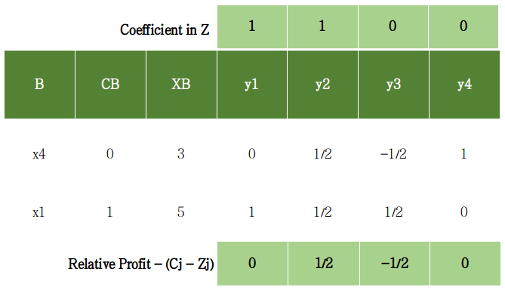

*Table at iteration 2*

Relative profits = 0, 1/2, -1/2, 0 Pivot index = [1, 5] Pivot element = 1/2 Perform necessary row operations. See next table

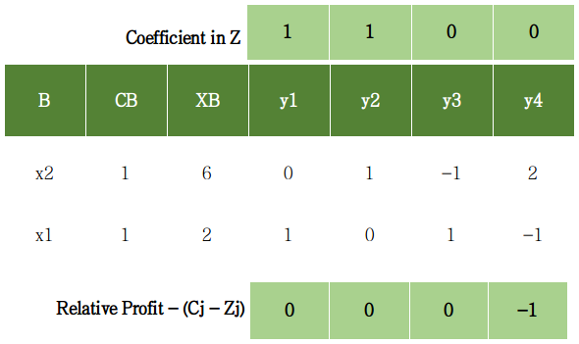

*Table At iteration 3*

Relative profits = 0, 0, 0, -1 Since all relative profits are less than or equal to 0. So optimality is reached. This will be the final simplex table and the optimal one. Value of Z at optimality = 6\*1 + 2\*1 = **8** **Following cases can occur while performing this algorithm.**

* **Case 1** – Unbounded Solution If the column corresponding to the max relative profit contains only non-positive real numbers then we won’t be able to perform the min ratio test. Therefore it is reported as unbounded solution.
* **Case 2** – Alternate Solution If at any iteration any one of the non-basic variable’s relative profit comes out to be 0, then it contains alternate solutions. Many optimal solutions will exist.

**Example 2** The above example was an equality case where we were able to find the initial basis. Now we will perform simplex on an example where there is no identity forming. MAX2x1+5x2s.t.x1+x2≤6x2≤3x1+2x2≤9 *MAX*2*x*1​+5*x*2​*s*.*t*.*x*1​+*x*2​≤6*x*2​≤3*x*1​+2*x*2​≤9 Convert the above problem into standard form i.e MAX2x1+5x2s.t.x1+x2+x3=6x2+x4=3x1+2x2+x5=9 *MAX*2*x*1​+5*x*2​*s*.*t*.*x*1​+*x*2​+*x*3​=6*x*2​+*x*4​=3*x*1​+2*x*2​+*x*5​=9 where x3, x4 and x5 are **slack variables**. These will form identity and hence the initial basis. Table at Iteration 0

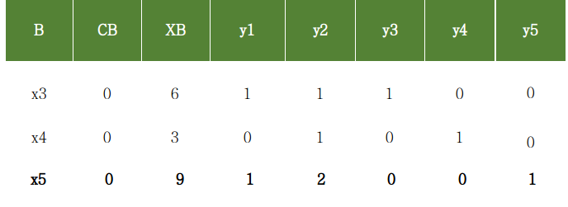

*Table at iteration 0*

Now continuing as the previous example. **Table at iteration 1**

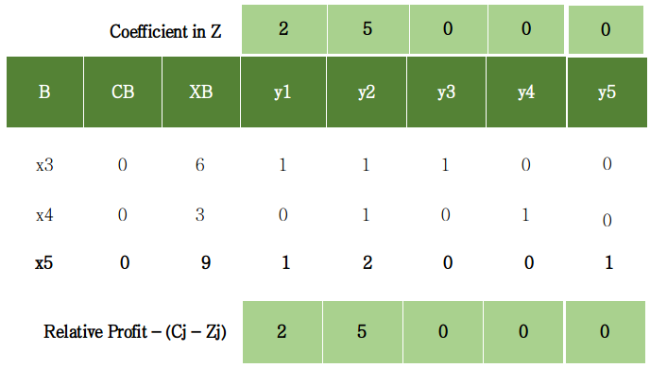

*Table at iteration 1*

Relative profits = 2, 5, 0, 0, 0 Pivot Index = [2, 5] Pivot element = 1 **Table at Iteration 2**

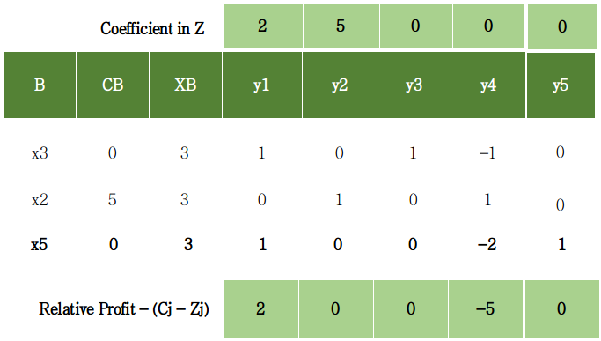

*Table at iteration 2*

Relative Profits = 2, 0, 0, -5, 0 Pivot Index = [1, 4] Pivot Element = 1 **Table at iteration 3**

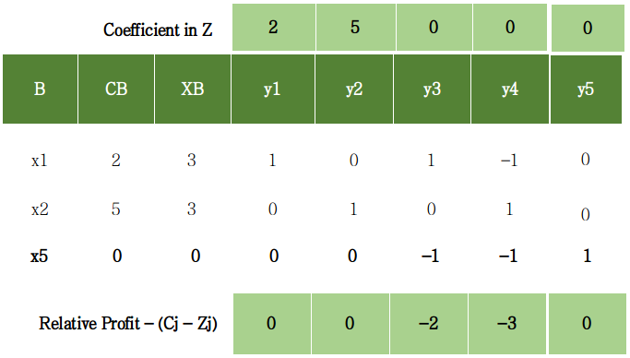

*Table at iteration 3*

Relative profits = 0, 0, 0, -2, -3, 0 Since all relative profits are less than equal to 0. Optimality is reached. This is the final simplex table and the optimal one. Value of Z at optimality = 3\*2 + 3\*5 + 0\*0 = **21** **Code Implementation of Simplex Algorithm**

**import** **numpy** **as** **np**

**from** **fractions** **import** Fraction *# so that numbers are not displayed in decimal.*

print(&quot;\n \*\*\*\*SiMplex Algorithm \*\*\*\*\n\n&quot;)

*# inputs*

*# A will contain the coefficients of the constraints*

A = np.array([[1, 1, 0, 1], [2, 1, 1, 0]])

*# b will contain the amount of resources*

b = np.array([8, 10])

*# c will contain coefficients of objective function Z*

c = np.array([1, 1, 0, 0])

*# B will contain the basic variables that make identity matrix*

cb = np.array(c[3])

B = np.array([[3], [2]])

*# cb contains their corresponding coefficients in Z*

cb = np.vstack((cb, c[2]))

xb = np.transpose([b])

*# combine matrices B and cb*

table = np.hstack((B, cb))

table = np.hstack((table, xb))

*# combine matrices B, cb and xb*

*# finally combine matrix A to form the complete simplex table*

table = np.hstack((table, A))

*# change the type of table to float*

table = np.array(table, dtype ='float')

*# inputs end*

*# if min problem, make this var 1*

MIN = 0

print(&quot;Table at itr = 0&quot;)

print(&quot;B \tCB \tXB \ty1 \ty2 \ty3 \ty4&quot;)

**for** row **in** table:

**for** el **in** row:

*# limit the denominator under 100*

print(Fraction(str(el)).limit\_denominator(100), end ='**\t**')

print()

print()

print(&quot;Simplex Working....&quot;)

*# when optimality reached it will be made 1*

reached = 0

itr = 1

unbounded = 0

alternate = 0

**while** reached == 0:

print(&quot;Iteration: &quot;, end =' ')

print(itr)

print(&quot;B \tCB \tXB \ty1 \ty2 \ty3 \ty4&quot;)

**for** row **in** table:

**for** el **in** row:

print(Fraction(str(el)).limit\_denominator(100), end ='**\t**')

print()

*# calculate Relative profits-&gt; cj - zj for non-basics*

i = 0

rel\_prof = []

**while** i&lt;len(A[0]):

rel\_prof.append(c[i] - np.sum(table[:, 1]\*table[:, 3 + i]))

i = i + 1

print(&quot;rel profit: &quot;, end =&quot; &quot;)

**for** profit **in** rel\_prof:

print(Fraction(str(profit)).limit\_denominator(100), end =&quot;, &quot;)

print()

i = 0

b\_var = table[:, 0]

*# checking for alternate solution*

**while** i&lt;len(A[0]):

j = 0

present = 0

**while** j&lt;len(b\_var):

**if** int(b\_var[j]) == i:

present = 1

**break**;

j+= 1

**if** present == 0:

**if** rel\_prof[i] == 0:

alternate = 1

print(&quot;Case of Alternate found&quot;)

*# print(i, end =&quot; &quot;)*

i+= 1

print()

flag = 0

**for** profit **in** rel\_prof:

**if** profit&gt;0:

flag = 1

**break**

*# if all relative profits &lt;= 0*

**if** flag == 0:

print(&quot;All profits are &lt;= 0, optimality reached&quot;)

reached = 1

**break**

*# kth var will enter the basis*

k = rel\_prof.index(max(rel\_prof))

min = 99999

i = 0;

r = -1

*# min ratio test (only positive values)*

**while** i&lt;len(table):

**if** (table[:, 2][i]&gt;0 **and** table[:, 3 + k][i]&gt;0):

val = table[:, 2][i]/table[:, 3 + k][i]

**if** val&lt;min:

min = val

r = i *# leaving variable*

i+= 1

*# if no min ratio test was performed*

**if** r ==-1:

unbounded = 1

print(&quot;Case of Unbounded&quot;)

**break**

print(&quot;pivot element index:&quot;, end =' ')

print(np.array([r, 3 + k]))

pivot = table[r][3 + k]

print(&quot;pivot element: &quot;, end =&quot; &quot;)

print(Fraction(pivot).limit\_denominator(100))

*# perform row operations*

*# divide the pivot row with the pivot element*

table[r, 2:len(table[0])] = table[

r, 2:len(table[0])] / pivot

*# do row operation on other rows*

i = 0

**while** i&lt;len(table):

**if** i != r:

table[i, 2:len(table[0])] = table[i,

2:len(table[0])] - table[i][3 + k] \*

table[r, 2:len(table[0])]

i += 1

*# assign the new basic variable*

table[r][0] = k

table[r][1] = c[k]

print()

print()

itr+= 1

print()

print(&quot;\*\*\*\*\*\*\*\*\*\*\*\*\*\*\*\*\*\*\*\*\*\*\*\*\*\*\*\*\*\*\*\*\*\*\*\*\*\*\*\*\*\*\*\*\*\*\*\*\*\*\*\*\*\*\*\*\*\*\*\*\*\*\*&quot;)

**if** unbounded == 1:

print(&quot;UNBOUNDED LPP&quot;)

exit()

**if** alternate == 1:

print(&quot;ALTERNATE Solution&quot;)

print(&quot;optimal table:&quot;)

print(&quot;B \tCB \tXB \ty1 \ty2 \ty3 \ty4&quot;)

**for** row **in** table:

**for** el **in** row:

print(Fraction(str(el)).limit\_denominator(100), end ='**\t**')

print()

print()

print(&quot;value of Z at optimality: &quot;, end =&quot; &quot;)

basis = []

i = 0

sum = 0

**while** i&lt;len(table):

sum += c[int(table[i][0])]\*table[i][2]

temp = &quot;x&quot;+str(int(table[i][0])+1)

basis.append(temp)

i+= 1

*# if MIN problem make z negative*

**if** MIN == 1:

print(-Fraction(str(sum)).limit\_denominator(100))

**else**:

print(Fraction(str(sum)).limit\_denominator(100))

print(&quot;Final Basis: &quot;, end =&quot; &quot;)

print(basis)

print(&quot;Simplex Finished...&quot;)

print()

For the above just plug in the required values and you will get a detailed step by step solution of your LPP by the simplex algorithm.

# Transportation Problem | Set 1 (Introduction)

**Last Updated :**18 Jan, 2024

**Transportation problem** is a special kind of **Linear Programming Problem (LPP)** in which goods are transported from a set of sources to a set of destinations subject to the supply and demand of the sources and destination respectively such that the total cost of transportation is minimized. It is also sometimes called as Hitchcock problem.

**Types of Transportation problems:**  
**Balanced:** When both supplies and demands are equal then the problem is said to be a balanced transportation problem.

**Unbalanced:** When the supply and demand are not equal then it is said to be an unbalanced transportation problem. In this type of problem, either a dummy row or a dummy column is added according to the requirement to make it a balanced problem. Then it can be solved similar to the balanced problem.

**Methods to Solve:**  
To find the initial basic feasible solution there are three methods:

1. NorthWest Corner Cell Method.
2. Least Cost Method.
3. Vogel’s Approximation Method (VAM).

**Basic structure of transportation problem:**  
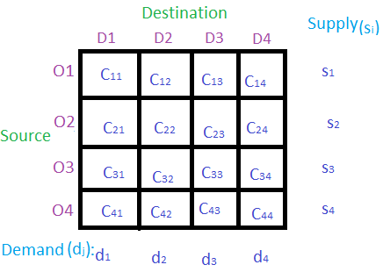  
In the above table **D1**, **D2**, **D3** and **D4** are the destinations where the products/goods are to be delivered from different sources **S1**, **S2**, **S3** and **S4**. **Si** is the supply from the source **Oi**. **dj** is the demand of the destination **Dj**. **Cij** is the cost when the product is delivered from source **Si** to destination **Dj**.

# Project Evaluation and Review Technique (PERT)

**Last Updated :**28 Oct, 2024

**Project Evaluation and Review Technique (PERT)** is a procedure through which activities of a project are represented in its appropriate sequence and timing. It is a scheduling technique used to schedule, organize and integrate tasks within a project. PERT is basically a mechanism for management planning and control which provides blueprint for a particular project. All of the primary elements or events of a project have been finally identified by the PERT.

In this technique, a PERT Chart is made which represent a schedule for all the specified tasks in the project. The reporting levels of the tasks or events in the PERT Charts is some what same as defined in the[work breakdown structure (WBS).](https://www.geeksforgeeks.org/software-engineering-work-breakdown-structure/)

*PERT chart*

## What is PERT Chart?

A PERT chart is a [project management tool](https://www.geeksforgeeks.org/ai-project-management-tools/) used to plan and schedule tasks, illustrating the sequence and timing of project activities. The PERT chart is used to schedule, organize and co-ordinate tasks within the project. the objective of PERT chart is to determine the critical path, which comprises critical activities that should be completed on schedule. This chart is prepared with the help of information generated in [project planning activitie](https://www.geeksforgeeks.org/project-plan/)s such as estimation of effort, selection of suitable process model for [software development](https://www.geeksforgeeks.org/what-is-software-development/) and decomposition of tasks into subtasks.

## What does a PERT Chart Contain?

Here are the main components of a PERT chart:

* **Nodes:** it represents the task or milestones. every node represents the task name and may also show duration of the task.
* **Arrows:**it indicates the direction or sequence of task and also dependencies between them. suppose an array from A to B, then task A must be completed before task B.
* **Time Estimation:**It estimates the time duration to complete the task.
* **Critical Path:**The critical path is the largest path in [project management](https://www.geeksforgeeks.org/project-management/) that always results in the shortest time to complete the project.
* **Milestones:**It is Key point in the project timeline that represent significant events or deadlines.

## How a PERT Chart Works?

A **PERT**chart used to plan and visualize tasks in a project. It breaks down the project into individual tasks and shows the sequence in which they must be completed. Each task is represented by a node, and arrows indicate the dependencies between tasks. By analyzing the chart, teams can identify the critical path, which helps determine the shortest time to complete the project and allocate resources effectively.

## How to Create a PERT chart?

To create a PERT chart, we can follow the below steps:

### Step 1: Identify Project Tasks

List all the tasks required to complete the project. Identifying tasks means listing all the steps needed to complete a project. Start by figuring out what the main goal is, then break it down into smaller actions. Ask team members for ideas and use clear action words for each task.

### Step 2: Define task dependencies

Defining task dependencies means figuring out which tasks must be completed before others can start. Look at your task list and identify connections by asking if one task relies on another. This helps you establish the order of work, ensuring everything is done in the right sequence.

### Step 3: Estimate Timeline

Estimating the timeline involves figuring out how long each task will take to complete. For each task, think about the quickest time it could be done (optimistic), the longest it might take (pessimistic), and the most likely time it will actually take. This gives you a better idea of the overall project duration and helps with planning.

### Step 4: **Calculate Critical Path**

Calculate [Critical Path](https://www.geeksforgeeks.org/software-engineering-critical-path-method/) means finding the longest sequence of tasks that determines the shortest time to complete the project. Identify which tasks can’t be delayed without affecting the overall [project deadline](https://www.geeksforgeeks.org/what-is-a-project-deadline/), helping you focus on what’s most important.

### Step 5: Manage task progress

It involves tracking how each task is going. Regularly check if tasks are on schedule, address any delays, and adjust plans if needed. This ensures the project stays on track and any issues are resolved quickly.

## PERT Chart Vs Gantt Chart

Here is a comparison of PERT and [Gantt charts](https://www.geeksforgeeks.org/what-is-gantt-chart-in-project-management/) in a detailed way:

| **Feature** | **PERT Chart** | **Gantt Chart** |
| --- | --- | --- |
| Purpose | Visualize project tasks and dependencies | Schedule tasks over time |
| Focus | Task relationships and sequence | Task duration and timeline |
| Representation | Network diagram with nodes and arrows | Horizontal bar chart |
| Time Estimation | Includes optimistic, pessimistic, and most likely durations | Shows start and end dates |
| Complexity | More complex, suitable for large projects | Simpler, easier to read |
| Flexibility | Adaptable for changing project paths | Less flexible once established |
| Best Use Case | Research and development projects | Construction and production schedules |

## What is PERT vs CPM?

Here are the following difference between PERT and CPM:

| **Aspect** | **PERT** | **CPM** |
| --- | --- | --- |
| **Abbreviation** | PERT stands for Project Evaluation and Review Technique. | CPM stands for Critical Path Method |
| **Definition** | PERT is a technique of project management which is used to manage uncertain (i.e., time is not known) activities of any project. | CPM is a technique of project management which is used to manage only certain (i.e., time is known) activities of any project. |
| **Orientation** | It is event oriented technique which means that network is constructed on the basis of event. | It is activity oriented technique which means that network is constructed on the basis of activities. |
| **Model Type** | It is a probability model. | It is a deterministic model. |
| **Focus** | It majorly focuses on time as meeting time target or estimation of percent completion is more important. | It majorly focuses on Time-cost trade off as minimizing cost is more important. |
| **Precision** | It is appropriate for high precision time estimation. | It is appropriate for reasonable time estimation. |
| **Nature of Job** | It has Non-repetitive nature of job. | It has repetitive nature of job. |
| **Crashing** | There is no chance of crashing as there is no certainty of time. | There may be crashing because of certain time bound. |
| **Dummy Activities** | It doesn’t use any dummy activities. | It uses dummy activities for representing sequence of activities. |
| **Sustainability** | It is suitable for projects which required research and development. | It is suitable for construction projects. |

## **Characteristics of PERT Chart**

The main characteristics of PERT are as following:

* It serves as a base for obtaining the important facts for implementing the decision-making.
* It forms the basis for all the planning activities.
* PERT helps management in deciding the best possible resource utilization method.
* PERT take advantage by using time network analysis technique.
* PERT presents the structure for reporting information.
* It helps the management in identifying the essential elements for the [completion of the project](https://www.geeksforgeeks.org/what-is-estimate-at-completion-in-project-management-eac/) within time.
* It specifies the activities that from the critical path.
* It describes the probability of completion of project before the specified date.
* It describes the dependencies of one or more tasks on each other.
* It represents the project in graphical plan form.

## **Advantages of PERT Chart**

It has the following advantages:

* Estimation of completion time of project is given by the PERT.
* It supports the identification of the activities with slack time.
* The start and dates of the activities of a specific project is determined.
* It helps project manager in identifying the critical path activities.
* PERT makes well organized diagram for the representation of large amount of data.

## **Disadvantages of PERT Chart**

It has the following disadvantages:

* The complexity of PERT is more which leads to the problem in implementation.
* The estimation of activity time are subjective in PERT which is a major disadvantage.
* Maintenance of PERT is also expensive and complex.
* The actual distribution of may be different from the PERT beta distribution which causes wrong assumptions.
* It under estimates the expected project completion time as there is chances that other paths can become the critical path if their related activities are deferred.

## Conclusion

In conclusion, the **Project Evaluation and Review Technique (PERT)** is a valuable tool for effective project management. It helps teams visualize the sequence of tasks, understand dependencies, and identify the critical path for timely project completion. By using PERT, organizations can improve planning, resource allocation, and overall project success, ensuring that goals are met efficiently and effectively.

# Advantages and Disadvantages of Critical Path Method (CPM)

**Last Updated :**02 Mar, 2020

[Critical Path Method (CPM)](https://www.geeksforgeeks.org/software-engineering-critical-path-method/) is a network analysis approach. It find out which sequence of activities has the least measure of scheduling resilience by which it predict the duration of the project. It is based on the estimation of the standard time needed for execution of a activity. CPM manages the both time and cost of the project.

In this method, the critical path of the project is established by identifying the critical activities of the project. Critical activities are the activities whose total float value is ‘0’.

**Advantages of Critical Path Method (CPM):**  
It has the following advantages:

1. It figures out the activities which can run parallel to each other.
2. It helps the project manager in identifying the most critical elements of the project.
3. It gives a practical and disciplined base which helps in determining how to reach the objectives.
4. CPM is effective in new project management.
5. CPM can strengthen a team perception if it is applied properly.
6. CPM provides demonstration of dependencies which helps in the scheduling of individual activities.
7. It shows the activities and their outcomes as a network diagram.
8. It gives a fair and concise procedure of documenting of project.
9. It helps in determining the slack time.
10. An explicit and clear approach of communicating project plans, schedules, time and cost performance is developed.
11. It is extensively used in industry.
12. It helps in optimization by determining the project duration.

**Disadvantages of Critical Path Method (CPM):**  
It has the following disadvantages:

1. The scheduling of personnel is not handled by the CPM.
2. In CPM, it is difficult to estimate the completion time of an activity.
3. The critical path is not always clear in CPM.
4. For bigger projects, CPM networks can be complicated too.
5. It also does not handle the scheduling of the resource allocation.
6. In CPM, critical path needs to be calculated precisely.

# Resource Allocation

**Last Updated :**09 Jun, 2020

To assign the available resources in an economic way is known as resource allocation. The planning of the activities and the resource required by these activities while taking into consideration both resources availability and project time is termed as resource allocation in project management.

There are 2 parts of resource allocation: Strategic Planning, and Resource Leveling. These are explained as following below.

1. **Strategic planning –**  
   In strategic planning resource allocation is a plan for using available resources, for example human resources, specially in the near term, to achieve goals for the future. It is the process of allocating resources among various projects or business units. The strategic planning has 2 parts.
   1. There is the basic allocation decision.
   2. There is the contingency mechanism.

The basic allocation decision is the choice of which items to fund in the plan and what level of fund in it should receive and which to leave unfunded; the resources are located to some items and not to others.

There may be contingency mechanism such as priority ranking of items excluded from the plan, showing which items are to be sacrificed to reduce total funding.

1. **Resource Leveling –**  
   The main objective is to smooth resource requirement by shifting slack jobs beyond periods of peak requirement. Some of the methods essentially replicate what a human scheduler do if he has enough time, procedures design especially for the computer. They of course depend for their success on the speed and capabilities of electronic compilers.

**Approach for resource allocation :**  
There are number of approaches to solve resource allocation problems:

1. Manual Approach
2. Algorithmic Approach
3. Combination of both

In algorithmic approach resource is allocated by using some computer program which is defined for a specific domain, this will automatically and dynamically distribute resources to the user. Electronic devices dedicated to routing and communication is commonly use this method. For example: channel allocation in wireless communication may be decided by base transceiver using an appropriate algorithm.

# Cost and Schedule Estimating Process

**Last Updated :**10 Jul, 2020

The cost and schedule estimation process helps in determining number of resources to complete all project activities. It generally involves approximation and development of costing alternatives to plan, perform or work, deliver, or give project. A good estimation is very much essential for keeping a project under budget.

Two perspectives are generally required to derive project plans. These perspectives are given below :

1. **Forward-Looking :**
   * The Forward-Looking approach is also known as Top-Down approach. This approach generally starts with describing and explaining various project tasks that involve starting with project aim or end deliverable and breaking it all down into smaller planning chunks.
   * Top-down budgeting also refers to a method of budgeting where project managers prepare a high-level budget for organization.
   * These project managers or senior management develops and creates a characterization of overall size, process, environment, people, and quality that is essential for software project. In this approach, duration of deliverable’s is estimated.
   * It generally takes less time and effort than bottom-up estimate. With help of software cost estimation model, an estimation of overall effort and schedule is done. The project manager generally divides estimation of overall effort into a top-level of WBS (Work Breakdown Structure).
   * They also divide schedule into major milestones dates. At this stage, sub-project managers are simply given responsibility for decomposing every element of WBS into lower levels with help of various allocations of top-level, staffing profile, and, major milestones dates as constraints.
   * The main benefit of this approach is use of holistic data from earlier projects or products, along with unmitigated risks, and scope creeps. This also helps in reducing risk of overlooked work activities or costs.
2. **Backward-Looking :**
   * Backward-Looking approach is also known as Bottom-up approach.
   * In this approach, project team breaks requirements of clients down, determining lowest level appropriate to develop a range of estimates, covering overall scope of project based on available definition of task.
   * Overall elements of lowest level WBS are generally explained into detailed tasks, for which WBS element manager is responsible for estimating budget and schedule.
   * All of these estimates are joined and integrated into higher-level WBS budgets and milestones.

Milestone scheduling also called budget allocation with help of top-down approach results in a highly optimistic plan. Whereas, bottom-up approach results in a highly pessimistic plan. Iteration is very much needed and important, using results of one approach to validate and even check results of other approach. Both of approaches should be used together, in balance, throughout life-cycle of project as shown below.

Below is diagram showing planning balance through life cycle.

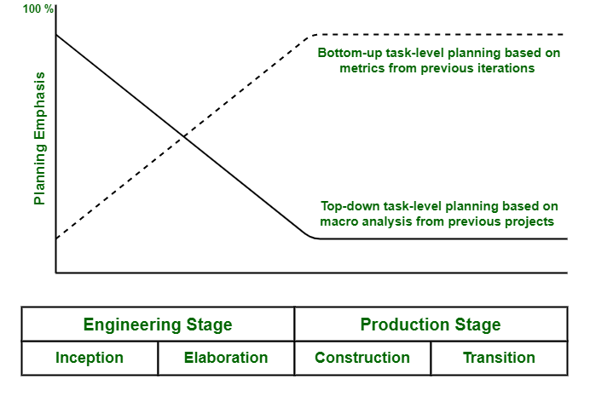

**Engineering stage planning emphasis on following points :**

* + Macro-level task estimation for engineering artifacts.
  + Macro-level task estimation for production stage artifacts.
  + Stakeholder concurrence.
  + Coarse-grained variance analysis of actual vs. planned expenditures.
  + Tuning top-down project-independent planning guidelines into project-specific planning guidelines.
  + WBS definition and elaboration.

**Production stage planning emphasis on following points :**

* + Macro-level task estimation for production stage artifacts.
  + Macro-level task estimation for maintenance of engineering artifacts.
  + Stakeholder concurrence.
  + Coarse-grained variance analysis of actual vs. planned expenditures.

Top-down perspective generally dominates during engineering stage. This is because there is no enough depth or details of understanding not even stability in sequences of detailed task to perform planning of bottom-up approach. On other hand, there is enough prior experience and planning fidelity that bottom-up planning perspective dominates during production stage.